The why and the what of Microsoft Fabric

Let us start with the question, what is Microsoft Fabric? Or to take it even further, why do we need such an offering?

Fabric is the answer to a (if not *the*) challenge of our times as data professionals:

All organizations have data that surfaces in different formats, is constantly growing, and needs to be consumed by users to drive decisions and generate insights. Those insights need to run through different workloads from real-time queries through analytical workloads, reporting, or AI-driven applications as you’ll see in [Figure 1-1](https://learning.oreilly.com/library/view/fundamentals-of-microsoft/9781098172916/ch01.html#fig_1_requirements_across_an_organization).

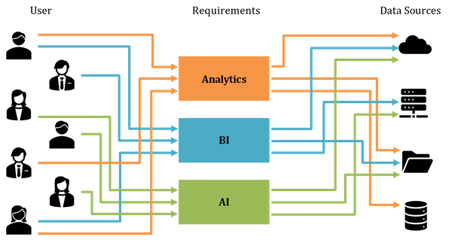

Figure 1-1. Requirements across an organization

Those users or personas usually have vastly different skill sets when it comes to working with data. They may not have any coding skills at all or they may be using different languages like Python or SQL across multiple teams in your organization as illustrated in [Figure 1-2](https://learning.oreilly.com/library/view/fundamentals-of-microsoft/9781098172916/ch01.html#fig_2_skillsets_across_an_organization).

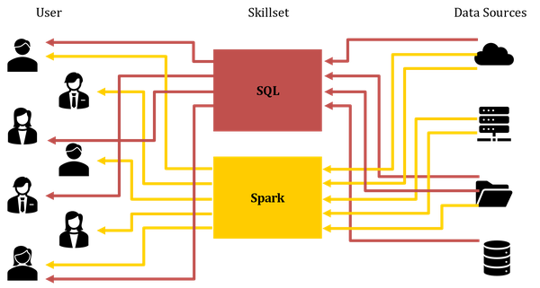

Figure 1-2. Skillsets across an organization

This means that to be able to cope with these new challenges and tasks, like responding to unprecedented amounts of data in real time, in our data driven world, you need to produce a solution that caters to all those different needs. You will need to allow different users to use different tools that match their skillset and needs, as well as to organize their data in a way that works for them. This can be raw data, a data lake, a data warehouse, or just a data mart.

Microsoft Fabric aims to solve all these problems in one single offering.

The Big Picture of Fabric

Fabric is an end-to-end solution that addresses exactly those complexities, challenges, and needs with a single product – or at least a single brand, as you’ll see in [Figure 1-3](https://learning.oreilly.com/library/view/fundamentals-of-microsoft/9781098172916/ch01.html#fig_3_fabric_overview).

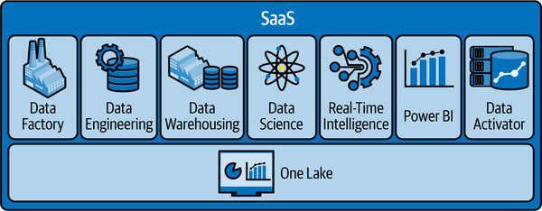

Figure 1-3. Fabric Overview

Fabric includes solutions, features, services, and tools for all the needs along the way from ETL, to building a data lake or warehouse, real-time analytics, and visualization. Above all that, Fabric provides Artificial Intelligence and Copilots along the way to support your entire experience and journey.

While we will talk about all the concepts, components and offerings in Fabric in more detail in Chapter 4, let us give you a 30.000 feet overview of what they are and how they contribute to the Fabric ecosystem.

**Workspaces and Domains**

Your main organizational units in Fabric are called workspaces and your workspaces can be grouped into domains.

Your domains and workspaces are the organizational overarching concepts for both your data as well as your lakehouses, your notebooks, your warehouses, your pipelines and all your other artifacts.

Your workspaces are also what will be controlled through CI/CD integrations.

All workspaces in Fabric support Power BI premium features.

**OneLake**

Fabric uses one joint storage layer called OneLake as its foundation to house all your data. OneLake is often referred to as the OneDrive for Data. [Figure 1-4](https://learning.oreilly.com/library/view/fundamentals-of-microsoft/9781098172916/ch01.html#fig_4_overview_of_onelake) shows the general overview of OneLake including its main components and APIs.

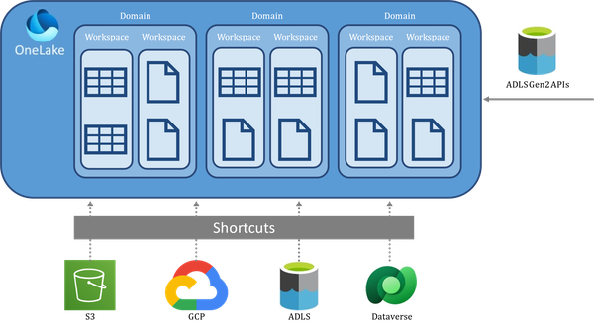

Figure 1-4. Overview of OneLake

OneLake is basically an Azure Data Lake Storage Gen2 account (Microsoft’s data lake solution for big data analytics) that manages all your data and artifacts across your domains and workspaces. In addition to storing data, which can be ingested in a multitude of ways (more on that in Chapter 3), it also comes with a data virtualization concept called shortcuts which allows you to access and use data in real-time that is sitting in other storage accounts like an AWS S3 bucket or Dataverse.

Data in OneLake is natively stored in Delta format but OneLake also supports access to storage accounts that use the Apache Iceberg format, another open-source table format that is - just like delta - agnostic to processing engine and file format.

**Data Factory**

Microsoft Fabric’s Data Factory is designed to offer cloud-scale data movement and transformation services, simplifying the management of complex data integration and ETL (Extract, Transform, Load) processes. It provides a user-friendly, robust, and enterprise-grade experience for data management. As the successor to Azure Data Factory, this service has evolved to incorporate cloud-scale capabilities, addressing the most intricate ETL challenges. Data Factory delivers a modern data integration experience, enabling users to ingest, prepare, and transform data from various sources, including databases, data warehouses, lakehouses, and real-time data streams.

**Data Engineering**

Synapse Data Engineering in Microsoft Fabric is a comprehensive suite tailored for data engineers to efficiently manage and transform large data volumes using Spark, facilitating the creation of lakehouse architectures. A lakehouse integrates the scalable storage of a data lake with the management capabilities of a data warehouse, providing a unified platform for data ingestion, preparation, and sharing. This architecture supports SQL queries, analytics, machine learning, and other advanced techniques on both structured and unstructured data. Microsoft Fabric enables users to create and manage lakehouses, design data movement pipelines, and utilize Spark job definitions for batch or streaming jobs. Additionally, notebooks are available for writing code related to data ingestion, preparation, and transformation.

**Data Science**

Synapse Data Science in Microsoft Fabric provides a robust platform for data scientists, supporting an end-to-end workflow for building, deploying, and operationalizing machine learning models. Key features include the use of R and Python in notebooks for data exploration, Data Wrangler for simplified analysis, and MLFlow for tracking and comparing model experiments. Users can efficiently perform batch scoring at scale with Predict, benefiting from deep integration across Fabric’s stack. This integration enables seamless data scoring in lakehouses, writing back predictions, and visualizing data in reports.

**Data Warehouse**

Synapse Data Warehouse in Microsoft Fabric streamlines data insights while ensuring robust data security and governance through T-SQL constructs. It utilizes a distributed engine to deliver high performance and scalability. Data stored in parquet format supports ACID transactions and interoperability across platforms, eliminating the need to duplicate data. Microsoft Fabric provides two warehousing experiences: the SQL analytics endpoint of the Lakehouse for read-only queries and the Synapse Data Warehouse for full transactional support, accommodating various data ingestion methods. This dual offering caters to diverse user needs, from data engineering to complex SQL operations.

**Real-Time Intelligence**

Synapse Real-Time Intelligence in Microsoft Fabric is a fully managed big data analytics platform tailored for streaming and time-series data. It simplifies data integration, allowing organizations to scale their analytics solutions and make data accessible to various users, from citizen data scientists to advanced data engineers. The platform includes features specifically designed for real-time analytics, such as automatic data streaming, indexing, and partitioning for any data source or format, along with on-demand query generation and visualizations. This enables organizations to quickly access data insights with minimal effort and high efficiency.

**Power BI**

You probably know this one, but if not: Power BI is a business analytics tool that enables users to visualize data and share insights across their organization or embed them in an app or website. It provides interactive visualizations and business intelligence capabilities with an interface simple enough for end users to create their reports and dashboards. Power BI is now part of Microsoft Fabric, enhancing its integration and scalability within the broader ecosystem of Microsoft’s cloud services. This integration allows users to seamlessly connect Power BI with other Fabric services, streamlining the process of data analysis and visualization within a unified analytics solution.

**Data Activator**

Data Activator in Microsoft Fabric is a no-code tool designed to automate actions based on patterns or conditions detected in changing data. It allows users to monitor data within Power BI reports and Event Streams, triggering actions when specified thresholds or patterns are met. This tool streamlines the process of responding to data changes, enabling users to efficiently manage data-driven actions without the need for coding.

**Copilots**

And, as previously mentioned, a variety of AI and copilot support along the way. There is not a single copilot in Fabric but a multitude of them, serving different purposes. They need to be enabled and require a certain minimum system size. More on that later as well as in the documentation (<https://learn.microsoft.com/en-us/fabric/get-started/copilot-fabric-overview>).

The Fabric Roadmap

**Note**

Another thing to be aware of is that Fabric is very agile. Some of the things, features and options in this book probably already got enhanced in one way or another by the time you play with it.

The Fabric public preview was announced at Microsoft Build in May 2023.

It went to GA at Microsoft Ignite in November 2023.

Another huge feature wave was announced at the Fabric Conferences in the US and Europe in 2024 as well as at Build and Ignite 2024 again. [Figure 1-5](https://learning.oreilly.com/library/view/fundamentals-of-microsoft/9781098172916/ch01.html#fig_5_microsoft_fabric_release_cycle_and_history) gives you an overview of the initial and post-launch feature waves of Fabric.

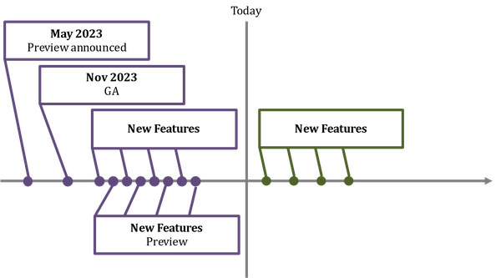

Figure 1-5. Microsoft Fabric Release Cycle and History

And since then, again, a huge list of new features has been provided, some of them still in preview.

Fabric constantly keeps getting new features and capabilities, so we’re going to see new features and the future popping up on very short cadences.

No matter how fast we publish this book or an update of it, the actual roadmap will always be out of date by the time of publishing due to the speed and agility.

Check out https://aka.ms/FabricRoadmap for an always up to date list of features that are currently the making or in preview.

**The Fabric Pricing Model**

Another interesting part about fabric is licensing or rather: Pricing. Rather than sizing, deploying, and paying for a variety of individual services and offerings, you are basically paying for one single product.

The fabric pricing consists of three components: storage, compute, and user licenses as you’ll see in [Figure 1-6](https://learning.oreilly.com/library/view/fundamentals-of-microsoft/9781098172916/ch01.html#fig_6_the_three_components_of_fabric_pricing).

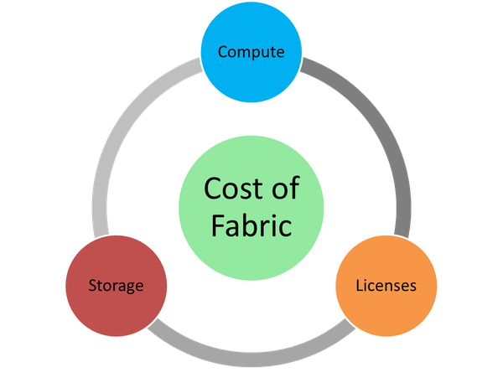

Figure 1-6. The three components of Fabric pricing

**Compute & Capacities**

When we talk about Compute in Fabric, we talk about something called capacities. Capacities form the compute power of your entire Fabric deployment, no matter which specific offerings you’re using so the words compute, and capacity are synonymous in the context of Fabric. [Figure 1-7](https://learning.oreilly.com/library/view/fundamentals-of-microsoft/9781098172916/ch01.html#fig_7_capacity_sizes_and_settings) for example is shows two capacities using different sizes in different regions.

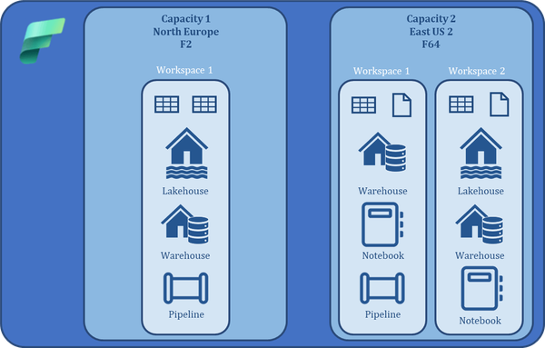

Figure 1-7. Capacity sizes and settings

Your entire fabric environment can be based off a single capacity, or you can run multiple capacities which will have different names, may sit in different regions and they may have different sizes. Depending on their sizes, they will have the ability to host a certain number of workspaces and workloads.

**Capacity types**

There are three kinds of fabric capacities: Fabric, Fabric Reserved and Fabric Trial. They are all shown in [Figure 1-8](https://learning.oreilly.com/library/view/fundamentals-of-microsoft/9781098172916/ch01.html#fig_8_fabric_capacity_types).

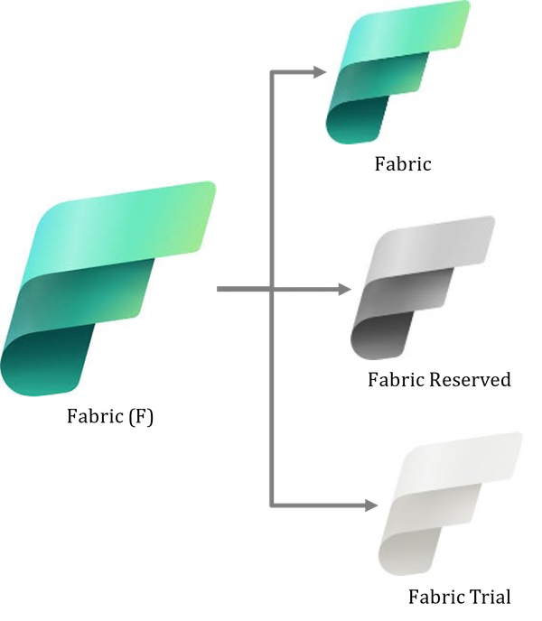

Figure 1-8. Fabric capacity types

A regular Fabric capacity will be billed on a pay as you go basis, so you only pay for the compute time your capacities are running whereas with a reserved capacity, you enter a commitment for a certain amount of time in exchange for a discount.

Both, Fabric and Fabric Reserved capacities will use Azure billing.

Trials give you access to almost the full feature set of Fabric at no cost for 60 days with the equivalent of an F64 capacity – more on that in the next section. The most important feature currently missing from trials are Copilots.

While any capacity can be paused, this usually only makes sense for Pay as You Go workloads as with a paused capacity, you will only pay for it while it is running – a reserved capacity will be billed 24/7 anyway. The process of pausing is for the capacity however – not the workload so unless you pause your capacity, you will still be billed even with no workload happening.

**Capacity sizes**

Fabric capacities come in different sizes and the size determines the number of capacity units – which is an equally abstract metric as you may have come across in other cloud offerings - and therefore the amount, performance and size of workloads this capacity can provide.

The smallest one is an F2 - which has 2 capacity units - followed by an F4 up to the largest one available right now: an F2048 which has 2,048 capacity units.

To make this a bit more transparent: A day has 86,400 seconds. An F2 capacity has 2 capacity units so

2*86,400 seconds = 172,800 compute seconds available to you while an F8 capacity has 8*86,400 resulting in 691,200 compute seconds available to you in a day (assuming you are running your capacity 24 hours a day) as you can also see in [Figure 1-9](https://learning.oreilly.com/library/view/fundamentals-of-microsoft/9781098172916/ch01.html#fig_9_meaning_of_capacity_sizes).

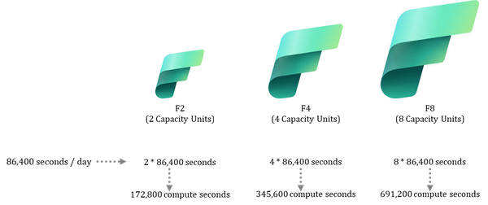

Figure 1-9. Meaning of capacity sizes

Unfortunately, there is no great guidance or general rule on how much can be achieved within a compute second as that is very workload (and offering) specific so the best practice when it comes to sizing your environment is still to start with an educated guess and then work your way up or down from there.

**Capacity Bursting (and Smoothing)**

Even the smallest capacities allow you to make use of a feature called bursting. Cool. What does that mean?

Let’s assume you run an F8 capacity, and you keep it running 24/7.

We now make another assumption: You run a workload that would usually take 10 minutes to complete using your F8 capacity.

Now through bursting, Fabric *MAY* grant you additional compute power – more than you pay for – so this workload completes in 5 minutes. As if you had bought an F16 capacity (see [Figure 1-10](https://learning.oreilly.com/library/view/fundamentals-of-microsoft/9781098172916/ch01.html#fig_10_bursting)).

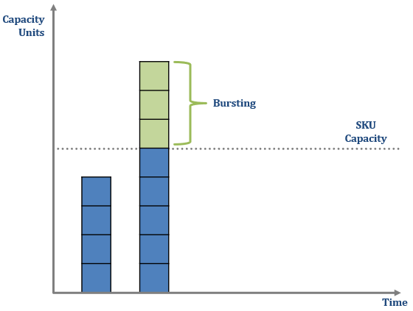

Figure 1-10. Bursting

So, Microsoft is gifting you free compute? Well, no. Think of it more as a credit line. Any extra compute that you consumed through bursting will need to be recovered through its counterpart, smoothing within 24 hours.

How does that impact you?

If you don’t use the full compute units all the time, the smoothing will simply be recovered through the spare capacity you’re not using as shown in [Figure 1-11](https://learning.oreilly.com/library/view/fundamentals-of-microsoft/9781098172916/ch01.html#fig_11_previous_bursting_being_recovered_in_a_less_idle_p).

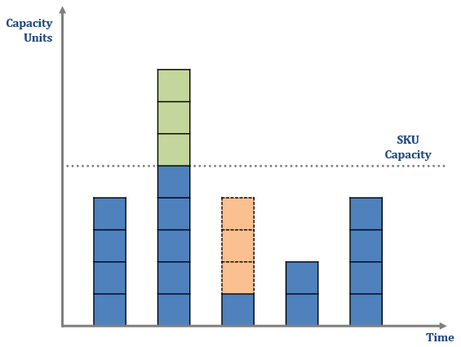

Figure 1-11. Previous bursting being recovered in a less idle period

If you constantly use the entire compute units available to you, at some point, as illustrated in [Figure 1-12](https://learning.oreilly.com/library/view/fundamentals-of-microsoft/9781098172916/ch01.html#fig_12_previous_bursting_being_recovered_through_throttli), your capacity will be throttled so while still paying for your F8 capacity, you may only get to use 4 capacity units for some time for example.

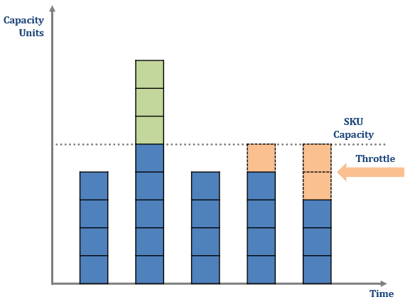

Figure 1-12. Previous bursting being recovered through throttling

And if you simply pause your capacity right after bursting? Then you will continue to be billed until you’ve paid your dues or in other words: until all the extra compute units used by bursting have been recovered. This is also illustrated in the “Pause” section of [Figure 1-13](https://learning.oreilly.com/library/view/fundamentals-of-microsoft/9781098172916/ch01.html#fig_13_previous_bursting_being_recovered_in_a_period_wher).

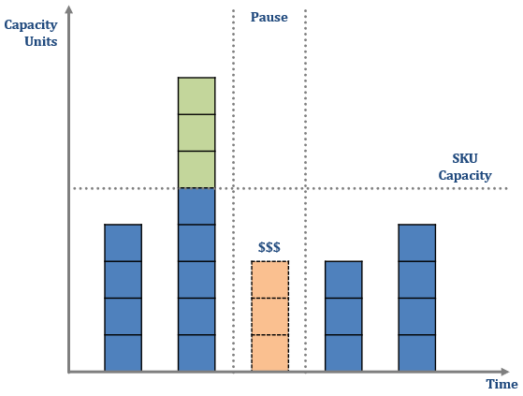

Figure 1-13. Previous bursting being recovered in a period where the capacity is pause

**Capacity limitations**

Some features require a certain minimum SKU.

Copilots for example, will only work if you have a F64 capacity or higher.

Similar restrictions apply to other features.

You can find an overview of current limitations at <https://learn.microsoft.com/en-us/fabric/enterprise/fabric-features>. That overview however isn’t always complete unfortunately. so if you are relying on a specific feature, make sure to double check its prerequisites in the documentation.

**Storage**

Storage pricing is straightforward. You simply pay for the storage you are using in OneLake, and you pay that per gigabyte.

Storage will always be billed independently of compute so even when you pause your capacity, you will pay for the storage used. You cannot pause your storage.

If you are making use of Mirroring, a way to replicate data into OneLake from other sources, you can make use of free storage for your mirrored data. We will explain more about Mirroring in a later chapter, but for now, with Mirroring, you receive free storage for replicas up to a certain limit based on the purchased compute capacity SKU you provision (1 TB per capacity unit). For example, if you purchase an F8 capacity, you will get 8 free terabytes worth of storage. OneLake storage is billed only when the free Mirroring storage limit is exceeded, or the provisioned compute capacity is paused.

**User Licenses**

User licenses do not play a significant role within Fabric with one exception: Power BI.

If you are not using Power BI within Fabric or your capacity has a size of F64 or above, only report creators will need a Pro license. Only If you are using Power BI on a capacity that is smaller than F64, you will require a Power BI Pro license for every user that is using Power BI in workspaces within that capacity.

Otherwise, no paid user licenses are required, and your workloads are being charged through the cost of capacities and storage alone. Every user accessing a workspace without a Power BI License will need a Free Fabric license though.

**Networking**

Charges for Networking have been announced but are not implemented yet.

**Regional Differences**

As with all cloud services, keep in mind that prices also vary by region and sometimes the differences are surprisingly big. Make sure to take a look at the Microsoft pricing page (<https://azure.microsoft.com/en-us/pricing/details/microsoft-fabric/#pricing>) to get a full overview of Microsoft fabric pricing applicable to you. Your choice of a region should of course also take latency as well as potential data residency restrictions into account.

Also, when making use of some offerings like OpenAI – for example Copilots, those aren’t available in every region so pricing, feature offering, latency and data residency should all be factored into your decision on where to deploy Fabric.

Summary

Let us try to wrap up this first chapter. Fabric is an end-to-end software as a service solution, meaning you only provision a single Azure resource despite potentially using hundreds of different workloads which simplifies your deployments, and you also only receive a single bill for that.

Fabric is lake centric which means that all its data is being stored in OneLake. With OneLake on one and capacities on the other side, Fabric gives you full separation of data and compute.

Copilots enhance the entire experience to get you to your results even quicker.

Fabric is organized through shared workspaces which are all premium workspaces so users can share their data as well as their artifacts.

While we have not looked at those aspects yet, Fabric is of course a governed platform including security, monitoring and role concepts. We will get into that in Chapter 7: Microsoft Fabric - Administration, Security, Governance and Monitoring.

Our next Chapter, All Roads Lead to OneLake, will focus on how to access OneLake, it’s architecture and most importantly, how to ingest data to and retrieve data from OneLake.

Chapter 2. Getting Started with Microsoft Fabric

**A Note for Early Release Readers**

With Early Release ebooks, you get books in their earliest form—the author’s raw and unedited content as they write—so you can take advantage of these technologies long before the official release of these titles.

This will be the 2nd chapter of the final book.

If you have comments about how we might improve the content and/or examples in this book, or if you notice missing material within this chapter, please reach out to the editor at *sevans@oreilly.com*.

In Chapter 1 we gave you an overview of what Microsoft Fabric is, and in this Chapter we’ll give you a step-by-step guide on how to get started with Fabric and the Fabric Portal. If you’ve had initial experiences with Fabric, feel free to skip this chapter – otherwise, while we may be skipping a few details in this chapter to provide you with a big picture (so don’t worry if you feel like you’re missing some pieces here and there), these first steps will hopefully be helpful when it comes to handling and navigating the Fabric features in the Chapters 4 – 15 where we will be filling those gaps.

Creating an Azure Account

The very first requirement to get started with Fabric is to set up a Microsoft Azure Account.

If you already have an account, you can use that. Otherwise, navigate to portal.azure.com where you will be greeted by a login form which also provides the option to create a new account.

Enabling Fabric

To get started with Microsoft Fabric, you navigate to app.powerbi.com or app.fabric.microsoft.com, where you will again be greeted by a logon screen (see Figure 2-2):

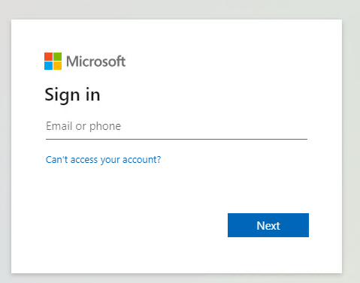

Figure 2-1. Fabric Portal Login Screen

You log in with your email address (your Azure Account) and the system will take you to the home page of either Fabric or Power BI – depending on the URL you chose. For this exercise, both work and do the same thing.

On this landing page, find the settings as highlighted in Figure 2-3 and select the admin portal:

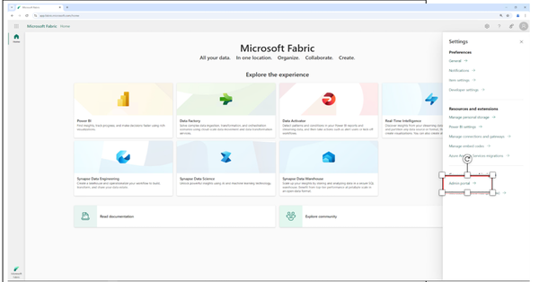

Figure 2-2. Settings in the Fabric Portal

While there are all kinds of settings and metrics to be found here (See Figure 2-4), we’ll focus on the crucial parts to get started quickly.

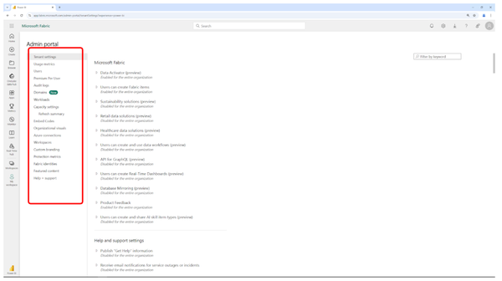

Figure 2-3. Fabric Admin settings

In the tenant settings, find the Microsoft Fabric section as highlighted in Figure 2-5 and make sure that users can create Fabric items – either the entire organization or at least those users that you want to try Fabric with. If these settings are greyed out or inaccessible for you, they are probably controlled by your organization’s administrators so you would either need to reach out to them to enable it for you or create a new account.

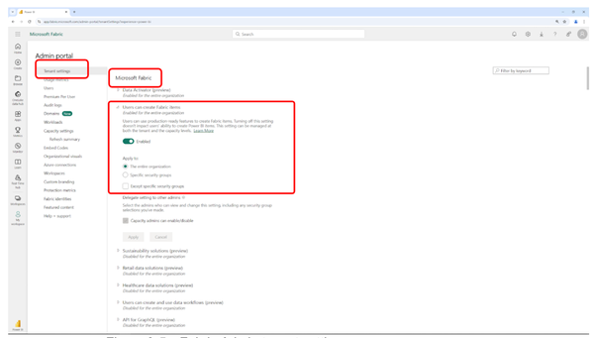

Figure 2-4. Fabric Admin tenant settings

If Fabric is enabled, the other thing we will need is at least one capacity. Navigate to the capacity section as shown in Figure 2-6.

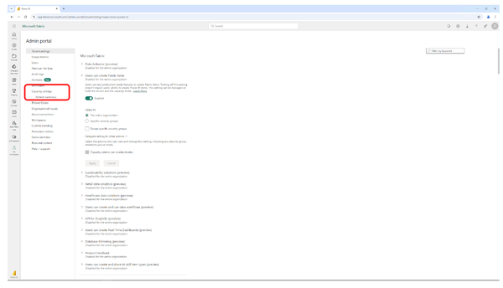

Figure 2-5. Fabric Admin capacity settings

Here, you can go ahead and purchase and manage one or multiple capacities.

If we click “Purchase” (Figure 2-7), we will be routed to the Azure portal using a deep link that will directly take us to the creation of a new capacity.

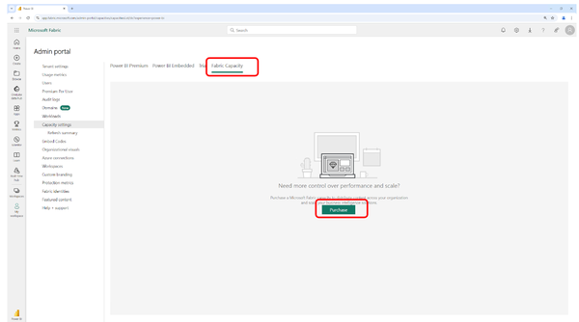

Figure 2-6. Fabric Admin capacity purchase

We provide our subscription, resource group, a name, a region and – most importantly the size (Figure 2-8).

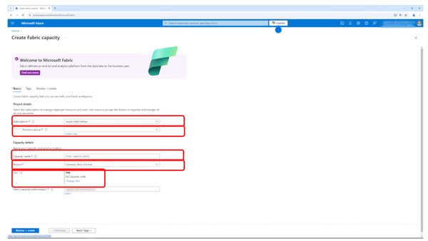

Figure 2-7. Azure Portal new Fabric capacity settings

When you click ”Change size” (as highlighted in Figure 2-8), you will see the available sizes in that region and for your subscription including their prices (shown in Figure 2-9).

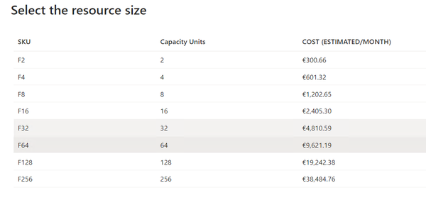

Figure 2-8. Azure Portal new Fabric capacity sizes and cost

We will however NOT go ahead here because we’ll do something even better: we will use a trial capacity to explore the capabilities of Fabric at no cost for up to two months. A trial gives you the equivalent of an F64 capacity with the exception of very few features (unfortunately, copilots are one of those).

**Tip**

Capacity pricing varies by Region and is subject to change. Difference in pricing between regions can be very significant! </HintBox>

To enable a trial, go back to the Fabric portal and simply hit “Free trial” as highlighted in Figure 2-10:

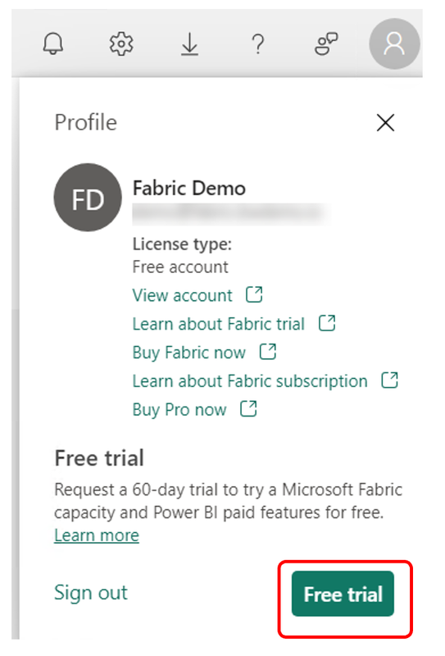

Figure 2-9. Fabric Capacity trial start

You will be asked to confirm if you really want to upgrade to a free Fabric trial capacity, which you can confirm by clicking “Activate” again (see Figure 2-11).

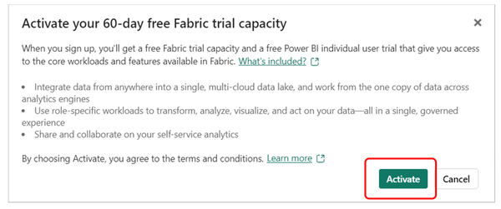

Figure 2-10. Fabric Capacity trial confirmation

A message (as shown in Figure 2-12) confirms that your capacity got upgraded and you can choose between being redirected to the Fabric home page or to stay on the current page.

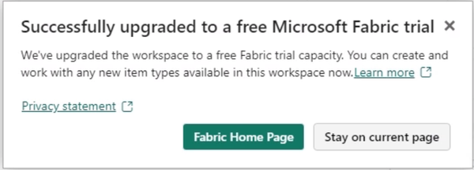

Figure 2-11. Fabric Capacity trial confirmation

**Tip**

The number of trials per tenant is limited. If this limit has already been reached for your organization, please create a new account for that purpose.

When selecting to stay on the the current page, everything gets refreshed and you can see the number of days remaining in the top bar (highlighted in Figure 2-13).

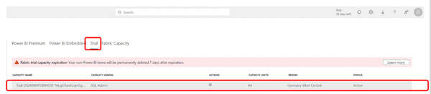

Figure 2-12. Fabric trial capacity overview

In the capacity settings (see Figure 2-13), on the trial tab, our trial capacity is showing up (just as regular capacities would on the other tabs if we had bought any).

Our Fabric environment is now ready for use!

If we were to share this environment with other users, we’d need to add them to the appropriate roles, which we will elaborate on more in Chapter 17.

First steps with Fabric

With a capacity in place, navigate back to app.fabric.microsoft.com - and in this case it DOES matter which page you pick, as powerbi.com won’t give you the same experience - you will get the entire overview of what Fabric has to offer from Power BI over data factory to data engineering and so on (see Figure 2-14). In this example, we’ve chosen Synapse Data Engineering.

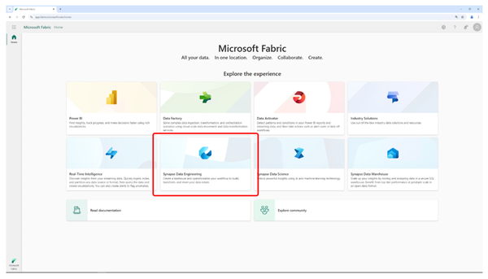

Figure 2-13. Fabric Portal Overview

We will walk you through some of those experiences and their functionality and features in the next section simply to give you an idea of handling and navigation.

**Building a Lakehouse**

We will start by building a Lakehouse which is part of data engineering, so if you click on “Synapse Data Engineering” (the data engineering experience) (Figure 2-15) you will end up on the homepage of that experience.

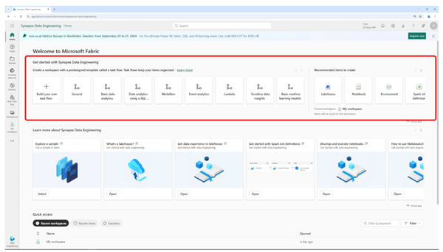

Figure 2-14. Fabric Portal Data Engineering

You will be prompted to create a Lakehouse, notebook etc. as shown in Figure 2-16:

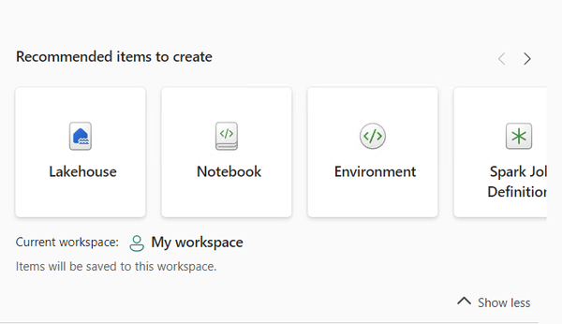

Figure 2-15. Fabric Portal Data Engineering Experience

Let us pick a Lakehouse, give it the name BookHouse and hit “Create“ (Figure 2-17).

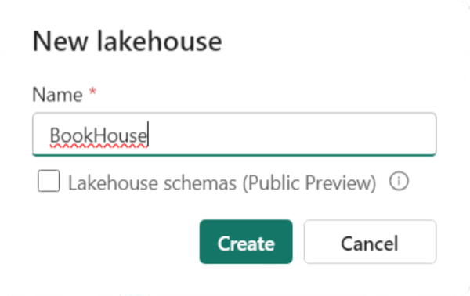

Figure 2-16. Fabric Portal Data Engineering Experience - New Lakehouse

The Lakehouse got created but as you can see in Figure 2-18, it is - of course - empty:

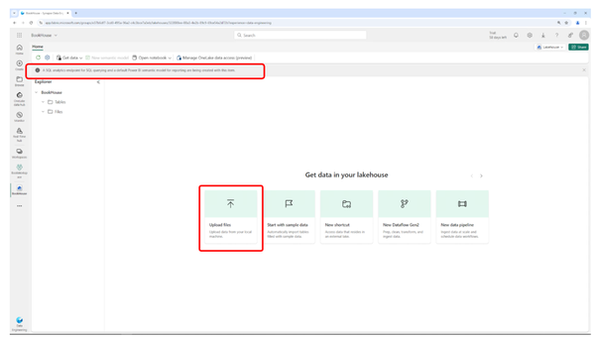

Figure 2-17. Fabric Portal Data Engineering Experience – New Lakehouse after creation

As also highlighted in Figure 2-18, even though the Lakehouse is ready, the SQL endpoint is still getting created (this takes a few minutes and will report back as finished once completed). Whenever you create a Lakehouse, it will automatically receive a SQL endpoint to make it accessible through SQL based client tools. Despite this still being created, we can start working on the Lakehouse already.

Right from the landing page of our (empty) Lakehouse, we could now go ahead and upload files to it (Figure 2-19).

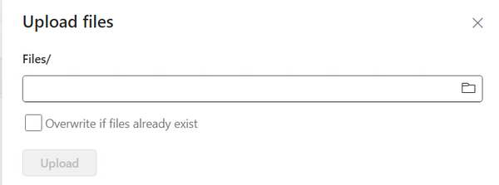

Figure 2-18. Fabric Portal Data Engineering Experience – Upload files to Lakehouse

We could also create a new data flow or a data pipeline or a shortcut - a concept specific to Fabric which we’ll explore in Chapter 3 when discussing OneLake (Figure 2-20).

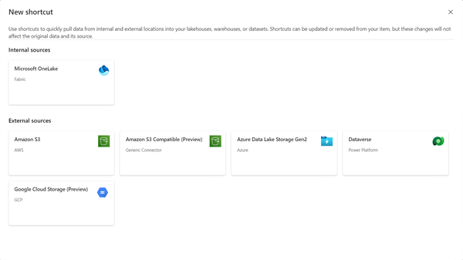

Figure 2-19. Fabric Portal Data Engineering Experience – Create a shortcut

For our first experience, to keep things simple, we just start with sample data, which means that this lake gets populated with a couple of sample files and tables that we can then use to work with. Simply clicking “Start with sample data” (Figure 2-21) on the Data engineering landing page will trigger this process which will take a few moments.

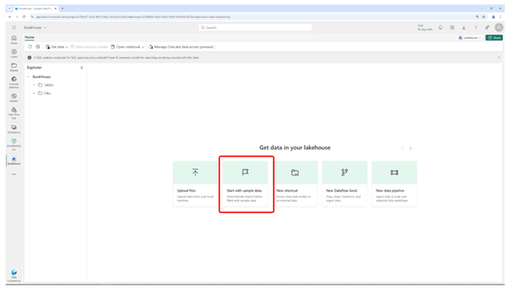

Figure 2-20. Fabric Portal Data Engineering Experience – Start with sample data

Data in a Lakehouse is categorized as either tables or files and the sample data process generates both for us.

This has for example generated a table called public holidays which you can reach by expanding the tables of the Lakehouse and then explore its data by simply left-mouse clicking it (Figure 2-22).

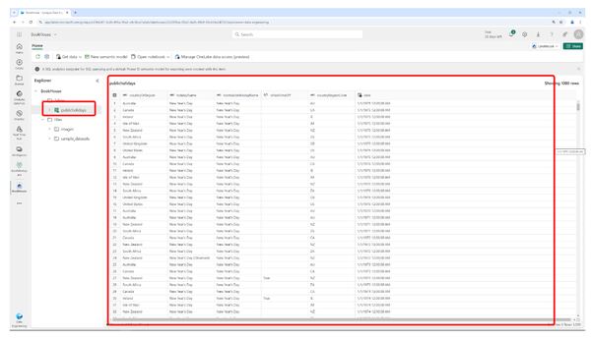

Figure 2-21. Fabric Portal Data Engineering Experience – Finding and exploring sample data

What you will notice is that the first time reading that table takes a really long time. That is because the spark pools etc. in the background need to be started up first. Once that is done, all subsequent reads should be way faster.

If you navigate to the files of our sample datasets and take a look you will find a couple of CSVs and parquet files (see Figure 2-23). Of course, we could always add additional data by just clicking “Get data” in the top menu.

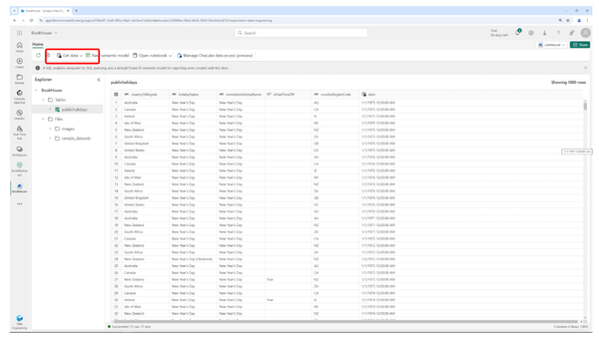

Figure 2-22. Fabric Portal Data Engineering Experience – Sample files

If we want to explore the data in those files, we could now for example, select the US population county area CSV file and right mouse clicking it and selecting “Load to Tables” and “New table” as shown in Figure 2-24.

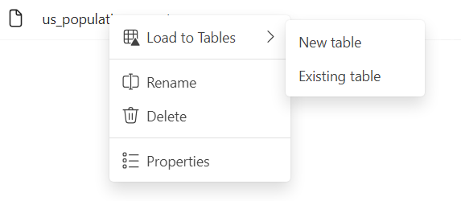

Figure 2-23. Fabric Portal Data Engineering Experience – Load CSV to table

As shown in Figure 2-25, since it’s a CSV that we selected, we can define that there’s a column header and which separator to use and this will be loaded into our Lakehouse in a table.

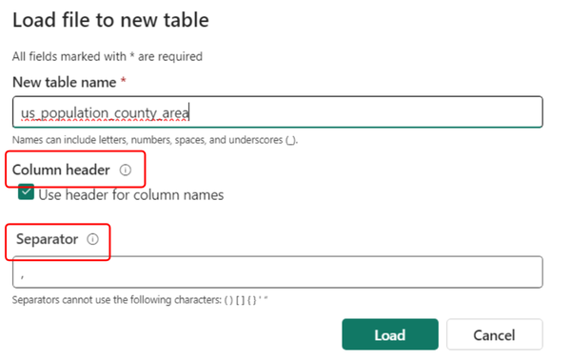

Figure 2-24. Fabric Portal Data Engineering Experience – Load CSV to table (settings)

This will make the data available in a table that would then for example be exposed through the SQL endpoint of our Lakehouse.

If we wanted to explore or transform data, rather than just clicking a table, we could for example also open the public holidays table in a new notebook by clicking “Open notebook” and “New notebook” (Figure 2-26).

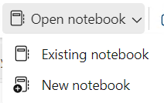

Figure 2-25. Fabric Portal Data Engineering Experience – Explore data in Notebook

What this will do is it will create a new notebook where we can then add the code snippets that will read that table from our Lakehouse. First, expand your Lakehouse (Figure 2-27).

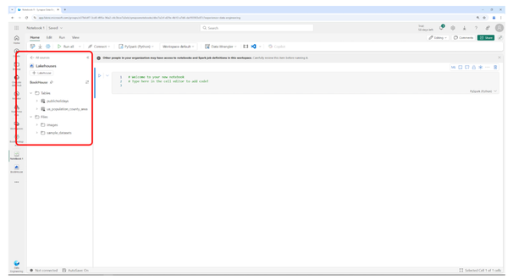

Figure 2-26. Fabric Portal Data Engineering Experience – Explore data in Notebook – Tables in Lakehouse

If you right mouse click one of your tables in there, you can select “Load data” and use Spark (Figure 2-28). This table will now be added to our notebook:

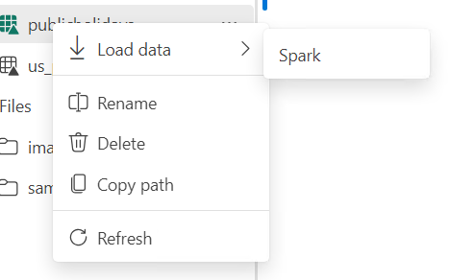

Figure 2-27. Fabric Portal Data Engineering Experience – Explore data in Notebook – add table to Notebook

By clicking the little play button next to the added code, your table’s data will be added to the Notebook using spark (Figure 2-29).

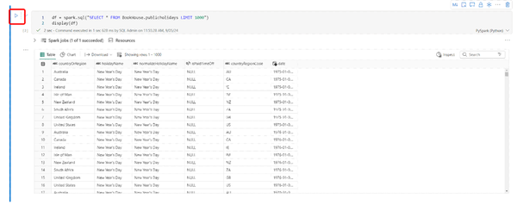

Figure 2-28. Fabric Portal Data Engineering Experience – Explore data in Notebook – Data from Table

We could of course write more complex queries, write views, insert data into new tables, organize your Lakehouse in schemas, build a medallion architecture… but all this is out of the scope of this chapter.

**Building a Warehouse**

Was the entire concept of a Lakehouse new to you because you come from a background in data warehousing? Let us also create a data warehouse in Fabric (we will dive deeper into Lakehouses and their structure in Chapter 5).

To do that we go back to the homepage that is now optimized for the data engineering experience.

To change our currently selected experience, we go to the lower left and select the data warehouses experience. We could also pick power BI, Data Factory, Real Time Analytics etc.

You can change that experience on the lower left (see Figure 2-30) where you will simply click on the experience you want to switch to.

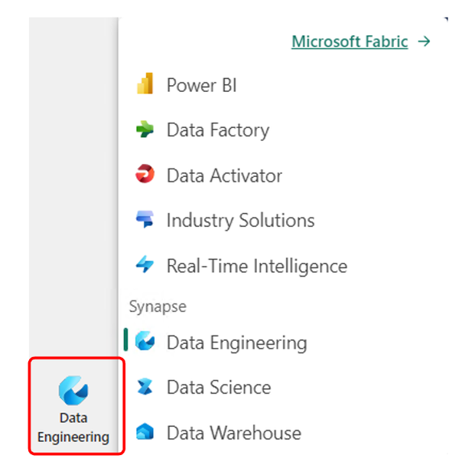

Figure 2-29. Changing the Fabric Experience/Persona

Changing the experience will give us an entirely new view as you can see in Figure 2-31.

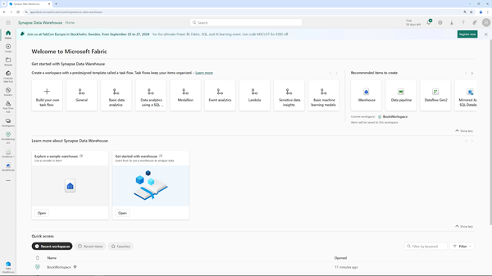

Figure 2-30. Fabric Portal Data Warehouse Experience

You can also click “Create” on the upper left (below Home, see Figure 2-32) and will receive the option to create any kind of artifact, independent of the currently selected experience. However, when using the individual experiences, that view is much more focused and clean.

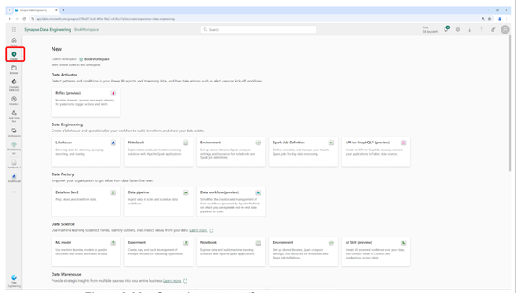

Figure 2-31. Generic create artifact screen

We will select “Warehouse”, which will create a new warehouse we name BookWarehouse and click “Create” as pictured in Figure 2-33. This will create a new warehouse rather than a new Lakehouse for us.

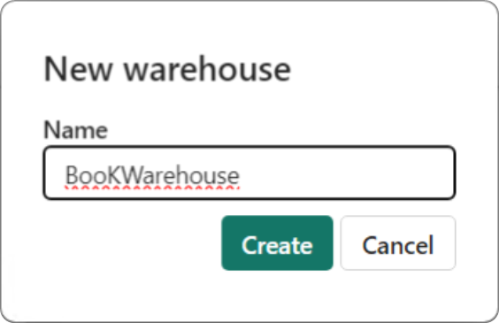

Figure 2-32. Fabric Portal Data Warehouse Experience – New Warehouse

Just as in the Lakehouse, we could select “Get data” to import additional data into that warehouse but we also have the opportunity to just use sample data again, which is what we’ll do (Figure 2-34).

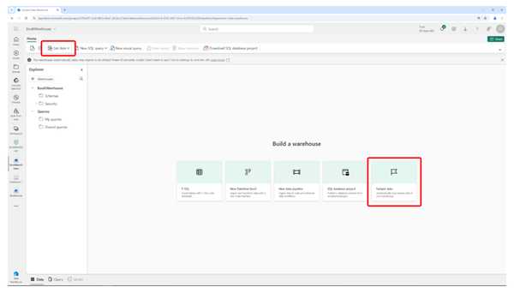

Figure 2-33. Fabric Portal Data Warehouse Experience – Add Sample Data

By clicking “Sample data” a couple of tables were created and sample data has been loaded into those tables. Some views as well as a couple of stored procedures have been added on top of that and all of them can be found in the respective subfolders of the default schema (dbo) as shown in Figure 2-35. We will talk more about organizing your warehouse through schemas in chapter 6.

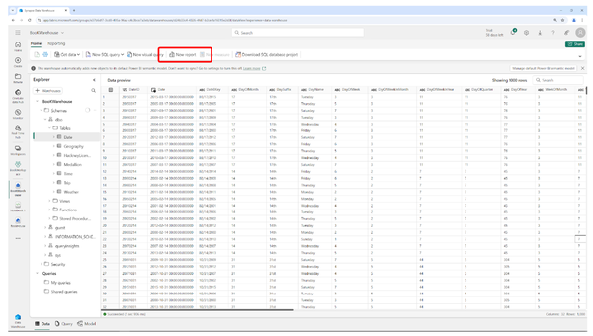

Figure 2-34. Fabric Portal Data Warehouse Experience – Sample Data shown

By just clicking one of the tables or views, we are shown a preview of that data in it.

**Visualizing Fabric Data in Power BI**

One very crucial part of the end-to-end analytics experience in Microsoft Fabric is not just storing of data but of course also the visualization of this data. One way of doing that - which also shows how seamless the components of Fabric are integrated - is right from the previous Screen which has a button on top to create a new report based on the data in this warehouse (see Figure 2-36).



Figure 2-35. Fabric Portal Data Warehouse Experience – Create a new Report from a Warehouse

Clicking this Button will start up Power BI which - as you can see in Figure 2-37 - already knows about all those tables from that warehouse because they have automatically been added to a semantic mode, the default semantic model.

**Tip**

The default semantic model will always be in direct lake mode.

If you want to learn more about semantic models, which were previously known as datasets, or direct lake mode, we will elaborate on them in Chapter 9 (Power BI).

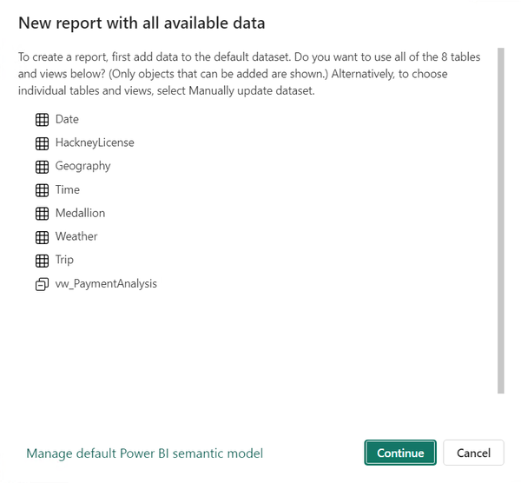

Figure 2-36. Power BI – Default Semantic Model

In this report, we can for example add the total amount from the taxi trips table by just expanding the “Trip” table and clicking “TotalAmount” (Figure 2-38).

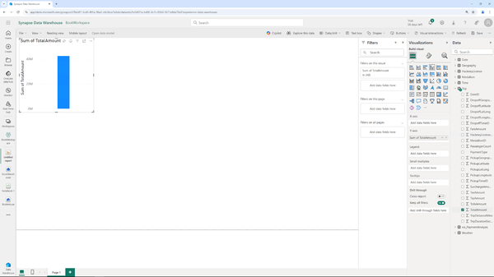

Figure 2-37. Power BI – Adding a first value to a report

This results in a single bar (which is the default visualization). We could then for example group it by payment type by again simply clicking “Payment type” and our bar chart will adjust accordingly (Figure 2-39).

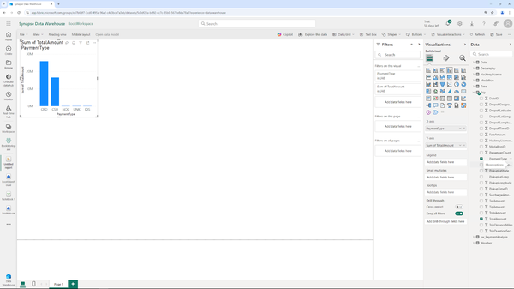

Figure 2-38. Power BI – Grouped Bar Chart

We could now go ahead and change the visualization type, color palette, add more data and visuals etc. but that would also be beyond what we were trying to showcase in this chapter. Our point was simply to show how easy it is to create a simple visual report based on the data that we had just added to Fabric a few moments before without setting up any additional manual data sources, gateways, firewall rules etc.

Summary

With just a few clicks, we’ve created a new Lakehouse, created a new warehouse, loaded data into those and finished up by creating a simple report. While of course only touching the surface, we hope that this chapter helped a bit with showcasing the power of Microsoft Fabric. End to end, from loading to processing to visualizing and analyzing data.

Before we dive into all the different experiences and features, Chapter 3 will walk you through the concept of OneLake, the unified storage layer of Microsoft Fabric.

Chapter 3. All Roads Lead to OneLake

**A Note for Early Release Readers**

With Early Release ebooks, you get books in their earliest form—the author’s raw and unedited content as they write—so you can take advantage of these technologies long before the official release of these titles.

This will be the 3rd chapter of the final book.

If you have comments about how we might improve the content and/or examples in this book, or if you notice missing material within this chapter, please reach out to the editor at *sevans@oreilly.com*.

One of Fabric’s key characteristics is that it is lake centric - all of its data is being stored in a data lake - OneLake. This chapter will walk you through the basics of data lakes and the specifics of OneLake.

Overview of Data Lakes

A data lake is a centralized repository that allows for the storage of structured, semi-structured, and unstructured data at any scale. Unlike traditional data warehouses that store data in predefined schemas, data lakes are designed to hold vast amounts of raw data in its native format until it is needed. This flexibility supports diverse data types including text, images, videos, and social media streams, making data lakes an integral part of modern big data architectures.

The data stored in a lake can be processed and analyzed to extract valuable insights, facilitate real-time analytics, and support data science and machine learning applications. The structure of a data lake allows businesses to store all their data in one place, enabling comprehensive analysis and integration across different data sources.

Evolution of Data Storage Solutions

Data storage solutions have evolved significantly over the years, reflecting the growing complexity and scale of data management needs. The journey began with simple file systems and databases, progressed through data warehouses, and has now arrived at data lakes and beyond.

*File Systems and Databases*

In the early days of computing, data was primarily stored in basic file systems and relational databases. These systems were adequate for managing small to moderate volumes of structured data but struggled with unstructured data and scalability.

*Data Warehouses*

In the late 1980s, the emergence of data warehouses marked a significant advancement in data storage. These systems are optimized for read-heavy operations and designed to support business intelligence activities. Data warehouses store structured data in a predefined schema, facilitating efficient querying and reporting. However, they are less flexible in handling unstructured or semi-structured data.

*Big Data Technologies*

With the explosion of data from various sources like social media, sensors, and mobile devices, traditional data storage systems began to show limitations. Big data technologies such as Hadoop introduced the concept of distributed storage and processing, enabling the handling of massive datasets across clusters of commodity hardware.

*Data Lakes*

Building on big data principles, data lakes emerged as a more flexible and scalable solution. They can store data in its raw form, support a variety of data types, and provide a foundation for advanced analytics. Data lakes integrate with modern data processing frameworks, allowing organizations to derive insights from their data more effectively.

Figure 3-1 shows how Data Storage Solutions developed over time.

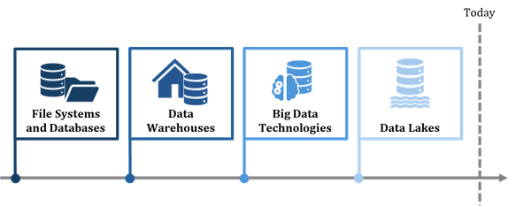

Figure 3-1. The evolution of storage systems

Traditional data storage, such as relational databases, organizes data in structured tables with predefined schemas, making it ideal for transactional systems and structured queries. Storing data in such a structured way requires data to be cleaned and formatted before storage, ensuring consistency and reliability.

As we mentioned in the introduction, data lake, on the other hand, is designed to store vast amounts of raw, unstructured, and structured data in its native format. This allows for greater flexibility in data analysis and processing, accommodating various data types such as text, images, and log files. Data lakes are particularly useful for big data analytics and machine learning, enabling data scientists to explore and extract insights without the constraints of rigid schemas.

The Importance of Data Lakes in Modern Data-Driven Businesses

In today’s data-driven world, businesses rely heavily on data to drive decisions, innovate, and maintain a competitive edge. Data lakes play a crucial role in this environment for several reasons:

*Scalability*

Data lakes are designed to handle large volumes of data, accommodating the growing influx of data from various sources without compromising performance.

*Flexibility*

Unlike traditional data warehouses, data lakes support a wide range of data types and formats. This flexibility allows businesses to store everything from transaction logs to multimedia files, enabling comprehensive data analysis.

*Cost-Effectiveness*

Data lakes utilize cost-effective storage solutions, often leveraging cloud storage services. This makes it feasible for organizations to store large datasets without incurring prohibitive costs.

*Advanced Analytics*

By storing data in its raw form, data lakes provide a rich resource for data scientists and analysts. They can use advanced analytics tools, machine learning models, and artificial intelligence to uncover insights and drive innovation.

*Data Integration*

Data lakes enable the integration of data from multiple sources, creating a unified view that supports more informed decision-making. This integration is essential for applications like customer 360° views, personalized marketing, and operational optimization.

*Real-Time Processing*

Modern data lakes support real-time data processing, allowing businesses to react quickly to changing conditions and make timely decisions. This capability is critical for applications such as fraud detection, supply chain management, and dynamic pricing.

*Governance and Compliance*

Data lakes can incorporate robust data governance frameworks, ensuring data quality, security, and compliance with regulations. This is increasingly important as businesses navigate complex regulatory environments.

To sum things up, data lakes represent a significant advancement in data storage and management, addressing the limitations of previous systems and providing a scalable, flexible, and cost-effective solution for modern businesses. By enabling the storage and processing of diverse data types, data lakes empower organizations to harness the full potential of their data, driving innovation and maintaining a competitive edge. As the volume and variety of data continue to grow, the role of data lakes in the enterprise ecosystem will become even more critical, supporting the next generation of data-driven applications and insights.

Introduction to OneLake

OneLake is a modern data lake solution developed by Microsoft, designed to streamline data management and analytics in the cloud. As part of Microsoft’s suite of cloud-based data services, OneLake integrates seamlessly with various Azure offerings, providing a unified platform for storing, processing, and analyzing data at scale. The development of OneLake reflects Microsoft’s commitment to empowering businesses with robust, scalable, and flexible data solutions, addressing the growing need for efficient data management in an increasingly data-driven world.

Figure 3-2 gives you a first look at the structure of OneLake.

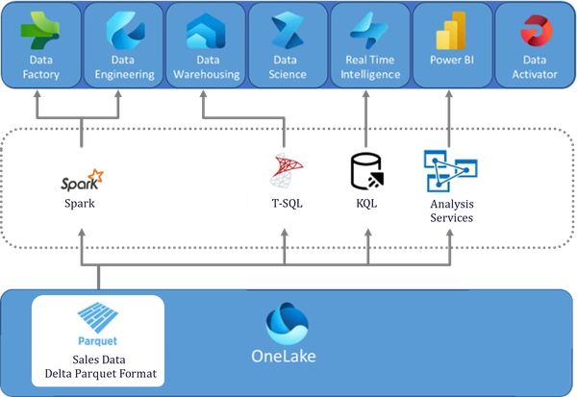

Figure 3-2. OneLake - the big picture

**Separation of Compute and Storage**

OneLake leverages the architectural principle of separating compute and storage which the data stored in OneLake and the compute happening in the processing experiences like the Data Warehouse, a significant evolution in data lake design. This separation allows businesses to scale storage and compute resources independently, optimizing costs and performance. By decoupling these components, OneLake ensures that data storage can be scaled without the need to simultaneously scale computing resources, and vice versa. This flexibility is crucial for managing variable workloads and achieving cost efficiency.

**File Explorer**

OneLake includes a user-friendly File Explorer interface, simplifying data navigation and management. The File Explorer allows users to browse, upload, download, and manage their data files within the lake, providing an intuitive way to interact with stored data. This feature is particularly useful for users who may not be familiar with command-line interfaces or complex data management tools, making OneLake accessible to a broader range of users.

**Unique Selling Points and Differentiation from Other Data Lakes**

OneLake offers several unique features that set it apart from other data lake solutions, enhancing its appeal and functionality.

**Shortcuts**

One of the most remarkable features of OneLake is its robust support for shortcuts, a transformative tool that greatly enhances data management and accessibility within Microsoft Fabric. Shortcuts empower users to create references to data stored in various locations within OneLake or even in external storage systems like Azure Data Lake or Amazon S3. This feature is particularly advantageous for large organizations where data is typically dispersed across multiple departments, projects, or geographical regions. Instead of duplicating data across different workspaces or domains-an approach that can lead to increased storage costs and complex data governance issues-shortcuts allow teams to seamlessly reference existing datasets.

For example, consider a scenario where a company’s marketing team maintains a customer behavior dataset in its workspace. The finance team can create a shortcut to this dataset within their own workspace without physically copying the data. This approach not only conserves storage space but also ensures that both teams are working with the most up-to-date information. Furthermore, these shortcuts preserve the security and access controls of the original data, ensuring that sensitive information remains protected and accessible only to authorized users, regardless of how many workspaces are referencing it.

Shortcuts also simplify data integration and collaboration across different departments. Analysts and data engineers can effortlessly incorporate data from various sources into their workflows without the need to repeatedly move or transform the data. This reduces the complexity of data pipelines and ensures consistency across reports and dashboards. As organizations increasingly adopt a data mesh architecture, shortcuts become even more invaluable. They enable each domain to manage and expose its data as a product, while other domains can quickly and easily integrate this data into their own analytics, all without disrupting the original datasets.

Moreover, shortcuts can be created for data stored in external systems, significantly expanding the range of accessible data within OneLake. For instance, if an organization has historical data archived in an Amazon S3 bucket, a shortcut can be established to this data, making it immediately available for analysis in Microsoft Fabric without the need to transfer it to OneLake. This capability supports hybrid and multi-cloud strategies, allowing organizations to maximize their existing data investments while also benefiting from the integrated analytics capabilities of Microsoft Fabric.

In summary, the use of shortcuts in OneLake greatly reduces redundancy, optimizes storage utilization, and simplifies data governance by centralizing data access while preserving the autonomy of individual teams and workspaces. This feature is closely aligned with modern data management principles, where agility, scalability, and security are of utmost importance. It enables organizations to derive insights more quickly and efficiently, enhancing their overall data strategy.

**Integration with Microsoft Ecosystem**

OneLake’s seamless integration with Microsoft’s suite of tools and services provides a significant advantage, offering a cohesive and comprehensive data management and analytics platform. This integration ensures that users can leverage familiar tools and workflows, enhancing productivity and reducing the learning curve.

**Scalability and Flexibility**

By separating compute and storage, OneLake provides unparalleled scalability and flexibility. Businesses can scale their storage capacity to accommodate growing data volumes while independently managing compute resources based on workload demands, optimizing both performance and cost.

**Advanced Security and Compliance**

OneLake incorporates robust security features and compliance frameworks, ensuring that data is protected and managed in accordance with industry standards and regulations. This focus on security and compliance is critical for businesses operating in regulated industries or handling sensitive data.

**Cost Efficiency**

The architectural design of OneLake, along with its integration capabilities and support for shortcuts, contributes to significant cost efficiencies. Businesses can minimize storage costs, avoid unnecessary data duplication, and optimize resource utilization, resulting in a more cost-effective data management solution. Part of that cost efficiency is also driven by the fact that shortcuts don’t consume any actual storage in OneLake and Mirroring, a data ingestion method we will discuss in the “Data Ingestion” section of this chapter, as well as in detail in chapter 11, comes with free storage.

As you can see in Figure 3-3, OneLake differentiates itself from traditional lakes while keeping their key characteristics.

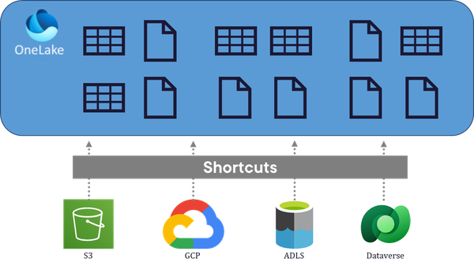

Figure 3-3. OneLake and shortcuts as a differentiator

In a nutshell, OneLake represents a significant advancement in data lake technology, offering a powerful, scalable, and flexible solution for modern data management and analytics. Developed by Microsoft, OneLake leverages the company’s extensive expertise in cloud computing and data services, providing a robust platform that integrates seamlessly with a wide range of tools and services. Its unique features, such as the separation of compute and storage, user-friendly File Explorer, and innovative shortcuts, differentiate it from other data lake solutions, making it an attractive choice for businesses looking to harness the full potential of their data. As data volumes continue to grow and analytics become increasingly complex, OneLake stands out as a critical tool for driving data-driven decision-making and innovation.

The Foundation of OneLake

At the core of OneLake’s architecture is the concept of unified storage. This approach ensures that all types of data-structured, semi-structured, and unstructured-are stored in a single, cohesive repository. Unified storage eliminates data silos, enabling seamless access and analysis across various data types. This centralization simplifies data management, reduces redundancy, and ensures consistency across the enterprise.

Unified storage in OneLake is designed to support the diverse needs of modern data-driven businesses. Whether dealing with transactional data, log files, multimedia content, or real-time streaming data, OneLake provides a flexible and scalable environment that can accommodate the full spectrum of data requirements. This foundation is essential for enabling comprehensive analytics and insights.

**Delta and Iceberg Format**

OneLake supports advanced data formats like Delta and Apache Iceberg, which are pivotal for managing big data efficiently.

*Delta Format*

Delta Lake is an open-source storage layer that brings ACID (Atomicity, Consistency, Isolation, Durability) transactions to big data workloads. Delta format enhances reliability and performance by enabling scalable and reliable data engineering pipelines. It supports features such as time travel (data versioning), schema enforcement, and the ability to handle both batch and streaming data efficiently. By using the Delta format, OneLake ensures data integrity and enables complex data processing operations with ease.

*Iceberg Format*

Apache Iceberg is another open-source table format designed for large analytic datasets. It is built to manage petabyte-scale tables while providing fast read and write operations. Iceberg’s support for schema evolution, hidden partitioning, and robust metadata handling makes it ideal for modern data lake architectures. OneLake’s support for Iceberg ensures compatibility with various analytics engines and improves query performance by optimizing data layout and minimizing data scans.

**Interoperability**

OneLake’s design emphasizes interoperability, ensuring seamless integration with a wide range of tools and systems. This capability is crucial for organizations that use diverse technologies and need to integrate their data lake with existing workflows and applications.

OneLake is fully compatible with Azure Data Lake Storage (ADLS) Gen2 APIs, which provide hierarchical namespace support, enhanced security features, and optimized performance. This compatibility allows OneLake to integrate effortlessly with applications and services that already utilize ADLS Gen2, ensuring a smooth transition and consistent experience. By leveraging these APIs, OneLake offers robust access control, simplified management, and high-performance data processing capabilities.

**Scalability and Performance**

Scalability and performance are foundational aspects of OneLake, designed to meet the demands of large-scale data environments.

*Scalability*

OneLake is built to scale horizontally, allowing organizations to expand their storage capacity as their data grows. This scalability ensures that OneLake can handle massive datasets, from terabytes to petabytes, without compromising performance. By leveraging cloud-based infrastructure, OneLake provides virtually unlimited storage capacity, enabling businesses to store and analyze ever-increasing volumes of data.

*Performance*

OneLake is optimized for high performance, supporting fast data ingestion, processing, and querying. The use of advanced data formats like Delta and Iceberg contributes to improved read and write speeds, efficient data compression, and minimized latency. Additionally, the separation of compute and storage resources ensures that performance can be tuned and scaled independently, optimizing resource utilization based on workload demands. This design allows for rapid data access and real-time analytics, empowering organizations to derive insights quickly and make data-driven decisions.

In summary, the foundation of OneLake is built on unified storage, advanced data formats, interoperability, and a focus on scalability and performance. These elements combine to create a robust, flexible, and high-performing data lake solution that meets the diverse needs of modern enterprises. By supporting unified storage, OneLake eliminates data silos and ensures consistency across data types. The use of Delta and Iceberg formats enhances data reliability and performance, while interoperability with ADLS Gen2 APIs ensures seamless integration with existing tools and systems. Finally, OneLake’s scalability and performance capabilities enable organizations to handle massive datasets efficiently, driving faster insights and facilitating data-driven innovation. As a result, OneLake stands out as a foundational component of a comprehensive data management and analytics strategy.

**Data Stored in OneLake**

OneLake, as a versatile data lake solution, is designed to store a wide variety of data types to meet the diverse needs of modern enterprises.

**Primary Data**

The majority of data stored in OneLake is obviously primary data - you might even call it your actual or real data -and there are multiple types of operational data both on OneLake as well as in general.

**Structured Data**

Structured data is highly organized and formatted to fit into traditional databases or spreadsheets. It follows a consistent schema and is typically stored in rows and columns.

Structured data originates from relational database management systems (RDBMS) like SQL Server, Oracle, MySQL, and PostgreSQL and it can be ingested into OneLake. This includes tables, indexes, and views.

Content wise, this is often also referred to as transaction data and operational data. Transaction data being generated from business transactions such as sales records, financial transactions, and order processing. Operational data meaning data produced by day-to-day business operations, including inventory levels, human resources records, and customer relationship management (CRM) systems.

Besides raw data, data originating from other systems and sources, another typically found example of structured data is derived data. Derived data is processed and transformed from raw data to provide valuable insights and analytics such as aggregated data (summarized data from various sources, such as monthly sales totals, average customer ratings, and summary statistics) or analytical data (processed data ready for analysis, including data cubes, dashboards, and reports).

**Semi-Structured Data**

Semi-structured data does not follow a rigid schema but contains tags or markers to separate data elements, making it more flexible than structured data.

Typical examples would be:

*JSON and XML Files*

Data formatted in JavaScript Object Notation (JSON) and Extensible Markup Language (XML), often used for web applications and APIs.

*Log Files*

System and application logs generated by servers, applications, and network devices. These files often contain valuable insights for monitoring and troubleshooting.

*Sensor Data*

Data from Internet of Things (IoT) devices, including temperature readings, humidity levels, and other environmental sensors.

*Email*

Content (and also metadata) from email communications.

**Unstructured Data**

Unstructured data lacks a predefined format, making it the most challenging type of data to store and analyze. OneLake can handle vast amounts of unstructured data efficiently.

Unstructured data can usually be found in the following places.

*Multimedia Files*

Images, videos, and audio files used in media production, marketing, and communications.

*Documents*

Text documents, PDFs, presentations, and other file types used in business operations and communications.

*Social Media Data*

Data from social media platforms such as posts, comments, likes, and shares.

*Web Data*

Content scraped from websites, including HTML, CSS, and JavaScript files.

OneLake’s flexible and scalable architecture allows it to store a wide variety of data types, making it an essential component of a comprehensive data management strategy. By accommodating structured, semi-structured, and unstructured data, as well as supporting real-time and big data, OneLake provides a unified platform for storing and analyzing diverse data sets. This capability ensures that organizations can leverage all their data assets to drive insights, innovation, and competitive advantage.

**Metadata**

Metadata plays a crucial role in managing and understanding the data stored within the lake. It provides context, facilitates data discovery, and ensures that data is used appropriately. In Fabric, that data is also stored in OneLake.

Said metadata can be grouped by a number of types again, containing different kinds of information.

*Technical Metadata*

Schema Information, Details about the structure of data, such as table definitions, column types, and data formats.

Data Lineage, Information about the origin of data, how it has moved through various stages of processing, and any transformations applied.

Storage Details, File paths, locations within the data lake, and storage formats.

*Operational Metadata*

Data Quality Metrics, Information on data accuracy, completeness, consistency, and validity.

Usage Statistics, Data on how often datasets are accessed, modified, or queried.

Processing Logs, Records of data ingestion processes, ETL jobs, and data transformation steps.

*Business Metadata*

Data Catalogs, Descriptions of datasets, business terminology, and data classifications.

Tags and Annotations, Keywords, labels, and notes added to datasets to facilitate search and discovery.

*Security Metadata*

Access Control Information, Permissions and roles associated with different datasets and users.

Audit Logs, Records of who accessed or modified data and when.

**Notebooks and Analytical Artifacts**

In addition to traditional metadata, OneLake will also store analytical artifacts such as:

*Notebooks*

Interactive documents that contain live code, equations, visualizations, and narrative text. These are commonly used for data analysis, exploration, and machine learning tasks.

*Scripts and Code*

Python, R, Scala, and other programming scripts used for data processing and analysis.

*Machine Learning Models*

Trained models, along with their configurations and performance metrics.

*Dashboards and Reports*

Visualizations and reports created using Power BI

Figure 3-4 makes it more clear to understand the variety of data and formats that gets stored in OneLake.

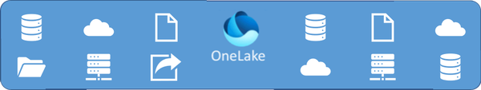

Figure 3-4. The data variety in OneLake

Metadata, including technical, operational, business, and security information as well as artifacts, are an integral part of OneLake. The platform supports the storage and management of various metadata types, as well as analytical artifacts like notebooks and scripts. This comprehensive metadata management enhances data discovery, governance, quality, and collaboration, making OneLake a powerful and efficient data lake solution.

Organizing Data in OneLake – Domains and Workspaces

To organize and group or partition your data in OneLake, there are two co-existing concepts: Domains and Workspaces.

**Domains**

Domains are logical partitions within OneLake, designed to organize and manage data according to specific business units, departments, or other organizational criteria. Each domain can be seen as a separate, secure data space with its own set of permissions, governance policies, and data structures.

Domains align with the organizational structure, making it easier to manage data relevant to specific business units or departments. Domains allow for precise control over data access and governance, ensuring that only authorized users can access sensitive information. They provide a framework for managing data lifecycle, quality, and consistency within specific organizational contexts.

In summary, domains in OneLake serve as foundational elements that enhance data governance, security, organization, collaboration, scalability, and integration. They are essential for managing data effectively within large organizations, ensuring that data is accessible, secure, and well-organized to support business objectives.

**Workspaces**

In Microsoft Fabric, particularly within the OneLake environment, workspaces are another critical component for organizing and managing data and collaborative efforts.

Workspaces are collaborative environments within OneLake where users can create, manage, and share semantic models, reports, dashboards, and other analytical artifacts such as Lakehouses or Pipelines. Each workspace acts as a container for these resources, facilitating teamwork and project management.

Workspaces are designed to enable teams to work together on data-related projects, sharing insights and resources effectively. They help in organizing projects and resources in a logical manner, making it easier to manage and navigate. Workspaces allow for setting permissions and access controls, ensuring that only authorized users can view or edit the contents.

**Key Differences Between Domains and Workspaces**

While at first look you may have them confused, there are some major differences between Domains and Workspaces.

**Scope and Purpose**

Domains focus on organizing data across the entire organization according to business units, departments or any other structure that fits your needs, ensuring data governance, security, and organizational alignment.

Workspaces on the other hand focus on facilitating collaboration and project management within specific teams or projects, centralizing resources and enabling efficient teamwork.

Imagine a large tech company that decides to implement a data mesh approach to better manage its diverse and distributed data landscape. In this context, the domains in Microsoft Fabric represents the entire company, serving as the overarching structure that contains all the data, resources, and users across the organization. Domains could be Sales, HR, IT, Marketing or others. Within each domain, workspaces functions as a specific data product or business unit, like a self-contained project team responsible for its own data, reports, and analytics. For example, the international sales team and the domestic sales team could each act in their own workspaces which both belong to the Sales domain. This setup aligns with the data mesh principles by empowering each team to manage its data while ensuring governance and connectivity across the organization.

**Security and Governance**

Domains implement organization-wide security and governance policies, managing access to data based on business unit or departmental needs. Workspaces implement project-specific or team-specific access controls, managing permissions for collaborative work on semantic models, reports, and other resources.

**Organization**

While Domains organize data at a higher level, often aligning with the organizational structure. Workspaces organize resources at a project or team level, focusing on the needs of specific collaborative efforts.

In summary, while both domains and workspaces play crucial roles in OneLake, they serve different purposes. Domains provide a structured and secure environment aligned with the organizational hierarchy, while workspaces offer flexible, collaborative environments for managing projects and team efforts. Together, they ensure that data is well-organized, secure, and accessible to those who need it within the organization.

Figure 3-5 illustrates the differences between Domains and Workspaces in OneLake.

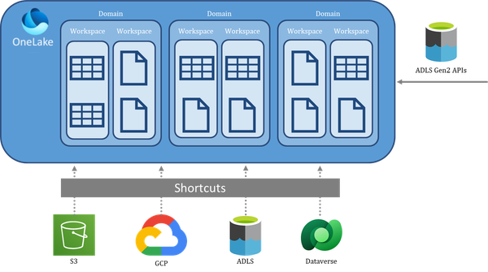

Figure 3-5. Differences between Domains and Workspaces in OneLake

Ingesting Data to and integrating with OneLake

Data ingestion and integration are critical processes that ensure data from various sources is efficiently and effectively brought into OneLake. These processes enable businesses to leverage their diverse data assets for analytics, decision-making, and innovation. OneLake supports a variety of data ingestion methods and integration mechanisms, making it a versatile platform for managing complex data environments.

**Methods of Data Ingestion into OneLake**

To ingest data to OneLake, there are many different ways, and we will discuss them in more detail in Part II of this book. To still give you an overview of the available methods: you can either use a shortcut, which is not really ingesting data, but only making it available in your lake.

Or you can use Spark, Dataflows, data factory activities, pipelines, streams, T-SQL or Mirroring. While you may have heard of the others, let me elaborate a bit more on this one. Mirroring in Microsoft Fabric is a feature designed to simplify data integration and enhance analytics experiences by creating a real-time, read-only replica of data in the open Delta format, without the need for ETL processes. It is basically a smart way of replicating your data from other sources into one lake in almost real time without the need to manually load said data.

As shown in Figure 3-6, the number of ways to ingest data into OneLake is sheer endless.

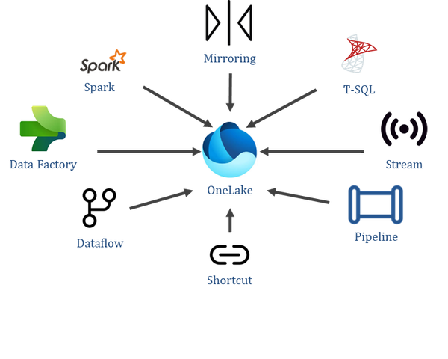

Figure 3-6. Data Ingestion into OneLake

**Integration Mechanisms with OneLake**

OneLake integrates seamlessly with a wide range of services, enabling a cohesive data management and analytics ecosystem.

**Integration with Microsoft Services**

First and foremost, Fabric and OneLake obviously integrate very well with other Microsoft services such as:

*Power BI*

Power BI can connect directly to OneLake, allowing users to create interactive reports and dashboards from their data stored in the lake. This integration supports advanced data visualization and business intelligence.

*Azure Machine Learning*

Data scientists can use Azure Machine Learning to build, train, and deploy machine learning models using data stored in OneLake. This integration facilitates the development of predictive analytics and AI solutions.

*Microsoft Dynamics 365*

Integration with Dynamics 365 enables businesses to combine operational data from their CRM and ERP systems with other data sources in OneLake for comprehensive analytics. This is typically done using a feature called Fabric Link which will automatically generate shortcuts.

**Integration with Third-Party Tools**

OneLake’s open architecture also allows it to integrate with a variety of third-party data processing and analytics tools. While there is no way to come up with a comprehensive list, a few popular choices and tools include the following.

*Apache Spark*

Microsoft Fabric integrates with Apache Spark by enabling users to leverage Spark’s powerful distributed computing capabilities for big data processing directly within the Fabric environment. This integration allows for efficient execution of complex analytics, machine learning, and data processing tasks using Spark, while benefiting from Fabric’s seamless data connectivity and visualization tools. The combination facilitates robust data workflows and accelerates insights through scalable and high-performance data processing.

*Databricks*

Microsoft Fabric integrates with Databricks by providing a unified environment where users can access Databricks’ advanced analytics and machine learning capabilities alongside Fabric’s comprehensive data management tools. This integration allows for seamless data sharing and collaboration, enabling users to perform complex data processing and analysis within Databricks and leverage Fabric’s data visualization and reporting features. The collaboration streamlines workflows and enhances data-driven insights through a cohesive and efficient platform.

*Tableau*

Microsoft Fabric integrates with Tableau by allowing users to connect, visualize, and analyze data stored in Microsoft Fabric directly within Tableau’s powerful visualization platform. This integration ensures seamless data flow and consistency, enabling users to create interactive and insightful dashboards that draw from Fabric’s comprehensive data management and analytics capabilities. It enhances data-driven decision-making by combining Tableau’s intuitive visualizations with Fabric’s robust data infrastructure.

*Snowflake*

Microsoft Fabric integrates with Snowflake by providing a seamless connection that allows users to access, analyze, and visualize Snowflake data directly within the Microsoft Fabric environment. This integration leverages Snowflake’s data warehousing capabilities and Fabric’s analytics tools, enabling efficient data management and comprehensive insights through a unified interface. The collaboration enhances data-driven decision-making processes by streamlining workflows and ensuring data consistency across platforms.

*Amazon S3*

Microsoft Fabric integrates with Amazon S3 by enabling users to connect and manage their S3 data directly within the Fabric environment. This integration allows for seamless data access, transfer, and analysis, leveraging Fabric’s robust data management and analytics tools. Users can efficiently incorporate S3 data into their workflows, enhancing data-driven decision-making through Fabric’s comprehensive visualization and reporting capabilities.

**API-Based and Endpoint Integration**

OneLake supports API-based integration, allowing developers to build custom applications and services that interact with the data lake. For organizations operating in hybrid environments, OneLake can also integrate with on-premises data sources, providing a seamless data management experience.

OneLake provides REST APIs for programmatically accessing and managing data. These APIs can be used to automate data ingestion, retrieval, and management tasks.

By supporting ADLS Gen2 APIs, OneLake ensures compatibility with a wide range of existing applications and tools that already utilize these APIs for data operations.

SSIS and other ETL tools can be used to create data integration workflows that move data between on-premises systems and OneLake, facilitating hybrid data management, mostly using Fabric’s SQL Endpoints.

All of these features show how OneLake offers a comprehensive and flexible platform for data ingestion and integration, supporting a wide range of methods and tools to bring data from various sources into the lake. Whether through batch or real-time ingestion, migration tools, or integration with Microsoft and third-party services, OneLake ensures that businesses can efficiently manage their data. Its support for API-based integration, data virtualization, and hybrid data environments further enhances its versatility, making it an essential component of modern data architectures. As organizations continue to embrace data-driven strategies, the robust ingestion and integration capabilities of OneLake will be crucial in unlocking the full potential of their data assets.

Figure 3-7 illustrates the vast variety of ways Fabric can interact with other tools and vice versa:

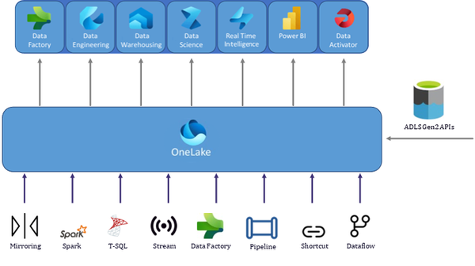

Figure 3-7. OneLake and its interaction with the data ecosystem

Conclusion

In conclusion, OneLake stands out as a modern and robust data lake solution, integral to Microsoft Fabric, designed to meet the complex data management and analytics needs of today’s businesses. By storing all data in a centralized lake, OneLake leverages unified storage to eliminate data silos and support diverse data types, from structured to unstructured. It incorporates advanced data formats like Delta and Iceberg for efficient data handling, and the separation of compute and storage enhances scalability and cost-effectiveness. OneLake’s seamless integration with Microsoft’s suite of tools and third-party services, coupled with its advanced security and compliance features, makes it a versatile and powerful platform. This flexibility ensures that businesses can drive innovation, gain comprehensive insights, and maintain a competitive edge in an increasingly data-driven world.

In Part 2 of this book, we will deep dive into the different features and capabilities of Fabric!

--

DATA Factory

This chapter kicks off part two of this book where we will dive into all the different features and experiences that Microsoft Fabric has to offer. The first feature we’ll explore is Data Factory.

Microsoft Fabric Data Factory is a cloud-based data integration service designed to make ETL (Extract, Transform, Load) and ELT (Extract, Load, Transform) processes as seamless as possible. One of its standout features is its ability to cater to users across a spectrum of technical expertise. For those seeking a no-code or low-code experience, Data Factory provides an intuitive drag-and-drop interface that allows users to design, orchestrate, and manage data pipelines visually. This makes it ideal for business analysts or data professionals who want to focus on workflows without diving into the complexities of coding.

For example, a marketing team might need to automate the process of aggregating data from a web analytics platform, a CRM, and an ad platform. Using Data Factory’s no-code interface, they can create a pipeline that extracts data from all three sources, performs basic transformations like filtering and joining, and loads the results into a central data warehouse—all without writing a single line of code. This simplicity empowers non-technical users to build effective data solutions independently.

However, Data Factory doesn’t stop at no-code solutions. For data engineers or advanced users who need greater control and flexibility, the platform seamlessly integrates code-heavy options such as Jupyter Notebooks. These notebooks, which will be explored in depth in Chapter 6, allow users to implement custom transformations, perform advanced analytics, or handle specialized use cases using Python or Spark. For instance, a data engineering team working on fraud detection might use notebooks to apply machine learning models to transaction data as part of their pipeline.

This dual functionality makes Microsoft Fabric Data Factory a versatile tool, bridging the gap between no-code simplicity and the power of advanced, code-driven customization. It ensures that organizations can scale their data operations while catering to the needs of diverse roles, from business analysts to data scientists and engineers.

In the next section, we’ll take a closer look at pipelines and how they facilitate data movement and orchestration in Data Factory.

Pipelines

In Microsoft Fabric Data Factory, pipelines play a vital role in organizing and automating data workflows, from ingestion and transformation to delivery. A pipeline serves as a logical framework, grouping together activities that allow users to manage and automate tasks such as moving, preparing, and transforming data across multiple sources and destinations. This enables the creation of comprehensive data flows that connect diverse systems, apply necessary transformations, and deliver data to various storage environments like data lakes or warehouses.

Each pipeline is composed of one or more activities, each representing a distinct operation. These activities range from basic copy tasks, which handle data movement between sources and destinations, to data flow tasks, which carry out complex transformations. Pipelines allow users to create workflows that link these tasks, manage dependencies, and set up execution triggers, such as scheduled runs or event-based actions. Additionally, control activities like loops, conditionals, and error handling help ensure pipelines are both dynamic and resilient.

In Fabric Data Factory, pipelines are tightly integrated with the wider Microsoft Fabric ecosystem, making it easier to connect with services such as Fabric Lakehouse, Data Warehouse, and Real-Time Analytics. This integration allows businesses to efficiently move, process, and manage their data within a unified platform, reducing the need for external tools like Azure Data Factory. Fabric Data Factory aims to streamline the creation of data workflows with no-code or low-code interfaces, while still providing the flexibility to support more complex use cases.

Building a Data Pipeline

With your Fabric capacity and workspace ready, let’s create a first data pipeline in Microsoft Fabric Data Factory.

Start by navigating to the Data Factory section in your Fabric workspace (see [Figure 4-1](https://learning.oreilly.com/library/view/fundamentals-of-microsoft/9781098172916/ch04.html#ch04_figure_1_1734033260185673)).

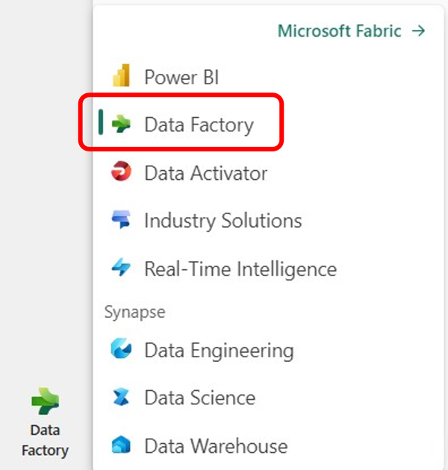

Figure 4-1. Data Factory Selection

Once there, select “Data pipeline” to open the pipeline designer as shown in [Figure 4-2](https://learning.oreilly.com/library/view/fundamentals-of-microsoft/9781098172916/ch04.html#ch04_figure_2_1734033260185714).

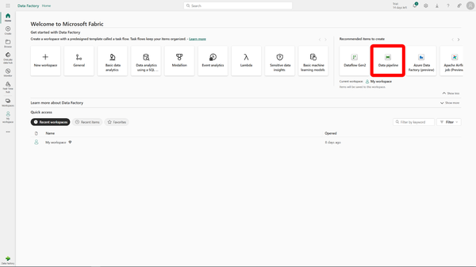

Figure 4-2. New Pipeline button in the Data Factory Experience

This is the space where you will build your data pipeline. The designer features a central canvas for organizing activities and a toolbox on the left that offers a range of activities to choose from and you see a few of them showcased in [Figure 4-3](https://learning.oreilly.com/library/view/fundamentals-of-microsoft/9781098172916/ch04.html#ch04_figure_3_1734033260185736).

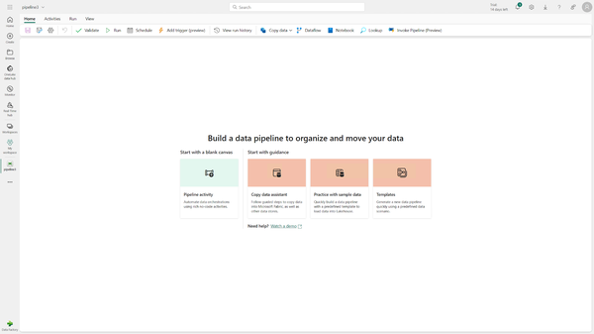

Figure 4-3. Pipeline Canvas

You now have created a first (empty) pipeline but it doesn’t contain any activities yet. In the next sections of this chapter, we’ll explore how to move and transform data as well as how to orchestrate and execute those tasks.

Moving and Transforming Data

The most important part of Data Factory is certainly data movement - we can also modify and transform our data further down the road but all that requires to get the data into Fabric first.. Data Factory offers three main ways of moving data and each one differs in features and complexity: *copy activity, dataflow gen 2, and copy job*.

**Copy activity**

The Copy activity is a critical task within a Microsoft Fabric Data Factory pipeline, designed to handle data movement between various sources and destinations. Rather than being a standalone artifact, it serves as part of a larger orchestration process, working alongside other activities in the pipeline to automate data workflows. The Copy activity allows for seamless data transfer between on-premises systems and cloud environments, supporting scenarios where businesses need to move large amounts of data from legacy systems to modern cloud infrastructures or between various cloud services. This flexibility makes it a powerful tool for enterprises undergoing digital transformation.

One of the key advantages of the Copy activity is its ability to work across diverse environments, enabling smooth data transfers from on-premises data centers to cloud-based systems like Azure Data Lake or Amazon S3. With built-in connectors for databases, file systems, SaaS applications, and cloud storage, it supports a wide array of data sources, making it versatile enough for any data integration scenario. Whether you’re dealing with relational databases like SQL Server or Oracle or working with cloud storage systems, the Copy activity ensures that data can be read and written seamlessly across multiple platforms.

To optimize performance, the Copy activity allows for customization of throughput and parallelism, which influence how quickly data is transferred and how many tasks can be processed simultaneously. These settings are crucial for improving data transfer speeds, particularly when handling large datasets or working across cloud environments where bandwidth and processing power are variable. By tuning throughput and parallelism, you can ensure that your pipeline makes the most efficient use of resources, balancing data transfer speed with system load.

When working with large-scale data transfers, the Copy activity provides several strategies to handle these efficiently, including staging, partitioning, and compression. Staging helps manage data transfers by temporarily storing the data in an intermediary location before delivering it to its final destination. Partitioning splits large datasets into smaller chunks for parallel processing, speeding up transfers, while compression reduces the size of the data being transferred, saving bandwidth and time, especially in cloud-to-cloud or cross-region data transfers.

Microsoft Fabric Data Factory supports an extensive list of data sources, making the Copy activity adaptable to various scenarios. Supported sources include on-premises databases like SQL Server, Oracle, and MySQL, as well as cloud storage options like Azure Blob Storage, Amazon S3, and Google Cloud Storage. Additionally, SaaS platforms like Salesforce and Google Analytics can be integrated, allowing you to pull data from numerous enterprise systems into a unified pipeline.

To finish this section up, let’s walk through the steps required to add a Copy activity to our previously created pipeline.

In the pipeline designer, select the Copy activity and click “Add to canvas” (see [Figure 4-4](https://learning.oreilly.com/library/view/fundamentals-of-microsoft/9781098172916/ch04.html#ch04_figure_4_1734033260185755)). This will be the core task in your pipeline, handling the movement of data.

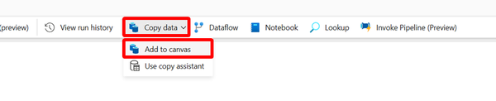

Figure 4-4. Adding a copy activity

When adding a copy activity, it will immediately show its general settings like name, description and whether it is activated (shown in [Figure 4-5](https://learning.oreilly.com/library/view/fundamentals-of-microsoft/9781098172916/ch04.html#ch04_figure_5_1734033260185786)).

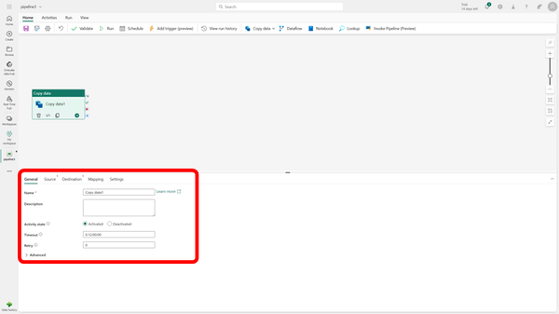

Figure 4-5. Copy activity – General settings

To move data, we will start by configuring the source for which we navigate to the “Source” tab. Here, you’ll create a new reference to your source by selecting the appropriate data source (e.g., SQL Server, Azure Blob Storage, etc.) and entering the necessary connection details, such as file paths, database names, and credentials (shown in [Figure 4-6](https://learning.oreilly.com/library/view/fundamentals-of-microsoft/9781098172916/ch04.html#ch04_figure_6_1734033260185805)).

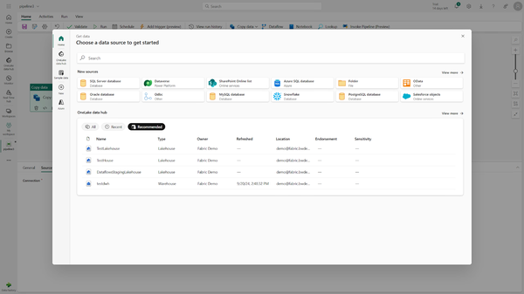

Figure 4-6. Copy activity – Source

After setting up the source, move to the Destination tab to define the data destination. Create a new dataset for the destination, select the target destination (e.g., Azure Data Lake, SQL Database, Amazon S3), and configure the connection details for the destination system (shown in [Figure 4-7](https://learning.oreilly.com/library/view/fundamentals-of-microsoft/9781098172916/ch04.html#ch04_figure_7_1734033260185826)).

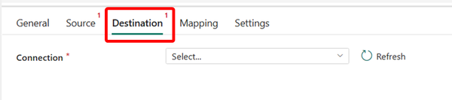

Figure 4-7. Copy activity – Destination

In the Mapping tab, you can define how the fields from the source map to the destination. This step allows manual field mapping if the data structures differ between the source and destination, or you can opt for automatic mapping if the fields match by name (shown in [Figure 4-8](https://learning.oreilly.com/library/view/fundamentals-of-microsoft/9781098172916/ch04.html#ch04_figure_8_1734033260185843)). This also means that the entire “Mapping” tab is optional.

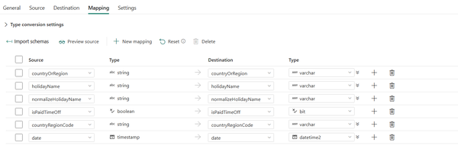

Figure 4-8. Copy activity – Mapping

The final tab setting allows you to manage parallelism and other settings like logging and fault tolerance. To get started, you can leave all of those at their defaults (shown in [Figure 4-9](https://learning.oreilly.com/library/view/fundamentals-of-microsoft/9781098172916/ch04.html#ch04_figure_9_1734033260185862)).

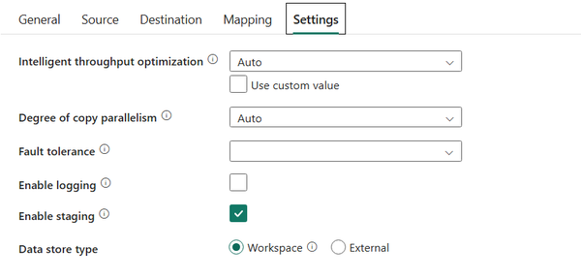

Figure 4-9. Copy activity – Settings

By following these steps, you’ve successfully created your first Copy activity within a pipeline. In the following sections, we’ll explore advanced configurations and performance tuning to further optimize your data movement processes.

To make sure all your required settings have been setup, you can either validate or run the pipeline (not the individual task but the entire pipeline!) using the buttons highlighted in [Figure 4-10](https://learning.oreilly.com/library/view/fundamentals-of-microsoft/9781098172916/ch04.html#ch04_figure_10_1734033260185879).

**Note**

Validating a pipeline only checks if the required settings do exist and look plausible. It does not run a full simulation or anything similar so any issues on the source for example like conversion errors would not be found at this point.

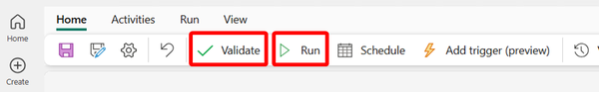

Figure 4-10. Pipeline – Validate and Run

**Dataflow Gen 2**

Unlike the copy activity, a Dataflow Gen 2 is not necessarily part of a pipeline but a pipeline only has the capability to execute Dataflows. This means that you could also create your Dataflow directly from the Start Page of Data Factory – it is by default a standalone Fabric artifact that CAN be added as a pipeline activity. Since we already started working with our pipeline, we will however stay in our pipeline and add a new Dataflow to it by clicking the “Dataflow” Button as shown in [Figure 4-11](https://learning.oreilly.com/library/view/fundamentals-of-microsoft/9781098172916/ch04.html#ch04_figure_11_1734033260185896).

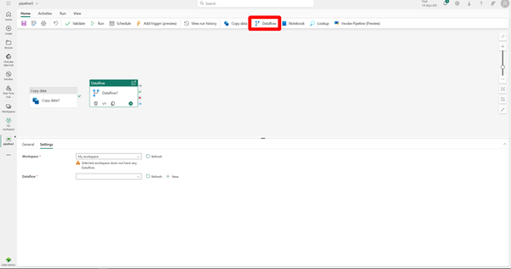

Figure 4-11. Add a Dataflow to a pipeline

Dataflow Gen 2 in Microsoft Fabric marks a significant advancement in the platform’s data transformation capabilities. It introduces more powerful, scalable, and flexible data pipelines that are optimized to handle complex and large-scale data scenarios. Unlike previous iterations, Dataflow Gen 2 is deeply integrated with the Microsoft Fabric ecosystem, allowing for seamless data transformations directly within data lakes, warehouses, and other storage solutions. One of its core benefits is the ability to manage massive data volumes and advanced transformations without requiring data movement across systems.

The most notable enhancement in Dataflow Gen 2 is its focus on scalability and performance. Leveraging cloud-native distributed compute and storage infrastructure, it can process data at petabyte-scale without sacrificing efficiency. The incorporation of in-memory processing accelerates transformations by minimizing the time spent on I/O operations, ensuring that even complex Dataflows are executed swiftly. This enables organizations to manage their data operations cost-effectively, while fully utilizing the power of cloud computing to handle growing data workloads.

Another major advantage of Dataflow Gen 2 is its no-code and low-code interface. This feature allows users to build complex data transformations visually, by selecting pre-configured transformations and linking datasets, without writing code. It is particularly beneficial for data professionals who may lack coding expertise but still need to carry out intricate operations such as joins, aggregations, filters, and data cleaning. Dataflow Gen 2 supports a variety of transformations, from basic row-level changes to advanced operations like processing unstructured data and working with nested structures, making it adaptable to a wide range of use cases.

Additionally, Dataflow Gen 2 integrates seamlessly with the Microsoft Fabric environment, making it easy for users to access and transform data from other Fabric services like Lakehouse, Real-Time Analytics, and Data Warehouse. This integration eliminates the need for custom connectors or manual data migration, facilitating a smoother data flow across systems. The built-in monitoring and debugging tools also ensure that users can track and optimize data pipeline performance in real-time, guaranteeing that their data transformations are both efficient and error-free.

If you look at the previously created Dataflow (see [Figure 4-12](https://learning.oreilly.com/library/view/fundamentals-of-microsoft/9781098172916/ch04.html#ch04_figure_12_1734033260185911)), you will see that we will start with adding a source again. This can be done right from the canvas or using the “Get Data” Button.

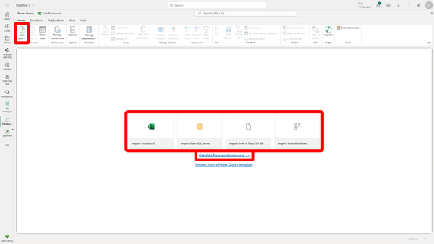

Figure 4-12. Dataflow - Canvas

Select “Other Sources” to get a full overview of supported data sources.

If you select “New”, you will get that full list which is almost endless and ranges from manually uploading files over Microsoft offerings to directly accessing third-party databases and software (see Figure [Figure 4-13](https://learning.oreilly.com/library/view/fundamentals-of-microsoft/9781098172916/ch04.html#ch04_figure_13_1734033260185927)).

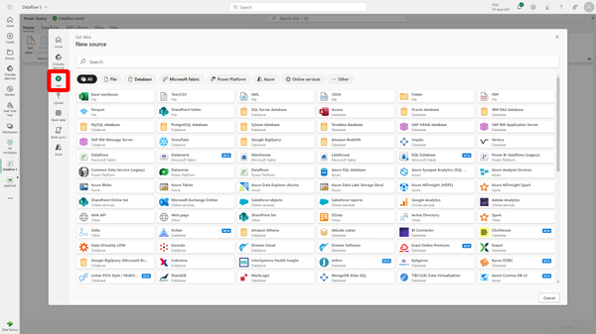

Figure 4-13. Supported Data Sources

Let us limit that view by filtering on Fabric items and selecting a Lakehouse as our source (see [Figure 4-14](https://learning.oreilly.com/library/view/fundamentals-of-microsoft/9781098172916/ch04.html#ch04_figure_14_1734033260185943)).

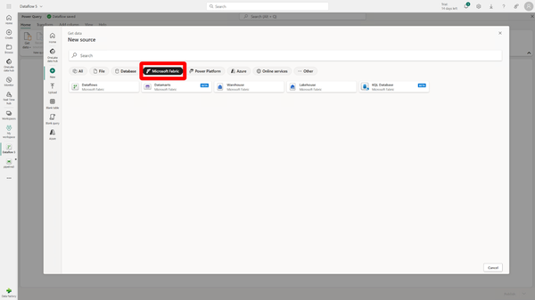

Figure 4-14. Dataflow – Fabric Sources

The wizard will walk you through the connection to your Lakehouse and the selection of the data you want to load, even providing a preview.

You can finalize this step by clicking “Create” (illustrated in [Figure 4-15](https://learning.oreilly.com/library/view/fundamentals-of-microsoft/9781098172916/ch04.html#ch04_figure_15_1734033260185960)).

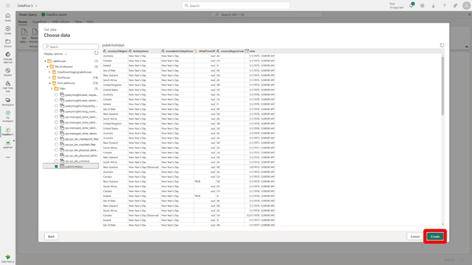

Figure 4-15. Dataflow – Fabric Source – Data Preview

In this Dataflow that just got created, you now have the option to add all kinds of transformations to your data (see the “Transform” tab in [Figure 4-16](https://learning.oreilly.com/library/view/fundamentals-of-microsoft/9781098172916/ch04.html#ch04_figure_16_1734033260185979)).

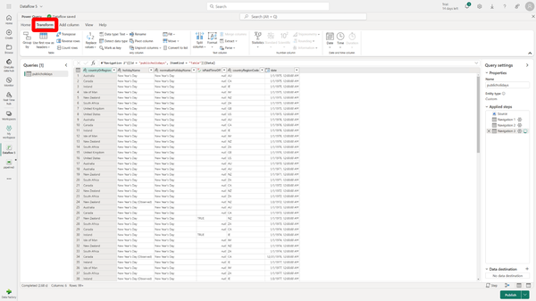

Figure 4-16. Dataflow – Transformations

Transformations allow you to change data types, add calculated columns, remove or rename columns, filter your data, and much more.

Once you’ve applied all your transformations, pick a destination for your data and publish your Dataflow (both steps shown in [Figure 4-17](https://learning.oreilly.com/library/view/fundamentals-of-microsoft/9781098172916/ch04.html#ch04_figure_17_1734033260185997)).

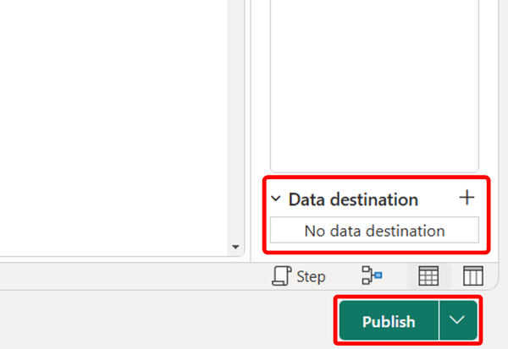

Figure 4-17. Dataflow – Destination and Publish

**Copy job**

The Fabric Copy job in Microsoft Fabric is a powerful artifact for managing and automating data ingestion, functioning independently like Dataflows. This independence allows users to create, manage, and run Copy jobs outside of broader workflows, providing flexibility in how data is ingested and moved between systems. The Copy job simplifies the complexities of large-scale data ingestion, making it easier to transfer vast amounts of data without the need for extensive coding or manual effort.

One of the standout features of the Fabric Copy job is its ability to manage incremental data loads, which is especially beneficial for large datasets. Rather than reloading entire datasets, the Copy job allows users to transfer only the data that has changed by tracking modifications through a watermark column. This column, often a datetime or integer field, helps the system identify what has already been copied, ensuring that only new or modified data is transferred. This method improves efficiency, reduces the load on source systems, and accelerates data ingestion processes.

Performance optimization is another crucial aspect of the Fabric Copy job. By running distributed queries, the system only transfers the data that falls within the specified watermark range, reducing unnecessary data movement and improving the speed of ingestion. This makes the Copy job ideal for large datasets and complex workflows, where efficiency and scalability are critical for maintaining high performance in data environments.

Overall, the Fabric Copy job is an essential tool for automating data ingestion. Its ability to handle incremental loads, schedule automated refreshes, and optimize performance through distributed querying makes it a versatile solution for various data scenarios. While the majority of use cases can be handled effectively by the Copy job, more advanced configurations may still be required for highly complex data environments. Nonetheless, for most organizations, the Copy job provides a streamlined and efficient way to ensure that data pipelines remain up-to-date and fully optimized.

Just like the Dataflow, a Copy job is an artifact by itself so it can be created from the Start page of Data Factory. Unlike a Dataflow, at the time of writing, it cannot be created from a Pipeline Canvas.

To create a new Copy job, navigate to the Start Page of Data Factory and click on Copy job as highlighted in [Figure 4-18](https://learning.oreilly.com/library/view/fundamentals-of-microsoft/9781098172916/ch04.html#ch04_figure_18_1734033260186013).

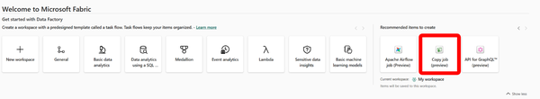

Figure 4-18. Create new Copy job

After providing a name for the job, you will be shown a wizard (shown in [Figure 4-19](https://learning.oreilly.com/library/view/fundamentals-of-microsoft/9781098172916/ch04.html#ch04_figure_19_1734033260186029)) that will walk you through the setup.

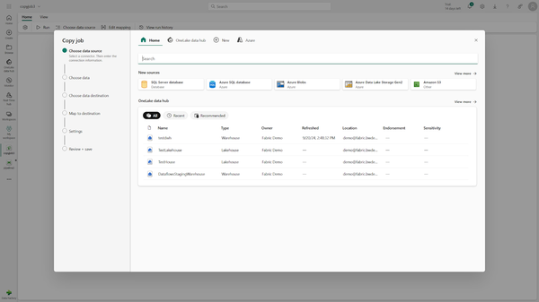

Figure 4-19. Copy job – Wizard

It will start with source and destination just like the other data movement mechanisms.

On the settings page however ([Figure 4-20](https://learning.oreilly.com/library/view/fundamentals-of-microsoft/9781098172916/ch04.html#ch04_figure_20_1734033260186046)), you can choose between a full load and an incremental load. The latter requires a numeric or date column to detect changes and will base its load patterns on that column.

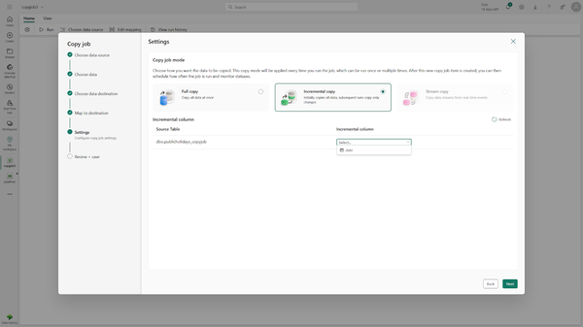

Figure 4-20. Copy job – Wizard – Settings

Depending on your source, you may also be able to pick a streaming copy of your data.

Comparing Data Movement Functions

When comparing Copy activity, Copy job, and Dataflow in Microsoft Fabric, key differences emerge in their execution contexts, primary functions, and ideal use cases:

**Execution Context**

Copy activity is always embedded within a pipeline. It cannot exist independently, meaning its scheduling and orchestration depend on the broader pipeline workflow. The Copy job and Dataflow, however, are standalone artifacts. This independence allows them to be created, configured, and executed separately from other pipelines, providing more flexibility for individual or recurring tasks.

*Primary Function*

The main purpose of Copy activity and Copy job is data movement. They focus on transferring data from one location to another, without performing transformations along the way. Dataflow, on the other hand, specializes in data transformation. While it also moves data, its strength lies in applying complex transformations (like joins, aggregations, or filtering) to the data during the process. Copy activity and Copy job do not provide this advanced level of transformation natively.

*Data Transformation Capabilities*

Dataflow is designed with rich transformation capabilities, including a no-code/low-code interface that allows users to perform advanced transformations visually. It’s ideal when you need to modify or enrich data as it moves between systems. Copy activity and Copy job do not natively support transformations at this level; they focus purely on data movement. While they can move transformed data, the actual transformation has to be handled separately.

*Scheduling and Automation*

Copy jobs and Dataflows can be scheduled to run independently of any broader pipelines. This makes them highly suitable for automated, recurring workflows, especially when regular updates or transformations are required. Copy activity, being a part of a pipeline, relies on the pipeline’s triggers and cannot be scheduled independently. It depends on pipeline execution logic for automation.

*Use Cases*

Copy activity is best suited for simple data movement within a larger pipeline where it complements other tasks, such as data validation or notification. The Copy job is ideal for large-scale, recurring data ingestion, particularly when you need an independent, automated solution for copying data across systems. Dataflow is the tool of choice when the task involves not just moving but also transforming data, such as applying complex business rules or cleaning up datasets before storing them in a destination.

In summary, while the Copy activity excels in integrated workflows within pipelines, Copy job and Dataflow offer flexibility as standalone artifacts. Copy jobs are tailored for data ingestion tasks and Dataflows are designed for scenarios where data transformation is a critical requirement.

A lot also comes down to personal preference where we for example see Dataflows as the “almost default” amongst many citizen data engineers who heavily rely on Power Query and its interface.

**Other Pipeline activities**

While, as mentioned above, data movement is certainly the most important part of Data Factory in general, there are many other activities to allow for the creation of feature rich pipelines and orchestrations.

The data movement tasks are also linked from the Start page of your canvas, all others can be found on the Activities tab where the “…” gives you a full and searchable list of all supported activities (see [Figure 4-21](https://learning.oreilly.com/library/view/fundamentals-of-microsoft/9781098172916/ch04.html#ch04_figure_21_1734033260186062)).

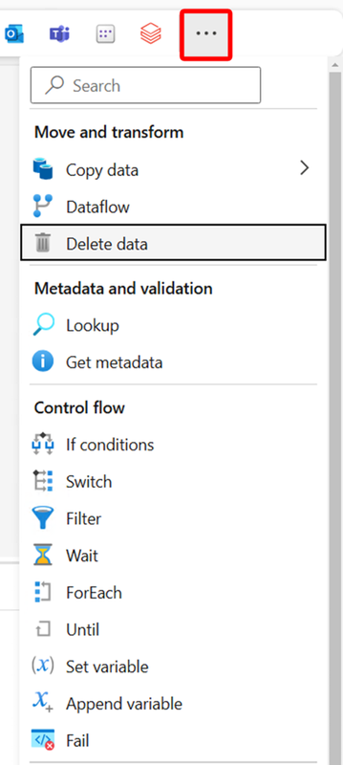

Figure 4-21. Pipeline activities

They are grouped into multiple categories.

**Move and transform**

These are the activities used to move data that we already discussed in the previous sections. The only additional activity in there is “Delete data” which – as you probably guessed – is one easy way to delete data in one of your tables, for example before inserting new data to it.

**Metadata and validation**

This group allows you to query for a single value, to for example later be used in a variable, or an entire metadata table from different sources, which can then be used in your pipeline. It can for example be used to parameterize your pipeline or to automate your Copy activities by using a central repository that controls which tables to load rather than creating a manual Copy activity for each table.

*Control flow*

In this group, you will find the tools to control your pipeline through loops, variables and conditions. It also contains additional activities to wait for other activities to finish or to throw an error.

*Orchestrate*

This group allows you to run other activities such as other Pipelines, Notebooks, calling Web Endpoints, Azure Functions, and more.

*Notifications*

The activities in this group allow you to send out notifications through either email (using an Outlook 365 connection) or Teams which can for example be useful to let your users know when a specific pipeline has completed or failed.

*Transform*

These activities allow you to transform your data in the language and methodology of your choice through stored procedures, Notebooks, Spark Jobs, Scripts, or KQL.

*Machine Learning*

The only activity in this group allows you to run Azure machine learning jobs, meaning you can reference and execute an existing job in Azure ML from a pipeline.

**Schedules and Triggers**

We already looked into running a pipeline or task manually which is great for ad hoc requests and of course also testing. But that isn’t a great option for those jobs running every hour or in the middle of the night.

This is where schedules and triggers come into play, and they can both be found right next to the Run button (see [Figure 4-22](https://learning.oreilly.com/library/view/fundamentals-of-microsoft/9781098172916/ch04.html#ch04_figure_22_1734033260186077)).

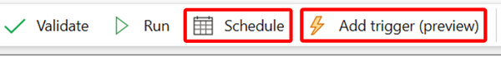

Figure 4-22. Schedules and Triggers

**Schedules**

In Microsoft Fabric Data Factory, schedules are a powerful feature used to automate the execution of pipelines at predefined intervals, ensuring that data workflows are consistently and reliably run without manual intervention. A schedule-based trigger allows users to specify when a pipeline should start, such as on an hourly, daily, weekly, or monthly basis, or even with more customized intervals. This is particularly useful for recurring tasks like nightly ETL (Extract, Transform, Load) processes, regular data refreshes, or periodic data backups. The flexibility in configuring schedules means you can set the exact time and frequency of execution, making it easy to align data processes with business needs.

Schedules in Data Factory also offer time zone and recurrence options, allowing users to adjust pipeline execution based on regional or global requirements. You can configure the trigger to account for specific time ranges, ensuring pipelines run only within a designated window (for example, between 9 AM and 5 PM in a specific time zone). Moreover, scheduling options can include start and end dates, allowing for temporary data workflows that only run during a specific project period. By using schedule-based triggers, users ensure that data pipelines are executed consistently, which is vital for maintaining up-to-date and synchronized data across different systems.

A pipeline can have multiple schedules.

To add a schedule, simply click the “Schedule” button shown in the previous figure and then configure the schedule’s settings (when and how often the pipeline should be executed) as shown in [Figure 4-23](https://learning.oreilly.com/library/view/fundamentals-of-microsoft/9781098172916/ch04.html#ch04_figure_23_1734033260186092). Make sure to activate the schedule for it to be executed.

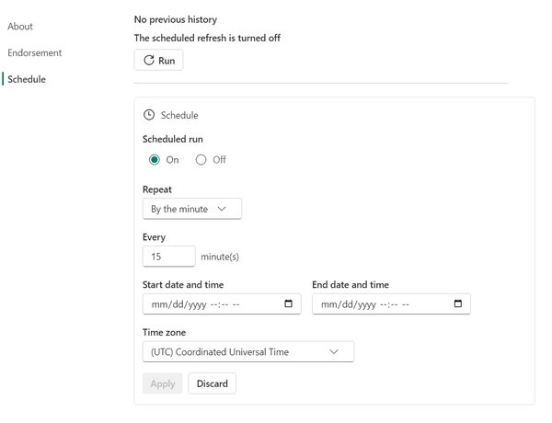

Figure 4-23. Schedule settings

**Triggers**

Unlike schedules, which run your pipeline at a certain time, triggers fire up your pipeline based on external events.

To add a trigger, you first click the corresponding “Add trigger” button.

The most important setting is which events the trigger should react to (See [Figure 4-24](https://learning.oreilly.com/library/view/fundamentals-of-microsoft/9781098172916/ch04.html#ch04_figure_24_1734033260186107)).

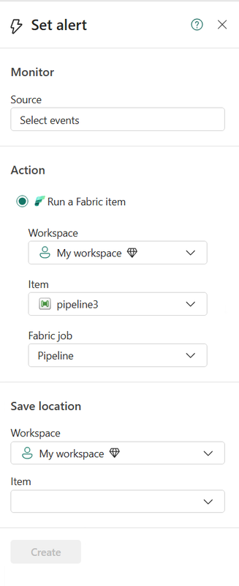

Figure 4-24. Trigger basic settings

Click on “Select events” where you will first have to select a data source which can be an Azure Blob Storage or any Fabric item (see [Figure 4-25](https://learning.oreilly.com/library/view/fundamentals-of-microsoft/9781098172916/ch04.html#ch04_figure_25_1734033260186126))

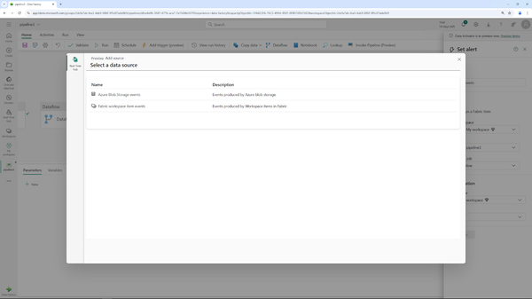

Figure 4-25. Triggers – Select source

If you click on Fabric items as your source, you can configure which event types to look out for (for example a successful update of an item) and also narrow down which parts of your workspace you want monitored based on filters (see [Figure 4-26](https://learning.oreilly.com/library/view/fundamentals-of-microsoft/9781098172916/ch04.html#ch04_figure_26_1734033260186145)).

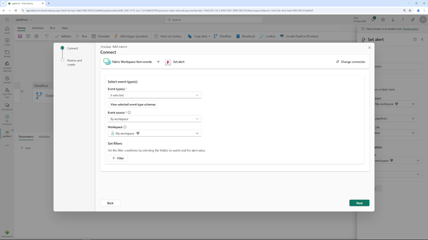

Figure 4-26. Triggers – Settings for Fabric Items as Trigger Source

By monitoring your fabric items or a blob container for changes, you can for example run your ETL pipeline as soon as a new file has been added or run your notification pipeline in case any tasks ran unsuccessful.

Summary

Microsoft Fabric Data Factory is a cloud-native service for managing, processing, and orchestrating data workflows. It handles tasks from extracting raw data to transforming and loading it into target systems for analysis. Data Factory seamlessly integrates data across cloud, on-premises, and hybrid environments.

Supporting both ETL and ELT processes, it offers flexibility in cleaning and transforming data either before or after loading. Data Factory automates workflows through scheduling and triggers, and its no-code/low-code interface makes it accessible to both technical and non-technical users. Integration with other Microsoft Fabric services ensures smooth data flows across the organization’s architecture.

In short, Microsoft Fabric Data Factory simplifies and scales modern data engineering workflows.

In Chapter 5, we will look into the Data Engineering Experience in Microsoft Fabric.

DATA Engineering

In Chapter 4, we looked into how we can use the tools and mechanisms in Data Factory to load data into Fabric, and in this chapter, we will now focus on the Data Engineering experience.

Data engineering involves creating the technical infrastructure required for capturing, storing, and processing significant volumes of data. This field includes designing pipelines to extract data from multiple sources, transforming it to ensure high quality and uniformity, and storing it in databases or storage solutions where it can be analyzed. Data engineers use a variety of technologies to keep these systems reliable, efficient, and scalable. Their work ensures that data is readily available and usable, forming the backbone of data analytics and supporting informed, data-driven decisions within businesses.

In data engineering, data processing, transformation, and orchestration are vital roles that convert raw data into actionable insights, often through tools like Synapse Spark, Notebooks, Pipelines, and Jobs. Data processing entails cleaning, aggregating, and structuring raw data from multiple sources, leveraging Synapse Spark’s capacity to handle large datasets efficiently and at scale. Transformation refines this data to meet analytical and business requirements. Using Notebooks, data engineers can iteratively transform, visualize, and verify data, fostering collaboration and precision. Orchestration then automates and schedules these workflows, ensuring each stage operates reliably and sequentially. Pipelines and Jobs empower data engineers to design, track, and manage these workflows, allowing control over dependencies, triggers, and scheduling. Together, these functions enable a cohesive process that prepares high-quality, timely data for analytics and machine learning, supporting a seamless journey from data ingestion to insightful results.

This also implies that certain tasks from Chapter 4, - for example pipelines - are part of a data engineer’s role.

In Microsoft Fabric, within the Data Engineering Experience, data is organized and stored in lakehouses.

Fundamentals of a Lakehouse

A Lakehouse is a modern data architecture that blends the strengths of a data lake and advanced data management features into a unified platform. At its core, a lakehouse enables organizations to manage all types of data - structured, semi-structured, and unstructured -within a single environment. The primary advantage of a lakehouse is its ability to store raw data in its native format, such as JSON, images, videos, or logs, while also allowing for more complex processing and analytics on that data, including real-time insights and machine learning applications. Unlike traditional storage systems that often require separate environments for different data formats, the lakehouse brings everything together into a cohesive platform that is both scalable and flexible.

Lakehouses also provide robust data management capabilities, such as enforcing schema definitions, data versioning, and ACID transactions.

**Note**

ACID transactions are a set of properties that ensure reliable database processing: Atomicity (all-or-nothing execution), Consistency (preservation of data integrity), Isolation (independent operation of transactions), and Durability (permanent changes once a transaction is complete). These properties ensure reliable transaction processing and maintain data accuracy.

Those characteristics ensure data integrity and consistency across various processes, making it easier for organizations to manage, query, and analyze large datasets. A key feature of the lakehouse architecture is its support for advanced analytics workloads, enabling machine learning, artificial intelligence, and big data processing all from the same platform. Additionally, a lakehouse can handle massive volumes of data, scaling easily to accommodate growing data needs without compromising on performance.

By supporting multiple data formats and use cases, lakehouses create a streamlined environment for data teams to collaborate, reducing the need for multiple platforms or complex data pipelines. This flexibility allows organizations to ingest, process, and analyze data at scale while keeping the complexity of infrastructure low, making it a popular choice for modern, data-driven enterprises seeking to unlock the full value of their data.

Data Lake vs. Lakehouse

You may have been wondering - Lakehouse. Is that a data lake?

A data lake and a lakehouse represent two distinct approaches to data storage and processing, each designed to meet different needs. A data lake is a large, scalable repository that stores massive amounts of raw, unstructured, or semi-structured data in its original format, supporting a wide range of data types, including text, images, video, audio, and structured datasets from databases. This flexibility makes data lakes ideal for handling “big data” and for use cases like analytics, machine learning, and data science. However, without careful management and governance, data lakes can become disorganized and challenging to query, sometimes leading to what’s known as a “data swamp.”

In contrast, a lakehouse blends the flexibility of a data lake with the structure and management capabilities of a data warehouse. It provides schema enforcement, data versioning, and transaction support, enabling more efficient data querying and analytics. By supporting both structured and unstructured data, a lakehouse allows organizations to perform SQL-based analytics directly on large datasets without needing to move data into a separate data warehouse. This hybrid architecture makes lakehouses an attractive option for companies looking to streamline their data infrastructure, uniting storage and analytics in a single, more manageable platform (see also [Figure 5-1](https://learning.oreilly.com/library/view/fundamentals-of-microsoft/9781098172916/ch05.html#ch05_figure_1_1734033282039001)).

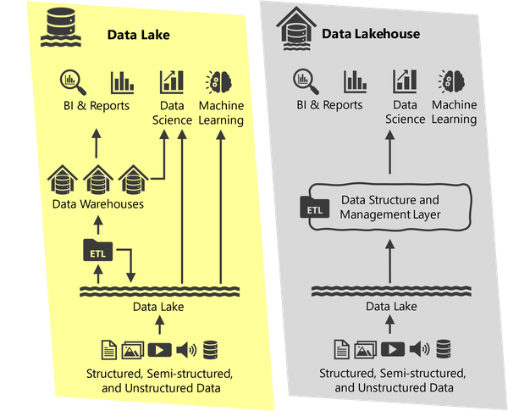

Figure 5-1. Data Lake vs. Data Lakehouse

If you are already familiar with the concept of data warehousing, your next question might be - what is the difference between a Lakehouse and a Warehouse then? We’ll get to that in Chapter 6!

The Medallion Architecture

Data in a Lakehouse is often organized using the so-called medallion architecture.

The Medallion Architecture is a structured approach in data lakehouse design that organizes data across distinct layers, enhancing data quality, accessibility, and utility. Data is segmented into three stages - Bronze, Silver, and Gold - each representing a step in the data’s journey from raw intake to business-ready output.

*Bronze Layer – Raw Data*

The Bronze Layer serves as the initial storage for raw data from diverse sources, often retained in its original form. This layer acts as a historical record, preserving unprocessed data for potential reprocessing or analysis. The data here is only minimally organized, with basic metadata applied to support accessibility.

*Silver Layer – Cleaned and Enriched Data*

The Silver Layer refines data further, undergoing processes to clean, enrich, and standardize formats, removing duplicates, and addressing missing values. Data engineers transform this layer to provide a structured view that is consistent and reliable, ideal for foundational analytics and deeper business insights.

*Gold Layer – Business-Ready Data*

The Gold Layer is the culmination, where data is fully processed, aggregated, and tailored to meet specific business needs. This layer offers a “single source of truth” for reporting, dashboards, and high-performance analytics, aligning data to specific use cases with high-quality standards for decision-making.

This organized layering in the Medallion Architecture supports data governance, reliability, and accessibility, ensuring that organizations can manage data at scale and convert it effectively from raw information into valuable, actionable insights (See also [Figure 5-2](https://learning.oreilly.com/library/view/fundamentals-of-microsoft/9781098172916/ch05.html#ch05_figure_2_1734033282039056)).

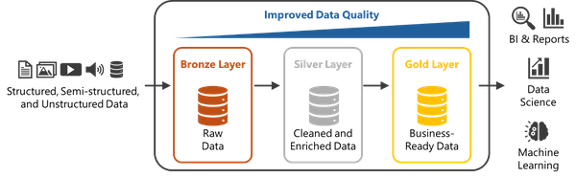

Figure 5-2. Medallion Architecture

While it by far is not the only way of organizing your Lakehouse, it is one of the most popular ways and has turned out to become a de-facto standard by most data engineers.

Lakehouses in Microsoft Fabric

Although Lakehouse is a generic term, there are some specifics to the way a lakehouse is implemented in Fabric.

**Lakehouse Schemas**

In Microsoft Fabric, a lakehouse schema defines the structure and organization of data within the lakehouse, combining elements of both a data lake and a data warehouse to support analytics and data management in a single unified environment. The lakehouse schema is designed to allow both structured and unstructured data to coexist and be accessed using various analytics tools, bridging the gap between raw data storage and structured, query-optimized data for analytics and reporting. Lakehouse schemas are also a very elegant way to build your medallion architecture. So rather than separating your layers across multiple Lakehouses, you can simply put your tables into different schemas.

**Integrating Data to a Lakehouse**

To move data into your Lakehouse, you have multiple options.

We already discussed the options of Data Factory in Chapter 4 as well as Shortcuts in Chapter 3 but there are two more ways of getting data into a Lakehouse: streaming (whichwe will cover more of in Chapter 8)and simply copying data to the Lakehouse.

Remember from Chapter 3, how, under the hood, OneLake offers the same APIs as any other Azure Data Lake Storage Gen 2 so you can also simply copy files to it and then consume those files as a Lakehouse natively supports accessing data stored in files rather than tables.

**Querying and working with data in your Lakehouse**

One very popular and easy way to access your Lakehouse is the SQL Analytics Endpoint that automatically gets created for you when deploying a Lakehouse - we saw this in Chapter 2 - and the SQL endpoint is a very valid way of working with your lakehouse, if SQL is the sole language of your choice.

**Note**

For a Lakehouse, the SQL Endpoint is read only!

Many engineers have different preferences or also simply additional requirements that SQL can’t (easily) satisfy. This is where the other - probably more popular - approach comes into play: Notebooks.

**Synapse Notebooks**

Notebooks play a vital role in data engineering, offering a cohesive environment that supports interactive development, rapid iteration, and data exploration. They allow data engineers to break down code into smaller, testable segments, enabling them to execute and visualize results immediately, experiment with different approaches, and refine their methods in real time. This iterative workflow fosters faster development cycles and effective problem-solving, making it easy for engineers to transform, analyze, and clean data. Notebooks also enhance collaboration, as engineers can document their steps, share code, and present visualizations, creating a transparent workflow that keeps team members and stakeholders aligned.

A major strength of notebooks is their flexibility in integrating multiple languages and frameworks - such as Spark, SQL, and Python - within a single interface, allowing for comprehensive, end-to-end data workflows. Data engineers can harness Spark’s distributed processing capabilities for handling large datasets, use SQL for structured data manipulation, and tap into Python’s extensive libraries for transformation, visualization, or machine learning, all within one notebook. This seamless integration eliminates the need to shift between separate tools, streamlining workflows and boosting productivity. Notebooks enable data engineers to build dynamic pipelines, visualize intermediate results, and fine-tune models in a single, unified environment, simplifying complex data engineering tasks.

In Fabric, Notebooks further enable real-time data exploration, helping engineers delve into datasets to uncover patterns before implementing transformations. By combining code, narrative text, and visualizations, notebooks provide an effective means of documenting data lineage and transformation logic. This approach enhances reproducibility and traceability, while also facilitating the onboarding of new team members and reinforcing best practices in data engineering. Acting as both a development and communication tool, notebooks bridge the gap between raw code and meaningful insights, forming an indispensable component of the modern data engineering toolkit.

All your Notebooks can of course be part of your orchestration pipelines as laid out in Chapter 4.

**Leveraging Spark for Data Engineering**

Apache Spark is a powerful, open-source analytics engine designed for large-scale data processing, enabling data engineers to efficiently transform and analyze vast datasets. Its distributed, in-memory processing architecture allows Spark to handle big data tasks with remarkable speed, making it ideal for diverse data workflows such as ETL (Extract, Transform, Load) pipelines, machine learning, and real-time analytics. Spark supports multiple languages, including Python, Scala, and SQL, offering flexibility for data engineers to leverage their preferred tools. In Microsoft Fabric, Spark integrates seamlessly, providing a robust framework for scaling data engineering tasks.

Data engineers can use Spark Pools to handle ETL operations, data transformations, and interactive data exploration, while optimizing cost and performance according to specific requirements.

To perform data transformations at scale, data engineers can write Spark applications in languages like PySpark (Python for Spark) or Scala and submit them to Spark Pools. This setup supports complex ETL pipelines, allowing engineers to extract data from multiple sources, transform and clean it, and load it into structured storage for further analysis. Spark’s distributed architecture ensures efficient data processing, even with massive datasets, and facilitates scalable, automated data workflows, making it an essential component for handling data at scale in Synapse.

Spark in notebooks enhances flexibility by enabling interactive transformations with PySpark, allowing data engineers to tackle complex tasks in a single, cohesive interface. Engineers can leverage advanced Spark functions - like *filter*, *groupBy*, and *map* - within notebooks to transform and analyze data interactively. This environment is ideal for prototyping, where engineers can iteratively develop and visualize their data workflows, making real-time adjustments and optimizations. For example, a notebook can be used to load a large dataset, remove duplicates with *dropDuplicates*, handle missing values with *fillna*, and aggregate data using *groupBy* and *agg*, providing a streamlined process for data cleansing and transformation.

Notebooks in Fabric offer a practical interface for advanced data engineering, blending code, visualizations, and narrative text for clear documentation. By combining Spark transformations with Python’s extensive data libraries, engineers can achieve a cohesive workflow within a single environment. This setup not only enhances data accessibility but also promotes collaboration and reproducibility, enabling data engineers to explore, document, and refine their data processes effectively. As a result, leveraging Spark in notebooks forms an essential part of the modern data engineering toolkit, bridging the gap between data exploration and production-ready workflows.

**A step-by-step example: Building an ETL Pipeline in a Notebook**

To get started, we will create a new Lakehouse called *LakehouseChapter5* and add sample data to it. Not sure how to get started? Please refer to Chapter 2 where we’ve built our first Lakehouse.

We will start by creating our medallion layers so if you right click your tables section in your Lakehouse, you get the option to create a new schema (see [Figure 5-3](https://learning.oreilly.com/library/view/fundamentals-of-microsoft/9781098172916/ch05.html#ch05_figure_3_1734033282039084)).

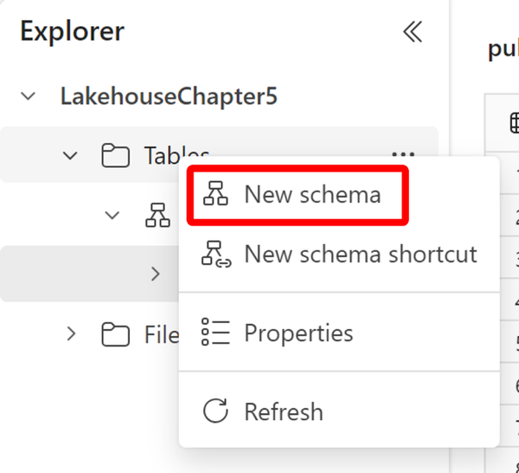

Figure 5-3. Adding Schemas to your Lakehouse

Your final result should look like the illustration in [Figure 5-4](https://learning.oreilly.com/library/view/fundamentals-of-microsoft/9781098172916/ch05.html#ch05_figure_4_1734033282039105).

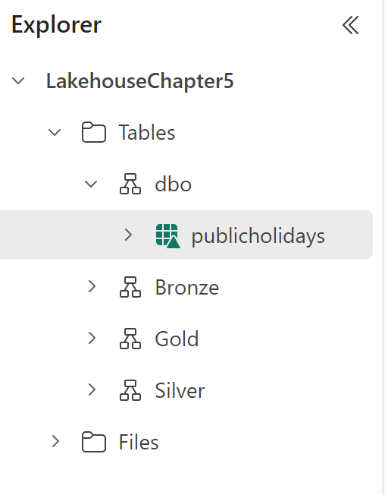

Figure 5-4. Medallion architecture through schemas

As our last step of preparation, we will load the New York Taxi Yellow dataset from the Files to a new table in the bronze layer. While we could do all of that from our Notebook, let’s keep things simple for now.

Navigate to the file and select “Load to Table” and “New table” as shown in [Figure 5-5](https://learning.oreilly.com/library/view/fundamentals-of-microsoft/9781098172916/ch05.html#ch05_figure_5_1734033282039123).

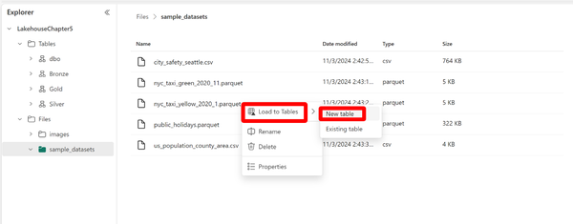

Figure 5-5. Load data to table from file

Select the bronze layer and shorten the name of the table to *nyc_taxi_yellow* as shown in [Figure 5-6](https://learning.oreilly.com/library/view/fundamentals-of-microsoft/9781098172916/ch05.html#ch05_figure_6_1734033282039141).

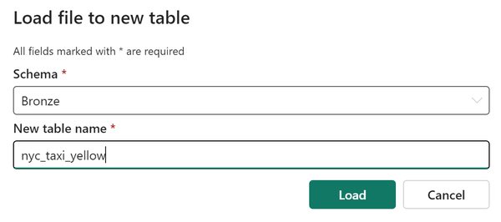

Figure 5-6. Load file to new table in bronze layer

Now it’s time to create our Notebook which you can do right from the top menu (see [Figure 5-7](https://learning.oreilly.com/library/view/fundamentals-of-microsoft/9781098172916/ch05.html#ch05_figure_7_1734033282039156)).

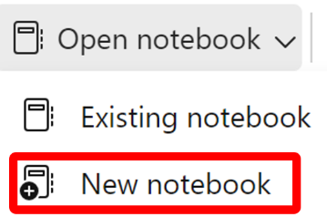

Figure 5-7. New notebook

We will first explore the data in our sample file. In your Lakehouse, navigate to the corresponding file, select “Load data” and pick “Spark” (see [Figure 5-8](https://learning.oreilly.com/library/view/fundamentals-of-microsoft/9781098172916/ch05.html#ch05_figure_8_1734033282039172)).

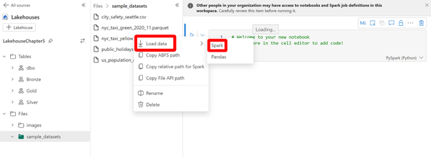

Figure 5-8. Load file using Spark

This will create the code to load this file’s content to a dataframe, you can execute the cell using the “Play” button on the upper left (see [Figure 5-9](https://learning.oreilly.com/library/view/fundamentals-of-microsoft/9781098172916/ch05.html#ch05_figure_9_1734033282039190)). A DataFrame in PySpark is a distributed collection of data structured into named columns, similar to a table in a relational database or a Pandas DataFrame. It is designed for large-scale data processing, capable of handling both structured and semi-structured data, and leverages Spark’s parallel processing for efficient data manipulation and analysis.

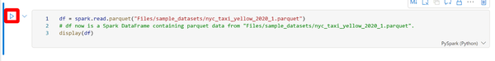

Figure 5-9. Code to load file to dataframe using Spark.

This will immediately show us the data as well as a first overview about it (see [Figure 5-10](https://learning.oreilly.com/library/view/fundamentals-of-microsoft/9781098172916/ch05.html#ch05_figure_10_1734033282039205))

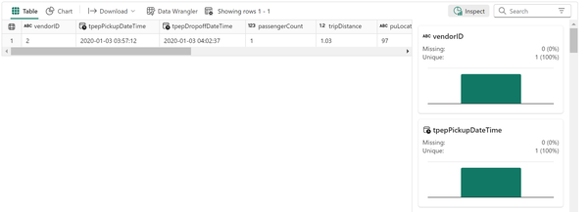

Figure 5-10. Output of display(df)

As you can see, our file only has one row. If you right click the table in our bronze layer, you will get the exact same results.

Now, we first need to make sure our data can get easily refreshed from our file to our table.

To achieve that, we will modify the code in our cell to this:

df = spark.read.parquet("Files/sample_datasets/nyc_taxi_yellow_2020_1.parquet")

df.write.format("delta").mode("overwrite").saveAsTable(f"LakehouseChapter5.Bronze.nyc_taxi_yellow")

The mode overwrite will make sure that all contents in our table will get overwritten. If we’d use *append* instead, that data would be appended every time we run this cell.

Usually, we’d clean that data first when needed, for our sample data we can skip this step.

For our silver layer, we only care about the Day of a trip, its distance and its fare.

We therefore add another cell by clicking on the “+ Code” button below our existing cell (see [Figure 5-11](https://learning.oreilly.com/library/view/fundamentals-of-microsoft/9781098172916/ch05.html#ch05_figure_11_1734033282039220)).

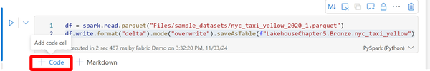

Figure 5-11. Add new code cell

In this cell, we add the code to convert our trip’s timestamp to a date and only add the distance and fare amount:

df = spark.sql("SELECT cast(tpepPickupDateTime as date) DTE,tripDistance,fareAmount FROM LakehouseChapter5.Bronze.nyc_taxi_yellow”)

df.write.format("delta").mode("overwrite").saveAsTable(f"LakehouseChapter5.Silver.TaxiTrips")

This will automatically create the target table in our silver layer and populate it.

For our business users, we will eventually aggregate that data by month using our last code snippet:

df = spark.sql("SELECT last_day(DTE) MT,sum(tripDistance) Distance,sum(fareAmount) Amount FROM LakehouseChapter5.Silver.TaxiTrips group by last_day(DTE)")

df.write.format("delta").mode("overwrite").saveAsTable(f"LakehouseChapter5.Gold.TaxiTrips")

To check our result, we will add one last code cell.

In this code cell, we will change the language directly to Spark SQL on the lower right, which allows us to directly write a SQL query as shown in [Figure 5-12](https://learning.oreilly.com/library/view/fundamentals-of-microsoft/9781098172916/ch05.html#ch05_figure_12_1734033282039239). Only this specific cell will be executed using the Spark SQL Kernel whereas the remainder of the Notebook will still be using the default for the Notebook.



Figure 5-12. Spark SQL Cell

We have now created a simple Notebook that will load a parquet file, move it to our bronze layer, clean it and store it to our silver layer, aggregate it to our gold layer, and then show the result using SQL.

We could either click “Run all” at the top to execute the entire Notebook at once or, for example, schedule the Notebook through a pipeline (see [Figure 5-13](https://learning.oreilly.com/library/view/fundamentals-of-microsoft/9781098172916/ch05.html#ch05_figure_13_1734033282039256)).

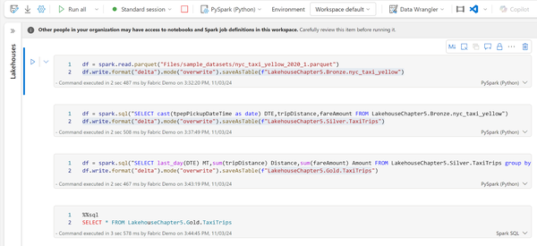

Figure 5-13. Full Notebook

Summary

In this chapter, we had a look at data engineering in Microsoft Fabric, focusing on the tools, architectures, and workflows that enable efficient data ingestion, transformation, and orchestration. Building on the foundational data-loading techniques introduced earlier, this chapter examines how data engineers utilize Synapse Spark, Notebooks, Pipelines, and Jobs to transform raw data into actionable insights. Key concepts such as the Lakehouse architecture and Medallion Architecture were introduced, demonstrating how data can be organized across Bronze, Silver, and Gold layers for structured refinement and high-quality output. Through these tools and methods, data engineering in Microsoft Fabric supports scalable, efficient data processing, enabling organizations to manage large datasets, streamline workflows, and derive valuable insights seamlessly.

In Chapter 6, we will look at the - if you will - counterpart of Lakehouses: Data Warehouses.

DWH

Fundamentals of Data Warehousing

A data warehouse is a core element of today’s data management and analytics systems. It serves as a centralized platform for storing, managing, and analyzing large volumes of structured data from various sources. Data warehouses are specifically organized to support business intelligence (BI) functions such as reporting, querying, and analysis. Since they are optimized for read-heavy operations, they are well-suited for tasks like generating dashboards, analytics reports, and supporting executive decision-making.

Key characteristics of a Data Warehouse are:

*Structured Data*

Data warehouses primarily handle structured data, meaning it is arranged in predefined formats such as tables, columns, and rows, with established relationships between data points. This structure is typically enforced through ETL (Extract, Transform, Load) processes, ensuring that data entering the warehouse adheres to specific formats and business rules.

*Historical Data Storage*

Data warehouses are built to store extensive historical data, often spanning many years. This makes them invaluable for long-term trend analysis, enabling organizations to rely on detailed records for forecasting and strategic planning.

*Schema-On-Write*

The schema, or data structure, must be defined before data is written into the warehouse. This “schema-on-write” approach ensures data consistency and integrity but requires a solid understanding of the business rules and data structure prior to ingestion.

*Optimized Query Performance*

Data warehouses are fine-tuned for high query performance, especially when handling complex operations like aggregations, joins, and filtering across large datasets. Performance enhancements are achieved using technologies such as indexing, partitioning, and OLAP (Online Analytical Processing) cubes.

Difference between Warehouse and Lakehouse

Data warehouses and data lakehouses differ significantly in their architecture and the types of data they manage. A data warehouse is built specifically for handling structured data, organized into predefined schemas to optimize fast querying, making it well-suited for tasks like business intelligence (BI) and analytics that focus on historical, relational data. On the other hand, a data lakehouse blends the capabilities of both data warehouses and data lakes, enabling it to accommodate both structured and unstructured data with greater flexibility. While data warehouses follow a schema-on-write approach—defining the data structure prior to ingestion—data lakehouses use schema-on-read, where the structure is applied only when the data is accessed. This allows data lakehouses to store vast amounts of raw data, making them ideal for big data processing, machine learning, and advanced analytics, while still offering the performance benefits typical of data warehouses.

**Note**

Due to their nature with regards to the data they are holding, we often see Lakehouses being used for the Bronze and Silver Layer with the Gold Layer being a Data Warehouse.

Differences specific to Fabric

There are some major differences between data engineering or using lakehouses and using a data warehouse which are specific to Microsoft Fabric, as you’ll see in [Table 6-1](https://learning.oreilly.com/library/view/fundamentals-of-microsoft/9781098172916/ch06.html#ch06_table_1_1734033330461570).

| **Lakehouse** | **Data Warehouse** |
| --- | --- |
| SQL endpoint is read-only | SQL endpoint is writeable |
| can use SQL, Python | language is T-SQL only, resulting in faster and cheaper queries |
| Table 6-1. key differences between a lakehouse and a data warehouse | |

*SQL Endpoint*

The SQL Endpoint in the Data Warehouse is writeable whereas it is read-only for a Lakehouse.

*T-SQL vs Python/pySpark*

The first big difference is that in a Data Warehouse, you will use T-SQL as your language whereas in a Lakehouse, you can use SQL but also other / such as python. Despite the lakehouse also providing a SQL Endpoint and the opportunity to wrap a SQL query into python code, the primarily used language will differ between these two.

*Better SQL Performance*

The Data Warehouse uses SQL as its native language so as a rule of thumb, SQL queries will run faster and cheaper.

*Files*

Due to the nature of Data Warehouses relying on structured data, all its information will be stored in tables so the concept of reading from files does not apply to the data warehouse experience natively. There are ways however to include data from a lake house into your data warehouse which we’ll discuss in more depth in the “Querying a Warehouse” section of the next paragraph.

Warehouses in Microsoft Fabric

Since we already created a first Warehouse in Chapter 2, let us dive right into how we can work with a Data Warehouse in Fabric.

**Integrating Data to a Warehouse**

To integrate data directly into your Data Warehouse, you will either use Data Factory (Pipelines, Copy Jobs, Dataflows…) or you can insert data to it using the SQL Analytics Endpoint. To make things slightly more confusing though, you can also access data that isn’t actually stored in your Warehouse so not all your data needs to be integrated or inserted into your Warehouse tables.

**Querying a Warehouse**

With SQL being the “language of the Data Warehouse”, the SQL Endpoint is the obvious first choice. The SQL Endpoint does allow cross querying across multiple Warehouses though – and also across Lakehouses. So a you can send a query to the SQL Endpoint that immediately joins a table in your Warehouse with data from your Lakehouse. And that is how data residing in files that are not natively built into the Warehouse still make their way to it.

Code Sample 6-1 shows how you can cross query a Warehouse and a Lakehouse.

**Example 6-1. Code 6-1 – Cross Warehouse Query**

SELECT col1,col2...FROM myWarehouse.dbo.myDWHTable a INNER JOIN myLakehouse.dbo.myLHTable b on a.col1 = b.col1

**Elements of a Fabric Data Warehouse**

Have you worked with SQL Server, Azure SQL DB or similar flavors of SQL before? Then all of the elements of a Fabric Data Warehouse should be very familiar to you.

*Schemas*

In Microsoft Fabric, schemas act as containers that organize database objects like tables, views, stored procedures, and functions within a data warehouse. They serve as a logical framework for categorizing data based on different business domains or departments, providing a clear structure to manage access and permissions. This organization not only enhances data security by controlling access at the schema level but also makes it easier to navigate and maintain the database as it grows, ensuring that related data and resources are grouped together logically.

*Tables*

Tables are the core structures in a data warehouse where data is stored in rows and columns, resembling a spreadsheet layout. Each table typically represents a specific entity, such as “Sales” or “Customers,” and stores records that align with that entity. Tables are designed to handle large volumes of structured data, making them foundational for querying, reporting, and analytics. With the help of indexing and partitioning techniques, tables in Microsoft Fabric are optimized for efficient data retrieval and querying, supporting the high-performance requirements of business intelligence workloads.

*Views*

Views in Microsoft Fabric are virtual tables created by defining a query that pulls and filters data from one or more tables. Unlike tables, views do not store data themselves; they provide a dynamic way to present specific slices of data based on predefined criteria. Views are particularly useful for simplifying complex queries and abstracting underlying data complexity. By creating views, data engineers can present data in a user-friendly format, improve security by restricting access to specific data, and support business needs by delivering targeted data views for analytics and reporting.

**Note**

Views will cause Direct Lake queries to fall back to DirectQuery queries!

*Stored Procedures*

Stored procedures are predefined sets of SQL commands stored within the database, allowing for reusable and efficient execution of routine operations. In Microsoft Fabric, stored procedures are widely used to automate repetitive tasks, such as data transformations, validation, and bulk data loading. By encapsulating logic in stored procedures, developers can streamline processes, reduce code duplication, and ensure consistency across data operations. Stored procedures also help in optimizing performance, as SQL code is precompiled and executed within the database, making them a powerful tool for maintaining the efficiency of a data warehouse.

*Functions*

Functions in Microsoft Fabric are specialized SQL routines designed to perform specific calculations or transformations on data, often returning a single value or result. These can be used within SQL statements to simplify and reuse common expressions, making complex queries more manageable and readable. Functions are especially valuable in scenarios that require consistent calculations, such as date conversions, data formatting, or aggregations. By leveraging functions, data engineers can encapsulate logic in reusable components, which enhances code maintainability and promotes standardized data handling across the data warehouse.

Summary

In summary, data warehousing in Microsoft Fabric provides a powerful, structured, high-performance environment tailored to business intelligence and analytics needs. Fabric data warehouses are optimized for handling large volumes of historical, structured data, enabling complex querying and reporting. Unlike lakehouses, which offer schema-on-read flexibility for unstructured data, Fabric data warehouses focus on structured data operations. Microsoft Fabric’s unique integration between data warehouses and lakehouses supports cross-querying and combines T-SQL for warehouse tasks with Python for lakehouse applications. Featuring familiar SQL elements like schemas, tables, views, and stored procedures, Fabric’s data warehousing capabilities offer robust support for enterprise-grade analytics and decision-making.

In our next chapter, Chapter 7, we will elaborate Fabric’s capabilities around Data Science.

Not so long ago, in 2012, data scientist was branded as “the sexiest job of the 21st century” by the Harvard Business Review: [*https://hbr.org/2012/10/data-scientist-the-sexiest-job-of-the-21st-century*](https://hbr.org/2012/10/data-scientist-the-sexiest-job-of-the-21st-century)

Obviously, we can argue about the validity of this label more than a decade after it was proclaimed. However, the fact is that “individuals that can coax treasure out of messy, unstructured data” are still in high demand, and Microsoft Fabric doesn’t disappoint anyone who considers themselves a data scientist.

Before we dig deep into examining particular data science workloads in Microsoft Fabric, let’s first look at Figure 7-1 and try to depict the most common data science process stages from a high-level perspective. Please keep in mind that this process is not exclusively related to Microsoft Fabric - it’s more of a generic, tool-agnostic approach.

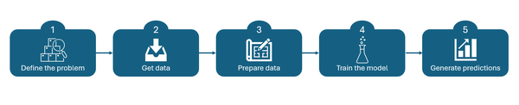

Figure 7-1. The most common data science workflow

In this chapter, we will discuss different options that Microsoft Fabric provides to support data science workloads. These options include various ready-made solutions that can be seamlessly integrated with other Fabric experiences, as well as some unique features, such as Semantic link, to support specific Fabric-related use cases.

MLFlow

MLFlow is a free and open-source platform for the complete machine learning lifecycle, including experimentation, reproducibility, and deployment. There are numerous benefits to using MLFlow, so let’s focus on the most important ones. First, it enables data scientists to manage their machine learning projects more systematically, by tracking experiments. In addition, it can be used to facilitate deployment in various environments and support a wide range of machine learning frameworks and tools, making it a suitable choice for use in diverse projects, such as sales forecasting, model deployments, and similar.

Figure 7-2 displays a typical workflow in the experiment and build machine learning models phase.

*MLFlow*

MLFlow is used to streamline Machine Learning development, including tracking experiments and sharing and deploying machine learning models.

*SynapseML*

In contrast to MLFlow, SynapseML enables a simplified process for creating scalable machine learning pipelines..

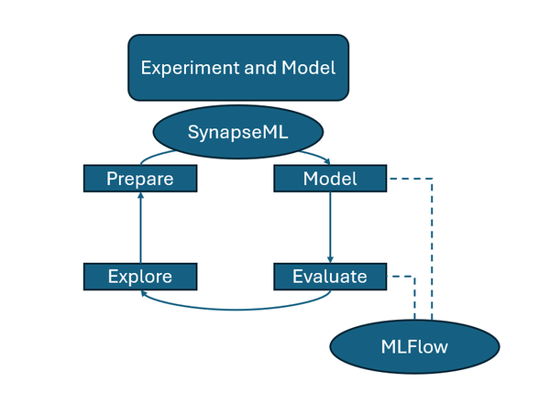

Figure 7-2. MLFlow and SynapseML used in synergy for ML workloads

The most commonly used component of MLFlow is *tracking*. It allows tracking of machine learning models - information such as parameters, metrics, and artifacts. The only thing you need to do is import the **mlflow** library and start logging.

import mlflow

#Define experiment name

EXPERIMENT_NAME = "customer-churn-experiment" # MLflow experiment name

As a prerequisite, an *experiment* must be created. Each time you train the model, it’s tracked as an experiment run.

Besides experiment tracking, MLFlow provides additional features for enhancing data science workloads in Microsoft Fabric. For example, you may leverage a model registry, a centralized model repository that allows storing and versioning of machine learning models, thus making it easier to manage model lifecycle and deployments.

MLFlow also supports packaging models into a format that can be deployed across multiple platforms. It also enables model deployment by using REST APIs.

Due to its versatility, MLFlow can be implemented in dozens of real-life scenarios. Let’s examine a few of them.

**Experimentation tracking for sales forecasting**

A global retailer company plans to create a machine learning model to forecast future sales based on historical data, but also include additional factors, such as promotions, holidays, and weather. The company’s data science team leverages different algorithms and applies various hyperparameters to tune the model. By using MLFlow’s experiment tracking capabilities, they log each run, record parameters, metrics, and model artifacts. After running 50 different experiments with different hyperparameters, the data science team can easily review logs in MLFlow, visualize performance metrics, and finally choose the optimal model configuration.

**Deploying models as REST APIs to support non-technical teams**

Similarly, a telecommunication company creates a machine learning model to predict customer churn. After they trained the model, MLFlow is used to package and deploy the model into the production environment as a REST API on Microsoft Fabric. This allows non-technical teams, such as marketing and customer service teams, to access the API in real-time, assign scores to customers, and predict which customers are likely to leave. Hence, non-technical users can integrate churn prediction analysis without needing to understand the underlying machine learning model.

**Managing model versions**

A large logistics company relies on a machine learning model to predict demand for their transportation services. However, ever-changing market conditions require constant updates and retraining of the model. MLFlow’s model registry feature allows easy version control, keeping track of which model version is in production and which model version is in development. This enables the data science team to register multiple versions of their demand forecasting model in MLFlow. Then, for example, they can mark version 1.0 as a production version, while at the same time experimenting with the 1.1 version. This way, the data science team ensures that the production environment always runs the most reliable model.

SynapseML

Data scientists and developers may leverage SynapseML to build complex machine learning pipelines at scale, making it ideal for enterprises dealing with large datasets and diverse machine learning (ML) requirements.

In a nutshell, SynapseML is an open-source library built on top of Apache Spark and integrated into the Microsoft Fabric platform. It’s best for dealing with big data scenarios because it enables data scientists to perform myriad of tasks, such as distributed training, or deep learning, as well as integration with widely adopted machine learning frameworks like PyTorch, TensorFlow, and ONNX.

Since SynapseML supports various programming languages, such as Python, Scala, and Java, it is a suitable choice for different types of data scientists. Hence, data scientists can use pre-built machine learning models to perform tasks like text processing, anomaly detection, and image recognition. Finally, SynapseML integrates perfectly with other Microsoft services, such as Azure Cognitive Services, enabling data scientists and developers to integrate various AI features, like translation, computer vision, and many more, in their applications.

There is a wide range of use cases for SynapseML. Here, we want to single out a few of these:

*Sentiment Analysis for social media data*

Social media posts generate a vast amount of data. Let’s imagine that the marketing team wants to analyze customer sentiment from this data. They can leverage SynapseML to load a large dataset that contains social media posts data into Spark, perform various text processing operations, and use pre-trained models to classify sentiment as either positive, negative, or neutral. The best thing is that SynapseML supports parallelism, so different developers may process the data in parallel.

*Anomaly detection of IoT data*

Real-time sensors from IoT devices are another huge producer of data. Let’s say that a manufacturing company collects this data and needs to process it. Using SynapseML’s anomaly detection capabilities, data scientists may process vast amounts of data in a Spark cluster, and identify unusual patterns or, even more importantly, potential equipment failures. This helps implement predictive maintenance scenarios, and reduce downtime and repair costs.

*Speech-to-Text for call center analytics*

Nowadays, almost every company relies on the efficient customer service department. Let’s imagine that a customer service department plans to transcribe and analyze recordings of phone calls, in order to improve customer satisfaction. They can integrate SynapseML with Azure Cognitive Services and use distributed processing to perform speech-to-text conversions on hundreds or even thousands of call recordings. These transcriptions can then be analyzed, keywords or customer sentiment can be searched for, and finally, actionable insights can be provided to enhance the service quality.

*Image recognition*

SynapseML can also be used to create an image recognition model that inspects products and flags in case of any defects. By labeling images of both defective and non-defective products within the dataset, SynapseML can train a machine learning model on Spark and automate the detection process, providing high-quality outputs with minimal manual intervention.

*Recommendation system for E-commerce business*

Building a recommendation system is probably a key requirement for any online retailer company. Data scientists in these companies can leverage SynapseML to build a robust recommendation system based on customer behavior and customer purchase history. In addition, SynapseML can apply advanced filtering techniques to recommend products, boosting sales and improving the customer experience.

AutoML

AutoML is a functionality that was introduced to automate machine learning model building in Microsoft Fabric and even be used by users without in-depth data science knowledge and skills. The system provided utilizes machine learning techniques to automatically choose algorithms, tune hyperparameters of the dataset, and generate a model based on the input dataset.

Let’s examine the key features of AutoML:

*Automated Model Selection*

Based on the provided data, AutoML applies an auto selection of the best-fit algorithm for that data.

*Feature Engineering*

AutoML can identify and transform relevant features from data, improving model performance.

*Hyperparameter Tuning*

AutoML will automatically optimize the tuning of model parameters to improve accuracy

*Model Explanation*

AutoML provides interpretable features that help users understand the factors leading to a prediction.

*Deployment and Management*

Users can deploy the generated models directly within Microsoft Fabric and manage them through the platform.

Data scientists may leverage AutoML in various real-life scenarios. Here are some of the most common use cases where AutoML can help build and training machine learning models:

*Customer Churn prediction*

An E-commerce business wants to predict which customer is going to get churned from their subscriptions or not, by taking into account some of the features like purchase history, engagement, and support interactions. By using AutoML in Microsoft Fabric, the company can present historical customer data and an ML model will be created automatically, able to detect repeatable patterns of churn. This is followed by being able to predict who those customers are so that a company can do something about it before they walk out the door.

*Demand Forecasting for Inventory Management*

An e-commerce platform needs to forecast product demand. AutoML on Microsoft Fabric takes historical sales data as input, and trains a time-series forecasting model. This model will enable predicting future sales trends, which will allow the company to optimize stock levels and minimize overstock or out of stock situations.

*Fraud Detection in Financial Transactions*

A financial institution has to recognize fraudulent transactions in real time. With AutoML, they can upload a transaction dataset that is already labeled as fraudulent or regular, based on historical data. AutoML goes in and evaluates the data, figures which classification algorithms have the best potential to accurately identify a fraudulent transaction, tunes them all together and spits out one single model that can be implemented to detect potentially suspected transactions automatically which helps significantly tightened security while reducing losses.

*Image Classification in Healthcare*

AutoML could be used to classify medical images, such as X-rays, MRIs, and similar, at a hospital for diagnostics. Once image datasets with labeling are uploaded, AutoML can automatically create and optimize a deep learning model to detect anomalies such as tumors, enabling medical professionals to make a faster and more accurate diagnosis.

Semantic Link

Since Microsoft Fabric was publicly unveiled in May 2023, there has been an ocean of announcements around this new platform. In full honesty, plenty of those were just a marketing or rebranding of the features and services that already existed before Fabric. Hence, in this ocean of announcements, some features went under the radar, with their true power still somehow hidden behind the glamour of those “noisy neighbors”.

Semantic Link is probably one of the best examples of these hidden Fabric gems.

**Tip**

Despite all of the aforementioned data science and machine learning tools and features, we sincerely consider Semantic Link as one of the most revolutionary features in the entire Microsoft Fabric realm, because it opens a whole new world of possibilities when creating a unified view of data across multiple disparate sources

If you take a look at the official documentation at [*https://learn.microsoft.com/en-us/fabric/data-science/semantic-link-overview*](https://learn.microsoft.com/en-us/fabric/data-science/semantic-link-overview), you’ll learn that “Semantic link is a feature that allows you to establish a connection between semantic models and Synapse Data Science in Microsoft Fabric”. Doesn’t sound too exciting, right?

But, what if we tell you that you can leverage this feature to optimize your Power BI semantic models quickly? Or to visualize all dependencies between tables, columns, and measures in the semantic model? How about running the DAX code from the Fabric notebook? These are only some of the Semantic Link use cases. And this is just for starters.

In this section, we’ll examine some handy implementations of the Semantic Link feature in real-life scenarios.

However, let’s first take a short ride through the evolution of collaborative work between a data scientist and a BI developer - if something like that had even existed in the past.

In Figure 7-3, you may notice how these two personas were totally isolated in the pre-Fabric era:

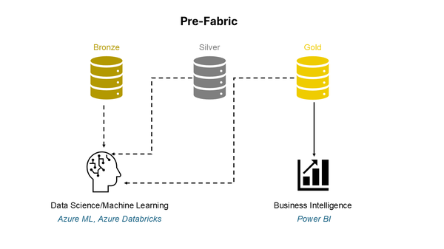

Figure 7-3. No integration between data science and BI workloads

As you’ve already learned in Chapter 1, Microsoft Fabric was introduced as an end-to-end analytics solution, where all data personas can seamlessly collaborate and access the “one copy” of the data stored in OneLake. Figure 7-4 depicts how Fabric provided a unified location for all data professionals in the form of the Fabric workspace:

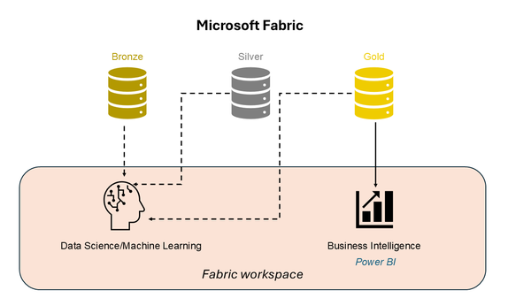

Figure 7-4. Fabric workspace as a unified container for various items

However, regardless of how big a step this was in the direction of unification, these workloads were still isolated and seen as separate solutions. There was no way of unifying data science workloads with BI reporting and vice versa. Well, not before Semantic Link entered the stage. Figure 7-5 shows how Semantic Link creates a bridge between data science and Business Intelligence by providing the possibility to leverage semantic model data in data science using a familiar set of tools: Notebooks, Python, and Spark, to name a few of the most popular.

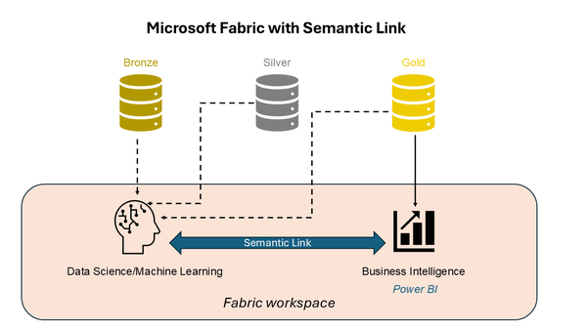

Figure 7-5. Semantic Link as a bridge between data science and

Semantic Link relies on a special Python library called **sempy**. This library enables connecting to any Power BI semantic model and accessing all the information about the model - including, but not limited to - relationships, measures, calculated columns, and many more.

What’s even more powerful, if the Read/Write for XMLA Endpoint in the Admin Portal is enabled, you can also apply changes to existing semantic models directly from the Fabric notebook! This opens a whole new world of possibilities, as previously, writing via XMLA Endpoint was an exclusive privilege of various external tools, such as Tabular Editor, VS Code, and similar.

Let’s now examine five real-life scenarios where Semantic Link may be used to enhance the development process.

**Tip**

Writing Python code is not something you would expect from every data professional. Hence, the credit for the ease of use of various Semantic Link implementations goes to **Michael Kovalsky**. Michael works at Microsoft, and he created and maintains an entire library called Semantic Link Labs: [*https://github.com/microsoft/semantic-link-labs*](https://github.com/microsoft/semantic-link-labs). This library extends the generic **sempy** library and consists of multiple ready-made functions you can use out-of-the-box to leverage Semantic Link feature in Microsoft Fabric

**Visualize dependencies in the semantic model**

How many times have you had to deal with monster semantic models - you know, those models consisting of tens or even hundreds of tables, with *spaghetti* relationships all over the place, and hundreds of measures and calculated columns implemented to enrich the model with additional business logic? Yes, I know, we’ve all been there.

Wouldn’t it be great if we could somehow visualize all dependencies between various structures in the model?

Figure 7-6 illustrates a dependency tree of the FactInternetSales table from the sample Adventure Works database, which can be downloaded for free from the following link: [*https://learn.microsoft.com/en-us/sql/samples/adventureworks-install-configure*](https://learn.microsoft.com/en-us/sql/samples/adventureworks-install-configure)

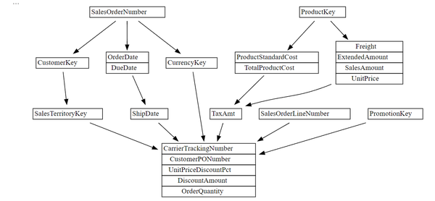

Figure 7-6. Visualizing model dependencies has never been easier with Semantic Link

I was able to plot the dependency tree by executing exactly six lines of Python code.

import sempy.fabric as fabric

from sempy.dependencies import plot_dependency_metadata

dataset = "S1"

sales = fabric.read_table(dataset, "aw_FactInternetSales")

dependencies = sales.find_dependencies()

plot_dependency_metadata(dependencies)

Similarly, I could have also visualized measure dependencies, as shown at the bottom of Figure 7-7:

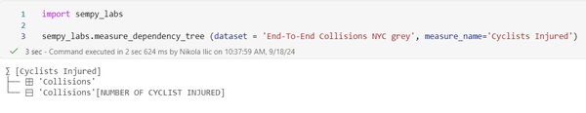

Figure 7-7. Visualizing measure dependencies

There are also plenty of other built-in functions that enable you to analyze and understand all the details of the semantic model, such as tables, columns, relationships, measures, calculation groups, Row-level, and Object-level security definitions, to name just a few.

**Optimize semantic models with Best Practice Analyzer rules**

For all of you who consider yourself a *professional* Power BI developer, Best Practice Analyzer (BPA) probably sounds familiar. In a nutshell, BPA scans the semantic model and flags all the issues found in the model. Think of finding the inappropriate usage of data types, bad practices in writing DAX code, and sub-optimal relationship types, all the way to alerting if the columns are missing descriptions. Based on the findings, you may decide to apply fixes to the model directly, or to ignore the warning simply.

Before Semantic Link, this task could have been performed exclusively by using the external tool Tabular Editor. Best Practice Analyzer is essentially the extension that one needs to install within Tabular Editor. With Semantic Link, the same outcome can be achieved directly from the Fabric notebook.

Figure 7-8 shows the result of the semantic model scan using the Best Practice Analyzer in the notebook:

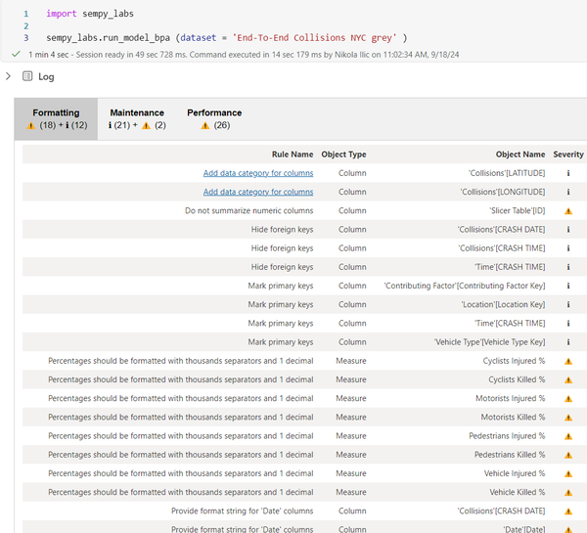

Figure 7-8. Best Practice Analyzer executed from the Fabric notebook

What’s even more powerful - and this is one of the huge advantages compared to the “old-fashioned” BPA in Tabular Editor - you can now run Best Practice Analyzer rules in bulk! This means, with a single line of code, you can scan all semantic models in a workspace. This was not possible before Semantic Link, because in Tabular Editor, BPA can scan one model at a time.

**Translate semantic models**

In real life, it’s common to have users speak different languages. This is especially relevant in enterprises doing their business in different countries, where each subsidiary prefers to have the data in their local language.

Let’s imagine that our company has a subsidiary in Italy, and users from Italy want to see the data in their language.

To achieve this fairly simple requirement, before Semantic Link, someone who is proficient in both, let’s say, English and Italian, had to stroll through the model and manually translate each object! There were also many workarounds introduced over time, but the sad truth was that translating model metadata was a tedious and daunting task.

With Semantic Link, it requires a single line of code. We know that this sounds *too-good-to-be-true*, so please take a look at Figure 7-9, which shows how the model objects were translated into Italian:

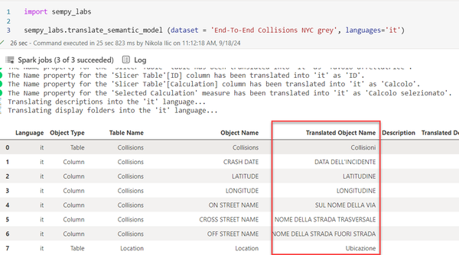

Figure 7-9. A single line of code to translate model objects to the desired language

The only thing you need to do is to provide the model name and the desired language. Semantic Link will take care of all the hard work in the background.

**Migrate existing semantic models to Direct Lake**

Microsoft Fabric introduced plenty of innovative solutions across the platform. One that particularly stands out is Direct Lake, a groundbreaking feature for Power BI semantic models. We cover Direct Lake in detail in Chapter 9.

Currently, most Power BI semantic models use either Import or DirectQuery storage mode, or are built as composite models. Don’t worry, we also cover all these options in depth in Chapter 9. However, chances are that with the expected growth in Fabric adoption, more and more Power BI semantic models will be using Direct Lake mode.

While creating a Direct Lake model from scratch is a fairly easy and straightforward process, the legitimate question would be: **what happens with the thousands of existing Import and DirectQuery models?** Do we need to recreate the entire model from zero, including establishing all relationships, recreating tens or hundreds of measures, and rebuilding hierarchies and calculation groups?

Fear not, Semantic Link again comes to the rescue! The entire process is documented here: [*https://github.com/microsoft/semantic-link-labs?tab=readme-ov-file#direct-lake-migration*](https://github.com/microsoft/semantic-link-labs?tab=readme-ov-file#direct-lake-migration)

By leveraging various Semantic Link Labs built-in functions, you can extract the entire model structure and business logic implemented into a model and recreate the model to use Direct Lake mode, without any manual intervention or need to rebuild from scratch. Not only that, but you can easily rebind all the existing reports to new Direct Lake models. Do I need to tell you how powerful it is? And, the best thing is that it’s feasible by running a single line of Python code:

import sempy_labs

sempy_labs.report.report_rebind_all (dataset = 'Current semantic model', new_dataset = 'New semantic model')

This will probably be one of the most common use cases for Semantic Link in the coming months, as many organizations seek the most convenient way to migrate their existing Import and DirectQuery models to Direct Lake.

**Augment the gold layer**

If we agree that the gold layer contains business-reporting-ready data, usually implemented as a Star schema data model, and all the necessary, verified business logic (calculations that are checked and verified by domain experts), the common scenario is to use a reporting tool of choice, such as Power BI, to consume the data from this gold layer.

In real life, we usually create data marts to support individual departments or business groups (i.e. Financials, Marketing, HR), so we end up having multiple reports - for example, Sales, Forecast, Customer Retention, etc. - each connecting to a particular semantic model. Now, imagine the following scenario: you get the requirement from a user, and let’s pretend that it’s a very important user, like a CFO, for example, who needs to have both sales and forecast data at their disposal. We can either create a dashboard and pin visuals from both reports, or design another semantic model Sales+forecast to combine information from the existing models. Let’s now discard the “dashboard option” and focus on the option to merge info from multiple semantic models.

At first glance, this might look like a trivial task – grab tables from here and there, and there you go. But, let’s stop for a moment and consider the following:

* This approach requires the serious involvement of someone responsible for creating semantic models. This means, there is a dependency on the availability of these individuals
* What about the calculations that were already verified and are part of the existing semantic models? If we create a new semantic model by simply combining tables from the existing ones, calculations need to be defined from scratch. That is fine if you have just a few of them…But, what if your semantic model contains hundreds of calculations?

In this case, we want to focus on the following scenario: let’s imagine that you have an existing semantic model with a 1 billion rows fact table on a day level of granularity. The semantic model contains 100+ verified calculations. Now, a small group of users needs to analyze the data on a monthly level (budgeting, forecasting, etc.). To satisfy this requirement, you have a few options at your disposal:

*Extend the existing semantic model*

Extend the existing semantic model with the aggregated table on a monthly level—this approach may work very well until the queries hit your aggregated tables. If not, performance will probably suffer. In addition, someone needs to create those aggregated tables, add them to a semantic model, establish relationships, set the proper storage mode for each table, and finally manage aggregations from Power BI

*Create a new semantic model*

Create a new semantic model with a fact table on a monthly level – the performance of this model should definitely be better than the previous one, but what happens with 100+ calculations? Yes, you’re right, you would have to re-create them in the new semantic model

*Augment the existing data model*

Augment the existing data model by leveraging the Semantic Link – this would be a mix of the previous two approaches: you’ll create a new semantic model, assuming that we store the SQL query results in the Delta table, but this semantic model may also include 100+ verified calculations available out-of-the-box

When run from a Fabric notebook, the following query will change the granularity - we are moving from the individual date to the year/month level - while keeping the existing measures available.

%%sql

SELECT

YEAR(`Dates[Date]`) as _Year

, MONTH(`Dates[Date]`) as _Month

, CAST(SUM(`Sales Amt`) AS DECIMAL (18,2)) as SalesAmt

, CAST(SUM(`Sales Qty`) AS DECIMAL (18,2)) as SalesQty

FROM pbi.`S1`.`_Metrics`

GROUP BY YEAR(`Dates[Date]`)

, MONTH(`Dates[Date]`)

**Tip**

Being able to do something doesn’t necessarily mean that you SHOULD do it. Leveraging Semantic Link for the purpose of creating a new semantic model as a combination of multiple existing semantic models, although it looks very handy, is far from the best practice, and it should definitely not be your default choice. However, it’s good to have the possibility to choose between different options and, based on the specific scenario, decide which one works in the most efficient way in that particular use case.

Summary

Data scientists will definitely feel like first-class citizens in Microsoft Fabric. It comes as no surprise, because of the numerous capabilities that Fabric provides out of the box. MLFlow is the best example, as a built-in feature for managing the complete machine learning lifecycle. On a similar note, the SynapseML Spark library provides scalable machine learning tools, and users can easily streamline their predictions to Power BI. Let’s not forget AutoML, which automates the process of building machine learning models in Fabric.

All of these capabilities undoubtedly have their place in regular data science workloads. However, there is one special ingredient for data science in Microsoft Fabric. The Semantic Link feature is that “X factor”, something that gives a whole new dimension to the data science experience and opens an infinite number of use cases. We firmly believe that what was a missing link before, now with Semantic Link is gone, as this feature finally enables bridging the gap between data science and Business Intelligence.

--

Real time intelligence

Once upon a time, handling streaming data was considered an *avanguard* approach. Since the introduction of relational database management systems in the 1970s and traditional data warehousing systems in the late 1980s, all data workloads began and ended with the so-called *batch processing*. Batch processing relies on the concept of collecting numerous tasks in a group (or batch) and processing these tasks in a single operation.

On the flip side, there is a concept of *streaming data*. Although streaming data is still sometimes considered a cutting-edge technology, it already has a solid history. The roots of streaming data processing go as far as 2002, when Stanford University researchers published the paper called “[Models and Issues in Data Stream Systems”](https://dl.acm.org/doi/10.1145/543613.543615). However, it wasn’t until almost one decade later (2011) that streaming data systems started to reach a wider audience, when the **Apache Kafka** platform for storing and processing streaming data was open-sourced. The rest is history, as people say. Nowadays, processing streaming data is not considered a luxury, but a necessity.

Microsoft recognized the growing need to process the data “*as soon as it arrives*”. Hence, Microsoft Fabric doesn’t disappoint in that regard, as Real-time Intelligence is at the core of the entire platform and offers a whole range of capabilities to handle streaming data efficiently.

Before we dive deep into explaining each component of Real-time Intelligence, let’s take one step back and take a more tool-agnostic approach to stream processing in general.

What is stream processing?

If you enter “what is stream processing” in Google Search, you’ll get more than 100,000 results! Therefore, we’re sharing an illustration in Figure 8-1, which represents *our* understanding of stream processing. We consider any high-frequent data flow as a source. The key ingredient of the streaming data systems is the nature of data processing, which occurs at the time the data is created. Various data destinations that may react immediately or store the data for later usage are the final pieces in this jigsaw.

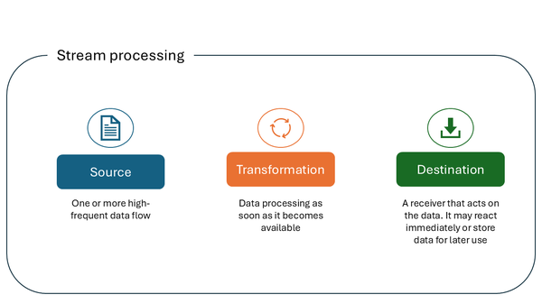

Figure 8-1. Stream processing key components

Let’s now examine typical use cases for stream processing. Each of the real-life scenarios listed below heavily relies on having the data processed as soon as it’s created in the source system:

* Fraud detection
* Real-time stock trades
* Customer activity
* Log monitoring - troubleshooting systems, devices, etc.
* Security information and event management - analyzing logs and real-time event data for monitoring and threat detection
* Warehouse inventory
* Ride share matching
* Machine learning and predictive analytics

As you may have noticed, streaming data has become an integral part of numerous real-life scenarios and is considered vastly superior to traditional batch processing for the aforementioned use cases.

Let’s now explore how streaming data processing is performed in Microsoft Fabric and which tools of trade we have at our disposal.

Figure 8-2 shows the high-level overview of all Real-time Intelligence components in Microsoft Fabric:

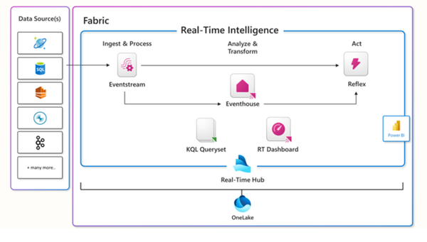

Figure 8-2. Real-time Intelligence in Microsoft Fabric

In the following sections, we will break down each of these components in more detail. For the starter, let’s introduce a 10.000-feet high overview of the entire workflow. We usually start by identifying data sources. Eventstream is then created to connect to the specified data source and ingest the streaming data into Fabric. Evenstreams can optionally be leveraged to transform the data on the fly, before sending transformed data to a destination. A destination can be both Activator’s Reflex item, which enables immediate action if the specified conditions are met, and Eventhouse, where we can store data for later usage. Once the data is stored in the Eventhouse, it can be consumed in numerous ways - for example, it may be queried by leveraging the KQL queryset item, or visualized by using either Real-Time Dashboards and/or Power BI reports.

Last but not least, please keep in mind that every Real-Time Intelligence item can be accessed and managed from a Real-Time Hub, which represents an integral part of OneLake as a central storage repository for all organizational data. We covered OneLake in depth in Chapter 3.

Real-Time hub

Let’s kick it off by introducing a Real-Time hub. Every Microsoft Fabric tenant automatically provisions a Real-Time hub. This is a focal point for all *data-in-motion* across the entire organization. Similar to OneLake, there can be one, and only one, Real-Time hub per tenant - this means, you can’t provision or create multiple Real-Time hubs.

The main purpose of the Real-Time hub is to enable quick and easy discovery, ingestion, managing, and consuming streaming data from a wide range of sources. Figure 8-3 shows the overview of all the data streams in the Real-Time hub in Microsoft Fabric:

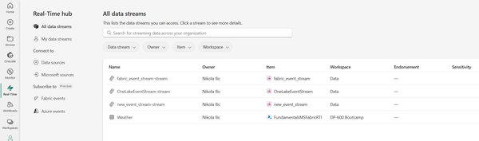

Figure 8-3. Real-time hub in Microsoft Fabric

Let’s now explore all the available options in the Real-Time hub.

*All data streams*

The *All data streams* tab displays all the streams and tables you can access. Streams represent the output from Fabric eventstreams, whereas tables come from KQL databases. We will explore both evenstreams and KQL databases in more detail in the following sections of this chapter

*My data streams*

The *My data streams* tab shows all the streams you brought into Microsoft Fabric into My workspace

*Data sources*

The*Data sources* tab is at the core of bringing the data into Fabric, both from inside and outside. Once you find yourself in the Data sources tab, you can choose between numerous, out-of-the-box provided connectors, such as Kafka, CDC streams for various database systems, external cloud solutions like AWS and GCP, and many more. Figure 8-4 shows a fraction of the available connectors in the Data sources tab:

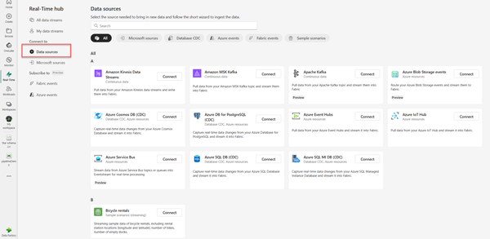

Figure 8-4. Connectors in the Data sources tab in the Real-Time hub

*Microsoft sources*

The *Microsoft sources* tab filters out the previous set of sources to include Microsoft data sources only.

*Fabric events*

The *Fabric events* tab displays the list of system events generated in Microsoft Fabric that you can access. Here, you may choose between Job events, OneLake events, and Workspace item events. Let’s dive into each of these three options:

* Job events are events produced by status changes on Fabric monitor activities, such as job created, succeeded, or failed
* OneLake events represent events produced by actions on files and folders in OneLake, such as file created, deleted, or renamed
* Workspace item events are produced by actions on workspace items, such as item created, deleted, or renamed

*Azure events*

The *Azure events*tab shows the list of system events generated in Azure blob storage.

Real-Time hub provides various connectors for ingesting the data into Microsoft Fabric. It also enables the creation of streams for all of the supported sources. After the stream is created, you can process, analyze, and act on them.

* *Processing* a stream allows you to apply numerous transformations, such as aggregate, filter, union, and many more. The goal is to transform the data before you send the output to supported destinations
* *Analyzing* a stream enables you to add a KQL database as a destination of the stream, and then open the KQL Database and execute queries against the database.
* *Acting* on streams assumes setting the alerts based on conditions and specifying actions to be taken when certain conditions are met

Eventstreams

If you’re a low-code or no-code data professional and you need to handle streaming data, you’ll love Eventstreams. In a nutshell, Eventstream allows you to connect to numerous data sources, which we examined in the Real-Time Hub section, optionally apply various data transformation steps, and finally output results into one or more destinations. Figure 8-5 illustrates a common workflow for ingesting streaming data into three different destinations - Eventhouse, Lakehouse, and Activator. Eventhouse and Activator are core components of the Real-Time Intelligence workload in Fabric. Hence, we cover them in more detail in the following sections of this chapter. A Lakehouse, similar to Eventhouse, may be used for storing unstructured, semi-structured, and structured data in OneLake, but it belongs to a Data Engineering workload. We provide a thorough overview of the lakehouse and Data Engineering workload in Chapter 5.

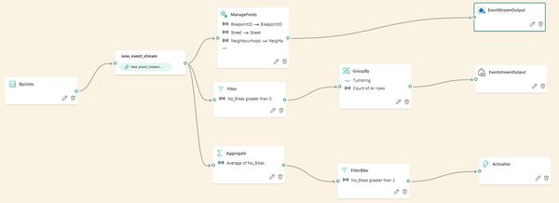

Figure 8-5. Common workflow for ingesting data with Evenstream

Within the Eventstream settings, you can adjust the retention period for the incoming data. By default, the data is retained for one day, and events are automatically removed when the retention period expires.

Aside from that, you may also want to fine-tune the event throughput for incoming and outgoing events, as displayed in Figure 8-6. There are three options to choose from:

* **Low**: < 1 MB/s
* **Medium**: 1-50 MB/s
* **High**: > 100 MB/s

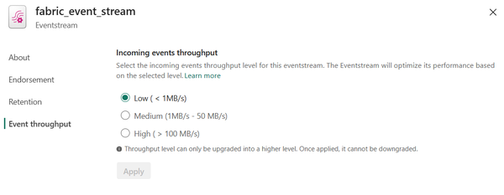

Figure 8-6. Configuring Event throughput in the eventstream settings

In the Endorsement tab of the Eventstream settings, you can label the eventstream as Promoted or Certified, which signals that the eventstream is recommended for others to use (Promoted) or considered as a trusted source (Certified), as shown in Figure 8-7:

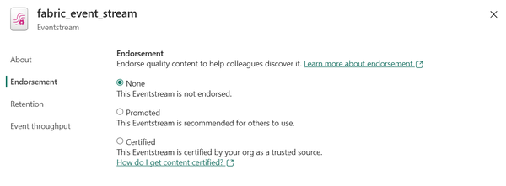

Figure 8-7. Configuring Endorsement in the eventstream settings

Evenstreams can be easily activated and deactivated. This can be done on two different levels:

* **Deactivate/Activate All** - this will pause/resume all the activities in the eventstream
* **Deactivate/Activate Toggle Switch Button** on a particular eventstream node

You may choose to deactivate eventstreams to reduce the capacity consumption.

Eventhouse and KQL database

In the Eventstreams section, you’ve learned how to connect to various streaming data sources, optionally transform the data, and finally load it into the final destination. As you might have noticed, one of the available destinations is the Eventhouse. In this section, we’ll explore Microsoft Fabric items used to store the data within the Real-Time Intelligence workload.

**Eventhouse**

We’ll first introduce the Eventhouse item. The Eventhouse is nothing else but a container for KQL databases. Eventhouse itself does not store any data - it simply provides the infrastructure within the Fabric workspace for dealing with streaming data. Figure 8-6 displays the System overview page of the Eventhouse:

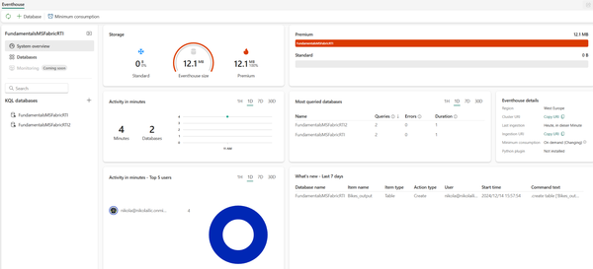

Figure 8-8. System overview page of the Fabric Eventhouse

The great thing about the System overview page is that it provides all the key information at a glance. Hence, you can immediately understand the running state of the eventhouse, OneLake storage usage, further broken down per individual KQL database level, compute usage, most active databases and users, and recent events.

If we switch to the Databases page, we will be able to see a high-level overview of KQL databases that are part of the existing Eventhouse, as shown in Figure 8-7:

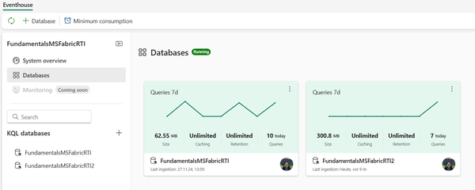

Figure 8-9. Databases page shows all KQL databases in the Eventhouse

You can create multiple eventhouses in a single Fabric workspace. Also, a single eventhouse may contain one or more KQL databases, similar to the illustration in Figure 8-8:

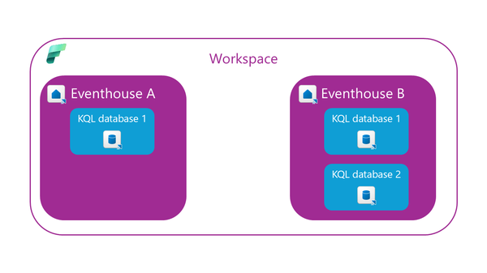

Figure 8-10. One Eventhouse may contain one or more KQL databases

Let’s wrap up the story about the Eventhouse by explaining the concept of **Minimum consumption**. By design, the Eventhouse is optimized to auto-suspend services when not in use. Therefore, when these services are reactivated, it might take some time for the Eventhouse to be fully available again. However, there are certain business scenarios in which this latency is not acceptable. Think of real-time stock trading or credit card fraud detection, where every second matters. In those scenarios, make sure to configure the Minimum consumption feature.

By configuring the Minimum consumption, the service is always available, but you are in charge of determining the minimum level, which is then available for KQL databases inside the Eventhouse. In Table 8-1, you may observe the options for configuring the [Minimum consumption](https://learn.microsoft.com/en-us/fabric/real-time-intelligence/eventhouse#minimum-consumption):

| **Minimum consumption level** | **Minimum CUs** | **SSD capacity of free storage (in GBs)** |
| --- | --- | --- |
| XXS (Extra extra small) | 4.25 | 20 |
| XS (Extra small) | 8.5 | 200 |
| S (Small) | 13 | 800 |
| M (Medium) | 18 | 3500-4000 |
| L (Large) | 26 | 5250-6000 |
| XL (Extra large) | 34 | 7000-8000 |
| XXL (Extra extra large) | 50 | 10500-12000 |
| Table 8-1. Table 8-1 Minimum consumption options in Fabric Eventhouse | | |

**Tip**

If you choose to go this route and configure the minimum consumption on your own, you’ll always pay for the selected minimum compute level, unless you go above the specified minimum consumption level. In that case, you’ll pay for the actual consumption. This may have an impact on your decision about Fabric capacity size, since the XXS level, for example, won’t work below F8 capacity.

**KQL database**

Now that you’ve learned about the Eventhouse container, let’s focus on examining the core item for storing real-time analytics data - the KQL database.

Let’s take one step back and explain the name of the item first. While most data professionals have *at least heard* about SQL (which stands for Structured Query Language), we are quite confident that KQL is way more cryptic than its “structured” relative.

You might have rightly assumed that QL in the abbreviation stands for Query Language. But, what does this letter K represent? It’s an abbreviation for *Kusto*. We hear you, we hear you: what is now Kusto?! Although the urban legend says that the language was named after the famous polymath and oceanographer Jacques Custeau (his last name is pronounced “*Kusto*”), we couldn’t find any official confirmation from Microsoft to confirm this story. What is definitely known is that it was [the internal project name for the Log Analytics Query Language](https://techcommunity.microsoft.com/discussions/azureobservability/what-is-name-of-azure-log-analytics-query-language-/173912).

When we talk about history, let’s share some more history lessons. If you ever worked with Azure Data Explorer (ADX) in the past, you are in luck. KQL database in Microsoft Fabric is the official successor of ADX. Similar to many other Azure data services that were rebuilt and integrated into SaaS-fied nature of Fabric, ADX provided platform for storing and querying real-time analytics data for KQL databases. The engine and core capabilities of the KQL database are the same as in Azure Data Explorer - the key difference is the management behavior: Azure Data Explorer represents a PaaS (Platform-as-a-Service), whereas KQL database is a SaaS (Software-as-a-Service) solution.

Although you may store any data in KQL database (non-structured, semi-structured, and structured), its main purpose is handling telemetry, logs, events, traces, and time series data. Under the hood, the engine leverages optimized storage formats, automatic indexing and partitioning, and advanced data statistics for efficient query planning.

**Tip**

You might be wondering what the differences between the Lakehouse (covered in Chapter 5), Warehouse (covered in Chapter 6), and the Eventhouse are, and when it would make sense to choose each of these items. Don’t worry. We cover the key use cases and implementation scenarios in Chapter 15: **When to Choose What**?

Let’s now examine how to leverage the KQL database in Microsoft Fabric to store and query real-time analytics data. Creating a database is as straightforward as it could be. Figure 8-9 illustrates the 2-step process of creating a KQL database in Fabric:

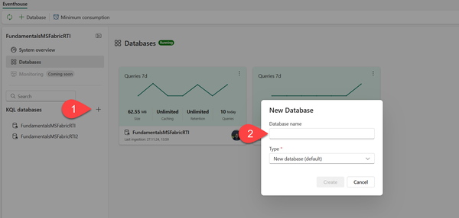

Figure 8-11. Two-step process of creating a KQL database

1. Click on the “+” sign next to KQL databases
2. Provide the database name and choose its type. Type can be the default new database, or a shortcut database. Shortcut database is a reference to a different database that can be either another KQL database in Real-Time Intelligence in Microsoft Fabric, or an Azure Data Explorer database

**Tip**

Don’t mix the concept of OneLake shortcuts we introduced in Chapter 3 with the concept of shortcut database type in Real-Time Intelligence! While the latter simply references the entire KQL/Azure Data Explorer database, OneLake shortcuts allow the use of the data stored in Delta tables across other OneLake workloads, such as lakehouses and/or warehouses, or even external data sources (ADLS Gen2, Amazon S3, Dataverse, Google Cloud Storage, to name a few). This data can then be accessed from KQL databases by using the **external_table()** function

Let’s now take a quick tour of the key features of the KQL database from the user-interface perspective. Figure 8-10 illustrates the main points of interest:

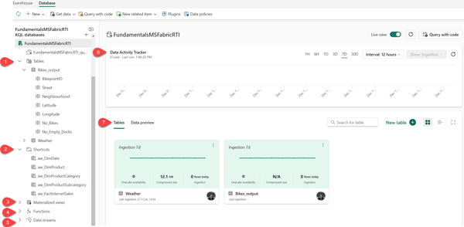

Figure 8-12. Key features of the KQL database

1. **Tables** - displays all the tables in the database
2. **Shortcuts** - shows tables created as OneLake shortcuts
3. **Materialized views** - a materialized view represents the aggregation query over a source table or another materialized view. It consists of a single summarize statement
4. **Functions** - these are User-defined functions stored and managed on a database level, similar to tables. These functions are created by using the .create function command
5. **Data streams** - all streams that are relevant for the selected KQL database
6. **Data Activity Tracker** - shows the activity in the database for the selected time period
7. **Tables/Data preview** - enables switching between two different views. Tables displays the high-level overview of the database tables, whereas Data preview shows the top 100 records of the selected table

Query and visualize data in Real-Time Intelligence

Now that you’ve learned how to store real-time analytics data in Microsoft Fabric, it’s time to get our hands dirty and provide some business insight out of this data. In this section, we will focus on explaining various options for extracting useful information from the data stored in the KQL database.

Hence, in this section, we will introduce common KQL functions for data retrieval, and explore Real-time dashboards for visualizing the data.

**KQL queryset**

The KQL queryset is the fabric item used to run queries and view and customize results from various data sources. As soon as you create a new KQL database, the KQL queryset item will be provisioned out of the box. This is a default KQL queryset that is automatically connected to the KQL database under which it exists. The default KQL queryset doesn’t allow multiple connections.

On the flip side, when you create a custom KQL queryset item, you can connect it to multiple data sources, as shown in Figure 8-11:

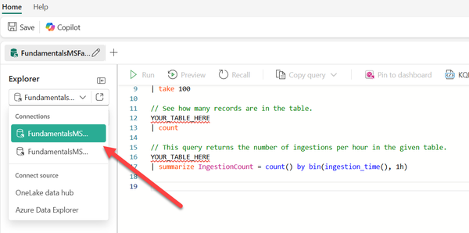

Figure 8-13. Creating multiple connections for the custom KQL queryset

Let’s now introduce the building blocks of the KQL and examine some of the most commonly used operators and functions. KQL is a fairly simple yet powerful language. To some extent, it’s very similar to SQL, especially in terms of using schema entities that are organized in hierarchies, such as databases, tables, and columns.

The most common type of KQL query statement is a**tabular expression** statement. This means that both query input and output consist of tables or tabular datasets. Operators in a tabular statement are sequenced by the “|” (pipe) symbol. Data is flowing (is piped) from one operator to the next, as displayed in the following code snippet:

MyTable

| where StartTime between (datetime(2024-11-01) .. datetime(2024-12-01))

| where State == "Texas"

| count

**Tip**

The piping is sequential - the data is flowing from one operator to another - this means that the query operator order is important and may have an impact on both the output results and performance.

In the above code example, the data in MyTable is first filtered on the StartTime column, then filtered on the State column, and finally, the query returns a table containing a single column and single row, displaying the count of the filtered rows.

**“Do I need a KQL if I already know SQL?”**

The fair question at this point would be: what if I already know SQL? Do I need to learn another language just for the sake of querying real-time analytics data? The answer is as usual: *it depends.*

Luckily, we have good and great news to share here!

The good news is: you **CAN** write SQL statements to query the data stored in the KQL database. But, the fact that you *can* do something, doesn’t mean you *should*…By using SQL-only queries, you are missing the point, and limitting yourself from using many KQL-specific functions that are built to cope with real-time analytics queries in the most efficient way

The great news is: by leveraging the **explain** operator, you can “ask” Kusto to translate your SQL statement into an equivalent KQL statement, as displayed in Figure 8-12

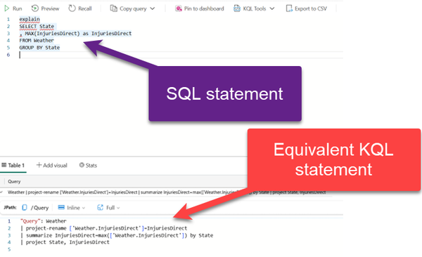

Figure 8-14. Using explain to “translate” SQL to KQL

In the following examples, we will query the sample Weather dataset, which contains data about weather storms and damages in the USA. Let’s start simple and then introduce some more complex queries. In the first example, we will count the number of records in the Weather table:

//Count records

Weather

| count

Wondering how to retrieve only a subset of records? You can use either *take* or *limit* operator:

//Sample data

Weather

| take 10

Please keep in mind that the *take* operator will not return the TOP n number of records, unless your data is sorted in the specific order. Normally, the take operator returns **any** n number of records from the table.

In the next step, we want to extend this query and return not only a subset of rows, but also a subset of columns:

//Sample data from a subset of columns

Weather

| take 10

| project State, EventType, DamageProperty

The **project** operator is the equivalent of the SELECT statement in SQL. It specifies which columns should be included in the result set.

In the following example, we are creating a calculated column, Duration, that represents a duration between EndTime and StartTime values. In addition, we want to display only top 10 records sorted by the DamageProperty value in descending order:

//Create calculated columns

Weather

| where State == 'NEW YORK' and EventType == 'Winter Weather'

| top 10 by DamageProperty desc

| project StartTime, EndTime, Duration = EndTime - StartTime, DamageProperty

It’s the right moment to introduce the **summarize** operator. This operator produces a table that aggregates the content of the input table. Hence, the following statement will display the total number of records per each state, including only top 5 states:

//Use summarize operator

Weather

| summarize TotalRecords = count() by State

| top 5 by TotalRecords

Let’s expand on the previous code and visualize the data directly in the result set. I’ll add another line of KQL code to render results as a bar chart, as shown in [Figure 8-13](https://learning.oreilly.com/library/view/fundamentals-of-microsoft/9781098172916/ch08.html#ch08_figure_13_1738703162136719):

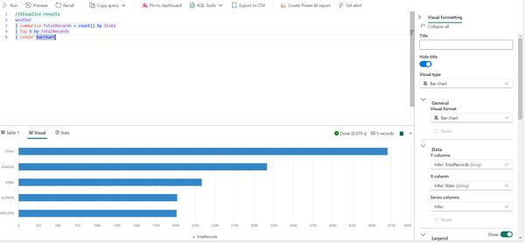

Figure 8-15. Visualizing query results in the query view

As you may notice, the chart can be additionally customized from the Visual formatting pane on the right-hand side, which provides even more flexibility when visualizing the data stored in the KQL database.

In some scenarios, you may need to perform a conditional count. It’s fairly simple to do this in KQL by using the **countif** function, like in the following example:

//Conditional count

Weather

| summarize StormsWithCropDamage = countif(DamageCrops > 0) by State

| top 10 by StormsWithCropDamage

Let’s wrap up KQL queryset examples by showing how to calculate the max number of injuries per state, renaming the column along the way:

//Max injuries per state

Weather

| project-rename ['Weather.InjuriesDirectRenamed']=InjuriesDirect

| summarize InjuriesDirectRenamed=max(['Weather.InjuriesDirectRenamed']) by State

| project State, InjuriesDirectRenamed

The first pipe leverages the **project-rename** operator to rename the column in the output result set. Then, we group the data by state and retrieve the maximum value of the renamed column for each state. Finally, the last pipe specifies that only State and InjuriesDirectRenamed columns should be included in the result set.

These were just basic examples of using KQL language to retrieve the data stored in the Eventhouse and KQL databases. We can assure you that KQL won’t let you down in more advanced use cases when you need to manipulate and retrieve real-time analytics data.

**Tip**

We understand that SQL is the “*Lingua franca*” of many data professionals. And although you can write SQL to retrieve the data from the KQL database, we strongly encourage you to refrain from doing this. As a quick reference, we are providing you with a “[**SQL to KQL cheat sheet**](https://learn.microsoft.com/en-us/kusto/query/sql-cheat-sheet?view=azure-data-explorer&preserve-view=true#sql-to-kusto-cheat-sheet)” to give you a head start when transitioning from SQL to KQL

**Real-time dashboards**

While KQL querysets represent a powerful way of exploring and querying data stored in Eventhouses and KQL databases, their visualization capabilities are pretty limited. Yes, you *can* visualize results in the query view, as you’ve seen in one of the previous examples, but this is more of a “first aid” visualization that won’t make your managers and business decision-makers happy.

Fortunately, there is an out-of-the-box solution in Real-Time Intelligence that supports advanced data visualization concepts and features. Real-Time Dashboard is a Fabric item that enables the creation of interactive and visually appealing business-reporting solutions.

Let’s first identify the core elements of the Real-Time Dashboard. A dashboard consists of one or more tiles, optionally structured and organized in pages, where each tile is populated by the underlying KQL query.

As a first step in the process of creating Real-Time Dashboards, this setting must be enabled in the Admin portal of your Fabric tenant, as displayed in Figure 8-14:

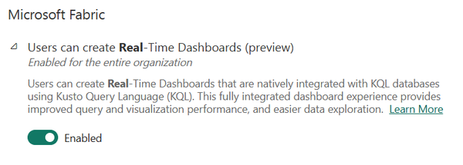

Figure 8-16. Admin portal: Enable setting for creating Real-Time Dashboards

Next, you should create a new Real-Time Dashboard item in the Fabric workspace. From there, let’s connect to our Weather dataset and configure our first dashboard tile. We’ll execute one of the queries from the previous section to retrieve the op 10 states with the conditional count function. Figure 8-15 shows the tile settings panel with numerous options to configure:

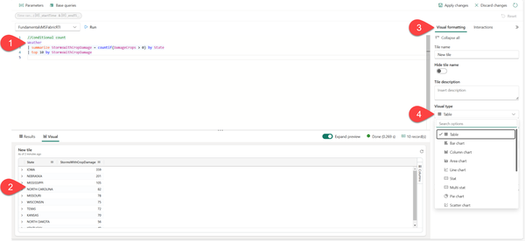

Figure 8-17. Configuration options for a tile in Real-Time Dashboard

1. KQL query to populate the tile
2. Visual representation of the data
3. Visual formatting pane with options to set the tile name and description
4. Visual type drop-down menu to select the desired visual type (in our case, it’s table visual)

Once you are happy with the tile look and settings, simply confirm changes by clicking on the Apply changes button in the top right corner of the screen. Let’s now add two more tiles to our dashboard. I’ll copy and paste two queries that we previously used - the first will retrieve the top 5 states per total number of records, whereas the other will display the damage property value change over time for the state of New York and for event type, which equals winter weather. Figure 8-16 displays the Real-Time Dashboard, which consists of three tiles:

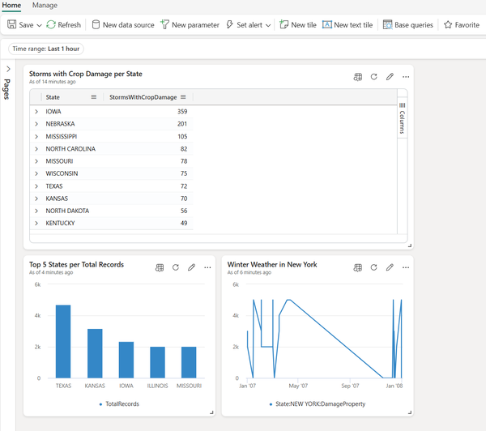

Figure 8-18. Real-Time Dashboard with three tiles

You can also add a tile directly from the KQL queryset to the existing dashboard, as illustrated in Figure 8-17:

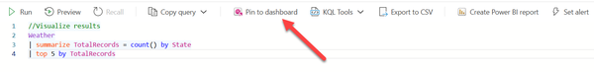

Figure 8-19. Pin query from the KQL queryset to the existing dashboard

Let’s now focus on the various capabilities you have when working with Real-Time Dashboards. In the top ribbon, you’ll find options to add a New data source, set a new parameter, and add base queries. However, what really makes Real-Time Dashboards powerful is the possibility to set alerts on a Real-Time Dashboard. Depending if the conditions defined in the alert are met, you can trigger a specific action, such as sending an email or Microsoft Teams message. An alert is created using the Activator item. We will briefly cover Activator in the next section, and in more detail in Chapter 10. Figure 8-18 illustrates how to configure the alert on a Real-Time Dashboard tile:

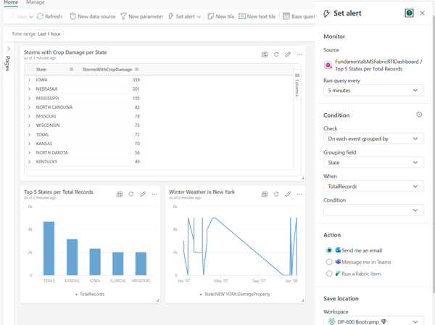

Figure 8-20. Setting the alert on a Real-Time Dashboard tile

You can additionally improve the dashboard performance by leveraging **parameters**. For example, you can parameterize the query and filter the data as early as possible. Hence, the dashboard will render faster. Another handy feature of Real-Time Dashboards is **auto refresh**. It enables you to set the automatic data update without the need to refresh the page manually. Auto refresh can be configured from the Manage tab in the top ribbon, as displayed in Figure 8-19:

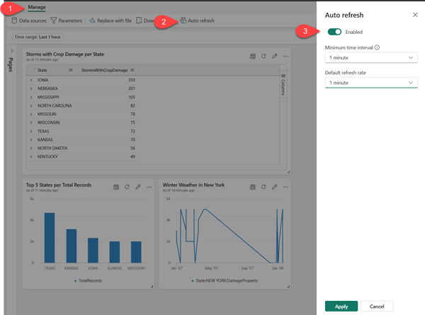

Figure 8-21. Configuring Auto refresh feature

To wrap up the story about Real-Time Dashboards, let’s examine the option to export the dashboard. Once you choose to export the dashboard, a new JSON file will be created, containing all the details about the dashboard. You may find this feature specifically useful in the following two scenarios:

* Dashboard template - the exported file can be used as a template for creating new dashboards
* Version control - the exported file can be used to restore the dashboard to a specific version

**Visualize data with Power BI**

Power BI is a mature and widely adopted tool for building robust, scalable, and interactive business reporting solutions. We cover Power BI in more depth in Chapter 9. In this section, we specifically focus on examining how Power BI works in synergy with the Real-Time Intelligence workload in Microsoft Fabric.

Creating a Power BI report based on the data stored in the KQL database couldn’t be easier. You can choose to create a Power BI report directly from the KQL queryset, as displayed in Figure 8-20:

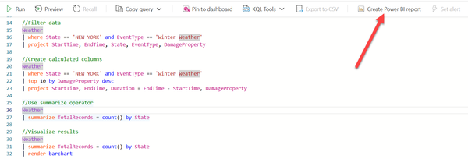

Figure 8-22. Creating a Power BI report directly from the KQL queryset

Each query in the KQL queryset represents a table in the Power BI semantic model. From here, you can build visualizations and leverage all the existing Power BI features to design an effective, visually appealing report.

Obviously, you can still leverage the “regular” Power BI workflow, which assumes connecting from the Power BI Desktop to a KQL database as a data source. In this case, you need to open a OneLake data hub and select KQL Databases as a data source, as illustrated in Figure 8-21:

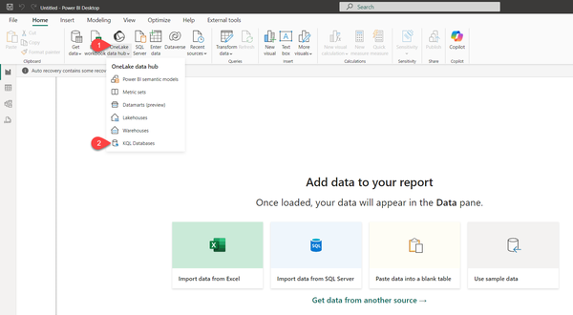

Figure 8-23. Creating a Power BI report by connecting from Power BI Desktop

The same as for SQL-based data sources, you can choose between the Import and DirectQuery storage modes for your real-time analytics data. Import mode creates a local copy of the data in Power BI’s database, whereas DirectQuery enables querying the KQL database in near-real-time.

Activator

Activator is one of the most innovative features in the entire Microsoft Fabric realm. Before you proceed with reading, here is a disclaimer: we cover Activator in detail in Chapter 10. Here, we just want to introduce this service and briefly emphasize its main characteristics.

Activator is a no-code solution for automatically taking actions when conditions in the underlying data are met. Activator can be used in conjunction with Eventstreams, Real-Time Dashboards, and Power BI reports. Once the data hits a certain threshold, the Activator automatically triggers the specified action - for example, sending the email or Microsoft Teams message, or even firing Power Automate flows. We cover all these scenarios in more depth in Chapter 10, where we also provide some practical scenarios for implementing the Activator item.

Summary

Real-Time Intelligence - something that started as a part of the “Synapse experience” in Microsoft Fabric, is now a separate, dedicated workload. That tells us a lot about Microsoft’s vision and roadmap for Real-Time Intelligence!

Don’t forget: initially, Real-Time Analytics was included under the Synapse umbrella, together with Data Engineering, Data Warehousing, and Data Science experiences. However, Microsoft thought that handling streaming data deserves a dedicated workload in Microsoft Fabric, which absolutely makes sense considering the growing need to deal with *data in motion*and provide insight from this data as soon as it is captured. In that sense, Microsoft Fabric provides a whole suite of powerful services, as the next generation of tools for processing, analyzing, and acting on data as it’s generated.

We are quite confident that the Real-Time Intelligence workload will become more and more significant in the future, considering the evolution of data sources and the increasing pace of data generation.

If you worked with Microsoft Power BI *before*Microsoft Fabric was announced, you might be (rightly) wondering – what’s all the fuss about? Nothing has really changed from the UI perspective and all of the features and functionalities are still available as they were in the pre-Fabric era (by the way, you’ll see us using this phrase multiple times throughout this chapter).

And, you are absolutely right! Fabric user interface was built on top of the existing Power BI Service UI. To be more precise, all the other experiences and workloads, such as Data Engineering, Data Warehouse, or Real-time Intelligence, which we already covered in chapters 5 to 8, were incorporated into the well-known Power BI experience. Hence, once you navigate to [https://app.fabric.microsoft.com/](https://app.fabric.microsoft.com/home) and choose Power BI from the home page, things will look quite familiar to anyone who has ever logged in to Microsoft Power BI Service.

Does this mean that Power BI remained the only unchanged island in the vast sea of innovations that Microsoft Fabric introduced? Absolutely not!

In this chapter, we will discuss how pre-Fabric Power BI workloads were integrated into the new ecosystem, as well as introduce brand-new concepts and features that Microsoft Fabric brought into the Power BI game. We’ll also bring some points to consider when planning your future analytics solutions and examine various scenarios for leveraging Power BI capabilities in the era of Microsoft Fabric.

Power BI Workloads in the Pre-Fabric Era

Dear reader, if you have never used Microsoft Power BI, don’t worry – we’ve got you covered! In this section, we are taking you on a 10.000-feet tour of Power BI and its main components so you can continue your Fabric journey well-equipped and feel more comfortable diving deeper into specific concepts and features of Power BI if necessary. We will also share some additional resources that we might consider useful for learning Power BI.

In a nutshell, Power BI represents a suite of tools and services for business reporting. The main mantra of Power BI is: *“5 minutes to WOW!”* To put it simply - there should be no longer than 5 minutes from the moment you connect to any of the various disparate data sources until you have nice-looking and visually appealing charts that provide insight from the underlying data. Of course, in reality, it’s usually more than 5 minutes, but the emphasis here is on the ease of use and pace of the development process.

We are not exaggerating if we say that Power BI has managed to live up to its promise. In the end, Gartner recognized Microsoft Power BI as an undisputed leader in Analytics and Business Intelligence Platforms “magic quadrant” for multiple years in a row. More details can be found here: <https://www.gartner.com/doc/reprints?id=1-2HVUGEM6&ct=240620&st=sb>

According to Gartner’s definition, a magic quadrant is a tool that provides a graphical competitive positioning of technology providers to help investors make smart investment decisions.

In the context of Fabric, we are talking about Microsoft Power BI as a mature and well-established product that democratized data analytics workloads. The level of Power BI adoption is already high, while the vibrant community of data professionals using Power BI ensures that the product gets more and more popularity over time.

To understand what has changed in Power BI workloads from a Fabric perspective, we first need to examine typical workflows in the pre-Fabric era.

Let’s kick it off with storage modes – in simple words – a storage mode determines how your data is stored in Power BI semantic models. There are three main options to choose from: Import, DirectQuery, and Dual. We will first introduce the Import mode, as a default storage mode in Power BI.

**Import mode for blazing-fast performance**

When using Import mode, once you connect to the data source(s), Power BI creates a local copy of the data and stores this local copy in the instance of a tabular Analysis Services model. From there, you can apply various transformations, such as replacing values, removing duplicates, adding new columns, to shape your data and implement additional business logic to enrich the existing data model. The important thing to keep in mind is that, since you are working with the local copy of the data, all the transformations and changes you’ve applied are relevant *only* to this local copy in the Analysis Services Tabular that Power BI uses for storing the data. Hence, you don’t need to worry that changes made to the Excel file stored in Power BI will be pushed back to the original Excel file stored on your local drive.

Once the data is stored in the Analysis Services Tabular, Power BI keeps it in the cache memory, in the columnar, in-memory database, called VertiPaq. As you may notice in [Figure 9-1](https://learning.oreilly.com/library/view/fundamentals-of-microsoft/9781098172916/ch09.html#fig_1_import_mode_workflow), all queries generated by the Power BI report will then retrieve the data from this in-memory storage, without even “knowing” about the “real” data source. In this scenario, the only data source is the instance of Analysis Services Tabular, and all the queries will refer to it for data retrieval.

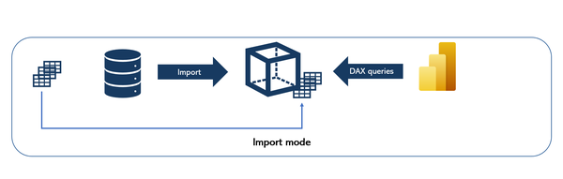

Figure 9-1. Import mode workflow

Since the data is stored in cache memory, the main advantage of using Import mode is the best possible performance of DAX queries. On the flip side, there are certain downsides when going the Import mode route. The most obvious one is *data duplication* because we are essentially creating a copy of the data from the data source in Power BI’s Tabular database, as well as *data latency*, which means that when you import the data from the original data source into Power BI, this is nothing else but the data snapshot *as of the moment* you imported it into Power BI.

Let us illustrate this: imagine that you’ve imported data from the Excel file stored on your local PC, on Monday at 9 AM. At that point in time, you had 1000 records in this Excel file. What happens if you insert another 100 records in the Excel file after Monday 9 AM? Well, Power BI doesn’t have an idea about that until you *refresh* the local copy of the data stored in Power BI. This means, that between Monday 9 AM and the next data refresh (let’s say on Tuesday 9 AM), Power BI will query and display the data as of Monday 9 AM.

To wrap up – Import mode provides the best possible experience from the performance point of view, but it also comes with two considerable shortcomings: data duplication and data latency.

**DirectQuery mode for real-time reporting**

DirectQuery mode solves these shortcomings of the Import mode.

As you can see in [Figure 9-2](https://learning.oreilly.com/library/view/fundamentals-of-microsoft/9781098172916/ch09.html#fig_2_directquery_workflow), there is no duplication, as no data is moved from the original data source into Power BI. Power BI stores metadata only and retrieves the necessary data directly from the source *at the query time*. This means that data resides in its original data source before, during, and after the query execution.

There is no latency, either. Since Power BI retrieves the data at the query time, whatever data is available at the source at the query time, will also be available in the Power BI report.

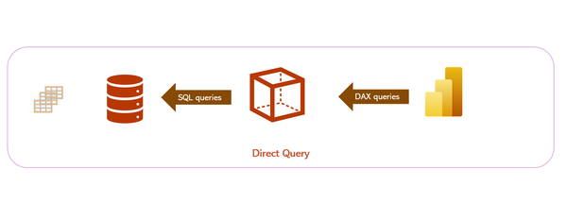

Figure 9-2. DirectQuery workflow

As you may notice in [Figure 9-2](https://learning.oreilly.com/library/view/fundamentals-of-microsoft/9781098172916/ch09.html#fig_2_directquery_workflow), all DAX queries generated by Power BI are simply translated on the fly into the SQL code and executed directly on the source database.

This is great, isn’t it?! No data duplication and no data latency, so why don’t we simply switch all our semantic models to DirectQuery? The answer is fairly simple: in most cases, the performance of DirectQuery semantic models is *significantly* worse than in Import mode. First of all, it highly depends on the data source performance capabilities, as well as network bandwidth and latency. Throw in the potential bottleneck of On-premises Gateway and we are talking about the performance degradation in the order of magnitude, which usually goes beyond 5x slower report over the same data compared to the Import mode.

Hence, choosing between Import and DirectQuery mode is usually a trade-off between the performance and real-time reporting requirements, as depicted in Table 9-1:

| **Storage mode** | **Advantages** | **Disadvantages** | **Use case** |
| --- | --- | --- | --- |
| Import | * Best possible performance * All DAX functions supported | * Data Latency * Data duplication | * Suitable for most scenarios |
| DirectQuery | * No data latency * No data duplication | * Significantly worse performance * Not all DAX functions supported * Data modeling limtations | * Real-time reporting requirements * Data size too large for Import mode |
| Table 9-1. *Import vs DirectQuery mode comparison* | | | |

Additionally, not all DAX functions are supported in the DirectQuery mode. Certain DAX functions can’t be “translated” to SQL language, thus preventing the usage of the DirectQuery storage mode.

Last but definitely not least, some data sources don’t support any querying language. Think of good, old Excel – there is no querying language for Excel files. Hence, your DAX queries can’t be translated into a language that Excel “understands”. As a consequence, you can’t use DirectQuery mode if your data source is an Excel file or any similar file type, such as CSV.

Truth be said, the choice might be more nuanced, as Power BI allows you to mix and match Import and DirectQuery modes in the form of the Composite model. A composite model enables using two or more connections to different source groups. As you may see in Figure 9-3, a source group is considered any individual DirectQuery source, such as SQL Server or Oracle, whereas all imported data is considered as one source group.

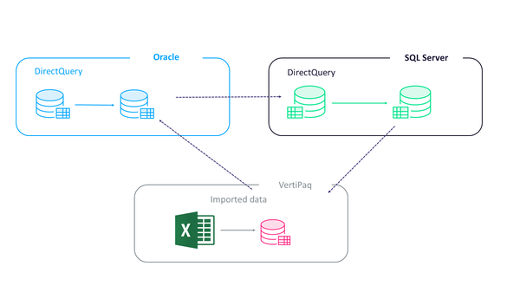

Figure 9-3. *Composite model in Power BI*

Although this “combo” may come in handy in various semantic model design scenarios, it still doesn’t resolve the individual shortcomings of each Import and DirectQuery mode.

There is also a third storage mode option, called Dual, which represents a hybrid version of Import and DirectQuery, and is widely used in Composite models to resolve constraints of limited relationships between tables in the semantic model. Explaining the shortcomings of limited relationships is outside the scope of this book.

Dual storage mode is commonly used for dimension tables in Composite models. In this case, Power BI keeps two copies of the same table – one in Import mode, and the other in DirectQuery – and, depending on if the queries retrieve the data from the Import mode or DirectQuery fact table, the “dual” table “behaves” the same as a fact table, ensuring that queries can take advantage of the regular relationships.

Power BI workloads in Microsoft Fabric

**Note**

All the storage modes we examined so far – Import, DirectQuery, and Dual – are here to stay, and they are all still relevant in the era of Microsoft Fabric.

In Chapter 1, you learned that Microsoft Fabric integrated many of the existing data services and solutions and unified them under one umbrella.

However, Fabric also introduced many brand-new concepts and features that may be considered as a “next step” in the ever-evolving ecosystem of modern data platforms.

**Understanding Direct Lake mode**

Direct Lake undoubtedly represents one of these features. The aim of Direct Lake is very straightforward – exploit the benefits and overcome the downsides of both Import and DirectQuery modes, which we examined in the previous section. We want the performance of the Import mode to match the “no data duplication and no data latency” of the DirectQuery mode. Sounds fairly simple, right? However, there is a whole range of resolutions and processes in the background to enable this “magic” to happen.

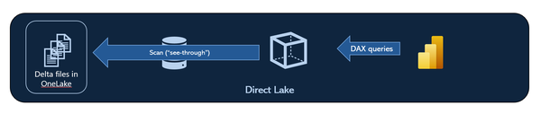

Figure 9-4. Direct Lake workflow

Let’s start with [Figure 9-4](https://learning.oreilly.com/library/view/fundamentals-of-microsoft/9781098172916/ch09.html#fig_3_direct_lake_workflow). As in the DirectQuery scenario, Power BI doesn’t store any physical copy of the data in the Analysis Services Tabular database, and all DAX queries will be executed directly against the files stored in OneLake, be it a Lakehouse and/or a Warehouse.

However, since the way the data is stored in Delta tables (in Parquet files, or as Microsoft prefers to call it Delta Parquet format) is very similar to the way it’s stored in the proprietary format of the Analysis Services Tabular (*.idf format), the engine is capable of transcoding the data from OneLake on the fly with minimal effort and overhead and store the data in memory, the same as in Import mode! Hence, we get the performance of the Import mode (or, let’s say, very close to Import mode), without creating another copy of the data and without needing to refresh our Power BI semantic model (although we’ll come soon to explain the concept of refresh in Direct Lake mode).

**Note**

Although you might see in Microsoft’s presentations that Direct Lake is labeled as a “perfect” solution because it takes the best characteristics of both Import and DirectQuery, we consider this as a too bold statement, and we’ll stick with a non-biased and less-marketing approach in our interpretation of Direct Lake.

**Prerequisites**

Before we dive deep into Direct Lake and examine how it works behind the scenes, let’s first understand the prerequisites for using Direct Lake.

First and most importantly, you need a Fabric capacity (F SKU).

Individual licenses, such as Premium-per-user, don’t support Direct Lake storage mode.

Then, you need a Lakehouse with the SQL Analytics Endpoint and/or a Warehouse in Microsoft Fabric.

Next, data must be stored in *delta tables*. Hence, if your data is stored in any format other than delta, such as Parquet, CSV, or JSON, Direct Lake cannot be used.

Finally, delta tables *should be* V-ordered. We are intentionally using the word “should,” as V-order is not a hard requirement for Direct Lake. This means that even though your delta tables are not V-ordered, Direct Lake could still work, but you might experience performance degradation in that case. We cover V-ordering in detail in chapter 16, “When to choose what”.

**Understanding the difference between the Default and a Custom semantic model**

Once you create a new lakehouse or warehouse item in the Fabric workspace, don’t be surprised when you see unexpected *neighbors* in the workspace. Each lakehouse comes with two additional companions: SQL analytics endpoint and a default semantic model, whereas creating a warehouse implies an automatic creation of the default semantic model as well.

This behavior might be quite baffling for someone who used to work with Power BI before Microsoft Fabric and who just embarked on their Fabric journey.

Let’s illustrate this with a real-life example: you are a Power BI developer in a retail company, and you’ve just created your nice-looking report in Power BI Desktop using the Import mode. You named your report *Sales Overview*. You hit the Publish button in Power BI Desktop and choose the workspace where you want your report to be published. If you navigate to the selected workspace, you should see two items with the same name - a report itself and a semantic model. A semantic model item contains the *real* data and other model definitions, including but not limited to relationships, hierarchies, calculated columns and measures, and so on. On the flip side, a report item contains report definitions, such as visuals, filters, report themes, and similar. Behind the scenes, these two items, the report, and semantic model, are tightly coupled and binded.

An important thing to keep in mind is that *the report can’t exist without a semantic model*, while the opposite is not valid. You *can* use a *Sales Overview* semantic model as a blueprint for multiple non-related reports by leveraging a Live connection feature. This feature provides a possibility to connect to already published Power BI semantic models (and other instances of Azure Analysis Services or SQL Server Analysis Services databases) and build a report on top of the existing semantic model. This report is called a *thin* report.

**Note**

You can try it yourself! Delete the report from the workspace, and you’ll see that the semantic model is still there. Inversely, try to delete a semantic model from the workspace, and you’ll notice that the report was also automatically removed. Be aware that if you’re trying this with real items, make sure to back up your semantic model before you delete it from the workspace.

Hence, there are no default vs custom semantic models in pre-Fabric world. However, for the sake of clarity, we’d like to emphasize that there is no item named *custom* semantic model - we are simply using this label to draw the line between a default semantic model and semantic models that are not created automatically when provisioning a new lakehouse or warehouse. Therefore, whenever you see the word *custom* next to the semantic model, be aware that we are referring to any semantic model that is not a default semantic model.

When you create a lakehouse or warehouse, if you stick with the default configuration settings, a default semantic model is just a shell - it doesn’t contain any objects. You can add objects to the default semantic model in two possible ways, as displayed in Figures 9-5 and 9-6. [Figure 9-5](https://learning.oreilly.com/library/view/fundamentals-of-microsoft/9781098172916/ch09.html#fig_4_manage_default_semantic_model_dialog_window) shows how to manually add objects by using the Manage default semantic model feature in the SQL analytics endpoint of the lakehouse, while Figure 9-6 leverages a property Sync the default Power BI semantic model as an option to automatically add new lakehouse objects to a default semantic model.

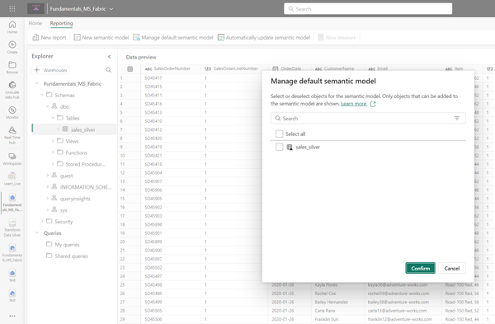

Figure 9-5. Manage default semantic model dialog window

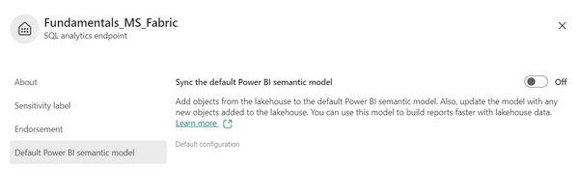

Figure 9-6. *Sync the default Power BI semantic model*

Bear in mind that this property is disabled by default - that means, any new tables you create in the lakehouse will *NOT BE* automatically included in the default semantic model. To include newly created objects in a default semantic model, you should either enable this property, or manually add tables, as shown in [Figure 9-5](https://learning.oreilly.com/library/view/fundamentals-of-microsoft/9781098172916/ch09.html#fig_4_manage_default_semantic_model_dialog_window).

**Note**

Enabling Sync the default Power BI semantic model property will cause permanent background traffic between the default semantic model and OneLake, which might incur additional OneLake consumption costs

While the default semantic model may be useful for some basic data exploration and ad hoc requests, we strongly encourage creating custom semantic models for enterprise-grade reporting and regular business use cases.

A custom semantic model should be your go-to choice since it provides a full set of functionalities and can be managed more flexibly than the default semantic model. This includes, but is not limited to, leveraging popular external tools, such as Tabular Editor, for managing and maintaining Direct Lake semantic models.

The fastest way to create a custom semantic model is to use web UI in the Power BI Service. As shown in Figure 9-7, you may simply choose the option New semantic model, which will initiate a similar workflow to the one described in [Figure 9-5](https://learning.oreilly.com/library/view/fundamentals-of-microsoft/9781098172916/ch09.html#fig_4_manage_default_semantic_model_dialog_window). However, this time, you must specify a name for your semantic model. In addition, you may choose to store the semantic model in a workspace different from the one where your lakehouse or warehouse resides. This is important in scenarios where the access to workspace items is defined through workspace roles, and you should differentiate between users who should have access to the lakehouse and SQL analytics endpoint objects versus access to the semantic model only.

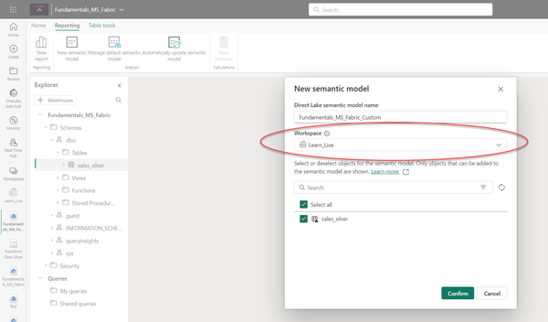

Figure 9-7. *Creating a custom semantic model, optionally in a different workspace*

Once you add objects to the semantic model, you can proceed with managing the model and enhancing it with relationships, DAX measures, Calculation groups, etc.

To conclude this topic, we summarize the key differences between the default and custom semantic models in Table 9-2.

|  | **Default semantic model** | **Custom semantic model** |
| --- | --- | --- |
| Automatically created | YES | NO |
| Can be managed with external tools | NO | YES |
| Can be stored in a different workspace than the lakehouse | NO | YES |
| Direct Lake as a default storage mode | YES | YES |
| Table 9-2. *Key differences between default and custom semantic models* | | |

**Direct Lake key concepts**

Now that we’ve introduced Direct Lake mode from a high-level perspective, it’s time to dig deeper and explain the various concepts behind this feature. Understanding these concepts will not only help you build scalable and efficient semantic models in Fabric, but also enable you to implement techniques to build more robust and performant analytics solutions.

**How does Direct Lake work?**

“Performance of the Import mode!” This is how Microsoft will *sell* you the Direct Lake feature. Hence, wondering how that could be possible would be a natural reaction. The answer is fairly simple, although the technical implementation is definitely not.

The key ingredient is the Delta Parquet format, which we examined in detail in Chapter 5. Simply said, data is stored within Delta Parquet files in a way *very similar* to that in the proprietary format of Power BI’s VertiPaq database.

In Figure 9-8, we are breaking down the entire workflow relevant to the query processing. Please keep in mind that this workflow doesn’t apply exclusively to Power BI, but also to other Microsoft Fabric workloads.

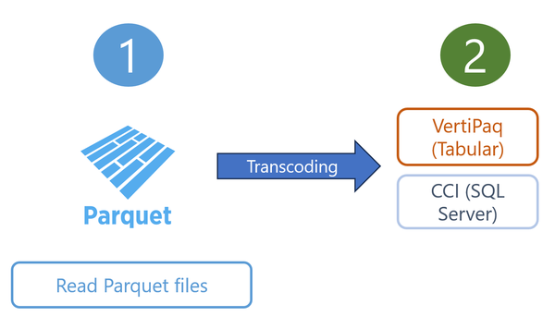

Figure 9-8. *Query processing workflow in Microsoft Fabric*

From a Direct Lake perspective, we are interested in both steps of the workflow.

Let’s explain this by using a real-life example. We have a Power BI report named *Sales Overview.* The report is created on top of the Direct Lake semantic model of the same name. Your manager opens the report and starts interacting with visuals. When the manager opens the report, initially, there is no data in the semantic model. Don’t forget that the physical data is stored in OneLake, which is based on the principle of “one copy for all data”, which we introduced in Chapter 3. Let’s assume that the report page contains a table with four columns: Calendar year, Product name, Total Revenue, and Total Sales Quantity. Once the report page opens, Power BI will load the data from OneLake *on demand* - meaning, Power BI will load only the columns needed by the report. During this data loading, the underlying data structures will be *transcoded*.

Transcoding is the process of translating data stored in Delta Parquet files into the VertiPaq native format. This process is not expensive in terms of time and resources. As we already learned, the way the data is stored in Delta Parquet files is quite similar to VertiPaq’s native format. Once the data is transcoded and loaded into VertiPaq, every subsequent report query that targets the same column(s) will be served from VertiPaq. This is of paramount importance because this is exactly the same *modus operandi* as in Import mode! Hence, “the performance of Import mode” proclaimed by Microsoft starts to make sense.

**Note**

When using Direct Lake, the first queries will take longer to execute because of the time needed for the transcoding process. Once the data is paged into memory (VertiPaq), from a technical point of view, there is no difference between Direct Lake and Import storage modes

**Direct Lake semantic model refresh (AKA “Framing”)**

One of the biggest points of confusion when discussing Direct Lake use cases is: How do we *refresh* a Direct Lake semantic model? This is a fair question, especially coming from Power BI professionals from the pre-Fabric era, who used to deal with regular and ad-hoc refreshes of their Import mode semantic models.

As a quick reminder, when you publish an Import mode semantic model to a workspace, you are just publishing a snapshot of the data at a certain point in time. Then, you need to ensure that the data is up to date with the data source, either by refreshing the semantic model on a scheduled plan (i.e. every 4 hours, every day, etc.) or by manually triggering the refresh process. Assuming that you didn’t implement an incremental refresh or applied custom partitioning of the tables in the semantic model, each table consists of a single partition that contains all the data. Hence, when you are refreshing a semantic model, all the rows and columns from each of the tables will be reloaded from the data source.

To illustrate, let’s imagine that you have a semantic model *Sales Overview*in Import mode, which consists of tables specified in Table 9-3:

| **Table name** | **Number of rows** | **Number of columns** | **Size in MB** |
| --- | --- | --- | --- |
| DimCustomer | 50,000 | 20 | 3 |
| DimProduct | 3,000 | 25 | 1 |
| DimDate | 7,000 | 20 | 2 |
| FactSales | 100,000,000 | 10 | 2000 |
| Table 9-3. *Example tables of the Sales Overview Import semantic model* | | | |

The following things happen when you initiate the refresh of the *Sales Overview* semantic model, which is approximately 2 GB in size:

* Power BI will keep a read-only replica of the model during the refresh process, so that users can continue using their reports during the refresh window
* This implies that you need approximately 4 GB of memory available during the refresh window - 2 GB for the semantic model you are currently refreshing, and 2 GB for the read-only replica
* If you haven’t configured an incremental refresh or applied custom partitioning of the tables, the entire table will be refreshed - in our case, this means that we need to load 100 million rows in our FactSales table each time we refresh the semantic model
* 100 million records of data will be *physically* stored in the FactSales table in the Power BI semantic model

Therefore, depending on data volumes and some other semantic model design decisions, refreshing Import mode semantic models may be an extremely costly operation, both in terms of time and resources needed to complete this operation.

The data refresh concept is totally different for Direct Lake semantic models. Since this is not a *real* data refresh, but a metadata refresh only, we will refer to the process of bringing the latest data into Direct Lake semantic models as *framing*.

**Note**

Don’t mix framing with syncing! As we’ve already explained in this chapter,*syncing* enables you to *add new tables to your semantic model*. *Framing*, on the other side, allows you to have *the latest version of the data in a particular table*.

However, to understand how framing works in reality, we first need to explain some of the intricacies of the data storage in Delta Parquet files. We’ll again use our *Sales Overview* model as an example. This time, we’ll focus on a table named DimCustomer. The DimCustomer table stores data about customers, including attributes such as first name, last name, email address, phone number, zip code, and more.

Here is the abbreviated view of Table 9-3, displaying data for a customer, Aaron Adams:

| **Customer Key** | **First Name** | **Last Name** | **Email Address** | **Phone** | **Zip Code** |
| --- | --- | --- | --- | --- | --- |
| 1 | Aaron | Adams | aaron48@adventure-works.com | 1-123-456 | 12345 |
| Table 9-4. *Abbreviated view of the DimCustomer table* | | | | | |

If you take a thorough look at Figure 9-9, you may notice that it consists of two parquet files. Additionally, you’ll spot an item called _*delta_*log, that enables tracking of all the changes that happened to the DimCustomer table:

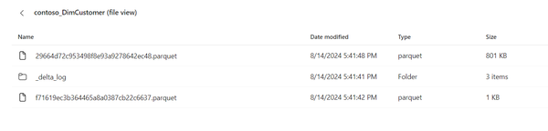

Figure 9-9. *DimCustomer table (file view) in OneLake*

If we open a _delta_log folder, we can spot a number of .json files inside. The number of files depends on how frequently the data changes in the specific table. This might sound weird at first glance, but let’s not forget that a table in OneLake is nothing else but a Parquet file or collection of Parquet . Parquet files are immutable - when we update a record in the file, the actual file doesn’t change to reflect the update. What happens is that a *new version* of the file will be created, and that new version will contain an updated record.

In [Figure 9-10](https://learning.oreilly.com/library/view/fundamentals-of-microsoft/9781098172916/ch09.html#fig_5_multiple_versions_of_the_dimcustomer_table_stored), you can see that our DimCustomer table _delta_log contains two versions of the file:

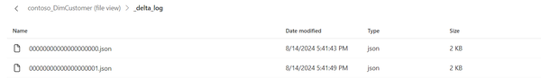

Figure 9-10. Multiple versions of the DimCustomer table stored in _delta_log folder

Finally, we created a custom semantic model with tables from the lakehouse and a very basic report that shows the information about the customer Aaron Adams, as shown in Figure 9-11:

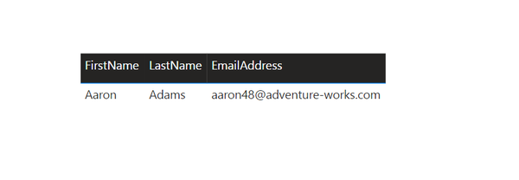

Figure 9-11. *Information about the customer displayed in Power BI report*

Let’s say that our customer Aaron Adams changed his email address from [**aaron48@adventure-works.com**](mailto:aaron1@adventure-works.com) to [**aaron49@adventure-works.com**](mailto:aaron2@adventure-works.com). In Figure 9-12, you may notice that a new file version ending with 002 has been added to the _delta_log:

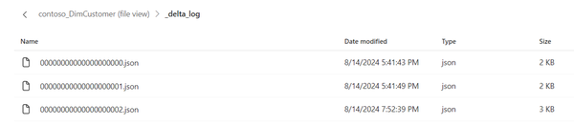

Figure 9-12. *New file version added to a _delta_log*

What happens now with the Power BI semantic model? Will this email address update be automatically reflected in our Sales Overview report? It depends!

If we stick with the default semantic model configuration settings, the answer is - YES. In Figure 9-13, you can see that the default behavior of the Refresh setting is to enable Power BI to detect changes to the underlying delta table and automatically update the Direct Lake semantic model:

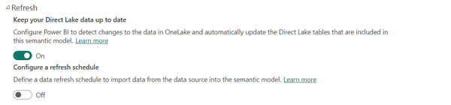

Figure 9-13. *Power BI will automatically update the semantic model to incorporate the latest data*

However, this might not be something that you want. Let’s say that you need to ensure that the Power BI semantic model is updated only *after all the underlying delta tables are processed*. Think of a scenario where you first process the fact table and then the DimCustomer table. With this setting enabled, as soon as you process a fact table, all changes will be reflected in the Power BI semantic model, whereas the DimCustomer table will still contain the previous version of the data. Hence, you might want to disable this option and implement a semantic model refresh as a stand-alone processing step once all data preparation tasks are completed.

Nevertheless, regardless of which option you choose, the refresh process itself is entirely different from that in Import mode semantic models. Unlike in Import mode models, where the physical data is stored in the model, in Direct Lake mode, only metadata is stored and refreshed.

Figure 9-14 illustrates what is considered part of the Direct Lake semantic model.

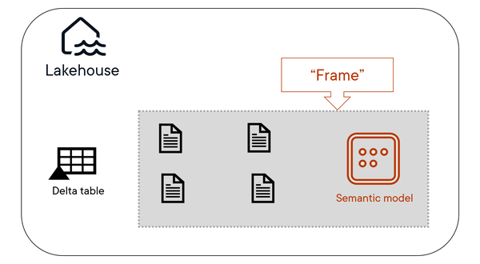

Figure 9-14. *Direct Lake model includes four existing files*

As you may see, there are four files currently *framed* in the context of the Direct Lake semantic model. Once the new file enters OneLake, like in our case when we updated a record in the DimCustomer table, this *frame* must be extended to incorporate the latest file version. Figure 9-15 shows the extended frame version, which includes the newly added file:

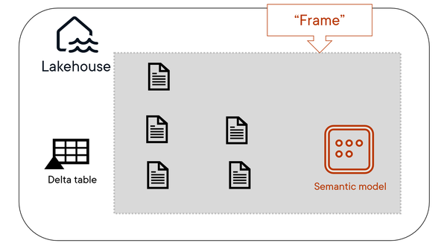

Figure 9-15. *Direct Lake model “reframed” to include newly added files*

The *reframing* process has multiple implications for the semantic model. First and foremost, whenever framing occurs, all the data currently stored in the memory, and we are referring to a cache memory, is dumped out from the cache. This is of paramount importance for the *paging* concept, that we are going to discuss in the next section of this chapter.

**Note**

Since the Direct Lake “refresh” is metadata-only refresh, it’s usually a low-intensive operation that shouldn’t consume too much time and resources. Even if you deal with a billion-row table, don’t forget - you are not refreshing billion rows of your data in the semantic model - you refresh only*the information* about that gigantic

table.

**Paging**

Now that we know how to synchronize the data from a lakehouse with the semantic model (*syncing*), and how to include the latest metadata in the semantic model (*framing*), it’s time to understand what really happens behind the scenes once you put your Direct Lake semantic models to action.

This is the selling point of the Direct Lake feature, right? Performance of the Import mode, but without copying the data.

**Note**

In plain English, paging represents a process of loading parts of the delta table or the entire delta table into cache memory.

When we say parts of the delta table, we are referring to particular columns of the table. Let us briefly absorb this fact and put it in the context of Import mode workloads.

* Loading data into cache memory is the ingredient that ensures the best possible performance provided by the Import mode
* In Import mode, in case you haven’t enabled a Large Format Semantic Model feature, the entire semantic model is stored in cache memory and it must fit memory limits. In Direct Lake mode, only columns needed by the queries are stored in cache memory, the same as for Import mode models with Large Format Semantic Model feature enabled

Let’s further break down these two bullet points. The first bullet point means that once columns from the Direct Lake semantic model are loaded into cache memory, from a technical perspective, this is absolutely the same as Import mode. The second bullet point means that the cache memory footprint of the Direct Lake semantic model could be significantly lower, or in the worst case, the same, than that of the Import mode equivalent. However, this lower memory footprint comes with a price - and we pay this price by increased waiting time for the initial data loading because of the transcoding operation that we’ve already examined in this chapter.

To demonstrate the difference between the memory footprint of the Import and Direct Lake semantic models, I’ve prepared two identical semantic models based on the Healthcare public dataset, which can be downloaded here: <https://healthdata.gov/>

Both semantic models consist of exactly the same set of tables, columns, relationships, and DAX measures. The only difference is the storage mode.

To analyze the semantic model size, I’ll be using a free external tool, DAX Studio, which can be downloaded here: <https://daxstudio.org/>. One of the built-in features of DAX Studio is VertiPaq Analyzer, an open-source tool for capturing various information about the semantic model. Explaining DAX Studio and VertiPaq Analyzer is out of the scope of this book. Hence, we’ll focus solely on functionalities relevant to understanding the differences between the Import and DIrect Lake storage modes.

Figure 9-16 shows the total size in memory of the Import mode model:

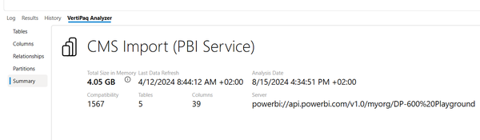

Figure 9-16. *The size of the Import mode semantic model, captured by VertiPaq Analyzer*

As you may observe, the size of the model is 4.05 GB. Once I perform the same check on the Direct Lake semantic model in Figure 9-17, you will notice that the difference in total size in memory is enormous:

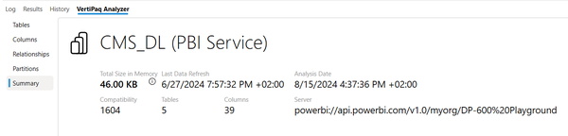

Figure 9-17. *The size of the Direct Lake semantic model, captured by VertiPaq Analyzer*

Instead of 4.05 GB, the size is now 46 KB! In the Direct Lake semantic model, it’s metadata only.

However, before you jump to quick conclusions based on the previous two figures, let me introduce you to another major concept in Direct Lake, called *temperature*, that may have an impact on the memory footprint of semantic models.

**Temperature**

The concept of temperature, in a nutshell, is fairly simple. It assumes that each column in the semantic model has its temperature. This property enables the Power BI engine to decide which column(s) stay in cache memory and which are kicked out back to OneLake.

**Note**

The more the column is queried, the higher its temperature is. The higher the temperature of the column, the bigger chances are that it stays in cache memory

You can identify columns with the highest temperature by querying dynamic management views (DMV) in the Power BI tabular model. You can use the aforementioned DAX Studio or SQL Server Management Studio to obtain the data about the semantic model. Figure 9-18 shows the initial results before any query against my Direct Lake semantic model was executed:

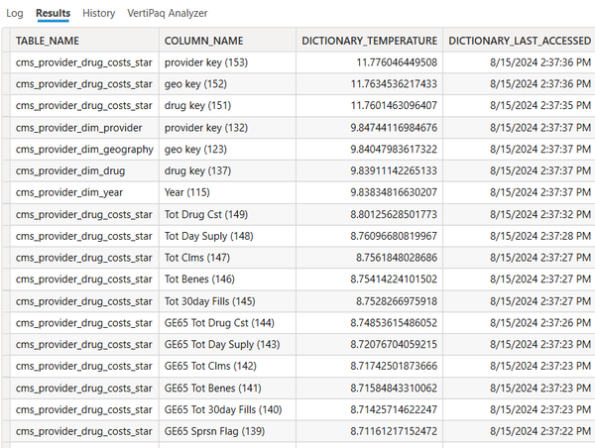

Figure 9-18. *Analyzing column temperature values*

Let us quickly decipher the results displayed in Figure 9-18. We focus on the column DICTIONARY_TEMPERATURE, which shows how “hot” a specific column is. Without going any further, you may notice that key columns dominate the top of our result set. The reason is simple - these columns are used to establish relationships between the tables in the semantic model. Hence, Power BI keeps them warm to enable quick filter propagation between the tables.

If no queries against the Direct Lake semantic model are executed, the temperature value will further decrease over time. Therefore, if I query the same dynamic management view after an hour of model inactivity, the temperature value may drop closer to zero.

But what happens if we activate the model and start interacting with the report built on top of it? Figure 9-19 shows the result of querying the same dynamic management view once we created a plain table visual to show the total number of records per year.

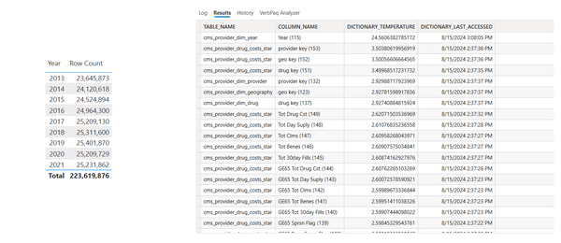

Figure 9-19. *Analyzing column temperature values after interacting with the model*

By adding a Year column to the report, its temperature skyrocketed and is approximately 8 times higher than the next column from the model. This way, the engine ensures that the most frequently used columns will stay in cache memory and be served from there so that the report performance will be the best possible for the end user.

The fair question at this point would be: what happens when all our users go home at 5 PM and no one interacts with Direct Lake semantic models until the next morning? The answer is simple: the first semantic model user will have to sacrifice for all the others and wait a little bit longer for the initial run. Then, everyone could potentially benefit from having warm columns ready in the cache. But what if the first user in the morning is your manager or a company CEO? We definitely don’t want to make this type of user wait for long to see their KPIs and figures.

The good news is that there is a fairly straightforward solution to this challenge. By pre-warming our model early in the morning, before any of the users open their reports, we can load the most frequently queried columns into cache memory and have them ready in advance. This can be performed in multiple ways, but probably the most convenient one is to leverage a semantic link feature, which we already examined in Chapter 7, and execute DAX code from the Fabric notebook. It doesn’t have to be any fancy DAX. A plain COUNTROWS of the table, or COUNT over a specific column or set of columns, will serve the purpose and enforce this data to be loaded into the cache. Then, you may schedule this notebook to run every morning at 8 AM before any user starts interacting with the Direct Lake model.

Since we covered a couple of very important concepts relevant to Direct Lake workloads in Power BI, let’s wrap up this section by compiling a high-level overview of all key concepts. Figure 9-20 illustrates each concept you need to know when working with Direct Lake semantic models in Microsoft Fabric:

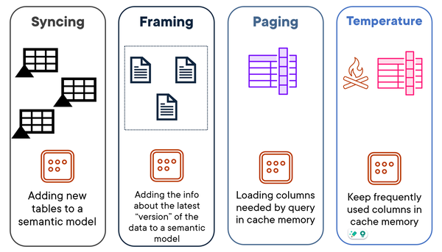

Figure 9-20. *Key Direct Lake concepts at a glance*

**Direct Lake Guardrails**

A complex query over huge amounts of data may cause havoc on your workload. We should not forget that Power BI is just one piece of the Microsoft Fabric puzzle and there might be dozens of other operations and tasks running in parallel, consuming their fair share of capacity units.

Hence, Microsoft imposes resource and memory guardrails that should enable the smooth running of your Fabric capacity workloads and ensure that no one gets throttled in the process.

Table 9-5 lists all the guardrails that might prevent your semantic models from using Direct Lake.

| **Fabric SKU** | **Parquet files per table** | **Rows per table (millions)** | **Max model size in OneLake (GB)** | **Max memory (GB)** | **Max memory per query (GB)** |
| --- | --- | --- | --- | --- | --- |
| F2 | 1,000 | 300 | 10 | 3 | 1 |
| F4 | 1,000 | 300 | 10 | 3 | 1 |
| F8 | 1,000 | 300 | 10 | 3 | 1 |
| F16 | 1,000 | 300 | 20 | 5 | 2 |
| F32 | 1,000 | 300 | 40 | 10 | 5 |
| F64 | 5,000 | 1,500 | Unlimited | 25 | 10 |
| F128 | 5,000 | 3,000 | Unlimited | 50 | 10 |
| F256 | 5,000 | 6,000 | Unlimited | 100 | 10 |
| F512 | 10,000 | 12,000 | Unlimited | 200 | 20 |
| F1024 | 10,000 | 24,000 | Unlimited | 400 | 40 |
| F2048 | 10,000 | 24,000 | Unlimited | 400 | 40 |
| Table 9-5. *Direct Lake guardrails* | | | | | |

Whenever your semantic model or query hits any of the limits specified in Table 9-5, Direct Lake will not take place. The next fair question is: What happens with our queries if Direct Lake is not in place? It depends. We’ll examine available options in the next section, but to give you a quick hint - if you don’t change the default configuration, whenever Direct Lake is not possible, queries will fall back to DirectQuery storage mode.

It’s not only about hitting resource and memory limits. Certain features and use cases are not yet supported for Direct Lake scenarios. The best example is T-SQL views, a commonly used database object for encapsulating complex query logic. While Power BI will not prevent you from using T-SQL views in Direct Lake semantic models, you should be aware that any query that retrieves the data from a T-SQL view, will not be able to leverage Direct Lake mode.

We’ll examine other limitations in the closing part of this chapter.

**Control Direct Lake behavior**

As we’ve already explained, if we stick with the default settings for our Direct Lake semantic models, whenever Direct Lake can’t be used - either because of resource or memory limit violation or using unsupported features - queries will fall back to DirectQuery storage mode.

However, we can modify this behavior by configuring the *DirectLakeBehavior* property of the semantic model. This property can be configured in three different ways:

*Automatic*

A default value. If Direct Lake can’t be used, all queries will use a DirectQuery mode.

*DirectLakeOnly*

All queries *only have to* use Direct Lake mode. If this is not feasible, queries won’t run, the error will be thrown, and the report won’t render. This behavior may come in handy when you need to identify resource-exhaustive queries before exposing them to the end user

*DirectQueryOnly*

The opposite of the previous one. All queries *only have to* use DirectQuery mode. The typical use case for this option is testing the performance of those queries that will exceed Direct Lake limits and will be served by using DirectQuery mode

Figure 9-21 shows what happens with queries against the Direct Lake semantic model once the Direct Lake mode can’t be used.

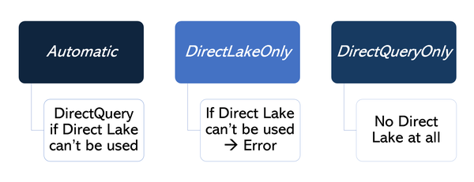

Figure 9-21. *Controlling Direct Lake model behavior*

DirectLakeBehavior property can be configured either from the web UI in Power BI Service or by using an external tool such as Tabular Editor.

**Direct Lake limitations**

Direct Lake is one of those features that you might think of - where have you been all my life? We believe that you’ve already understood how powerful the concept of Direct Lake mode is. However, before you jump *all-in* to Direct Lake, let’s examine the list of current limitations that might make you think twice before you hop on this train.

**Note**

This section covers technical limitations only. For architectural considerations and decision guidance for using Direct Lake over Import mode and vice versa, please refer to Chapter 16.

The key thing to keep in mind is that Microsoft Fabric is still an immature product that rapidly evolves. The same applies to the Direct Lake feature. Therefore, we would like to emphasize that some of the currently listed limitations may be lifted in the future. Hence, always make sure to check the list of the current limitations on the official Microsoft Learn site: <https://learn.microsoft.com/en-us/fabric/get-started/direct-lake-overview#known-issues-and-limitations>

* Only *delta tables* from the Fabric lakehouse or warehouse are supported. The emphasis is on both delta AND tables. Simply put - no delta format, no Direct Lake. Similarly, T-SQL views, as already explained in the previous section, will also prevent Direct Lake queries.
* *Single* Fabric lakehouse or warehouse - you can’t combine tables from multiple lakehouses and/or warehouses. However, shortcuts are supported. Therefore, you may create a shortcut in Lakehouse A, which points to a delta table in Lakehouse B, and the Direct Lake semantic model built on top of Lakehouse A will still be able to leverage data from Lakehouse B.
* No composite models - In the beginning of this chapter, we explained composite models. When you use Direct Lake storage mode, it’s all-or-nothing. This means, you can’t set the storage mode for Table A to Direct Lake, and then set the storage mode for Table B to Import or DirectQuery.
* No DAX calculated columns and DAX calculated tables - since these two data structures are calculated and persisted during the semantic model refresh process, and we’ve already learned that there is no data refresh process in Direct Lake semantic models, you need to implement the logic of calculated columns and/or tables further upstream - in the delta table stored in the Fabric lakehouse or warehouse.
* Relationships on DateTime data type columns are not supported
* Primary key columns must contain unique values - regardless of how awkward this sounds, constraints in Microsoft Fabric are not enforced. Hence, it might happen that your primary key columns contain duplicate values. In these circumstances, DAX queries will fail.

Summary

We covered a lot in this Chapter. This is not a coincidence, as the majority of Fabric users will be Power BI professionals.

If you are one of them, the good news is that your transition to Power BI workloads in Microsoft Fabric should be smooth sailing. If nothing more, the user interface and most of the functionalities remained the same as in the pre-Fabric era. Import and DirectQuery storage modes are here to stay, and from that perspective, nothing has changed in the way we design and build our Power BI items.

Yet, one of the most significant enhancements that Microsoft Fabric introduced to the data analytics world is specifically relevant to Power BI. If you’ve read this entire chapter, you know that we are referring to the Direct Lake mode—a revolutionary feature that aims to *supplement* Import and DirectQuery scenarios by exploiting and combining their strengths and overcoming their weaknesses.

At this point, we would like to emphasize two points:

* Direct Lake *is not* a replacement for Import and DirectQuery storage modes. It’s just another option for implementing Power BI solutions
* We strongly encourage you to broaden your existing Power BI knowledge and learn*when and how* to use Direct Lake mode, since this will become a necessary skill for every successful Power BI professional

From a future-proof point of view, we are quite confident that Power BI will continue to dominate the BI reporting tools market. Tight integration with other Microsoft Fabric components and the introduction of new, groundbreaking features, such as Direct Lake, will ensure increased adoption of Power BI and expand the number of use cases.

In Chapter 9 we talked about Power BI, which is the most known feature in the Fabric landscape since it has been around for more than 10 years. In this chapter, we’ll introduce one of Fabric’s newest features: SQL databases.

SQL databases in Fabric bring together the trusted power of SQL Server and Azure SQL database engines, and integrate them into the Fabric ecosystem. This integration offers the familiarity and strength of SQL within a robust, scalable platform, unlocking advanced analytics and smooth data integration opportunities. They therefore bridge the gap between the analytical world, which we’ve mostly focused on in this book, and the operational data world, allowing you to bring them to the same place.

In a nutshell, SQL databases give us the capabilities of SQL Server and Azure SQL but with fewer knobs and handles. As a result, we profit from more simplicity but in exchange, we have less control. Their combination of automation, AI integration, governance, and seamless data operations makes them a suitable solution for enterprise-scale applications while maintaining efficiency and reliability.

In application development scenarios, developers can leverage SQL databases in Fabric to modernize and improve their operations. With the introduction of built-in vector data types, teams can store and query product and customer information to enable advanced semantic search, enhancing AI-driven functionalities.

**Tip**

A vector data type stores multiple numerical values in a specific order, making it useful for mathematical operations, AI, and spatial data. Unlike single-value scalars, vectors enable efficient computations like similarity search, transformations, and indexing. You would use this for tasks such as recommendation systems, anomaly detection, natural language processing, and image recognition, where fast comparisons of complex data are needed. For example, in a music streaming app, vector data helps recommend songs by comparing user listening patterns with similar users

For organizations modernizing their analytics workflows, SQL databases in Fabric streamline processes by integrating directly with OneLake. When building a new app that uses SQL Databases in Fabric as its datastore, for example, that data will automatically be mirrored to OneLake, so you can use the data through analytical experiences like data engineering. This can eliminate the need for traditional ETL pipelines (it however only eliminates the need to copy data but doesn’t alleviate the need to transform it or load it into another platform like a data lake), reducing complexity and improving efficiency. Operational data stored in SQL databases can feed directly into Power BI for real-time reporting, enabling businesses to respond quickly to dynamic situations. Additionally, governance tools like Microsoft Purview ensure data management practices remain compliant and secure, empowering organizations to scale confidently.

**Tip**

As with most sources, there are limitations to the mirroring of a SQL database in Fabric. At the time of writing for example, the maximum number of tables that can be mirrored from a database was 1,000. You can find the most current list of limitations in the [Microsoft documentation](https://learn.microsoft.com/en-us/fabric/database/sql/mirroring-limitations).

Over the course of this chapter, we will first discuss the reasoning behind SQL databases in Fabric, followed by a look at its key features and how to work with data in them. We’ll round this out by walking you through all the steps required to get started with your first SQL database in Fabric.

Why SQL databases in Fabric?

The introduction of SQL databases in Fabric is a response to evolving business needs and the need for operational efficiency. With predictions of one billion new applications[**1**](https://learning.oreilly.com/library/view/fundamentals-of-microsoft/9781098172916/ch10.html#id398) being developed in the next five years, 87% of organizational leaders believe AI will play a critical role[**2**](https://learning.oreilly.com/library/view/fundamentals-of-microsoft/9781098172916/ch10.html#id399) for maintaining competitive edges.

The Role of AI

Fabric’s SQL databases empower developers to focus on building applications rather than managing complex infrastructure. By leveraging familiar T-SQL syntax and widely used tools like SQL Server Management Studio (SSMS) developers can streamline their workflows and reduce the learning curve. To further help simplify this development process, features like Copilot further accelerate development by simplifying database and application design processes while the inclusion of graph capabilities expands the potential for advanced relational modeling. Artificial Intelligence supports developers along the entire lifecycle of developing solutions using SQL Databases in Fabric, opening this world to developers without a strong SQL background.

Operational Efficiency

Operational efficiency is another cornerstone of SQL in Fabric. Autonomous operations – including automatic indexing, backups, and patching – minimize manual intervention, allowing teams to focus on innovation rather than maintenance. This combination of streamlined development, AI integration, and operational efficiency positions SQL databases in Fabric as a game-changing solution for modern application development.

As you can see in Figure 10-1, SQL databases in Fabric deliver a fully grown Azure SQL database that natively integrates with your Fabric workspace and capacity.

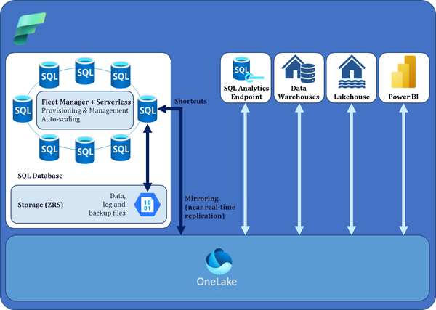

Figure 10-1. SQL databases architecture

As you can also see in Fkgure 10-1, SQL databases currently use a serverless deployment with zone redundant storage.

**Tip**

In Microsoft Azure, ZRS (Zone-Redundant Storage) is a redundancy option for storing data that replicates it synchronously across multiple availability zones within a region. This ensures higher availability and resiliency against failures in a single data center.

This seamless integration obviously also includes the pricing component. Your SQL database will consume its capacity units (2.61 CUs per vCore) and so be billed as part of your Fabric capacity. We will explain the concepts of billing and capacity units in more depth in Chapter 14.

Key Features of SQL Databases

SQL databases in Microsoft Fabric integrate advanced database management features with modern automation and intelligence, addressing the technical demands of enterprise-scale data operations. This section outlines the primary technical capabilities of SQL databases in Fabric.

**Simplicity and Autonomous Operation**

Database creation and management in Fabric are designed to be efficient and user-friendly. With minimal input, a database can be provisioned in seconds. The platform incorporates advanced automation to optimize performance and reduce the need for manual intervention, streamlining database administration for developers.

Integrated Copilot assists with tasks such as query generation, database design, and optimization, enabling developers to perform these operations more efficiently. The system supports auto-scaling, which dynamically adjusts compute and storage resources based on workload demands, ensuring consistent performance.

Fabric’s auto-provisioning establishes robust, fault-tolerant databases that remain operational during server failures and allow for rolling updates with no disruption to applications. Auto-configuration further refines database performance by tailoring memory usage, data formats, and access structures to specific workloads, enabling users to load data and begin operations immediately.

Auto-indexing, powered by machine learning, identifies and implements missing indexes that can improve query performance. It validates each index before applying changes, continuously learning to refine its recommendations. These features collectively optimize database operations without requiring manual oversight.

Automation extends to critical aspects such as the following:

*Data protection*

Continuous monitoring of sensitive and regulated data through a unified management interface.

*Security*

Built-in encryption for databases, backups, and connections, safeguarding data against external threats and unauthorized access.

*Backups and recovery*

Automatic daily backups with on-demand options, supporting point-in-time recovery within a seven-day window.

*Patching and failover*

Updates are applied without downtime, while failover mechanisms ensure seamless transition during server disruptions, meeting a 99.995% SLA.

These automation capabilities enhance database reliability, performance, and security while minimizing administrative overhead.

**AI Integration and Optimization**

SQL databases in Fabric are designed to facilitate the development of AI-enhanced applications. Support for vector data types allows developers to store embeddings from AI models and implement features like semantic search and recommendation systems. These capabilities enable the creation of applications with advanced AI-driven functionality.

Integration with Azure AI and OpenAI allows databases to incorporate external AI models. This enables the combination of relational data with AI-generated insights, enriching the scope of applications built on the platform. Developers can utilize Copilot Assistance to interact with data using natural language queries, generate scripts, and receive design recommendations, reducing the complexity of implementing AI in applications.

Additionally, SQL in Fabric supports the creation of AI-powered applications with built-in features for integrating AI models and vector data. Coupled with tools like LangChain, these capabilities allow developers to embed artificial intelligence into their applications, enabling functionality such as semantic search, recommendation engines, and other AI-driven experiences.

**Integrated Governance and Security**

Fabric provides centralized security and compliance controls through its Microsoft Purview governance layer. Databases are encrypted by default, both in storage and transit, with support for TLS 1.2 ensuring secure data communication. TLS 1.2 (Transport Layer Security version 1.2) is a protocol designed to secure network communications by encrypting data exchanged between systems. Its significance lies in safeguarding sensitive information, like passwords and financial details, from unauthorized access or tampering.

Zone-redundant setups provide high availability and disaster recovery, ensuring uninterrupted operations and robust data protection. While there is no equivalent to firewall rules, databases in Fabric use Entra authentication only, so you can use conditional access rules to limit database access.

We will also talk about governance and security in more depth in chapter 15.

**DevOps Integration**

SQL databases in Fabric are built to align with modern DevOps practices, enabling streamlined database management and agile workflows. Every database is fully integrated with source control, allowing teams to version databases, track changes, and collaborate efficiently. This integration ensures database schema and configurations to be part of the broader development lifecycle, enabling consistent deployments and reducing errors across environments.

By integrating with CI/CD pipelines, SQL databases in Fabric support automated testing, deployment, and monitoring. This compatibility allows organizations to implement robust DevOps strategies, ensuring rapid iteration and reliable database operations.

Unified Data Storage with OneLake

All SQL databases in Fabric are tightly integrated with OneLake, a shared storage layer for the entire Fabric ecosystem. This setup ensures real-time data replication across workloads, eliminating the need for traditional ETL processes. As a result, databases can directly support analytics in Power BI and other Fabric tools, simplifying data access and improving overall efficiency.

**GraphQL Interface**

SQL databases in Fabric also include a built-in GraphQL (for more information on GraphQL in Fabric, refer to Chapter 12) interface, offering a flexible and efficient way to query and interact with data. This interface enables developers to fetch precisely the data they need with a single query, minimizing over-fetching and under-fetching issues often encountered with traditional REST APIs.

The GraphQL interface simplifies data integration for modern applications, especially those with complex front-end requirements or microservice architectures. By combining the relational power of SQL with the flexibility of GraphQL, developers can seamlessly build data-driven applications, enabling rapid iteration and streamlined communication between database and application layers.

This especially opens up a lot of capabilities for developers who are not SQL native on which we’ll expand on more later in this chapter.

**Ingesting and querying data**

Data can be inserted into SQL databases in Fabric using a variety of methods. Since the engine provides a regular SQL endpoint, developers and analysts can use any SQL-compatible tool to interact with the database. This includes traditional tools like SQL Server Management Studio (SSMS) and SQLCMD, as well as modern data pipeline solutions such as Azure Data Factory and Microsoft Fabric Pipelines. Even legacy tools like SQL Server Integration Services (SSIS) remain fully compatible, allowing organizations with existing ETL processes to seamlessly integrate with Fabric’s SQL databases.

On the consumption side, data stored in SQL databases is mirrored in OneLake, Fabric’s unified data storage layer. This mirroring - which we will also explain in more depth in chapter 11 - enables real-time availability of data for analytics and other workloads without requiring traditional ETL processes to copy the data.

**Tip**

Keep in mind that mirrored data will retain the same structure as its source so you may still need to run some additional transformations to fulfill your analytical requirements.

Users can query the database directly using SQL tools or leverage OneLake to feed data into visualization tools like Power BI or other Fabric services. The seamless integration with OneLake ensures that data is always accessible for analytics, reporting, or machine learning applications, making it easier for organizations to implement modern data workflows without disrupting established practices.

A Step-by-Step Guide to Building and Managing SQL databases

As in previous chapters, let us do a step by step walkthrough on how to get started.

When you hit “Create” and scroll down or search for database, you will find the SQL database artifact (see Figure 10-2):

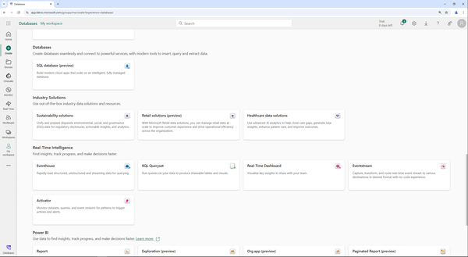

Figure 10-2. Create new SQL database

After clicking “Create” all you need to provide is a name for the “New SQL database” (Figure 10-3):

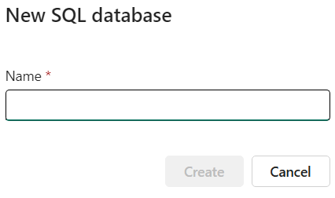

Figure 10-3. Create new SQL database - Name

We will call our database BookSQL which will create everything for us and after a few seconds, the provisioning is complete.

The provisioning also automatically created a Semantic model and a SQL analytics endpoint for us (see Figure 10-4).

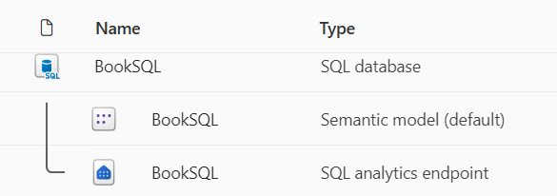

Figure 10-4. Created artifacts

Our SQL database effectively has two different SQL endpoints. The SQL analytics endpoint, which you’re already familiar with from lake houses for example, as well as the SQL endpoint of the SQL database itself. Just as in other experiences like Lakehouses which we discussed earlier in this book, the analytics endpoint is read-only while the endpoint of the SQL database does not allow cross-querying over the SQL database and for example another lakehouse, so the “correct” endpoint will highly depend on your use case and we will talk more about the decision-making process behind this in Chapter 16.

While this may be different in edge cases, the simplest analogy is probably to use the SQL database for OLTP-like workloads and the analytics endpoint for all analytical workloads. Of course, there are also situations like iterating over a metadata table where both endpoints will get you the same result. While we have seen slightly better performance on the SQL database over the SQL analytics endpoint in such cases, it won’t make a huge difference due to the usually very small amount of data involved in such scenarios.

Once you create the SQL database, it takes you to a welcome screen with multiple options – similar to previous experiences.

For users with a strong background in SQL, the connection strings are usually the first stop to connect to the new database using the tools we are comfortable with.

For this instance, we’ll add some sample data by simply clicking “Sample data” on the welcome screen as shown in Figure 10-5.

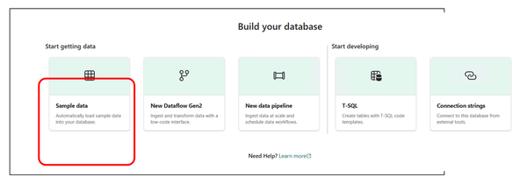

Figure 10-5. SQL database welcome screen

This will automatically trigger the AdventureWorksLT database to be populated to your database. You can also see this when expanding your database in the explorer view on the left (see Figure 10-6).

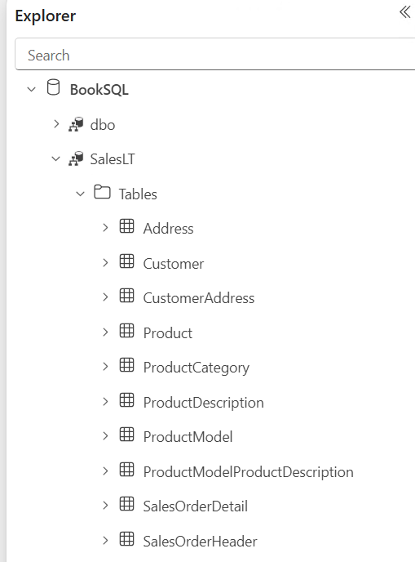

Figure 10-6. SQL database explorer

The main menu (see Figure 10-7) also provides shortcuts to open the database or rather connect to it using VS Code or SSMS as well as just starting a new SQL Editor in the browser (using “New Query”).

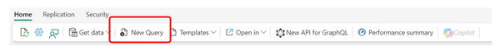

Figure 10-7. SQL database main menu

The SQL Editor (shown in Figure 10-8) comes with Copilot support as well as regular IntelliSense.

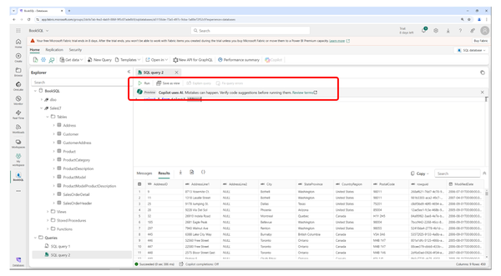

Figure 10-8. SQL Editor

It can be used for any T-SQL operation like querying and manipulating data as well as to create or modify tables and other objects.

The main menu also has a link to the performance summary (shown in Figure 10-9) which gives you a first impression of your database’s state with regards to performance and consumption. At the very bottom of that summary, you will find a link to the Performance Dashboard.

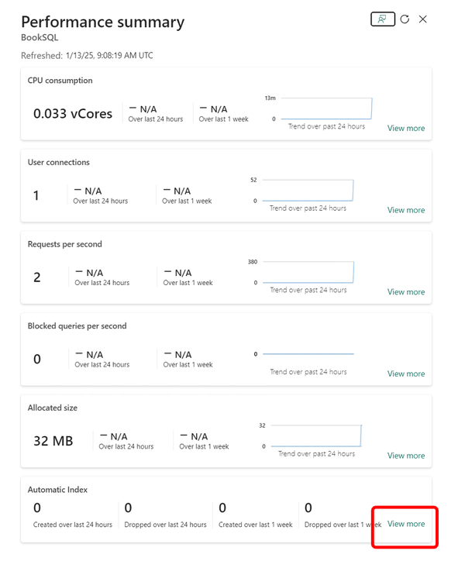

Figure 10-9. Performance summary

The Performance Dashboard provides a more detailed view on the state of your database as illustrated in Figure 10-10.

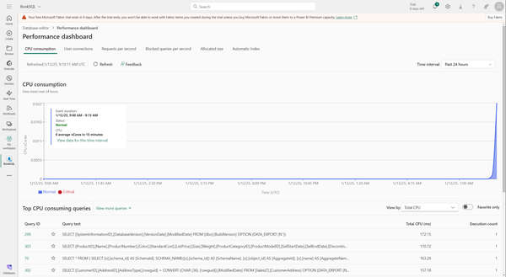

Figure 10-10. Performance dashboard

The main menu also has a ribbon for Replication from which you can reach the replication monitor which will show you the current status of database mirroring (more on that in Chapter 11) which is enabled by default (see Figure 10-11). That replicated data is available directly in OneLake as well as through the SQL Analytics Endpoint that got created for us.

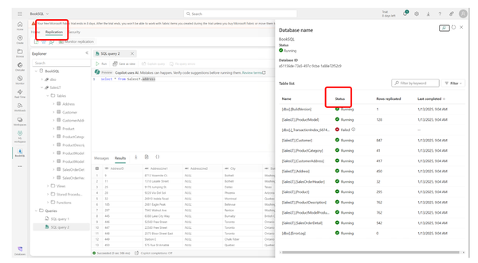

Figure 10-11. Replication monitor

We can immediately see data show up in our OneLake explorer (see Chapter 3) as it is being replicated there (Figure 10-12).

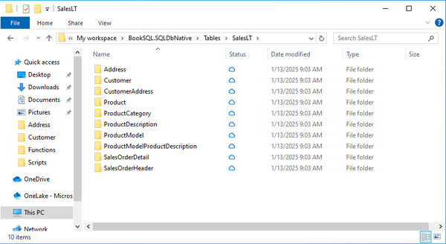

Figure 10-12. Mirrored data in OneLake Explorer

We will not go into the details of AI capabilities on SQL databases and vectors etc. – that would warrant a book by itself.

However, we do want to point out the simplicity of the GraphQL integration. To create a new GraphQL API, you can either right-click any table or the “New API for GraphQL” button in the main menu (See Figure 10-13).

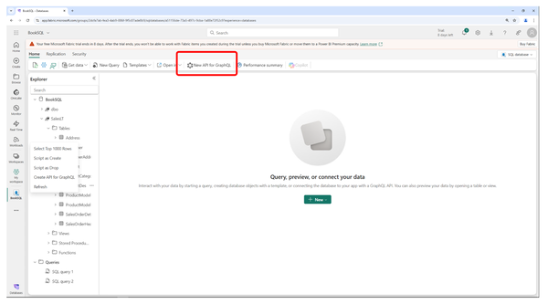

Figure 10-13. Graph API – Initiate wizard

We will use an Address table which prompts for a name to call the new API (Figure 10-14) and we will pick BookAPI.

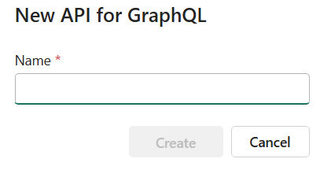

Figure 10-14. Graph API new API wizard

Then we need to select the data that should be available through that API. This selection can be modified afterwards, in this case the Address table is pre-selected as it is where we started the wizard from (Figure 10-15).

To use the selected table we click “Load” on that same screen.

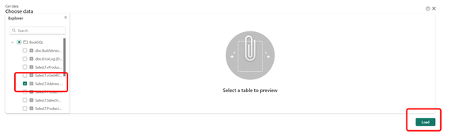

Figure 10-15. Graph API new API wizard - table selection

This has created an endpoint which we can query from a multitude of languages and platforms. The main menu of this screen has a button “Generate code” (Figure 10-16).

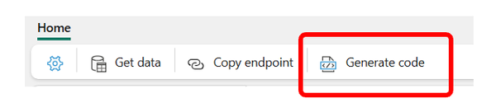

Figure 10-16. Graph API Main menu

This will auto-generate ready-to-use code using Python or node.js to query this exact endpoint (Figure 10-17).

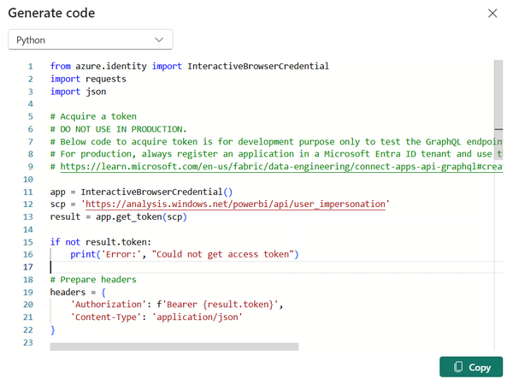

Figure 10-17. Graph API Code Generator

Similar to the SQL Editor, the Graph Editor comes with IntelliSense (Figure 10-18):

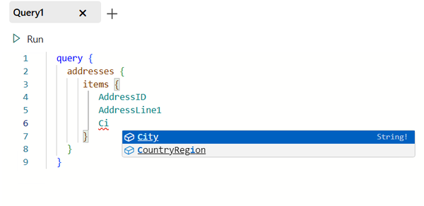

Figure 10-18. Graph Editor

The code from Listing 10-1 for example would query the AddressID, AddressLine1 and City properties from the Address table.

**Example 10-1. GraphQL Query**

query {

  addresses {

    items {

      AddressID

      AddressLine1

      City

    }

  }

}

The result when running this query would also be a JSON document (see Figure 10-19).

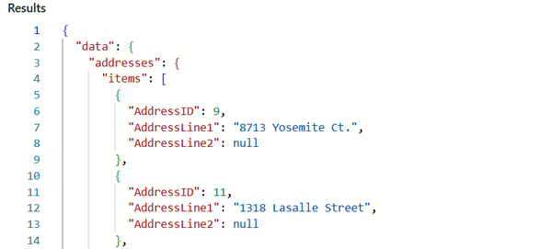

Figure 10-19. Result from GraphQL Query

For more details on GraphQL, take a look at Chapter 12.

Summary

SQL databases in Microsoft Fabric integrate SQL Server and Azure SQL database engines into a scalable, modern platform for advanced analytics and AI-driven applications. Developers can use familiar SQL tools alongside features like vector data types for semantic search and machine learning integration for personalized recommendations. With native OneLake integration, SQL Databases can help to eliminate some traditional ETL workflows, enabling real-time analytics and efficient data sharing across Fabric components, including Power BI.

Designed for enterprise-scale applications, Fabric’s SQL databases simplify management with tools like Copilot and autonomous features such as auto-indexing and auto-scaling. Security and governance are built-in, with encryption, automated backups, and compliance tools like Microsoft Purview. The platform aligns with modern DevOps practices, offering CI/CD pipeline integration and source control for streamlined workflows.

With support for AI model integration, a GraphQL interface for flexible querying, and real-time data replication via OneLake, SQL databases in Fabric empower organizations to build intelligent, efficient, and secure applications while modernizing their data strategies.

In our next chapter, we will look into a feature called mirroring, which allows you to replicate data into OneLake without using traditional ETL tasks.

Mirrorring

We looked into SQL Databases in Chapter 10, and this chapter will focus on a feature that allows you to seamlessly integrate operational data from other sources with Fabric through a smart mechanism called Mirroring.

Imagine a global retail company with operations spanning multiple regions, each with its own dedicated OLTP database, running in their closest Azure region on Azure SQL database. The headquarters, located in the United States, frequently runs complex analytical queries to assess worldwide sales trends and inventory status. Instead of creating manual ETL tasks for each of them or relying on slow cross-region queries, the company leverages mirroring in Microsoft Fabric. By mirroring the key datasets from their globally distributed operational databases to the US-based data warehouse in Fabric, analysts can access fresh data from all regions seamlessly without using any ETL.

This approach eliminates the latency and complexity of querying remote datasets or manually moving data in real-time, providing a centralized view of global operations while ensuring the data remains localized for regional workloads. The simplicity and efficiency of mirroring transform their global analytics strategy, making it faster and more scalable without extensive data movement or complex integration.

What is Mirroring?

Mirroring in Microsoft Fabric is a feature that creates a near real-time, read-only copy of an external source dataset within a Fabric workspace, allowing users to access and analyze live data without impacting the source system. While there is a low impact caused by the replication of your source data, all analytical queries will hit Fabric and have therefore no impact on your source. This source dataset can consist of an entire source database or only specific tables, also illustrated in Figure 11-1.

**Tip**

Mirroring in Fabric is not the same technology that you may be using in SQL Server (SQL Server database mirroring).

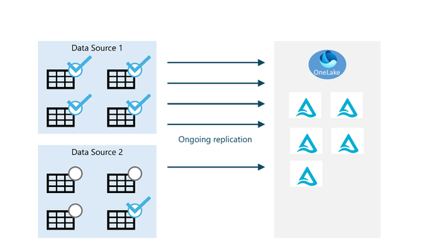

Figure 11-1. Mirroring in Fabric

Ok, that sounds great. But what does that mean, exactly?

Mirroring allows you to replicate your data from supported sources directly into parquet files in OneLake without writing any ETL or copy tasks or pipelines. At the time of writing, the supported sources are Azure SQL Database, Azure SQL Managed Instance, SQL Databases in Fabric (which we discussed in Chapter 10), Azure Cosmos DB, Azure Databricks, and Snowflake.

**Tip**

Besides those sources that are supported out-of-the-box, there is also a concept called open mirroring that allows you to write your own applications to mirror data from other sources. This extensible and customizable capability leverages the open Delta Lake table format to integrate existing data into OneLake, facilitating continuous replication and synchronization. You can learn more about open mirroring and its capabilities in the official [documentation](https://learn.microsoft.com/en-us/fabric/database/mirrored-database/open-mirroring).

Since the supported sources are being expanded constantly, make sure to check the Microsoft documentation for the latest [types of mirroring](https://learn.microsoft.com/en-us/fabric/database/mirrored-database/overview#types-of-mirroring).

Unlike a shortcut that exclusively keeps the data at its source, mirrored data does get replicated to OneLake so you have an actual copy of your data, requiring additional storage. To offset the additional cost assigned to that mirrored data, Microsoft provides you with 1 TB of free storage for mirrored data per capacity unit purchased. This means you get 2 TB of free mirror storage with an F2 and 64 TB with an F64.

**Tip**

The amount of free mirror storage is accurate at the time of writing and like all licensing and cost information subject to change!

Mirroring is a continuous process, so any changes to your source data will be reflected in almost real-time (depending on the number and complexity of changes, latency etc.). The fact that data is being replicated rather than linked to through a shortcut still implies that your data may or in some cases will be more accurate and up-to-date at the source than it is in Fabric. If no updates occur in the source tables, the replicator engine will gradually reduce its polling frequency, extending up to an hour. It will automatically return to regular polling frequency as soon as it detects new data updates.

**Tip**

The outlier with regards to mirroring is Azure Databricks. Unlike the other sources, this one only mirrors the metadata (called Unity Catalog) so despite the - slightly misleading name mirroring - it works more like a value-added shortcut.

Mirroring Requirements

While the entire process of mirroring is rather straightforward, there are some prerequisites besides having a Fabric warehouse and a compatible source system.

**Enabling Mirroring in your tenant**

To make sure you can use mirroring, go to your admin portal as highlighted in Figure 11-2.

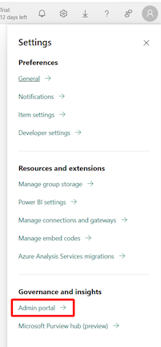

Figure 11-2. Admin Portal

The admin portal is searchable, so if you for example search for “API” you will find the setting “Service principals can use Fabric APIs” (amongst others, highlighted in Figure 11-3).

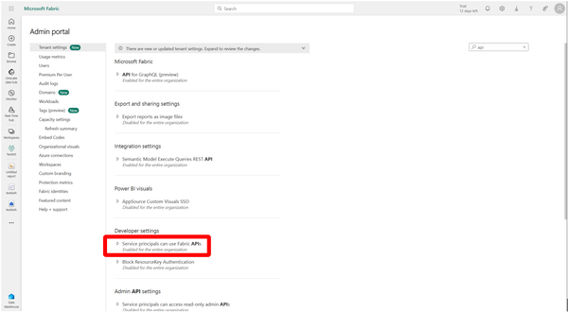

Figure 11-3. Search results for “API” in Admin Portal.

Make sure this setting is enabled.

**Networking**

Although the networking requirements are fairly easy, your source system must be reachable from your Fabric capacity, so set your firewall rules on those accordingly.

The networking side can also add to the cost of mirroring. While, at the time of writing, there are no ingress charges in Fabric, there can be egress charges on the source, for example for an Azure SQL database that is not in the same region as the Fabric capacity.

**Tip**

At the time of writing, Mirroring doesn’t support source systems behind an Azure Virtual Network or private networking.

**Source data**

Mirroring only supports tables. No other objects such as views, functions, or procedures can be replicated into Fabric through mirroring, and security settings won’t be replicated in Fabric either.

In addition, there are limitations and restrictions that depend on the source system being used. For example, when using Azure SQL Database as your source, all tables used with Mirroring must have a primary key. While this sounds fairly simple, this may be a huge issue because many source systems simply don’t use primary keys or handle them differently. You may not be able to simply add them. Some data types are currently unsupported to be either a primary key or for the entire replication process.

As the limitations per system change rather frequently, please refer to the official documentation with regards to the latest restrictions for [Azure SQL DB](https://learn.microsoft.com/en-us/fabric/database/mirrored-database/azure-sql-database-limitations), [Azure SQL Managed Instance](https://learn.microsoft.com/en-us/fabric/database/mirrored-database/azure-sql-managed-instance-limitations), [Cosmos DB](https://learn.microsoft.com/en-us/fabric/database/mirrored-database/azure-cosmos-db-limitations), [Databricks](https://learn.microsoft.com/en-us/fabric/database/mirrored-database/azure-databricks-limitations), and [Snowflake](https://learn.microsoft.com/en-us/fabric/database/mirrored-database/snowflake-limitations) in the context of mirroring.

A step-by-step guide to Mirroring from Azure SQL DB

Given that it’s probably the most widely used offering amongst the supported source systems and also the easiest to deploy, we’ve decided to use Azure SQL Database for step-by-step instructions on how to enable mirroring.

**Tip**

If you don’t have an Azure SQL Database, [create a new single database](https://learn.microsoft.com/en-us/azure/azure-sql/database/single-database-create-quickstart?view=azuresql-db&preserve-view=true&tabs=azure-portal). There is a free tier available so this won’t incur any additional charges.

**System Assigned Managed Identity (SAMI)**

To publish data to Fabric OneLake, the System Assigned Managed Identity (SAMI) of your Azure SQL logical server must be enabled and designated as the primary identity.

In the Azure portal, go to your logical SQL Server, select Security in the resource menu, then choose Identity and switch Status to “on” under System assigned managed identity (shown in Figure 11-4).

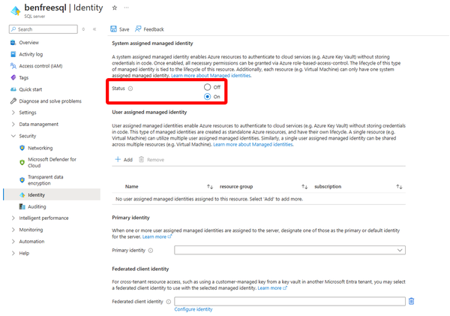

Figure 11-4. Enable SAMI on your Azure SQL Server

**Tip**

You can confirm that SAMI is set as the primary identity by executing the following T-SQL query:

SELECT * FROM sys.dm_server_managed_identities

**Grant access for Fabric through a Database principal**

You can either use a SQL authenticated user or an Entra account. We will use a SQL Account here for simplicity (you can create SQL Accounts yourself while Entra authentication may require support from your admin team).

<HintBox>In a production environment, we highly recommend using Entra authentication though due to the added security features and benefits.</HintBox>

Connect to the master database of your Azure SQL Server using a tool of your choice like [SQL Server Management Studio (SSMS)](https://learn.microsoft.com/en-us/sql/ssms/download-sql-server-management-studio-ssms).

Run the commands in Example Code 11-1 to create a login and assign the required role to it:

**Example 11-1. create a login and the corresponding role**

CREATE LOGIN fabric_mirror WITH PASSWORD = 'VerySecretPassword'

ALTER SERVER ROLE [##MS_ServerStateReader##] ADD MEMBER fabric_mirror

Then switch your context to the user database you want to mirror and create a user and the corresponding permissions based on the newly created login using the Example Code 11-2.

**Example 11-2. create a user and the corresponding permissions**

CREATE USER fabric_mirror FOR LOGIN fabric_mirror

GRANT CONTROL TO fabric_mirror

**Tip**

In SQL Server, the GRANT CONTROL TO statement gives a principal full control over an object, including all permissions such as SELECT, INSERT, UPDATE, DELETE, EXECUTE, ALTER, and the ability to grant or revoke permissions for others. It also allows modifying or dropping the object and accessing child objects within a schema. However, CONTROL does not permit transferring ownership, which remains exclusive to the object’s owner.

**Create a mirrored Azure SQL Database**

In Fabric, select the “Create”  icon, scroll to the “Data Warehouse” section and then select “Mirrored Azure SQL Database” (see Figure 11-5).

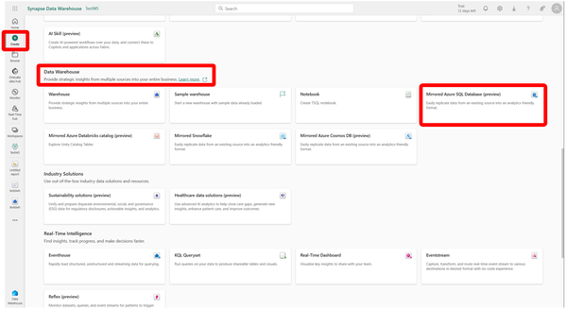

Figure 11-5. Create a mirrored Azure SQL Database in Fabric

To enable Mirroring, select “Azure SQL Database” as your new source in the first step of the wizard, shown in Figure 11-6.

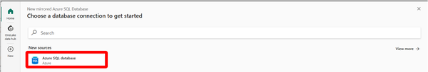

Figure 11-6. New source for Mirroring

In the next step, connect to the Azure SQL logical server from Fabric to establish a link between the Azure SQL Database and Fabric (see Figure 11-7).

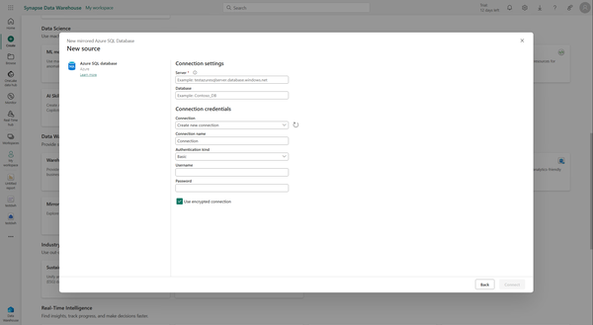

Figure 11-7. Connection settings

Fill in your connection details and select “Connect”.

In the next step of the wizard (Figure 11-8), configure which tables you want to have mirrored into Fabric. By default, all tables are selected. Optionally, you can also automatically add all future tables to mirroring. Note how some tables, that are (partially) unsupported due to unmet requirements, are being marked with an exclamation mark or a red cross.

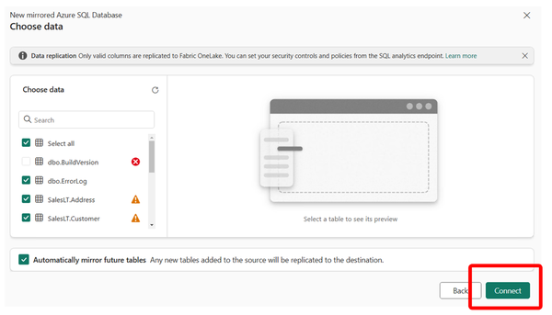

Figure 11-8. Configure mirroring

In our case, we’ll go ahead with all tables and confirm with “Connect”.

**Tip**

There is a limit to the number of tables that can be mirrored. At the time of writing, for Azure SQL database, this limit is 500 tables and if you select all tables, only the first 500 in alphabetical order will be mirrored. Make sure to check the most current [limitations](https://learn.microsoft.com/en-us/fabric/database/mirrored-database/azure-sql-database-limitations#database-level-limitations) in the documentation.

On the next screen (see Figure 11-9), we can define a name for our mirrored database and confirm with “Create mirrored database”.

**Tip**

As everywhere in Fabric, make sure to establish a proper naming convention for your mirrored items.

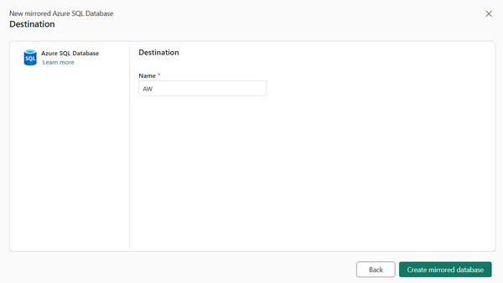

Figure 11-9. Create mirrored database

This will initialize the mirror which will take a few minutes, you are being informed through a screen as shown in Figure 11-10.

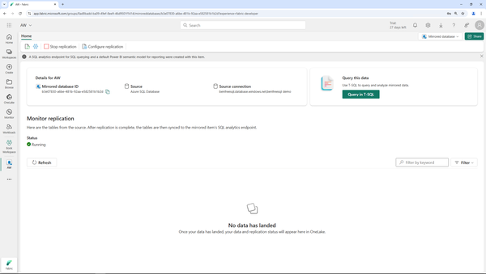

Figure 11-10. Mirrored Database is starting

Once the initialization is completed, you can select the “refresh” button which will show you to the replication status which should look similar to what you see in Figure 11-11.

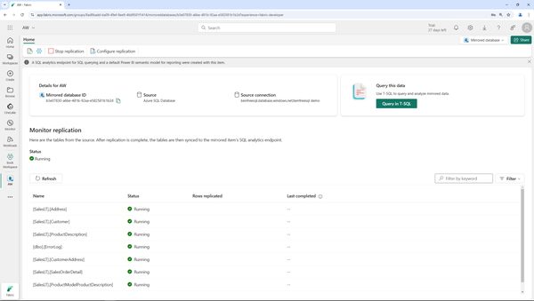

Figure 11-11. Monitor Replication

Once the initial replication is completed, you should see the number of rows as well as the last replication timestamp when refreshing that view.

Your mirrored database is an artifact by itself that you can find in your workspace along with a default semantic model as well as a SQL analytics endpoint that both get automatically created for every mirrored database (see Figure 11-12).

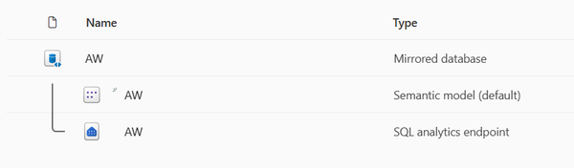

Figure 11-12. Mirrored database in workspace

When selecting it, you will get back to the screen that allows you to stop, configure or monitor your replication (see Figure 11-13).

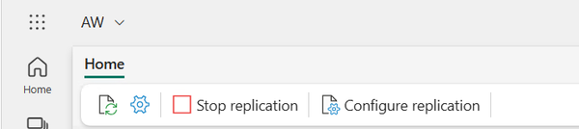

Figure 11-13. Existing mirror settings

If you select the SQL analytics endpoint that was created for this mirrored database, you can browse and query your tables like any other Warehouse in Fabric (see Figure 11-14). Of course, you could also directly access those files like any other file in OneLake through tools like OneLake Explorer (as we explained in Chapter 3).

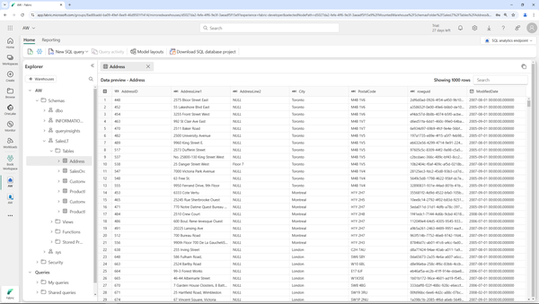

Figure 11-14. Mirrored data in Fabric

Fabric Link is not the same thing

A similar concept at first that often gets confused with Mirroring is Fabric Link. Fabric Link is a solution specifically for Microsoft’s ERP line Dynamics when run as a SaaS solution. Fabric Link also replicates operational data, this gets replicated to another storage level called Dataverse which will then be accessed through shortcuts. While those shortcuts get automatically created for you, the major difference is still that with mirroring the data gets replicated into Fabric whereas with Fabric Link, it ends up in Dataverse (see Figure 11-15).

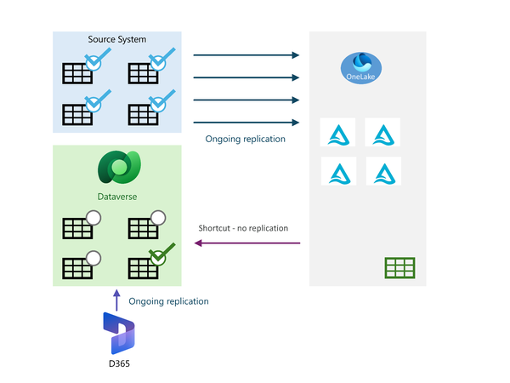

Figure 11-15. Mirroring vs. Fabric Link

Summary

In Microsoft Fabric, mirroring is a powerful feature that allows users to replicate near real-time, read-only copies of data from sources like Azure SQL DB, Azure Cosmos DB, Azure Databricks, and Snowflake into a Fabric Warehouse without the need for ETL pipelines or manual copying. By storing these replicas in OneLake, Fabric ensures that the data can be analyzed within the platform without impacting the source system, although this requires additional storage, for which Microsoft provides 1 TB of free mirroring storage per capacity unit purchased.

Mirroring differs from shortcuts, as it fully replicates - with the exception of Azure Databricks as your source - the data into Fabric, offering an actual copy rather than a link to the original source. This replication happens continuously, so updates from the source are reflected in Fabric with minimal latency. To enable Mirroring, certain prerequisites must be met, including admin settings adjustments and network configurations, and it currently supports only tables from source databases, excluding views or functions. The process also requires specific security settings and connection configurations, but once set up, it enables a variety of analytics capabilities on live data within Fabric. While it does take away the analytical workloads from your source system, the replication process itself does use and require additional resources on your source system.

In our next Chapter, Chapter 12, we will take a look at how you can use GraphQL in the context of Fabric.

If you’re coming from a developer background or role, you may be wondering: “We are creating a custom dashboard using code, and we need the data stored inside Microsoft Fabric. Can we access it in an alternative way than via SQL Analytics Endpoint?”

This is a real-life requirement we’ve encountered multiple times. And the short answer is: Yes, you can! For the longer answer, we encourage you to read this chapter and understand how to leverage the Fabric API for GraphQL feature for enhanced data retrieval experience compared to the traditional REST API approach.

Honestly, the official name - Fabric API for GraphQL - sounds too scary even for experienced data professionals, let alone someone who just started their Fabric learning journey, unless you are a seasoned application developer. Hence, let’s first try to demystify core concepts of this feature.

First and foremost, GraphQL is a query language. You might have already assumed that from its name - QL stands for query language. To bring this one step further: it’s not ANY query language, it’s a query language for the API. It’s an open-source protocol and has been successfully implemented in numerous programming languages. Since GraphQL is an API query language, it isn’t bonded to any particular database engine or vendor.

From a high-level perspective, the main advantages of GraphQL compared to REST APIs are:

*Flexibility*

GraphQL allows you to define individual columns that you need to extract, whereas most REST APIs provide a standard response only.

*Efficiency*

GraphQL enables combining multiple queries in a single call. A simple example would be the possibility of joining tables in the GraphQL query. In GraphQL, this will result in a single call, while in the REST API, this would produce multiple calls

Core GraphQL operations

GraphQL supports three operation types:

*Query*

Query is the essential operation type of GraphQL. To some extent, GraphQL queries may remind you of SQL queries, at least from a logical point of view: we can select specific fields from the table, we can join multiple tables, we can filter and sort the data, and so on

*Mutation*

Mutation corresponds to commands that enable data modification on the server side. Think of this type as an equivalent to CREATE, UPDATE, and DELETE statements in SQL

*Subscription*

Subscription allows subscribing to real-time data. You can subscribe to a particular event, such as data deletion or user creation, and whenever the event occurs, the server will send the data to a GraphQL query

**Tip**

At the moment of writing, Microsoft Fabric supports only Query and Mutation operation types for GraphQL, although it’s very likely that Subscription operation will be supported in the future for Real-Time Intelligence workloads

Working with GraphQL in Fabric

Before we explain how to create and execute GraphQL queries in Microsoft Fabric, let’s first take a brief overview of the currently supported operations based on the Fabric item type. Table 12-1 shows which GraphQL operations can be performed in Fabric items:

| **Fabric item type** | **GraphQL operation type** |
| --- | --- |
| Warehouse | Query/Mutation |
| Lakehouse | Query |
| Mirrored database | Query |
| SQL database in Fabric | Query/Mutation |
| Azure SQL DB | Query/Mutation |
| Table 12-1. Table 12-1: Supported GraphQL operations for various Fabric items | |

As you may notice, only Fabric Warehouse, Azure SQL Database, and SQL database in Fabric currently allow for modifying the data.

A single GraphQL item can be leveraged to query multiple warehouse, lakehouse, mirrored database, and SQL database items simultaneously, although it is not possible to create relationships between these items. Relationships are currently supported only in the scope of the single item.

Let’s now put the GraphQL feature into action. As you can see in Figure 12-1, as a prerequisite, the feature has to be enabled in the Admin portal of your Fabric tenant:

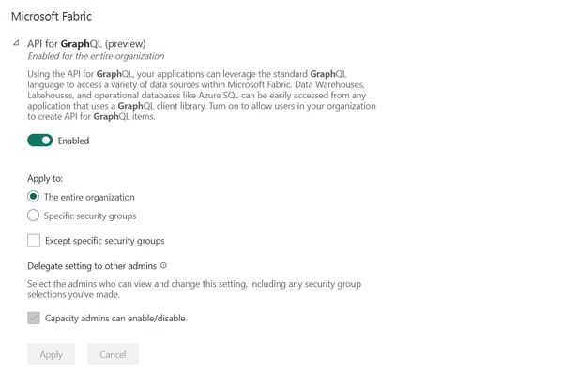

Figure 12-1. API for GraphQL must be enabled in the Admin portal

Once enabled, API for GraphQL is available for **all** Fabric item types that support this feature as specified in Table 12-1. This means, it’s not possible to implement a more granular control and enable GraphQL for, let’s say, lakehouses or warehouses only.

**Query the data with API for GraphQL**

Let’s first retrieve the data from individual Fabric Warehouse tables. As a starting point, we first need to create the API for GraphQL item in Microsoft Fabric. Once we provide the item name, choose the data source, such as lakehouse or warehouse, and pick particular tables from the source - we are ready to query the data.

The following code snippet executed directly inside the API for GraphQL item’s development environment will retrieve the data from specific columns of the dimProducts and dimCustomers tables:

query {

dimProducts { #Table 1 name

items { #Columns to be included in the query

ProductKey,

EnglishProductName,

Color,

Class

}

}

,

dimCustomers { #Table 2 name

items { #Columns to be included in the query

CustomerKey,

FirstName,

LastName,

Gender

}

}

}

This basic query will retrieve all the records from the columns we defined in the query. However, what if we are interested only in a subset of records or potentially in a single record from the table? We have good and bad news here - the bad news is that you can’t rely on *traditional*operators, such as “>”, “>=”, “<”, or “<=”. However, the good news is that we can still filter the data by substituting these operators with their verbose relatives. Hence, “=” becomes **eq**, “>” becomes **gt** (greater than), “<” becomes **lt** (less than), and so on, as displayed in Table 12-2:

| **GraphQL operator** | **Operation** |
| --- | --- |
| eq | equal to |
| neq | not equal to |
| gt | greater than |
| lt | Less than |
| gte | Greater than or equal to |
| lte | Less than or equal to |
| isNull | Check if the value is null |
| Table 12-2. Table 12-2: API for GraphQL logical operators | |

Imagine that you need to retrieve the data for customers whose first name equals Adam. Here is the code snippet that will meet this requirement:

query {

dimCustomers

(filter: {FirstName: {

eq:"Adam"

}}) {

items {

CustomerKey,

FirstName,

LastName,

Gender

}

}

}

Figure 12-2 displays the sample of results retrieved by the query:

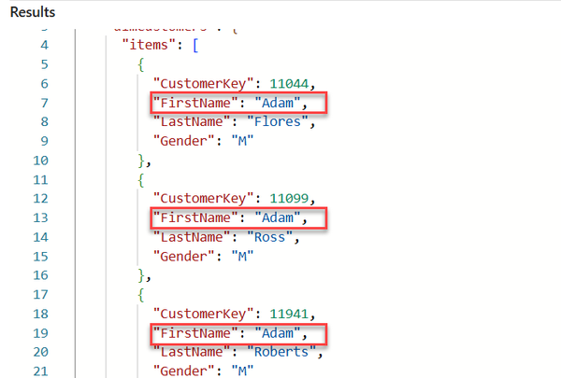

Figure 12-2. Results include only customers whose first name is Adam

**Creating relationships**

Relationships in API for GraphQL, like those in traditional relational database management systems, allow combining data from multiple tables in the same query. When you open the API for GraphQL item, the relationship properties are configured from the New relationship dialog window, as displayed in Figure 12-3. First, click on the three dots next to the schema name and then select the Manage relationships option:

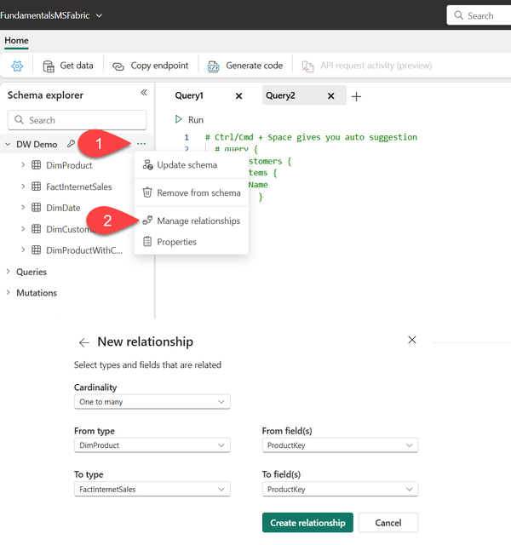

Figure 12-3. Creating a relationship between tables in API for GraphQL

Here, we are establishing a relationship with one-to-many cardinality between the DimProduct and FactInternetSales tables on the common column ProductKey.

Let’s now generate a query that will retrieve combined data from both DimProduct and FactInternetSales tables. The following code snippet represents the query that retrieves all blue products and relevant sales order numbers from the FactInternetSales table, including the Sales Amount value. Additionally, we are sorting the data on the SalesAmount column in descending order:

query {

dimProducts

(filter: {Color:{eq:"Blue"}}) {

items {

Color,

EnglishProductName

factInternetSales

(orderBy: {SalesAmount: DESC}){

items{

SalesOrderNumber,

SalesAmount

}

}

}

}

}

**Making changes by using mutations**

Mutations are a very powerful feature of API for GraphQL, as they enable data manipulation in the Fabric warehouse. As displayed in Figure 12-4, mutations for executing the CREATE statement are automatically included in the Schema explorer of the GraphQL item:

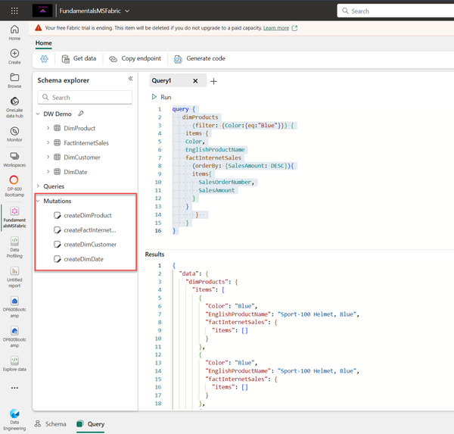

Figure 12-4. CREATE mutations are part of the Schema explorer by default

Hence, if we want to create a new record in the DimProduct table, we can leverage the existing mutation createDimProduct, as shown in the following code snippet:

mutation {

createDimProduct(

item: { ProductKey: 99999, EnglishProductName: "Fundamentals of Microsoft Fabric" }) {

result # Required to return the result of the mutation execution

}

}

Figure 12-5 confirms that our record was successfully created in the DimProduct table:

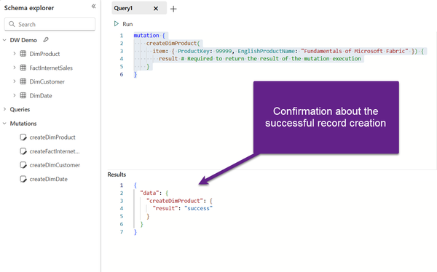

Figure 12-5. Creating a new record in the table

Let’s examine how to delete records from a specific table. Depending on how your table in the Fabric Warehouse was created, this may be performed in two different ways.

* If the table was created without a PRIMARY KEY constraint, UPDATE and DELETE operations are NOT available out-of-the-box
* If the table was created with a PRIMARY KEY constraint, even though this constraint must be specified as **not enforced** in the Fabric Warehouse, UPDATE and DELETE operations are available out-of-the-box

Let’s examine how to apply mutation operation for both scenarios.

Since DELETE mutations are not available out-of-the-box in the Schema explorer for tables without a primary key, we need to extend our toolbox and leverage stored procedures from the Warehouse. Explaining the concept of stored procedures and the benefits of using stored procedures is outside of the scope of this book.

**Tip**

To apply **DELETE** and **UPDATE** operations with API for GraphQL for tables with no primary key constraint, as a prerequisite, you must encapsulate transaction logic inside regular stored procedures in the Fabric Warehouse and then execute these procedures inside the GraphQL item

We’ve already created a basic stored procedure *spDeleteProduct*. This procedure takes the ProductKey input parameter and deletes the record from the DimProduct table where the ProductKey value is equal to the value defined in the parameter. The following T-SQL code snippet was used in the SQL query editor to create the stored procedure:

CREATE PROC [dbo].[spDeleteProduct]

@ProductKey int

AS

BEGIN

DELETE FROM DimProduct

WHERE ProductKey = @ProductKey

END

We can now execute this procedure from API for GraphQL and pass the parameter value we want to use. In Figure 12-6, you may notice that I’m deleting the product with the ProductKey 99999 that we previously created:

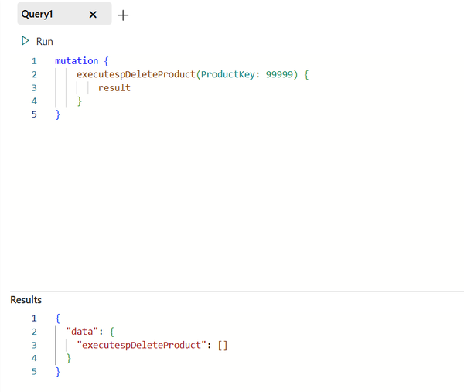

Figure 12-6. Deleting a record from the table by executing the stored procedure

Using similar logic, we can also update the existing records in the table. Again, to achieve this with the API for GraphQL, we need to create a stored procedure in Fabric Warehouse as the first step. From the GraphQL item, the execution logic and the code syntax are the same as in the previous example with the DELETE statement - it’s only the stored procedure inner logic that differs from the previous scenario, as you might want to execute the update statement instead of delete.

Let’s examine how to perform DELETE and/or UPDATE operations for tables with a primary key constraint. As you’ll notice, it’s a more straightforward process compared to the previous scenario.

Using the following T-SQL code snippet in the SQL query editor, I’ll create a new warehouse table, *DimProductWithConstraint,* and define a primary key constraint on the ProductKey column.

CREATE TABLE DimProductWithConstraint

(ProductKey INT NOT NULL

,ProductAlternateKey VARCHAR(100) NOT NULL

,EnglishProductName VARCHAR(100) NOT NULL

)

ALTER TABLE DimProductWithConstraint

ADD CONSTRAINT PK_Product PRIMARY KEY NONCLUSTERED (ProductKey) NOT ENFORCED;

INSERT INTO DimProductWithConstraint

SELECT ProductKey

,ProductAlternateKey

,EnglishProductName

FROM DimProduct

Please be aware that the primary key column can’t be nullable, or your query won’t work. Additionally, keep in mind that all constraints in Fabric Warehouse **MUST** be wrapped with the *NOT ENFORCED* clause. If you are coming from a traditional SQL Server world, this may come as a huge shock. However, all key constraints in Fabric Warehouse are supported only when NOT ENFORCED is used. You can read more about these requirements [in the official Microsoft documentation](https://learn.microsoft.com/en-us/azure/synapse-analytics/sql-data-warehouse/sql-data-warehouse-table-constraints).

Going back to our GraphQL item, when we define a table with a primary key constraint, **ALL** mutation operations are automatically available in the Schema explorer. Once I updated the schema, as you may see in Figure 12-7, all three mutation operations - create, update, and delete - are available for the DimProductWithConstraint table:

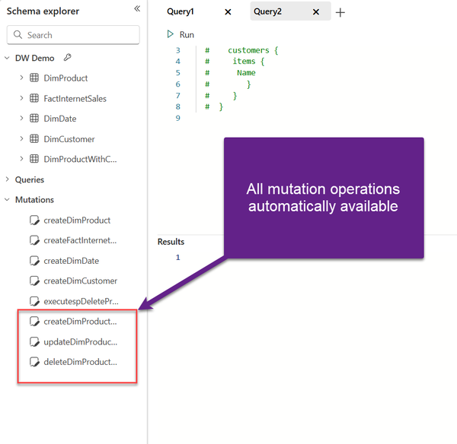

Figure 12-7. All mutation operations available out-of-the-box for a table with PK constraint

To wrap up this section - if tables in the Warehouse were created with primary key constraints, all mutation operations (create, update, and delete) in the GraphQL item would be created automatically. On the flip side, when tables don’t have a primary key explicitly defined, only the create operation is available out-of-the-box, whereas for the update and delete operations, you need to leverage stored procedures.

Going above and beyond with variables

As in other programming languages, you may find the concept of variables helpful in scenarios where you need to filter the data based on user input or when you want to reuse the same query with different parameter values.

Figure 12-8 depicts how you can define variables within the Query variables window of the GraphQL item and pass this value to the Mutation operation:

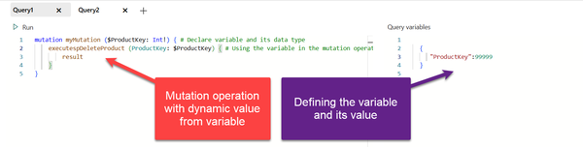

Figure 12-8. Passing the value dynamically to Mutation operation

Variables can also be leveraged in query operations. In the following example displayed in Figure 12-9, we are dynamically setting multiple filters for the query:

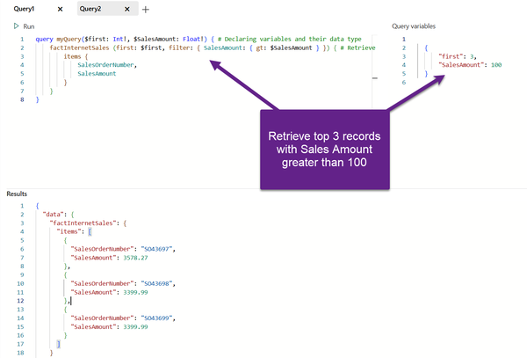

Figure 12-9. Passing multiple values dynamically to the Query operation

Let’s wrap up this chapter by pointing out a few of the key characteristics of the API for GraphQL item in Microsoft Fabric:

* API for GraphQL item requires applications to use Microsoft Entra for authentication. Your client application must be registered and configured properly to execute API calls against Microsoft Fabric
* Once you tested and prototyped the desired GraphQL operation, the API editor can generate boilerplate Python or Node.js code based on the query or mutation executed in the GraphQL editor
* The enable/disable feature for queries and mutations provides administrators and developers with granular control over API access and usage. It allows you to selectively activate or deactivate specific queries and mutations within the GraphQL schema

Summary

Although API for GraphQL might not look like a groundbreaking feature at first glance and probably won’t be frequently used by data engineers and Fabric admins, we still consider it a huge leap forward compared to the traditional way of dealing with API-related scenarios. Therefore, we are convinced that application developers, as a primary target group for this feature, will appreciate the possibility of leveraging GraphQL items in Microsoft Fabric.

Due to its portability and programming-language-independency, GraphQL opens a whole new world of options for querying and manipulating the data stored in Microsoft Fabric. Finally, by providing a rich set of features, such as querying data from multiple tables by sending a single query, creating relationships between tables, applying modifications to the data, and executing stored procedures, we are sure that GraphQL popularity will increase over time, and that it will soon become a de-facto standard when working with APIs.

Fasten your seatbelts - in the next chapter, get ready to meet Microsoft Fabric Copilots and other AI-powered features.

“Hey, Copilot, can you summarize this book for me?”

We sincerely hope you won’t write a prompt like this, since we firmly believe you should read our book in full. However, we won’t blame you much (just kidding, of course we will) if you leverage the latest technology to save yourself some time and effort. As you well know, we can’t deny the omnipresence of artificial intelligence (AI) and large language models (LLMs) in every segment of our lives.

In this chapter, we will examine how AI and LLMs can be leveraged in various Microsoft Fabric components, as well as in which scenarios you might consider asking Copilot for assistance. We have to be honest at the very beginning and warn you that this is going to be quite a long chapter—but this is not to scare you off from reading it! On the contrary, we wanted to assure you that you should expect a thorough overview of the AI features and Copilots in Microsoft Fabric.

Before we dive into exploring various implementations of AI in Microsoft Fabric, let’s first take a step back and examine LLMs, as they represent the backbone of Copilot, which we cover in depth in the next section. If we had written this book just two years ago, this chapter almost surely wouldn’t have existed. And as of today, it’s unthinkable to write practically any tech book without mentioning LLMs. That is how rapidly this new technology has risen to prominence.

In plain English, an LLM is the software that can “talk” to you using natural language. When we say talk, we mean that an LLM is capable of both understanding and responding using human language. LLMs are based on machine learning models trained on large amounts of data—hence, the name “large.” Chatting with software is nice, but this is just a minor part of LLM use cases. LLMs can be leveraged to generate essays, poems, and programming code, all the way to creating podcasts, videos, or images out of natural language prompts. Whenever we talk about LLMs in the context of creating something based on the natural language prompt, we are essentially talking about generative AI, a special type of deep learning model capable of producing text, images, programming code, and audio-visual content in response to a prompt.

**Warning**

Before we proceed, an important word of warning: Generative AI models are usually good at identifying patterns, but sometimes they identify patterns that don’t actually exist, or misapply a pattern that is present to an inappropriate use case. This can result in the models providing false information, a phenomenon known as hallucination.

Additionally, generative AI models are only as accurate as the data they are fed, and it is always recommended that you check the output validity, instead of blindly trusting results.

What Is Copilot?

Now that you understand how AI and LLMs can potentially make your life easier, let’s examine the way Copilot in Microsoft Fabric can enhance your productivity and make your usual workloads more straightforward. Before we dive deeper into exploring Copilots, we want to answer the question from the section title, What is Copilot?

It’s a generative AI chatbot based on LLMs. We want to emphasize that AI and Copilots are infused into every single Fabric experience, so you’ll find us examining numerous Copilots throughout this chapter: Copilot for Data Science and Data Engineering, Copilot for Data Factory, Copilot for Data Warehouse, Copilot for Power BI, Copilot for Real-Time Intelligence, and Copilot for SQL database.

Enable Copilot in Microsoft Fabric

Let’s first explain how to start using Copilot. Tenant or capacity geolocation plays a crucial role in the default settings for Copilot in Microsoft Fabric. If your tenant is outside the US or France, Copilot is disabled by default. To enable Copilot, you (or your Fabric administrator) need to navigate to the Tenant settings of the Admin portal, as displayed in [Figure 13-1](https://learning.oreilly.com/library/view/fundamentals-of-microsoft/9781098172916/ch13.html#fabric_ch_13_figure_1_1748224986309573).

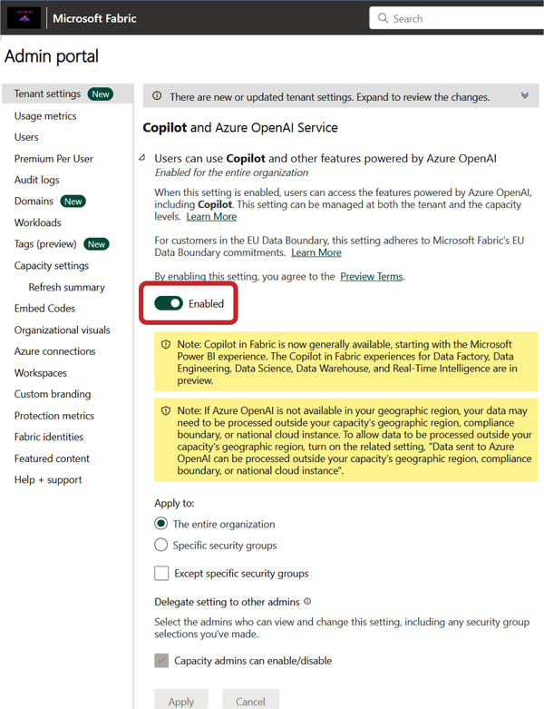

Figure 13-1. Copilot is disabled by default in Fabric tenants outside the US and France

In addition, there is a setting called “Data sent to Azure OpenAI can be processed outside your capacity’s geographic region, compliance boundary, or national cloud instance.” Quite a long name for the setting that is applicable only to organizations that want to use Copilot and AI features powered by Azure OpenAI, and whose capacity’s georegion is outside the European Union (EU) data boundary and the US. The [Microsoft documentation](https://learn.microsoft.com/en-us/fabric/fundamentals/copilot-fabric-overview#data-processing-across-geographic-areas) provides additional information about data processing across geographic areas.

By enabling the “Capacities can be designated as Fabric Copilot capacities” setting, a regular Fabric capacity becomes a special “Copilot capacity” type to enable more streamlined Copilot use and billing.

Geolocation is not the only consideration. At the time of writing, Copilot is supported only for F64 capacities or higher. If you are wondering whether a trial license can be used to try out Copilot, we have to disappoint you: a trial SKU is not eligible for Copilot.

In the remaining sections of this chapter, we’ll focus on exploring individual Copilots in Microsoft Fabric.

Copilot for Data Factory

As you learned in [Chapter 4](https://learning.oreilly.com/library/view/fundamentals-of-microsoft/9781098172916/ch04.html#fabric_ch_4_data_factory_1748224993298657), Data Factory allows for seamless data integration and data orchestration processes in Microsoft Fabric. As you may recall, two main Fabric items in the Data Factory experience are Dataflow Gen2 and data pipelines. Copilot in Data Factory is supported for both items. Here are a couple of examples of how Copilot can be used in Data Factory:

*Dataflow Gen2*

* Create new transformation steps for an existing query.
* Create a new query that can reference an existing query.
* Provide a summary of a query and its applied transformation steps.

*Data pipelines*

* Create a new pipeline from scratch.
* Summarize an existing pipeline, by explaining the content and relations between different pipeline activities.
* Provide error assistance, by troubleshooting data pipeline issues and providing actionable guidance on how to resolve them.

Let’s first see Copilot in action in the Dataflow Gen2. We’ll create a Dataflow called Orders Transform. As you see in [Figure 13-2](https://learning.oreilly.com/library/view/fundamentals-of-microsoft/9781098172916/ch13.html#fabric_ch_13_figure_2_1748224986309610), we’re connecting to the Delta table “orders,”which is stored in a lakehouse, and we’ll immediately open the Copilot pane from the top ribbon.

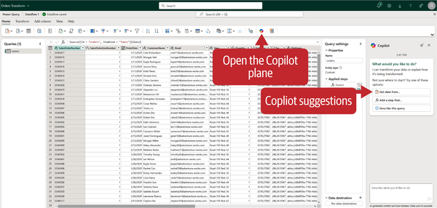

Figure 13-2. Copilot pane in Dataflow Gen2

Let’s now put Copilot to the test. In accordance with the recommended practices, I’ll first apply data filtering. Currently, the table contains data for three years: 2019, 2020, and 2021. Let’s imagine that we want to keep only the records from the year 2021. Therefore, I’ll write the following prompt in the Copilot chat window: “Keep only records for the year 2021.”

As you can see in [Figure 13-3](https://learning.oreilly.com/library/view/fundamentals-of-microsoft/9781098172916/ch13.html#fabric_ch_13_figure_3_1748224986309635), it worked! Two things happened behind the scenes based on our conversation with Copilot:

* There is now a transformation step called Filter rows in the Applied steps pane.
* The M code was automatically generated based on the conversation.

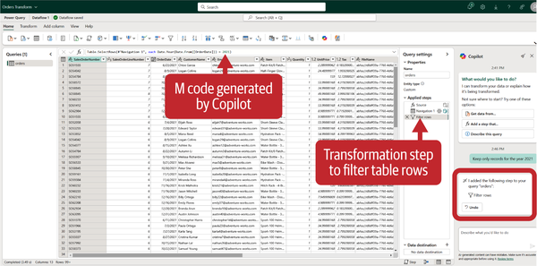

Figure 13-3. Filter transformation applied based on the conversation with Copilot

That’s nice, but let’s see if Copilot can support us with more sophisticated requirements. Currently, the customer name is stored as a full name, including both the first name and last name of the customer. Let’s imagine that we need these two stored separately. In the Copilot chat window, I’ll enter the following prompt: “Split the CustomerName column into FirstName and LastName.”

[Figure 13-4](https://learning.oreilly.com/library/view/fundamentals-of-microsoft/9781098172916/ch13.html#fabric_ch_13_figure_4_1748224986309658) confirms that Copilot did the job properly again—we have the FirstName and LastName stored as separate columns in the dataset.

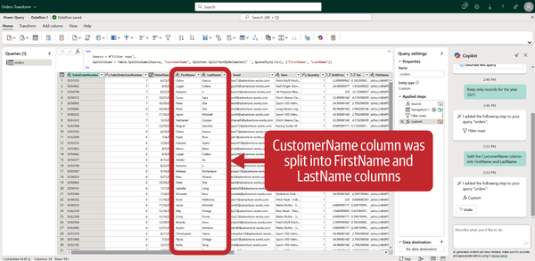

Figure 13-4. Column split transformation worked as expected

One last thing we want to try is to create a duplicate query named orders_agg based on the orders query, and then aggregate the data inside the orders_agg query, so that the total number of orders is displayed per item. We’ll enter the following prompt in the Copilot chat window: “Create a duplicate of the orders query and name it orders_agg.” This time, Copilot completed the task with some caveats. A new query was created, not as a duplicate of the base query, but as a reference. Explaining the difference between the duplicate and reference transformations in Power Query and Dataflows is outside the scope of this book. However, keep in mind that there are subtle differences between these two, especially from the perspective of what happens to the derived query (whether duplicated or referenced) in the case of changes applied to the base query (in our case, orders query).

Let’s wrap it up by aggregating the data. We’ll enter the following prompt in the Copilot chat window: “Count the number of orders per Item.” After Copilot successfully applied Group By transformation to calculate the total number of records per Item, we asked it to sort the data per OrderCount in descending order. [Figure 13-5](https://learning.oreilly.com/library/view/fundamentals-of-microsoft/9781098172916/ch13.html#fabric_ch_13_figure_5_1748224986309680) displays the final outcome.

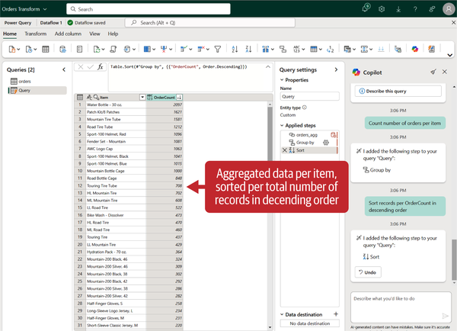

Figure 13-5. Copilot successfully applied Group By and Sort transformations

**Code Efficiency with Copilot**

Please bear in mind that Copilot might not always generate the most efficient code for the entire transformation pipeline. In some circumstances, the order of transformation steps might determine if query folding occurs. *Query folding* is the capability of Power Query’s engine to generate a single SQL statement that’s going to be executed on the data source side. The main benefit of query folding is that it pushes heavy data transformation operations to a data source, thus reducing the amount of work necessary to apply transformations in the Dataflow afterward. Additionally, there might be a more efficient way to perform a particular transformation step than the one implemented by Copilot. Therefore, it’s always the responsibility of the developer to check both accuracy and efficiency and optimization of the query.

Once you’re happy with the Copilot-made transformations, you can configure the data destination, such as a lakehouse or warehouse, and publish the Dataflow.

It’s now time to learn how to leverage Copilot when working with data pipelines. [Figure 13-6](https://learning.oreilly.com/library/view/fundamentals-of-microsoft/9781098172916/ch13.html#fabric_ch_13_figure_6_1748224986309700) shows how to launch the Copilot pane from the blank pipeline canvas.

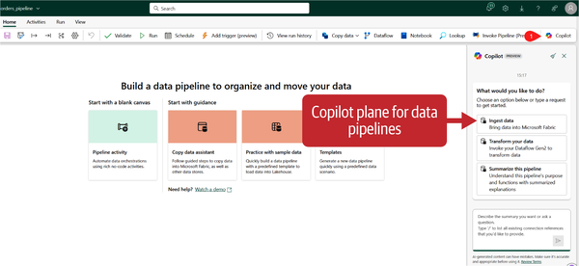

Figure 13-6. Copilot pane for data pipeline

Each of the available options generates a predefined prompt that might be used to instruct Copilot:

* Ingest data generates the prompt “Get data using copy data activity.”
* Transform your data generates the prompt “Transform data with Dataflow Gen2.”
* Summarize this pipeline generates the prompt “Summarize this pipeline.”

Let’s start with the “Ingest data” option. As soon as I confirm the predefined prompt, Copilot will insert a Copy data activity task on the pipeline canvas, as shown in [Figure 13-7](https://learning.oreilly.com/library/view/fundamentals-of-microsoft/9781098172916/ch13.html#fabric_ch_13_figure_7_1748224986309721).

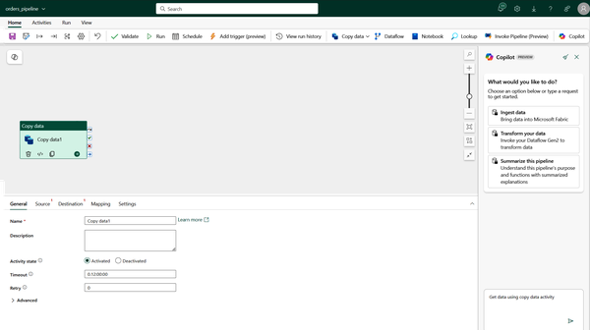

Figure 13-7. Data ingestion with Copilot and Copy data activity

The “Transform your data” option will add the Dataflow Gen2 task to the pipeline canvas. As you learned in [Chapter 4](https://learning.oreilly.com/library/view/fundamentals-of-microsoft/9781098172916/ch04.html#fabric_ch_4_data_factory_1748224993298657), Dataflow Gen2 is commonly used for implementing data transformations.

The “Summarize this pipeline” option may come in very handy with complex pipelines, where the summarized overview might be helpful to better understand various pipeline tasks and how they correlate with each other.

Copilot for Data Engineering and Data Science

We sincerely hope that you already have a good grasp of skills and knowledge about the Data Engineering and Data Science workloads in Microsoft Fabric, which we covered in depth in [Chapter 5](https://learning.oreilly.com/library/view/fundamentals-of-microsoft/9781098172916/ch05.html#fabric_ch_5_data_engineering_1748224993699749) and [Chapter 7](https://learning.oreilly.com/library/view/fundamentals-of-microsoft/9781098172916/ch07.html#fabric_ch_7_data_science_in_microsoft_fabric_1748224994452837), respectively.

Copilot for Data Engineering and Data Science may assist in providing the answers to the questions you ask about lakehouse tables and Power BI semantic models, as well as generate code snippets for data analysis and data visualization.

The process of interacting with Copilot starts by selecting a Copilot icon in a Fabric notebook and then asking questions in the chat panel. Copilot understands not only the metadata, but also the data that you load into the DataFrame. A *DataFrame* is a special temporary data structure in the Python programming language, stored in memory, that consists of rows and columns, similar to a database table or Excel spreadsheet.

Let’s see Copilot for Data Engineering and Data Science in action. We’ll open the notebook named Star Schema LH and initialize the Copilot chat window. As you can see in [Figure 13-8](https://learning.oreilly.com/library/view/fundamentals-of-microsoft/9781098172916/ch13.html#fabric_ch_13_figure_8_1748224986309741), Copilot provides a list of predefined prompts that you can use to quickly get up and running.

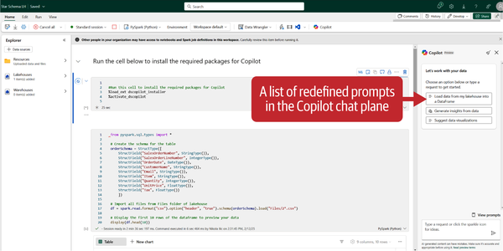

Figure 13-8. Predefined prompt list in the Copilot for notebook

Let’s follow the Copilot suggestions and first load the data into a DataFrame. We’ll now stop for a moment to examine [Figure 13-9](https://learning.oreilly.com/library/view/fundamentals-of-microsoft/9781098172916/ch13.html#fabric_ch_13_figure_9_1748224986309762).

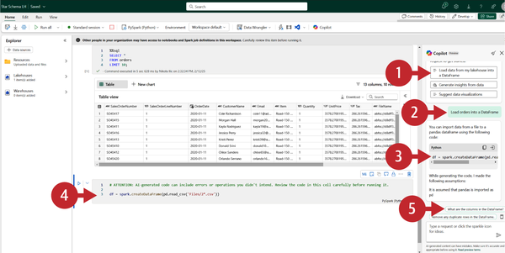

Figure 13-9. Loading data into DataFrame with Copilot

We’ve selected the predefined prompt: “Load data from my lakehouse into a DataFrame.”

1. In the prompt window, we’ve replaced the generic name with the name of my data source (orders).
2. Copilot generated a PySpark code snippet to load the data into a DataFrame.
3. Once we selected “Code insert” in the top left corner of the generated code, a new cell was created in the notebook to include the generated code.
4. Additional prompt suggestions popped up in the Copilot chat pane.

We can perform a quick data profiling with Copilot’s assistance, as shown in [Figure 13-10](https://learning.oreilly.com/library/view/fundamentals-of-microsoft/9781098172916/ch13.html#fabric_ch_13_figure_10_1748224986309783), where we check if there are any missing or duplicate values in the DataFrame.

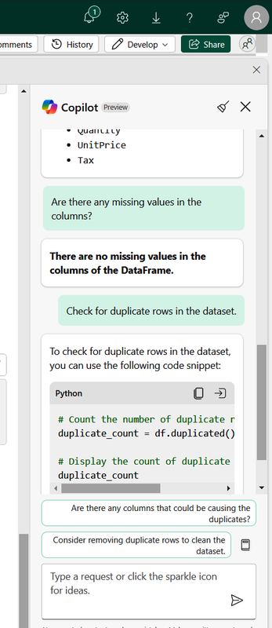

Figure 13-10. Basic data profiling with Copilot

Let’s now use Copilot to get some insights from the data. We’ll type the following prompt into the Copilot chat pane: “What is the average Unit Price?” [Figure 13-11](https://learning.oreilly.com/library/view/fundamentals-of-microsoft/9781098172916/ch13.html#fabric_ch_13_figure_11_1748224986309802) shows how Copilot first generated the PySpark code that we inserted with a single click into the notebook cell, and then calculated and displayed the average Unit Price value.

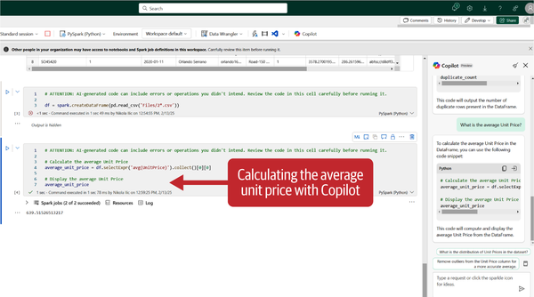

Figure 13-11. Basic data analysis with Copilot

Let’s wrap it up by asking Copilot to assist in data visualization tasks. We’ve first used the predefined prompt: “Suggest data visualizations.” In the chat window, we’ve replaced the generic name with our orders dataset, to get the following prompt: “Analyze orders and suggest ways to visualize the data.” Copilot generated eight different suggestions, starting with the sales trends over time, all the way to geospatial analysis. Based on Copilot’s suggestions, we’ve entered the following prompt: “Plot a line chart showing total sales amount over different time periods (e.g., daily, monthly, yearly) to identify trends and seasonality.”

The generated PySpark code snippet looked promising, so we inserted it directly into the notebook cell. However, poor Copilot incorrectly assumed that there is a TotalSalesAmount column in our DataFrame, which caused the query to throw an error as shown in [Figure 13-12](https://learning.oreilly.com/library/view/fundamentals-of-microsoft/9781098172916/ch13.html#fabric_ch_13_figure_12_1748224986309821).

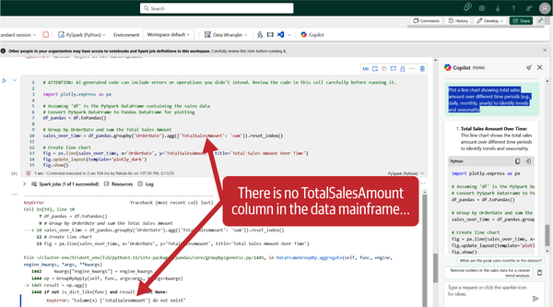

Figure 13-12. Copilot generated an incorrect code snippet

And, this is why we are constantly repeating: don’t blindly trust Copilot! Let’s imagine that we’re the analyst who’s currently working on this notebook. Apparently, we know our dataset well, and we can now use *our own knowledge* to fine-tune Copilot’s suggestion and fix this code. We’ll swap the nonexistent TotalSalesAmount column with the existing Quantity column, and now the code works like a charm, as you can confirm in [Figure 13-13](https://learning.oreilly.com/library/view/fundamentals-of-microsoft/9781098172916/ch13.html#fabric_ch_13_figure_13_1748224986309842).

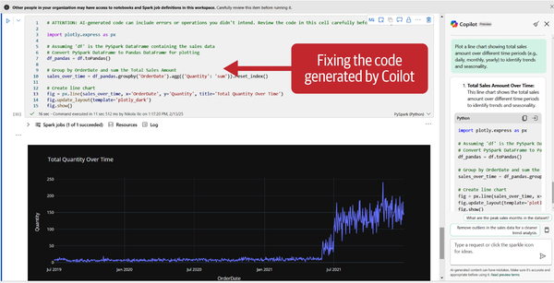

Figure 13-13. Fixing the Copilot generated code to produce desired results

The moral of this story is: take the warning from Line 1 of the generated code snippet seriously!

**Warning**

Attention: AI-generated code can include errors or operations you didn’t intend. Review the code in this cell carefully before running it.

Another possibility when using Copilot in a notebook is to write prompts directly in a cell, instead of using the Copilot chat pane. In [Figure 13-14](https://learning.oreilly.com/library/view/fundamentals-of-microsoft/9781098172916/ch13.html#fabric_ch_13_figure_14_1748224986309862), you can see how we’re leveraging a magic command within the cell to ask the natural language question directly: “What is the maximum Tax?” The output represents the Copilot-generated response.

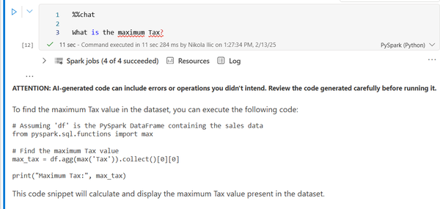

Figure 13-14. Interacting with Copilot directly from the notebook cell

As we saw in [Chapter 5](https://learning.oreilly.com/library/view/fundamentals-of-microsoft/9781098172916/ch05.html#fabric_ch_5_data_engineering_1748224993699749), magic commands are special instructions that expand upon the default Python capabilities. %%chat is just one of the numerous magic commands available when interacting with Copilot in Microsoft Fabric. You can also generate code by using the %%code magic command, or use %%describe to summarize and describe a dataframe. You can find the full list of [supported magic commands](https://learn.microsoft.com/en-us/fabric/data-engineering/copilot-notebooks-chat-magics) in the Microsoft documentation.

Copilot for Data Warehouse

If you implemented a warehouse as part of your Fabric architecture, you can use Copilot to assist in numerous use cases.

**Note**

Before we examine these cases, please bear in mind that Copilot doesn’t use data stored in warehouse tables to generate T-SQL statement suggestions. It relies only on table and column names, along with primary and foreign key metadata to come up with a T-SQL code suggestion.

Copilot for Data Warehouse can be accessed in three ways:

*Chat pane*

Use the chat pane if you want to ask questions using natural language. The generated response is either a T-SQL query or a natural language answer.

*Code completion*

Once you start writing T-SQL in the SQL query editor window, Copilot will automatically generate a code suggestion, which you can accept by pressing on the Tab key.

*Quick actions*

Within the SQL query editor, you will find Fix and Explain options as quick actions. Simply highlight the piece of T-SQL code and choose one of the quick action buttons:

* Explain, to get the natural language explanation of the selected query statement
* Fix, to fix errors in the query statement. In addition, Copilot will generate comments to explain fixes and suggest best practices for writing T-SQL code.

Let’s warm up Copilot in warehouse with a simple prompt: “How can I ingest data into Fabric Warehouse?” As you see in [Figure 13-15](https://learning.oreilly.com/library/view/fundamentals-of-microsoft/9781098172916/ch13.html#fabric_ch_13_figure_15_1748224986309883), Copilot provides a comprehensive list of all the available ingestion options.

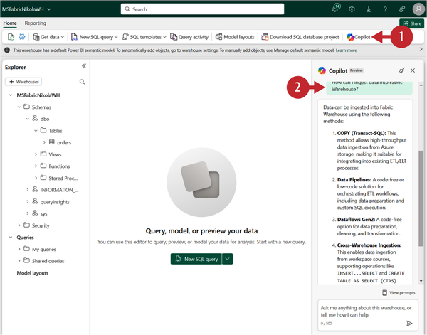

Figure 13-15. Copilot provides the list of data ingestion options

Now, we’ll move on to some more advanced scenarios. I’ll type the following prompt into the Copilot chat window: “How many customers made orders on January 1st 2021?” [Figure 13-16](https://learning.oreilly.com/library/view/fundamentals-of-microsoft/9781098172916/ch13.html#fabric_ch_13_figure_16_1748224986309905) shows how powerful Copilot can be for SQL-based scenarios.

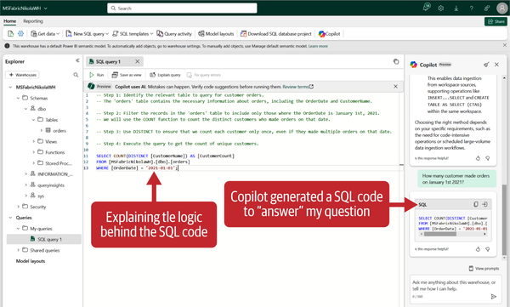

Figure 13-16. Copilot generated SQL code together with an explanation of the code logic

As you can see, Copilot first generated a SQL code snippet as the answer to our natural language question. We can then insert the code in the query window directly from the Copilot chat window. And, as you see, Copilot generated not only the code, but also generated comments explaining the logic behind the generated query.

We’ll now expand on the previous query and ask Copilot the following question: “How many customers made more than 2 orders on January 1st 2021?” Looking at [Figure 13-17](https://learning.oreilly.com/library/view/fundamentals-of-microsoft/9781098172916/ch13.html#fabric_ch_13_figure_17_1748224986309925), we consider this a wonderful way to not only retrieve the desired results, but also for to learn and better understand T-SQL code.

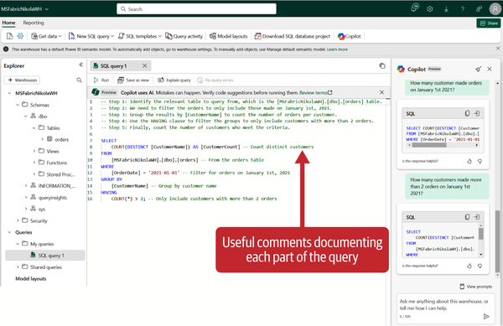

Figure 13-17. Very helpful code explanation provided by Copilot

This is nice, but let’s now really go wild with Copilot in Warehouse. In [Figure 13-18](https://learning.oreilly.com/library/view/fundamentals-of-microsoft/9781098172916/ch13.html#fabric_ch_13_figure_18_1748224986309953), we’re looking into an existing query that could have been written by us or someone else. Let’s say that we’re not sure what this query is supposed to do. We can simply type **/explain** in the Copilot chat window, and Copilot will explain the query.

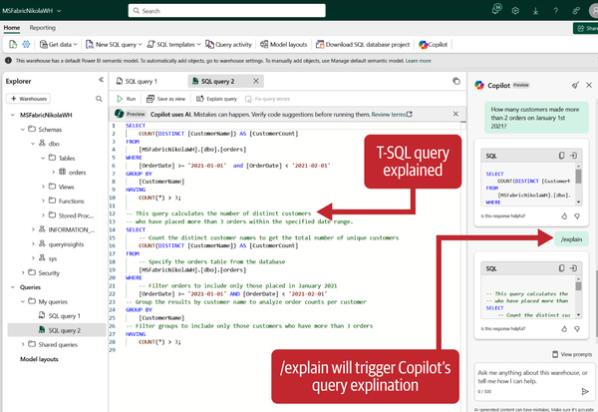

Figure 13-18. The “/explain” prompt will trigger a query explanation by Copilot

Generally speaking, the “/” commands may be used for numerous advanced use cases. [Table 13-1](https://learning.oreilly.com/library/view/fundamentals-of-microsoft/9781098172916/ch13.html#fabric_ch_13_table_1_1748224986317339) shows some common examples. Please keep in mind that, when using these commands, they must be at the start of your prompt.

| **Command** | **Generated action** |
| --- | --- |
| /generate-sql | T-SQL query from the prompt |
| /explain | Explanation of the active query |
| /fix | A fix for the active query |
| /question | Natural language response from the prompt |
| /help | Links to Copilot documentation |
| Table 13-1. Commands to generate actions | |

Another use case for Copilot in Warehouse is for code completion. You need to enable [“Show Copilot completions”](https://learn.microsoft.com/en-us/fabric/data-warehouse/copilot-code-completion) in the Warehouse settings. After that, you can check the status at the bottom of the query editor, as displayed in [Figure 13-19](https://learning.oreilly.com/library/view/fundamentals-of-microsoft/9781098172916/ch13.html#fabric_ch_13_figure_19_1748224986309974).

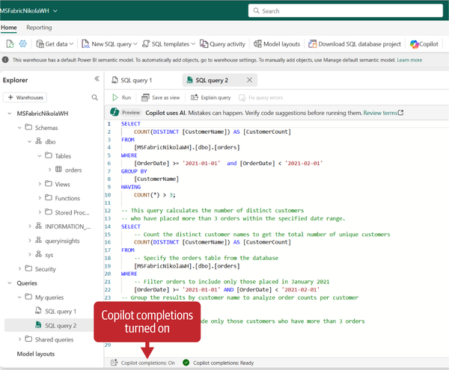

Figure 13-19. Check if the Copilot completion setting is turned on

Finally, Copilot quick actions is just a dressed-up implementation of the /explain and /fix commands that we mentioned in [Table 13-1](https://learning.oreilly.com/library/view/fundamentals-of-microsoft/9781098172916/ch13.html#fabric_ch_13_table_1_1748224986317339). [Figure 13-20](https://learning.oreilly.com/library/view/fundamentals-of-microsoft/9781098172916/ch13.html#fabric_ch_13_figure_20_1748224986309994) shows how to access these actions in the query editor.

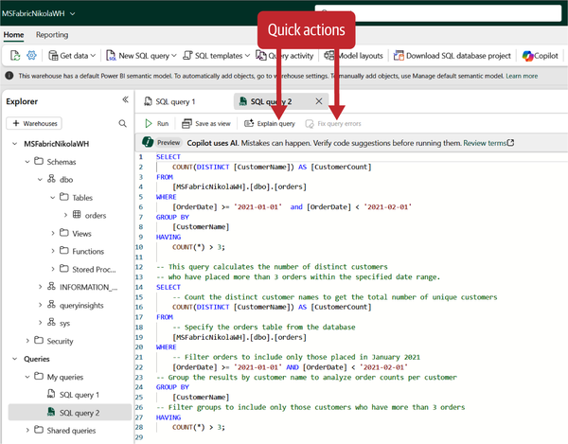

Figure 13-20. Quick actions to explain and/or fix a query

The “Fix query errors” option is disabled by default and becomes enabled only after a query run fails with errors.

Copilot for Power BI

We won’t be wrong if we say that Copilot for Power BI is the longest-standing of all Fabric Copilots. And, it’s not a coincidence, taking into consideration the solid history of various built-in AI features in Power BI, such as the Q&A feature, Smart Narratives, Analyze feature, Key influencers visual, and many more.

Copilot for Power BI can be leveraged for multiple tasks, both in the Power BI service and Power BI Desktop. In the following sections, we’ll examine some of the common scenarios for using Copilot for Power BI.

**Prepare Semantic Model for Copilot**

The universal truth when working with data is “garbage in, garbage out!” This means, if your data is of poor quality when you start building your analysis, you shouldn’t expect that it will somehow be automagically fixed and that your end users will get clean, high-quality output. Therefore, it is of paramount importance to invest time and effort in shaping the data before you start performing any analysis on it.

This is absolutely true in every scenario—including scenarios involving Copilot. You should be aware that Copilot is not a magician that can transform your “ugly duck” into “white swan” data.

[Table 13-2](https://learning.oreilly.com/library/view/fundamentals-of-microsoft/9781098172916/ch13.html#fabric_ch_13_table_2_1748224986317381) provides the list of considerations for various model objects that might have an impact on the results generated by Copilot.

| **Object** | **Recommendation** | **Consideration** | **Example** |
| --- | --- | --- | --- |
| Table | Define clear relationships | Ensure proper relationships are established, including relationship cardinality (1:1, 1:M, M:M) | The Sales table is connected to the Customer table on the CustomerKey column |
| Measure | Standardized calculation logic | Ensure standardized and clear calculation logic | The Total Sales measure calculated as the sum of the SalesAmount column from the Sales table |
| Measure | Naming conventions | Ensure the measure name clearly reflects the calculation | Use “Average_Tax_Amount” instead of “AvgTaxAmt” |
| Fact table | Create a fact table in accordance with the Star schema design | Fact tables should contain measurable data in addition to dimension keys | Orders, Sales, Purchases |
| Dimension table | Create a dimension table in accordance with the star schema design | Dimension tables should contain descriptive attributes relevant to the object of interest | Customer, Product, Date |
| Hierarchy | Logical grouping of attributes used for drilling down into data | Ensure the hierarchy has a logical sequence | Calendar hierarchy that consists of Year, Quarter, Month, and Day |
| Column | Use clear names | Ensure column names are unambiguous and self-explanatory | Use Customer_Name instead of CustomerKey |
| Column | Use proper and consistent data types | Ensure correct and consistent data types across all tables in the model | Set numeric type for columns used in calculations |
| Table 13-2. Semantic model considerations for Copilot | | | |

In addition, when using Copilot for writing DAX, you should provide clear descriptions of model objects (measures, tables, and columns) so that Copilot “knows” how do you want to handle a particular calculation.

**Create Reports in the Power BI Service or Power BI Desktop**

Let’s create our first Power BI report with Copilot. As a prerequisite, we need a semantic model that will be used as a blueprint for the report. We’ve created a fairly simple semantic model in Direct Lake storage mode, which consists of four tables:

* FactSales
* DimCustomer
* DimProduct
* DimDate

If you’re not sure what Direct Lake storage mode is, and how it works behind the scenes, we encourage you to revisit [Chapter 9](https://learning.oreilly.com/library/view/fundamentals-of-microsoft/9781098172916/ch09.html#fabric_ch_9_power_bi_1748224996890066), where we covered Direct Lake storage mode in detail. As you see in [Figure 13-21](https://learning.oreilly.com/library/view/fundamentals-of-microsoft/9781098172916/ch13.html#fabric_ch_13_figure_21_1748224986310014), tables are connected with regular 1:M relationships.

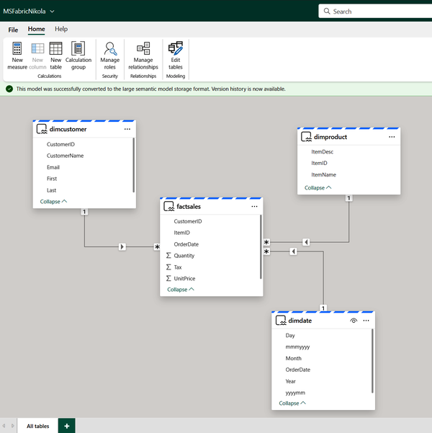

Figure 13-21. Direct Lake semantic model in the Power BI service

We’ve also created two DAX measures:

* Total Quantity = SUM(FactSales[Quantity])
* Sales Amount = SUMX(FactSales,  
  FactSales[Quantity] * FactSales[UnitPrice]  
  )

We will use this model for all our demos in this chapter. Once we choose the “Create report” option from the semantic model settings, our old buddy Copilot is ready to assist us. Similar to the experience you’ve seen in the previous sections with other Fabric Copilots, there is a list of predefined prompts in the Copilot chat window, as displayed in [Figure 13-22](https://learning.oreilly.com/library/view/fundamentals-of-microsoft/9781098172916/ch13.html#fabric_ch_13_figure_22_1748224986310038).

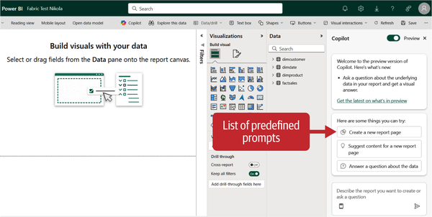

Figure 13-22. Copilot predefined prompts in the Power BI service

Let’s give it a try and start with the top suggestion, “Create a new report page.” After Copilot performs the model schema scanning, it provides a brief description of the suggested report pages, as you can see in [Figure 13-23](https://learning.oreilly.com/library/view/fundamentals-of-microsoft/9781098172916/ch13.html#fabric_ch_13_figure_23_1748224986310062).

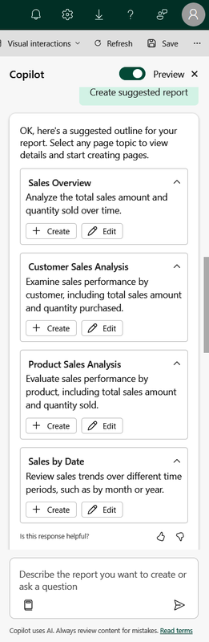

Figure 13-23. Copilot suggested creating a report with four pages

We’ve then asked Copilot to create the suggested report. As you might have noticed in the previous figure, you can choose between the Create and Edit options. Choosing Create will trigger the report page creation, whereas Edit enables you to fine-tune the generated suggestion and customize it according to your needs. In this case, let’s keep it simple and see what Copilot comes up with. [Figure 13-24](https://learning.oreilly.com/library/view/fundamentals-of-microsoft/9781098172916/ch13.html#fabric_ch_13_figure_24_1748224986310082) shows the Copilot-generated report.

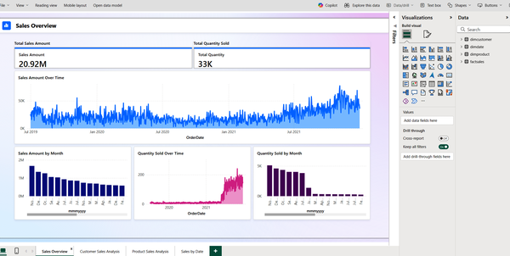

Figure 13-24. Copilot-generated report with four pages

Let’s be honest—this looks promising! You can obviously complain about using color X instead of color Y, or choosing visual type A instead of visual type B. But, we consider this an excellent starting point, which you can build upon to make your report look even better.

The next thing we want from Copilot is to suggest the content for the new report page. If you recall, this is one of the predefined prompts. Once we trigger this prompt, Copilot provides four suggestions for additional report pages:

* Customer Demographics
* Sales Tax Analysis
* Product Description Insights
* Order Quantity Trends

We can proceed to create or edit any or all of these pages.

The process of creating a Copilot-generated report in Power BI Desktop is very similar. The key thing to keep in mind when designing reports in Power BI Desktop is that you need to provide a Copilot-compatible workspace, as shown in [Figure 13-25](https://learning.oreilly.com/library/view/fundamentals-of-microsoft/9781098172916/ch13.html#fabric_ch_13_figure_25_1748224986310102).

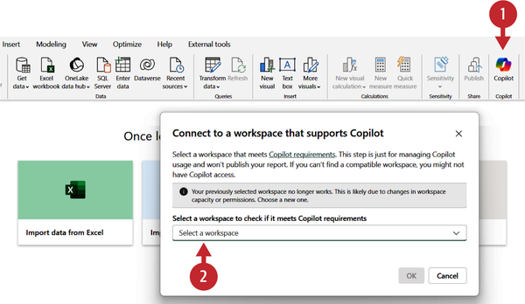

Figure 13-25. Creating a Copilot-generated report from Power BI Desktop

Please be aware that the workspace you select here doesn’t necessarily need to be a workspace where the report will be published. It just needs to be a workspace with Copilot enabled.

**Summarize Report Content in the Copilot Pane**

Sometimes, users don’t have permission to edit a Power BI report. However, even in these scenarios, Copilot can be of help, by providing a summary of the report in the Copilot chat pane. [Figure 13-26](https://learning.oreilly.com/library/view/fundamentals-of-microsoft/9781098172916/ch13.html#fabric_ch_13_figure_26_1748224986310121) displays Copilot’s response to the prompt: “Summarize visuals on this page.”

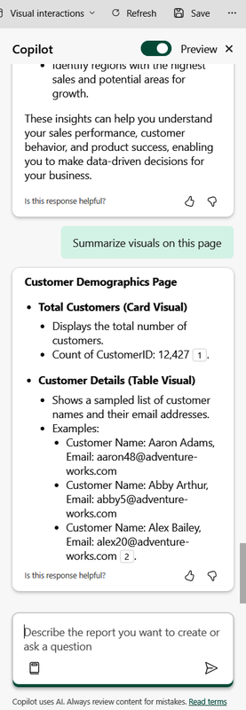

Figure 13-26. Copilot can summarize the report page content

**Write DAX with Copilot**

“DAX is simple, but not easy!” This sentence, shared by [Alberto Ferrari](https://www.linkedin.com/in/albertoferrarisqlbi/)and coined by one of his learners, best describes the feelings of the majority of Power BI practitioners. While DAX is definitely not a primary topic of this book, it is without a doubt an integral part of Power BI and probably the most intimidating skill to acquire for many Power BI data analysts. Having a dedicated Copilot for DAX is like a dream come true to ease the burden of writing DAX code and flattening the DAX learning curve.

DAX Copilot is available within the dedicated DAX query view in Power BI Desktop, as shown in [Figure 13-27](https://learning.oreilly.com/library/view/fundamentals-of-microsoft/9781098172916/ch13.html#fabric_ch_13_figure_27_1748224986310140).

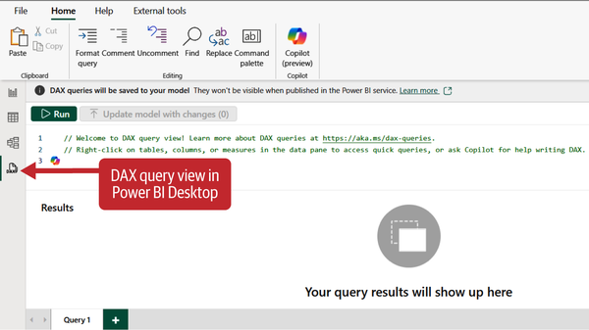

Figure 13-27. DAX query view in Power BI Desktop

We’ve connected to the semantic model we previously created and used in the previous sections. Once in a DAX query view, I’ve entered the following prompt in the dialog window: “Total Sales for each product.” And, if you take a look at [Figure 13-28](https://learning.oreilly.com/library/view/fundamentals-of-microsoft/9781098172916/ch13.html#fabric_ch_13_figure_28_1748224986310160), you’ll notice that Copilot did a wonderful job, as the generated DAX query produced the expected results.

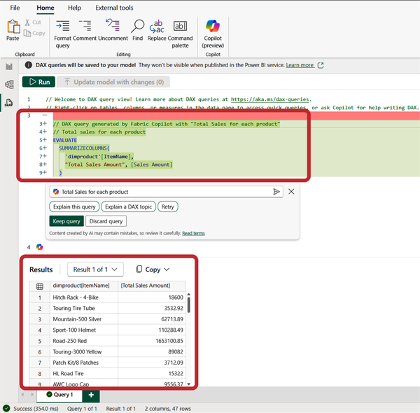

Figure 13-28. DAX query generated by Copilot and its results

Furthermore, we can ask Copilot to suggest measures for our report. Copilot rightly assumed that calculating the average value of the sales amount may be helpful for our end users, but it generated an invalid DAX statement. Since we don’t have a sales amount column in the model, Copilot tried to apply the AVERAGE function to the Sales Amount measure, which is not allowed. The query returned the error shown in [Figure 13-29](https://learning.oreilly.com/library/view/fundamentals-of-microsoft/9781098172916/ch13.html#fabric_ch_13_figure_29_1748224986310180).

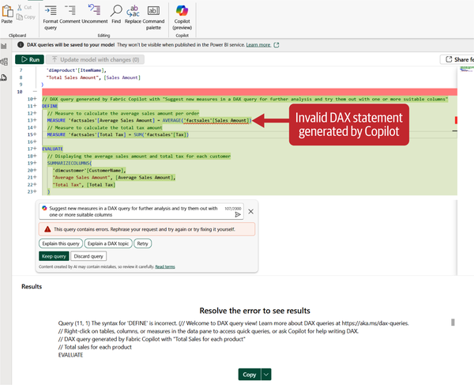

Figure 13-29. Invalid DAX statement generated by Copilot

Again, you shouldn’t be too surprised with this behavior. We will emphasize that you should always take Copilot-generated results with a grain of salt, as these results might be incorrect or unexpected.

In addition to assisting in writing DAX code, Copilot may be used as a learning tool. Choosing the “Explain a DAX topic” button will trigger Copilot to provide a narrative summary of the functions used in the previously generated query, as shown in [Figure 13-30](https://learning.oreilly.com/library/view/fundamentals-of-microsoft/9781098172916/ch13.html#fabric_ch_13_figure_30_1748224986310201).

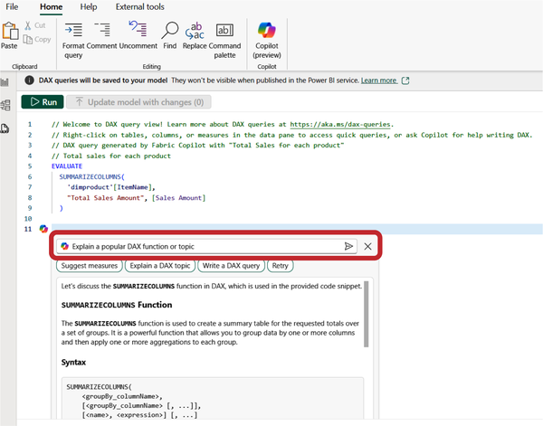

Figure 13-30. Copilot explaining a relevant DAX topic

Let’s try to summarize our experience of using Copilot in Power BI so far. It’s extremely powerful and versatile, covering a wide range of use cases and scenarios. As you saw, we’ve been able to quickly get up and running with creating multipage reports out of the blue, as well as level up our DAX coding skills. However, we want you to remember two key things about Copilot for Power BI:

* The same as with other Copilot and AI-generated results, be careful and evaluate and double-check the outcome.
* Building and maintaining a proper semantic model is more relevant than ever in Copilot-based scenarios .

Copilot for Real-Time Intelligence

With Copilot in the Real-Time Intelligence workload, your natural language queries can be easily translated into KQL language. If you are not sure what KQL is, we suggest you start by reading [Chapter 8](https://learning.oreilly.com/library/view/fundamentals-of-microsoft/9781098172916/ch08.html#fabric_ch_8_real_time_intelligence_1748224995739238), where we’ve already examined numerous KQL examples.

The same as its other Fabric “relatives,” Copilot for Real-Time Intelligence enables you to transform conversational interactions into actionable outcomes. In real life, this means you can dynamically refine Copilot-generated queries by adjusting the prompt to provide additional context if needed. Not only that, let’s say that the generated KQL query is correct, but you need to explore data in more detail. You can achieve that by asking follow-up questions, either by extending the scope of the original prompt, or by adding filters. All of that on top of the previous conversation with Copilot.

Copilot for Real-Time Intelligence can be accessed from the KQL queryset item. If you are not sure what the KQL queryset is, we recommend you first navigate to [Chapter 8](https://learning.oreilly.com/library/view/fundamentals-of-microsoft/9781098172916/ch08.html#fabric_ch_8_real_time_intelligence_1748224995739238), which covers all Real-Time Intelligence items, including the KQL queryset, in more depth.

Once we open the KQL queryset, the Copilot chat window can be expanded, as displayed in [Figure 13-31](https://learning.oreilly.com/library/view/fundamentals-of-microsoft/9781098172916/ch13.html#fabric_ch_13_figure_31_1748224986310227).

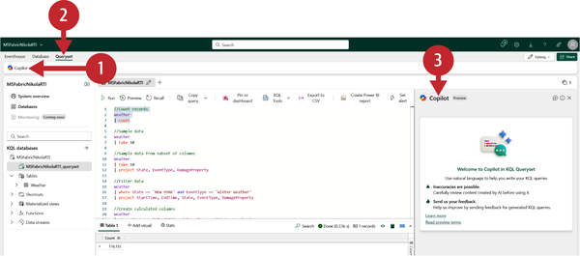

Figure 13-31. Copilot chat window in KQL queryset

We’ll be using the sample Weather dataset provided by Microsoft. Let’s start simply by entering the following prompt: “How many storm events happened in 2005?” The generated output is a KQL code snippet, which we may directly insert into the query editor, as shown in [Figure 13-32](https://learning.oreilly.com/library/view/fundamentals-of-microsoft/9781098172916/ch13.html#fabric_ch_13_figure_32_1748224986310260).

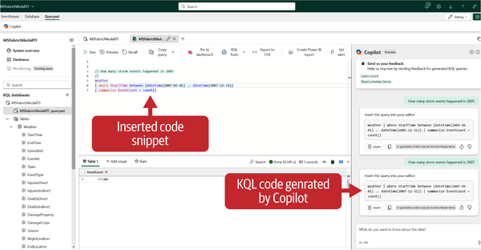

Figure 13-32. KQL code snippet as a response to a natural language question

As previously mentioned, we can ask follow-up questions. For example, let’s say that we are interested only in storm events that happened in New York. I’ve asked Copilot: “How many of those were in New York?”, where “those” refers to the result generated based on the previous question. Copilot didn’t disappoint and provided the following KQL code snippet to include the additional filter on the State column:

// How many of those were in New York?

//

Weather

| where StartTime between (datetime(2007-01-01) .. datetime(2007-12-31))

| where State == "New York"

| summarize EventCount = count()

This can be further customized. Let’s say that we want to see not only the summarized data, but also a detailed overview that includes every single storm event in New York in 2007. We asked Copilot: “Can you list all of them?” Again, pay attention to how the question is phrased: we’re not explicitly asking for “New York” and “2007” as filter criteria, but Copilot builds upon the previous conversation:

// Can you list all of them?

//

Weather

| where StartTime between (datetime(2007-01-01) .. datetime(2007-12-31))

| where State == "NEW YORK"

| project StartTime, EndTime, EpisodeId, EventId, State, EventType, InjuriesDirect, InjuriesIndirect, DeathsDirect, DeathsIndirect, DamageProperty, DamageCrops, Source, BeginLocation, EndLocation, EventNarrative, StormSummary, EpisodeNarrative, BeginLon, EndLon, BeginLat, EndLat

Copilot for SQL Database

Copilot for SQL database works the same way as Copilot for Data Warehouse. Therefore, all the features and use cases that we examined in the Copilot for Data Warehouse section are absolutely relevant in SQL database scenarios as well.

You can learn more about the SQL database in Fabric in [Chapter 10](https://learning.oreilly.com/library/view/fundamentals-of-microsoft/9781098172916/ch10.html#fabric_ch_10_sql_databases_1748224983704930).

AI Services in Microsoft Fabric

Azure AI services is the official successor to Azure Cognitive Services. The main goal of AI services is to enable developers and organizations to quickly build intelligent applications using customizable APIs and models.

Microsoft Fabric provides two options for using AI services:

*Prebuilt AI models in Fabric*

You can leverage numerous prebuilt AI models in Fabric to enrich the existing data. The following prebuilt AI models are currently available:

* Azure OpenAI Service includes widely adopted and used *GPT-35-turbo* and *GPT-4* family of models.
* Text Analytics includes language detection, sentiment analysis, key phrase extraction, personally identifiable information (PII) recognition, named entity recognition, and entity linking.
* Azure AI Translator enables text and document translation across more than 100 languages using a REST API

*Bring your own key (BYOK)*

This option allows for provisioning AI services and bringing your own key to use them from Microsoft Fabric.

One of the key considerations when using AI services in Fabric is the consumption rate, which may vary significantly depending on the model you use. We suggest you first [check the consumption rate](https://learn.microsoft.com/en-us/fabric/data-science/ai-services/ai-services-overview#consumption-rate) to ease the potential burden on the Fabric capacity.

Data Agent in Microsoft Fabric

The Fabric data agent feature was introduced with the aim of providing even more power and flexibility in implementing generative AI workloads. In a nutshell, Fabric data agent enables creating your own conversational Q&A systems based on the structured data stored in OneLake.

The core idea behind the Fabric data agent item is to provide instructions and examples in advance, thus guiding AI to ensure that the correct answer will be provided to the end user. As with Copilots, Fabric data agent relies on LLMs. We’ll explore key differences between Copilot and Fabric data agent in this section.

[Figure 13-33](https://learning.oreilly.com/library/view/fundamentals-of-microsoft/9781098172916/ch13.html#fabric_ch_13_figure_33_1748224986310283) displays a typical workflow in Fabric data agent.

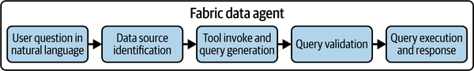

Figure 13-33. Fabric data agent common workflow

The process starts with the user asking a question in the Fabric data agent interface using natural language. The system takes this query and leverages the user’s credentials to access the data source. It then evaluates the user’s question against various data sources, such as lakehouses, warehouses, semantic models, and KQL databases. Then, the Fabric data agent invokes the appropriate tool and generates the query using the proper language: T-SQL for retrieving the data from the lakehouse or warehouse; DAX for querying Power BI semantic models; and KQL for getting the data from KQL databases. The generated query is validated, and finally, after the query is executed, results are displayed in a human-readable way, such as tables, summaries, or key insights.

Some of the common, real-life question examples that you may ask Fabric data agent are:

* How many active customers did we have on January 1st, 2025?
* Which marketing campaign had the biggest impact?
* What is the most sold product?

From a conceptual point of view, you can think of a Fabric data agent as similar to a Power BI report. When working with Power BI, you first create a report, and then you can share the report with other colleagues in the organization who can generate their own insights based on the original report. It is similar to the Fabric data agent item, which first needs to be created and configured, and then can be shared with others.

Please bear in mind that the Fabric data agent requires some fine-tuning to be able to provide meaningful answers to specific questions. While you may expect the Fabric data agent to provide out-of-the-box responses to reasonable questions, in some specific use cases, it may come up with incorrect answers. This is due to the lack of context about your organization and key data definitions. To overcome this issue and guide the Fabric data agent in the right direction, you should provide the Fabric data agent with specific instructions and examples.

**Fabric Data Agent versus Copilot**

With Fabric data agent and Copilot providing a very similar set of functionalities, and considering that they are both based on the same technology (generative AI and LLMs), the fair question would be, Which generative AI feature should I use in Microsoft Fabric?

There are two main considerations that might affect your decision:

*Flexibility*

Fabric data agent provides much more flexibility with configuration. You can provide it with instructions and examples, so it is fine-tuned to handle your specific use case. On the flip side, Copilot can’t be configured to handle particular, organization-specific scenarios.

*Scope*

Copilot is bound to Fabric workloads. It can assist you in generating the code for notebooks, writing DAX queries, or analyzing the content of a pipeline. On the other hand, a Fabric data agent works independently; for example, you can connect it to Microsoft Teams and other non-Fabric workloads.

**Working with the Fabric Data Agent**

Let’s see the Fabric data agent item in action. Once we create a new Fabric data agent item, the first step is to ensure that the data source is defined, as shown in [Figure 13-34](https://learning.oreilly.com/library/view/fundamentals-of-microsoft/9781098172916/ch13.html#fabric_ch_13_figure_34_1748224986310303).

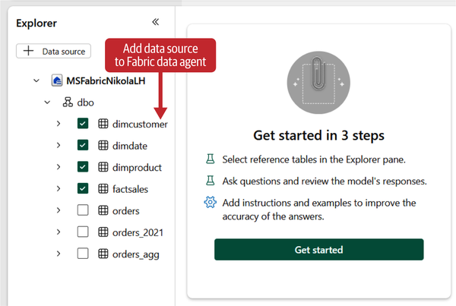

Figure 13-34. Adding a data source to Fabric data agent

Data source can be defined on the individual table level. In this example, we’ve added four tables from the lakehouse. We’re now ready to start asking our questions. Let’s start with a simple one: “What is the most expensive product we are selling?” Let us briefly stop here and explain the result you may observe in [Figure 13-35](https://learning.oreilly.com/library/view/fundamentals-of-microsoft/9781098172916/ch13.html#fabric_ch_13_figure_35_1748224986310323).

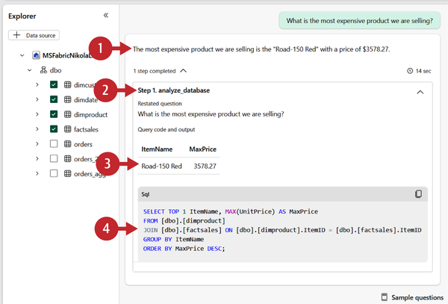

Figure 13-35. Fabric data agent response to a natural language question

1. The natural language response generated by the Fabric data agent
2. Explanation of all the steps taken to obtain the result
3. The tabular response generated by the Fabric data agent
4. SQL query generated to obtain the result

Observe how the Fabric data agent cleverly translated the word “product” into the item column from our dimproduct table, as we don’t have a product column in the model. We can also expect answers to questions such as:

* Which customer made the most orders?
* What product was sold more than three times on January 1st 2021?

However, if you try to search for some more sophisticated answers, by asking questions like:

* Why is our productivity lower in Q3 2021 than in Q3 2020?
* What is the root cause of the orders spike in 2021?

… it is not going to work. Please bear in mind that the final outcome of the Fabric data agent item is the query—SQL, DAX, or KQL. There is no SQL/DAX/KQL code with brain-like reasoning to *explain* something.

A Fabric data agent item can be configured to enhance the accuracy of the generated response by providing example queries. This is a well-known approach in generative AI, called *few shot learning*, which enables guiding the Fabric data agent to generate the responses that match, or almost match, your expectations. The steps for providing example SQL queries are depicted in [Figure 13-36](https://learning.oreilly.com/library/view/fundamentals-of-microsoft/9781098172916/ch13.html#fabric_ch_13_figure_36_1748224986310343).

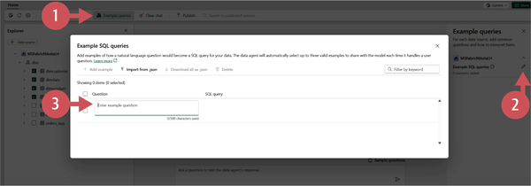

Figure 13-36. Enhancing Fabric data agent with example SQL queries

You should first select the “Example queries” option (1) and then, in the Example queries window (2) choose to edit Example queries. Finally, in the dialog window (3), enter the example question and provide the SQL query that answers that question.

Another way to help the Fabric data agent generate the expected result is by using the “Data agent instructions” feature. The main goal of “Data agent instructions” is to provide definitions in plain English. [Figure 13-37](https://learning.oreilly.com/library/view/fundamentals-of-microsoft/9781098172916/ch13.html#fabric_ch_13_figure_37_1748224986310362) displays the Data agent instructions workflow.

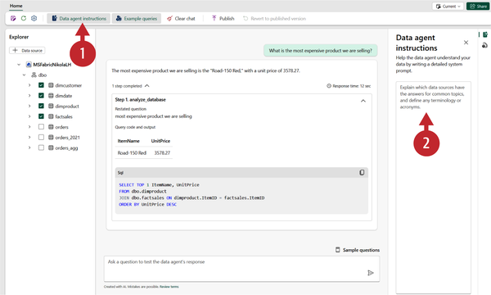

Figure 13-37. Helping Fabric data agent by providing instructions

Here are a few examples of Data agent instructions that you can use to fine-tune Fabric data agent generated responses:

* Whenever we ask for “the most sold” products, the metric of interest is Sales Amount and not Order Quantity.
* The primary table to use is Fact Online Sales. Only use table Fact Reseller Sales when explicitly asked about resales.
* When asked about the marketing campaign impact, check this on the Sales Amount and not on the number of units sold.
* Use the DimDate table and its attributes, such as Year, Month, or Day, to perform time-based analysis.
* When asked about customer demographics, join DimCustomer table to relevant fact tables.
* ListPrice in DimProduct table is the suggested selling price, while UnitPrice in Fact Online Sales is the actual price at which the product was sold.

Once you are happy with the Fabric data agent item configuration, you can publish it to the workspace. Since it’s a regular Fabric item, the Fabric data agent can also be shared with other users or group of users, as shown in [Figure 13-38](https://learning.oreilly.com/library/view/fundamentals-of-microsoft/9781098172916/ch13.html#fabric_ch_13_figure_38_1748224986310388).

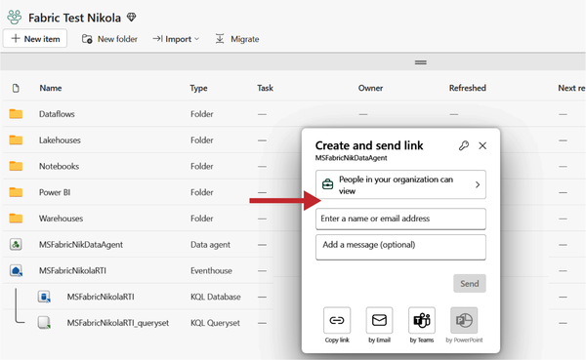

Figure 13-38. Sharing a Fabric data agent item with other users

Summary

If you made it to the end of this chapter without asking Copilot to summarize it, we salute you! By no means do we want to diminish the importance of AI and LLMs in today’s world. On the contrary, we firmly believe that if we delegate more tasks and operations to AI, especially manual and repetitive tasks, we will become not only more efficient, but have more time to spend on creative and strategic work.

A key takeaway from this chapter is this: generative AI models are only as accurate as the data they are fed, and it is always recommended that you check the output validity. Don’t forget, this is just a Copilot, and you should still be the *pilot*.

Since Copilot and other AI features come with a cost, we are sure you’ll enjoy reading the next chapter, where we cover the Microsoft Fabric pricing model in depth.

**Part III. Putting Fabric into Production**

This section fills in the remaining gaps by addressing important topics that go beyond just understanding individual features. While knowing how each experience in Fabric works is essential, bringing everything together for a real-world production deployment requires a broader view.

We will cover key considerations such as pricing and security, ensuring you have the necessary information to plan and optimize your Fabric implementation effectively. Understanding cost implications will help you make informed decisions about resource allocation, while security best practices will provide the confidence needed to handle data responsibly.

Another crucial aspect we will tackle is choosing the right experience for the right use case. Fabric offers multiple ways to solve many data challenges, and it’s not always immediately clear which approach is best. By clarifying when to use different components, we aim to remove uncertainty and provide guidance on how to design efficient, scalable, and maintainable solutions.

With these final pieces in place, you will have a complete picture of what it takes to move from learning Fabric’s features to successfully applying them in production.

Chapter 14. The Fabric Pricing Model

**A Note for Early Release Readers**

With Early Release ebooks, you get books in their earliest form—the authors’ raw and unedited content as they write—so you can take advantage of these technologies long before the official release of these titles.

This will be the 14th chapter of the final book. Please note that the GitHub repo will be made active later on.

If you’d like to be actively involved in reviewing and commenting on this draft, please reach out to the editor at *sevans@oreilly.com*.

After diving through all the features and experiences Fabric provides in [Part II](https://learning.oreilly.com/library/view/fundamentals-of-microsoft/9781098172916/part02.html#part2), Let’s kick off the final section of this book in [Part III, “Putting Fabric into Production”](https://learning.oreilly.com/library/view/fundamentals-of-microsoft/9781098172916/part03.html#part3) and look at another interesting aspect of Fabric: licensing, or rather, pricing. Rather than sizing, deploying, and paying for a variety of individual services and offerings, with Fabric you are basically paying for a single product.

Fabric pricing consists of three components: compute, storage, and user licenses, as you’ll see in [Figure 14-1](https://learning.oreilly.com/library/view/fundamentals-of-microsoft/9781098172916/ch14.html#fabric_ch_14_figure_1_1748224986578499) (which you’ve already seen in [Chapter 1](https://learning.oreilly.com/library/view/fundamentals-of-microsoft/9781098172916/ch01.html#fabric_ch_1_what_is_microsoft_fabric_1748224991062657)).

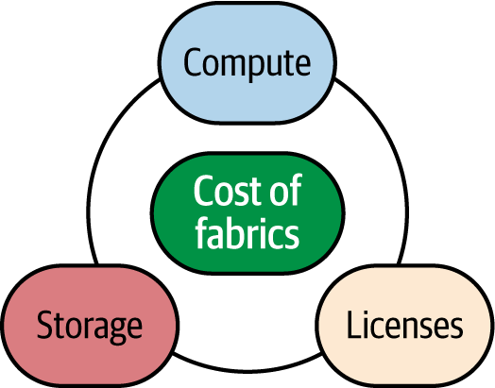

Figure 14-1. The three components of Fabric pricing

Compute & Capacities

When we talk about compute in Fabric, we talk about something called capacities. Capacities form the compute power of your entire Fabric deployment, no matter which specific offerings you’re using, so the words compute and capacity are synonymous in the context of Fabric. [Figure 14-2](https://learning.oreilly.com/library/view/fundamentals-of-microsoft/9781098172916/ch14.html#fabric_ch_14_figure_2_1748224986578532), for example, shows two capacities using different sizes in different regions.

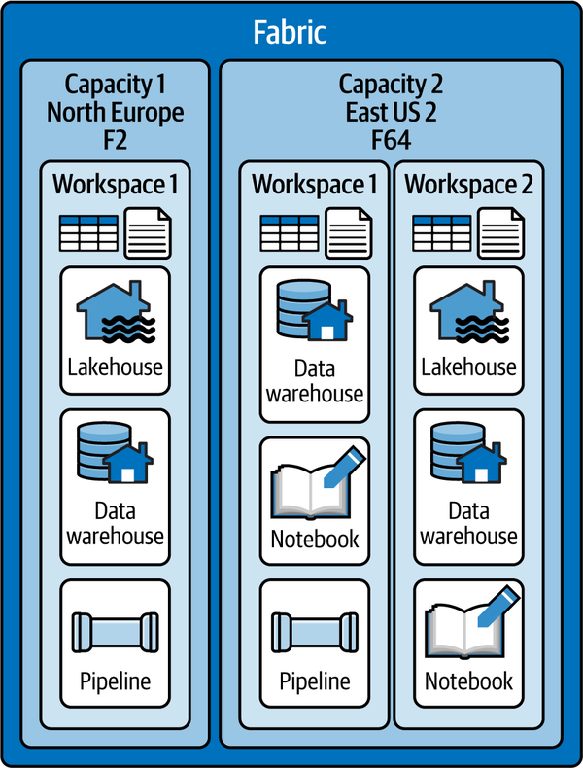

Figure 14-2. Capacity sizes and settings

Your entire Fabric environment can be based on a single capacity, or you can run multiple capacities that have different names, may sit in different regions, and may be different sizes. Depending on their sizes, they will have the ability to host a certain number of workloads at a time.

**Capacity Types**

There are three kinds of fabric capacities: Fabric, Fabric Reserved, and Fabric Trial (see [Figure 14-3](https://learning.oreilly.com/library/view/fundamentals-of-microsoft/9781098172916/ch14.html#fabric_ch_14_figure_3_1748224986578555)).

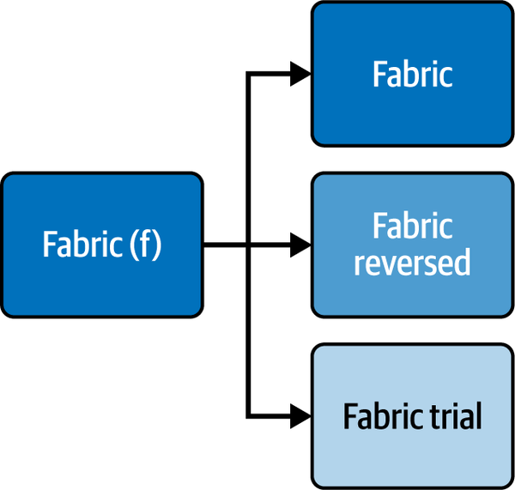

Figure 14-3. Fabric capacity types

A regular Fabric capacity will be billed on a pay-as-you-go basis, so you only pay for the compute time your capacities are running, whereas with a reserved capacity, you make a commitment for a certain amount of time in exchange for a discount.

Both Fabric and Fabric Reserved capacities use Azure billing. From a technical perspective they are the same thing, They are also technically the same thing. so the differentiation is solely for billing purposes.

Trials give you access to almost the full feature set of Fabric at no cost for 60 days with the equivalent of an F64 capacity—more on that in the next section. The most important feature currently missing from trials is Copilots.

While any capacity can be paused, this usually only makes sense for pay-as-you-go workloads because with a paused capacity, you will pay for it only while it is running; a reserved capacity will be billed 24/7 anyway. The process of pausing is for the capacity, not the workload, so unless you pause your capacity, you will still be billed even if there is no workload happening, meaning you are billed for capacity uptime.

**Capacity Sizes**

Fabric capacities come in different sizes. As you may have come across in other cloud offerings, size determines the number of capacity units (CUs)—an equally abstract metric—and therefore the performance and size of workloads this capacity can provide.

The smallest size is an F2, which has two capacity units, followed by an F4 up to F2048, the largest size currently available, which has 2,048 capacity units.

To make this a bit more transparent: A day has 86,400 seconds. An F2 capacity has 2 capacity units so 2*86,400 seconds = 172,800 compute seconds available to you, while an F8 capacity has 8*86,400 resulting in 691,200 compute seconds available to you in a day (assuming you are running your capacity 24 hours a day). See [Figure 14-4](https://learning.oreilly.com/library/view/fundamentals-of-microsoft/9781098172916/ch14.html#fabric_ch_14_figure_4_1748224986578576).

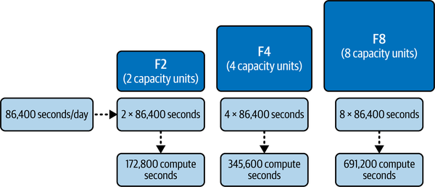

Figure 14-4. Meaning of capacity sizes

Unfortunately, there is no great guidance or general rule on how much can be achieved within a compute second because that is very workload (and offering) specific, so the best practice when it comes to sizing your environment is still to start with an educated guess and then work your way up or down from there.

What Exactly Is a Capacity Unit (CU)?

A CU is basically a made-up unit by Microsoft. It does not easily convert into memory, CPUs, or anything similar. Every offering in Fabric has its own translation of how it uses CUs, or how they map into something more relatable. Those mappings are, however, not public for every offering and are also subject to change. At the time of writing, for example, 2 CUs would translate to one vCore for Spark or 0.25 vCores for Power BI. This means, when running an F2 capacity, without bursting (which we’ll discuss in the next section), you could use one Spark vCore, but that would use your entire capacity. Especially with mixed workloads (lakehouse, warehouse, Power BI, etc.), you could easily end up in a situation with a very hard-to-predict requirement of CUs to support those workloads.

To better understand the consumption of your CUs, Microsoft has provided the [Metrics app](https://learn.microsoft.com/en-us/fabric/enterprise/metrics-app), which we will discuss in more detail in [Chapter 15](https://learning.oreilly.com/library/view/fundamentals-of-microsoft/9781098172916/ch15.html#fabric_ch_15_administering_and_monitoring_microsoft_fabric_1748224987379944).

**Tip**

One important thing to note: In general, a higher number of CUs will not give you more compute power, but only more compute time. So increasing the number of CUs will give you more concurrent compute resources but will not necessarily improve the performance of a single workload.

Capacity Bursting (and Smoothing)

Even the smallest capacities allow you to make use of a feature called *bursting*. Cool. What does that mean?

Let’s assume you run an F8 capacity, and you keep it running 24/7. Let’s now make another assumption: You run a workload that would usually take 10 minutes to complete using your F8 capacity. Now, through bursting, Fabric *may* grant you additional compute power—more than you pay for—so this workload completes in 5 minutes, as if you had bought an F16 capacity (see [Figure 14-5](https://learning.oreilly.com/library/view/fundamentals-of-microsoft/9781098172916/ch14.html#fabric_ch_14_figure_5_1748224986578596)).

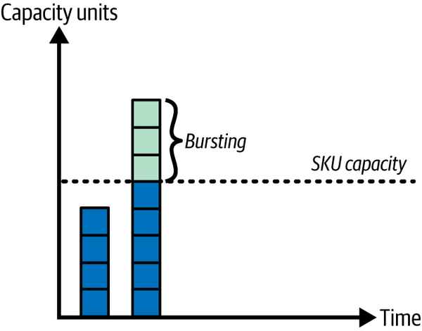

Figure 14-5. Bursting

So, is Microsoft gifting you free compute? Well, no. Think of it more as a credit line. Any extra compute that you consumed through bursting will need to be recovered through its counterpart, *smoothing*, within 24 hours. In addition, bursting is not guaranteed, so if you are running in a region that is at capacity, there may simply not be any additional resources available to you, which will mean no bursting for your capacity.

How does that impact you? If you don’t use the full compute units all the time, the smoothing will simply be recovered through the spare capacity you’re not using as shown in [Figure 14-6](https://learning.oreilly.com/library/view/fundamentals-of-microsoft/9781098172916/ch14.html#fabric_ch_14_figure_6_1748224986578616).

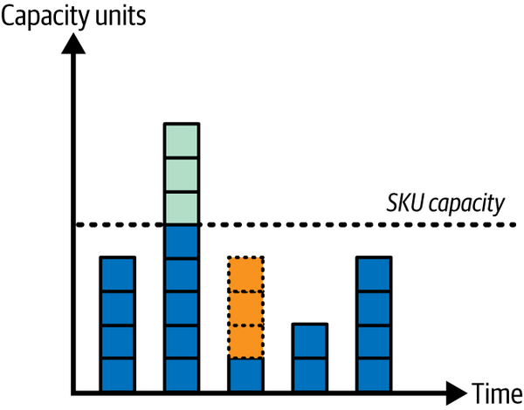

Figure 14-6. Previous bursting being recovered in a less idle period

If you consistently use all the compute units available to you, at some point, as illustrated in [Figure 14-7](https://learning.oreilly.com/library/view/fundamentals-of-microsoft/9781098172916/ch14.html#fabric_ch_14_figure_7_1748224986578637), your capacity will be throttled. This means that, for example, while you’re still paying for your F8 capacity, you may only get to use 4 CUs for a period of time.

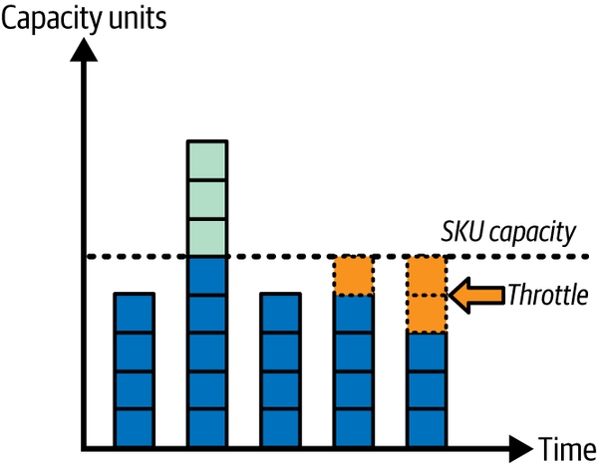

Figure 14-7. Previous bursting being recovered through throttling

And if you simply pause your capacity right after bursting? Then you’ll continue to be billed until you’ve paid your dues; that is, until all the extra compute units used by bursting have been recovered. See [Figure 14-8](https://learning.oreilly.com/library/view/fundamentals-of-microsoft/9781098172916/ch14.html#fabric_ch_14_figure_8_1748224986578658).

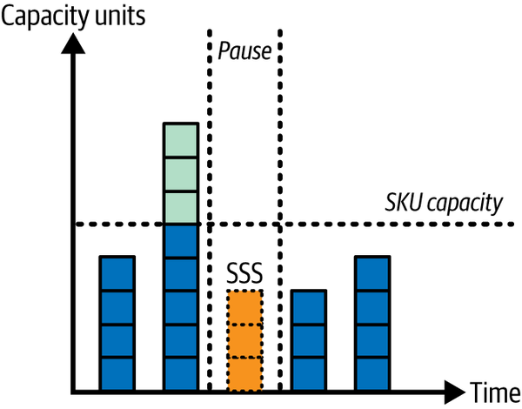

Figure 14-8. Previous bursting being recovered in a period where the capacity is paused

To help manage your CU consumption, you can also make use of a feature called *surge protection*. Surge protection helps manage compute consumption by limiting background job usage in a capacity. It is configured at the capacity level and serves to reduce throttling and rejections, though it does not replace scaling or optimization strategies. When enabled, two thresholds control its activation and deactivation. The *background rejection threshold* determines when surge protection becomes active by rejecting new background jobs once the 24-hour background percentage exceeds the set limit. Conversely, the *background recovery threshold* dictates when surge protection stops being active, allowing background jobs to resume once usage drops below the specified limit.

To enable surge protection, an admin role on the capacity is required. Go to the Fabric Admin portal, navigate to “Capacity settings,” select a capacity, expand Surge Protection, enable it, set the Background Rejection and Background Recovery thresholds, and select Apply, as shown in [Figure 14-9](https://learning.oreilly.com/library/view/fundamentals-of-microsoft/9781098172916/ch14.html#fabric_ch_14_figure_9_1748224986578679).

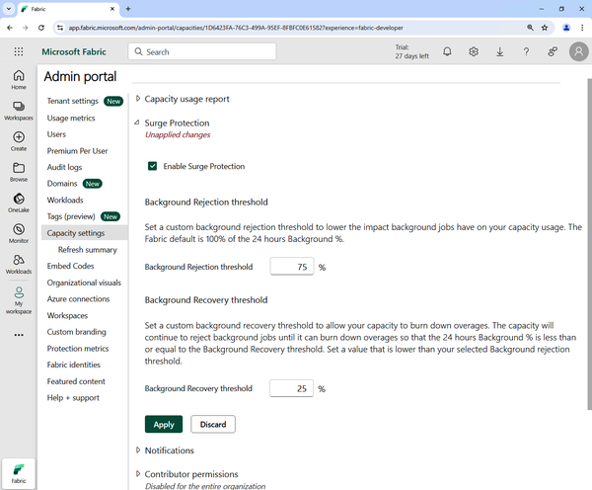

Figure 14-9. Enabling surge protection for a capacity

Capacity Limitations

Some features require a certain minimum SKU. Similar restrictions apply to other features. You can find an overview of current limitations at on the [Microsoft website](https://learn.microsoft.com/en-us/fabric/enterprise/fabric-features). Unfortunately, that overview isn’t always complete. so if you are relying on a specific feature, make sure to double-check its prerequisites in the documentation.

Storage

Storage pricing is straightforward. You simply pay per gigabyte for the storage you are using in OneLake. Storage will always be billed independently of compute, so even when you pause your capacity, you will pay for the storage used. You cannot pause your storage.

If you are making use of mirroring, which we elaborated on in [Chapter 11](https://learning.oreilly.com/library/view/fundamentals-of-microsoft/9781098172916/ch11.html#fabric_ch_11_mirroring_1748224984034275), you can take advantage of free storage for your mirrored data. With mirroring, you receive free storage for replicas up to a certain limit based on the purchased compute capacity SKU you provision (1 TB per capacity unit). For example, if you purchase an F8 capacity, you will get 8 free terabytes worth of storage. OneLake storage is billed only when the free mirroring storage limit is exceeded, or the provisioned compute capacity is paused.

User Licenses

User licenses do not play a significant role within Fabric with one exception: Power BI. If you’re not using Power BI within Fabric, or your capacity has a size of F64 or above, only report creators will need a Pro license. If you are using Power BI on a capacity that is smaller than F64, you will require a Power BI Pro license for every user that is using Power BI in workspaces within that capacity.

Otherwise, no paid user licenses are required (as long as you are strictly using Fabric capacities; there are other scenarios in the Power BI world that we don’t get into in this book), and your workloads are being charged through the cost of capacities and storage alone. Every user accessing a workspace without a Power BI license will need a Free Fabric license though.

Networking

Charges for networking have been announced in the [pricing calculator](https://azure.microsoft.com/en-us/pricing/details/microsoft-fabric/), but are not implemented yet.

**Regional Differences**

As with all cloud services, keep in mind that prices vary by region and sometimes the differences are surprisingly big. Make sure to take a look at the [Microsoft pricing page](https://azure.microsoft.com/en-us/pricing/details/microsoft-fabric/#pricing) to get a full overview of Microsoft Fabric pricing applicable to you. Your choice of a region should, of course, also take latency as well as potential data residency restrictions into account.

**Additional Pricing**

In addition to the concepts described above, Microsoft has started to introduce alternative pricing options to the universal capacity model. Those include providing dedicated capacities for specific workloads (like a dedicated AI capacity) as well as, for example, a pay-per-use model for Spark (Autoscale Billing for Spark in Microsoft Fabric).

**Note**

It is important to note that such options do not replace the capacity model but rather complement it to provide organizations with additional flexibility.

Summary

Microsoft Fabric follows a simplified pricing model with three main components: compute (capacities), storage, and user licenses. Compute power is measured in capacities, which dictate available resources for workloads. There are three types: Fabric (pay-as-you-go), Fabric Reserved (discounted commitment), and Fabric Trial (free for 60 days). Capacities range from F2 to F2048, with each size offering a specific number of CUs—an abstract metric determining available compute time rather than raw performance. Capacity bursting temporarily provides additional compute power, but must be balanced within 24 hours through smoothing, potentially leading to throttling if resources are overused.

Storage in OneLake is billed separately per gigabyte, with mirroring providing free storage up to a certain limit based on compute capacity. Power BI users require Pro licenses for capacities smaller than F64, while other Fabric workloads are charged via compute and storage costs. Networking charges are expected but not yet implemented, and regional pricing differences exist, affecting cost, latency, and feature availability (e.g., Copilots in OpenAI-based services).

In our next chapter, we will talk about administration, security, governance, and monitoring in Fabric.

Chapter 15. Administering and Monitoring Microsoft Fabric

**A Note for Early Release Readers**

With Early Release ebooks, you get books in their earliest form—the authors’ raw and unedited content as they write—so you can take advantage of these technologies long before the official release of these titles.

This will be the 15th chapter of the final book. Please note that the GitHub repo will be made active later on.

If you’d like to be actively involved in reviewing and commenting on this draft, please reach out to the editor at *sevans@oreilly.com*.

Microsoft Fabric is a vast and complex platform. Regardless of marketing phrases about the “ease of use,” “seamless integration,” or “AI-powered experience,” there are numerous challenges with maintaining this complex platform and ensuring that it aligns with your company’s business goals, while at the same time adhering to organizational policies.

In this chapter, we’ll examine why administering and monitoring Microsoft Fabric is essential for ensuring the reliability and performance of data workloads within the organization. As a unified data platform, Microsoft Fabric integrates multiple services and components discussed in the previous chapters. This multitude of services may sometimes represent a significant challenge to prevent unauthorized access, data breaches, and performance bottlenecks.

Effective Fabric administration ensures smooth workloads, while continuous monitoring through audit logs and performance analytics helps the organization to proactively identify and resolve issues, ensuring data integrity, optimal performance, and regulatory compliance. We’ll also introduce various approaches for implementing effective monitoring in Microsoft Fabric, with the ultimate goal of maximizing the business potential and minimizing operational risk.

Data Governance with Microsoft Fabric

Before we introduce the key pillars of data governance in Microsoft Fabric, let’s take a step back and explain what data governance represents. In a nutshell, data governance is a collection of policies, processes, features, and standards to ensure that data is secure, accurate, reliable, and available.

When we talk specifically about data governance in Microsoft Fabric, you can think of the set of capabilities and features to manage, protect, and monitor data to meet data governance and compliance requirements, as well as enhance the discoverability of sensitive organizational information. The majority of these capabilities and features are built-in, and you get them out of the box when you purchase a Fabric license, whereas some may require an additional service called Microsoft Purview.

Let’s start with a high-level overview of the various data governance topics we are going to cover in this chapter:

*Administering Microsoft Fabric*

You’ll learn how to leverage the Admin portal to configure and manage your data estate.

*Monitoring Microsoft Fabric*

You’ll understand features for monitoring Fabric workloads and data estate.

Administering Microsoft Fabric

Let’s kick it off by determining *who* in the organization can be a Microsoft Fabric admin. The Microsoft 365 user admin is the *capo di tutti cappi*[**1**](https://learning.oreilly.com/library/view/fundamentals-of-microsoft/9781098172916/ch15.html#id627)—they assign users to either the Fabric administrator or Power Platform administrator roles. Users in these two roles then have full control over the organizational Microsoft Fabric settings, except for licensing. After a user is assigned to the Fabric administrator or Power Platform administrator role, they can control and configure all the settings from the Admin portal.

Before we dive into individual settings in the Admin portal, let’s first introduce a high-level infrastructure of Microsoft Fabric. As you can see in [Figure 15-1](https://learning.oreilly.com/library/view/fundamentals-of-microsoft/9781098172916/ch15.html#fabric_ch_15_figure_1_1748224987367910), Fabric is structured as a hierarchy, starting from the tenant at the highest level, all the way to the individual items at the lowest level, such as notebooks, semantic models, lakehouses, and so on.

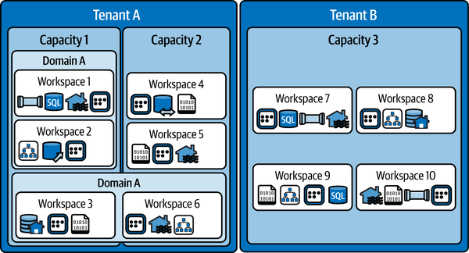

Figure 15-1. Hierarchical structure of Microsoft Fabric

*Tenant*

Tenant is a dedicated space for organizations to create, store, and manage Fabric items. Usually, there is a single Fabric tenant per organization, but there can be multiple tenants per organization. Each tenant consists of one or more capacities.

*Capacity*

Capacity represents a dedicated set of resources that is available at a given time to be used. Capacity determines the ability of a resource to perform an activity or produce an output. Different operations and items may consume capacity units at a certain time.

*Domain and workspace*

A domain is a logical grouping of workspaces, whereas the workspace represents a collection of individual Fabric items that bring together various functionalities. We covered domains and workspaces in more depth in [Chapter 3](https://learning.oreilly.com/library/view/fundamentals-of-microsoft/9781098172916/ch03.html#fabric_ch_3_all_roads_lead_to_onelake_1748224992659005).

Please bear in mind that the domain can span multiple capacities. In [Figure 15-1](https://learning.oreilly.com/library/view/fundamentals-of-microsoft/9781098172916/ch15.html#fabric_ch_15_figure_1_1748224987367910), domain B spans across both capacities in the tenant. Finally, Fabric items *are* the building blocks of the entire Fabric platform. These are the objects you create and manage in Microsoft Fabric. There are numerous item types, such as lakehouse, warehouse, KQL database, Dataflow Gen2, notebook, semantic model, and many more.

**Working with the Admin Portal**

Now that you are familiar with Microsoft Fabric core structure, let’s explore the main tool for administering and governing Fabric. [Table 15-1](https://learning.oreilly.com/library/view/fundamentals-of-microsoft/9781098172916/ch15.html#fabric_ch_15_table_1_1748224987372149) summarizes various Admin portal settings and their descriptions.

| **Setting** | **Description** |
| --- | --- |
| Tenant settings | Enable, disable, and configure Microsoft Fabric |
| Usage metrics | Explore the usage of Fabric workloads |
| Users | Manage users in the Microsoft 365 Admin portal |
| Premium Per User | Configure auto refresh and semantic model workload settings |
| Audit logs | Audit Fabric activities in the Microsoft Purview compliance portal |
| Domains | Create and manage domains |
| Tags | Create and manage tags to enhance data categorization and discoverability |
| Capacity settings | Manage Fabric (F) and Power BI Premium (P) capacities |
| Refresh summary | Schedule refresh on a capacity and view past refresh details |
| Embed codes | Manage embed codes for report sharing |
| Organizational visuals | Manage Power BI visual types accessible within the organization |
| Azure connections | Configure and manage connections to Azure resources |
| Workspaces | Manage workspaces |
| Custom branding | Adjust the look of Microsoft Fabric to match the organization’s branding |
| Protection metrics | Monitor sensitivity label usage |
| Featured content | Manage promoted Power BI content (reports, dashboards, apps) |
| Table 15-1. Settings in the Admin portal | |

Let’s now explore the Admin portal. Once you log in to Fabric using your admin account credentials, the portal can be accessed from the Settings icon in the top ribbon, as displayed in [Figure 15-2](https://learning.oreilly.com/library/view/fundamentals-of-microsoft/9781098172916/ch15.html#fabric_ch_15_figure_2_1748224987367947).

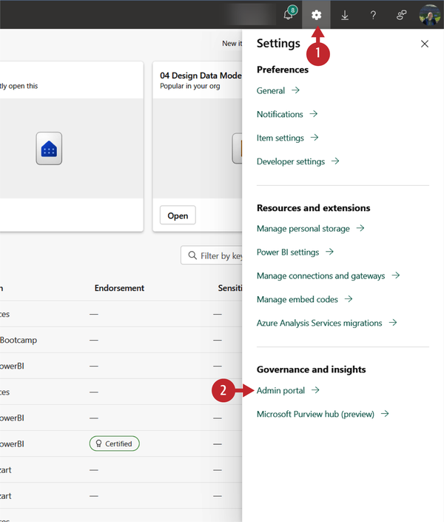

Figure 15-2. Accessing the Admin portal

Once in the Admin portal, you can navigate between the various settings specified in [Table 15-1](https://learning.oreilly.com/library/view/fundamentals-of-microsoft/9781098172916/ch15.html#fabric_ch_15_table_1_1748224987372149), by choosing the setting from the menu on the left-hand side. [Figure 15-3](https://learning.oreilly.com/library/view/fundamentals-of-microsoft/9781098172916/ch15.html#fabric_ch_15_figure_3_1748224987367972) illustrates the Tenant settings user interface, with Microsoft Fabric-related settings on the top.

Each setting in the Admin portal can be configured in the following ways:

* Enabled, where you may choose between two options:
  + The entire organization
  + Specific security groups
* Disabled

There is also a checkbox “Except specific security groups,” which is the opposite of “Specific security groups.” When you check this option, the specified security groups*will not* be able to use a particular feature.

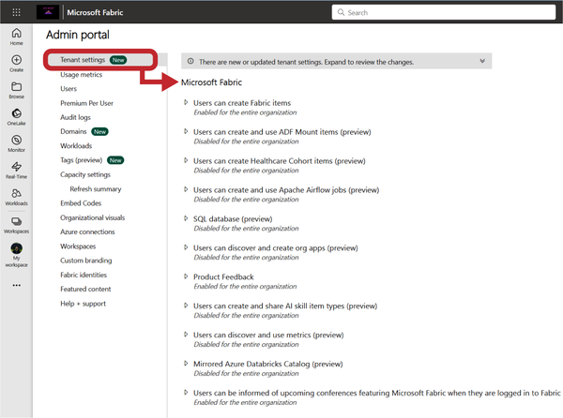

Figure 15-3. Fabric Tenant settings in the Admin portal

Probably the most important setting is the “Users can create Fabric items’” and we’ll soon come to explain why. A lot of organizations have been using Microsoft Power BI for years, long before Fabric was even an idea in someone’s head at Microsoft. So, the fair question would be, What if I want only Power BI? There will inevitably be organizations that simply want to continue using their favorite BI tool, without expanding their workloads to Microsoft Fabric. For this scenario, Fabric can be disabled, either on the tenant or capacity level.

On the flip side, you may also enable Fabric workloads on either tenant or capacity level. Please keep in mind that when Fabric is enabled on a tenant level, capacity admins can override this setting depending on the business needs and decide to disable Fabric workloads for a particular capacity.

The full list of the Tenant settings and their detailed description can be found in the [official Microsoft Learn page](https://learn.microsoft.com/en-us/fabric/admin/tenant-settings-index).

Under the Capacity settings page, you can manage all capacities in the tenant. Once you open a particular capacity, there are additional settings that can be configured, as shown in [Figure 15-4](https://learning.oreilly.com/library/view/fundamentals-of-microsoft/9781098172916/ch15.html#fabric_ch_15_figure_4_1748224987367993).

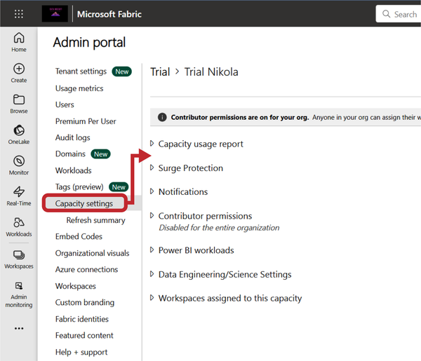

Figure 15-4. Fabric Capacity settings in the Admin portal

From this page, you can also create a new capacity, change the capacity name, add and remove capacity admins, resize the capacity, and so on.

On the Workspaces page, you’ll find personal and group workspaces that exist in your organization. Here, you can configure numerous workspace properties, such as access or capacity, as well as obtain information about specific workspaces, as displayed in [Figure 15-5](https://learning.oreilly.com/library/view/fundamentals-of-microsoft/9781098172916/ch15.html#fabric_ch_15_figure_5_1748224987368014).

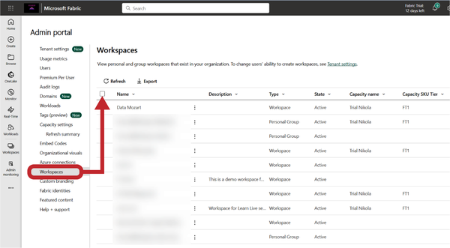

Figure 15-5. Managing workspaces from the Admin portal

These are just some of the most important pages in the Admin portal. Microsoft Fabric administration is an extremely broad topic that goes way beyond the scope of this book. Therefore, please don’t consider this section as a definitive guide to administering Microsoft Fabric, but more as a quick guide about the core administrative tasks. If your day-to-day job requires performing administrative tasks in Fabric, we strongly encourage you to explore additional resources that provide a deeper level of understanding of each and every component in the Admin portal.

A good starting point would be reading [the official Microsoft documentation about the Admin portal](https://learn.microsoft.com/en-us/fabric/admin/admin-center#what-can-i-do-in-the-admin-portal) and all the available options in the portal.

To wrap up this section, we’ll provide you with an overview of the admin roles related to Microsoft Fabric. [Figure 15-6](https://learning.oreilly.com/library/view/fundamentals-of-microsoft/9781098172916/ch15.html#fabric_ch_15_figure_6_1748224987368033) displays several roles that work together to administer Microsoft Fabric within the organization.

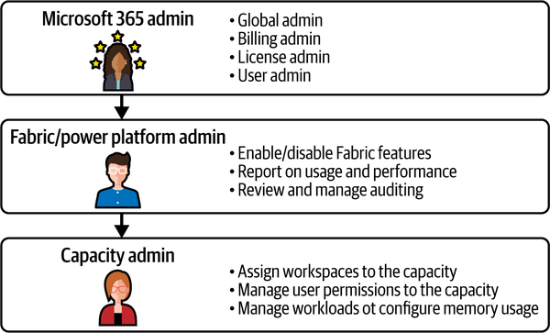

Figure 15-6. Admin roles related to Microsoft Fabric

Monitoring Microsoft Fabric

Setting the stage for proper data usage in Microsoft Fabric is, obviously, of paramount importance. Securing the data is one of the key aspects as well. Having the possibility to classify and catalog data brings the entire experience to a whole new level. But, we would not exaggerate if we think of monitoring Fabric as *icing on the cake*.

This is the part where all the pieces come together and the part that enables you to understand how your Fabric tenant *really* works. Microsoft Fabric offers several built-in capabilities to monitor, get insights, and act based on the events in the tenant. [Table 15-2](https://learning.oreilly.com/library/view/fundamentals-of-microsoft/9781098172916/ch15.html#fabric_ch_15_table_2_1748224987372177) provides a high-level overview of the monitoring features and their intended use cases and the target audience.

| **Feature** | **Use case** | **Target audience** |
| --- | --- | --- |
| Monitor hub | Monitor Fabric activities from a central location | Developers and team members for monitoring scheduled workloads |
| Capacity metrics app | Monitor usage and consumption | Fabric administrators, capacity administrators, developers performing workload optimization |
| Microsoft Purview hub | Manage and govern data estate, particularly with respect to endorsement and sensitivity labels | Fabric administrators, data owners |
| Admin monitoring | A dedicated workspace for security and governance tasks, such as audits and usage checks | Fabric administrators |
| Table 15-2. Monitoring features overview | | |

**Monitor Hub**

If you are searching for a central location to monitor various Fabric activities, look no further—the Monitor hub *is* the place to go. Any Fabric user can access the Monitor hub, although they will be able to see activities only for Fabric items they have permission to view. [Figure 15-7](https://learning.oreilly.com/library/view/fundamentals-of-microsoft/9781098172916/ch15.html#fabric_ch_15_figure_7_1748224987368063) displays the Monitor hub main page.

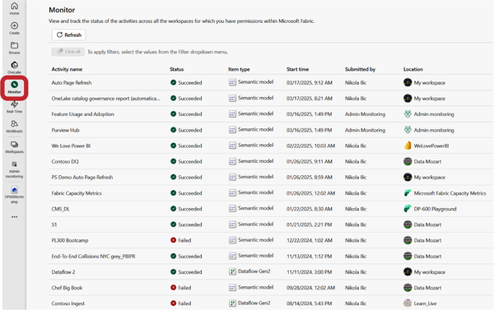

Figure 15-7. Monitor hub in Microsoft Fabric

The Monitor hub displays activities for the following Fabric items: pipelines, dataflows, data marts, lakehouses, notebooks, semantic models, and Spark job definitions. There are numerous options to rearrange the way the data is displayed; for example, you can filter the data based on different criteria, add or remove particular columns, or sort the data in a different order.

Additionally, if you have proper permissions, you might be able to perform specific actions, as shown in [Figure 15-8](https://learning.oreilly.com/library/view/fundamentals-of-microsoft/9781098172916/ch15.html#fabric_ch_15_figure_8_1748224987368082), where the user may access additional details, or check historical runs of the selected item.

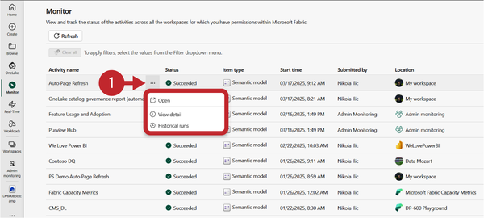

Figure 15-8. Take action on a specific item

**Capacity Metrics App**

Microsoft Fabric Capacity Metrics app is a built-in application that enables monitoring of the Fabric capacity. To start using the Capacity Metrics app, you have to be a capacity administrator. The first step is to install the app from the AppSource, which you can access from the [AppSource web page](https://appsource.microsoft.com/en-us/product/power-bi/pbi_pcmm.microsoftpremiumfabricpreviewreport?tab=Overview) or from the Power BI service by selecting Apps > Get apps > Microsoft Fabric Capacity Metrics app, as shown in [Figure 15-9](https://learning.oreilly.com/library/view/fundamentals-of-microsoft/9781098172916/ch15.html#fabric_ch_15_figure_9_1748224987368104).

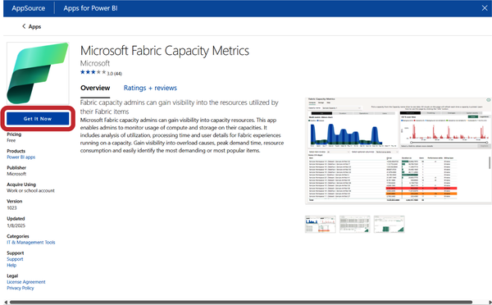

Figure 15-9. Installing the Capacity Metrics app from the AppSource

Once you install the app, you’ll get access to an abundance of information. Let’s try to break down the core metrics of the app. We’ll start by exploring the Compute page of the generated Power BI report, which is shown in [Figure 15-10](https://learning.oreilly.com/library/view/fundamentals-of-microsoft/9781098172916/ch15.html#fabric_ch_15_figure_10_1748224987368123).

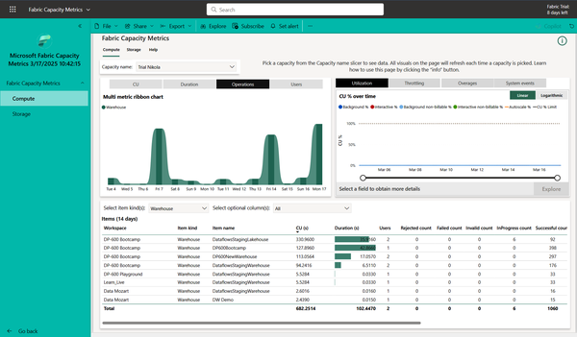

Figure 15-10. Compute page of the Capacity metrics app

The multi-metric ribbon chart on the top left provides an hourly view of the capacity usage. You can switch between the following metrics in the visual:

*CU*

Capacity units processing time in seconds

*Duration*

Processing time in seconds

*Operations*

Total number of operations in the capacity

*Users*

Number of unique users (including Service principals) that performed operations

The visual in the top right provides four different information types:

*Utilization*

This shows capacity units usage over time. There are various metrics included in the Utilization visual, such as Background %, Interactive %, Background non-billable %, Interactive non-billable %, Autoscale CU % Limit, and CU % Limit. You can find more details about each of these metrics in the [Microsoft Learn documentation](https://learn.microsoft.com/en-us/fabric/enterprise/metrics-app-compute-page#utilization).

*Throttling*

This shows delay and rejection over time. Throttling is based on the amount of future capacity consumption as a result of multiple smoothing policies. If you are not sure what smoothing is, we have you covered in [Chapter 14](https://learning.oreilly.com/library/view/fundamentals-of-microsoft/9781098172916/ch14.html#fabric_ch_14_the_fabric_pricing_model_1748224986582927).

*Overages*

This shows the add, burndown, and cumulative carryforward percentages over time. It takes into account only billable operations.

*System events*

This shows capacity events, such as the state of the capacity (Active, Deleted, Overloaded, Suspended), state change reason (e.g., Created, ManuallyResumed, AllRejected), and the time the capacity was paused or resumed. You can find more details about system events on the [Microsoft Learn official page](https://learn.microsoft.com/en-us/fabric/enterprise/metrics-app-compute-page#system-events).

Finally, the matrix visual at the bottom provides a tabular overview of various metrics for each item in the capacity. You can use slicers to narrow down the displayed data to a specific Fabric item (or multiple items), as well as customize columns included in the matrix.

Let’s now examine the Storage page of the Capacity Metrics app. The default view is shown in [Figure 15-11](https://learning.oreilly.com/library/view/fundamentals-of-microsoft/9781098172916/ch15.html#fabric_ch_15_figure_11_1748224987368142).

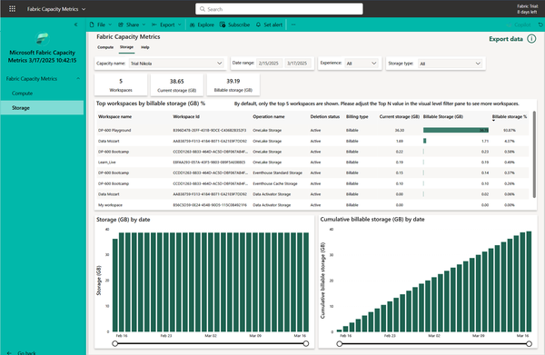

Figure 15-11. Storage page of the Capacity Metrics app

Card visuals on the top provide information about the number of workspaces, current storage in GB, and the billable storage in GB. The table visual in the middle shows storage information for the selected top *n* workspaces in the capacity. The remaining two column charts at the bottom display the storage trend for the previous 30 days. If necessary, you can drill down into a particular day and see the data on an hourly level.

**Microsoft Purview Hub**

Microsoft Purview hub represents a centralized location in Fabric, where Fabric administrators can manage and govern their organizational data estate. Microsoft Purview hub provides a set of built-in reports, providing insights about sensitive data, item endorsement, and domains. It’s also a gateway to more advanced features of Microsoft Purview, such as Data Catalog, Information Protection, Data Loss Prevention, and Audit.

To access the Microsoft Purview hub, you need to have a Fabric administrator role. Microsoft Purview hub can be accessed from the Settings option in the top ribbon, as shown in [Figure 15-12](https://learning.oreilly.com/library/view/fundamentals-of-microsoft/9781098172916/ch15.html#fabric_ch_15_figure_12_1748224987368159).

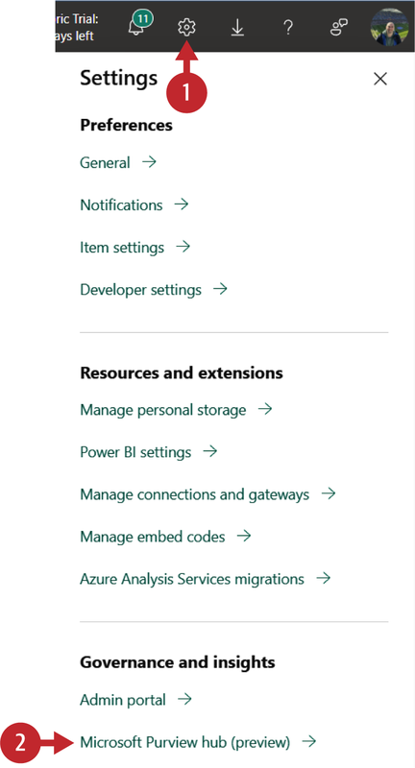

Figure 15-12. Accessing Microsoft Purview hub

Once you find yourself in the hub, you’ll discover various built-in visualizations to help you understand the current data estate. The report provides numerous insights into sensitivity labels, endorsements, domains, and items explorer, as shown in [Figure 15-13](https://learning.oreilly.com/library/view/fundamentals-of-microsoft/9781098172916/ch15.html#fabric_ch_15_figure_13_1748224987368178).

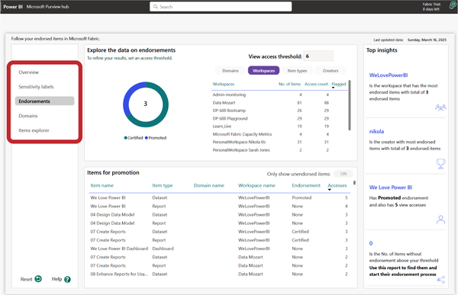

Figure 15-13. Built-in Power BI report in Microsoft Purview hub

In addition, you can access various Microsoft Purview capabilities, like Data Catalog, Information protection, and many more, directly from the hub.

**Admin Monitoring Workspace**

When you work as a Fabric administrator, wouldn’t it be great if you had your own dedicated environment to monitor and manage Fabric workloads and usage? That’s exactly what the Admin monitoring workspace enables you to accomplish.

The Admin monitoring workspace is automatically installed the first time an admin logs into Fabric and selects “Admin monitoring” from the workspaces. Since this is a workspace, the content can be shared with other users in the organization when needed.

Inside the Admin monitoring workspace, you’ll find the built-in Power BI semantic model and a report called Feature Usage and Adoption. Let’s explore this report in more depth. The Overview page, shown in [Figure 15-14](https://learning.oreilly.com/library/view/fundamentals-of-microsoft/9781098172916/ch15.html#fabric_ch_15_figure_14_1748224987368197), enables you to identify daily activities and user trends, the most active capacities and workspaces, and activities by most or least active users.

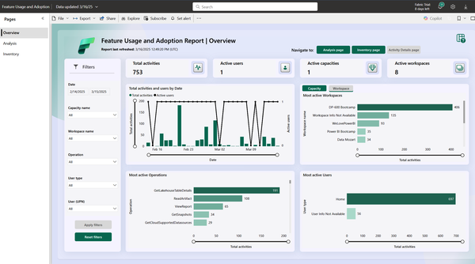

Figure 15-14. Overview page of the Feature Usage and Adoption report

Let’s imagine for a moment that you work as a Fabric administrator for a large global retailer. You’ve configured a separate, dedicated capacity for each department in the organization. Your common workflow might start by looking at the Overview page, where you identify that the Sales and Financials department capacities had more than 1,000 activities, whereas other capacities had less than 100. To obtain more insight into this behavior, you might navigate to the Analysis page of the report and use the decomposition tree visual to drill down and understand the details, as illustrated in [Figure 15-15](https://learning.oreilly.com/library/view/fundamentals-of-microsoft/9781098172916/ch15.html#fabric_ch_15_figure_15_1748224987368216).

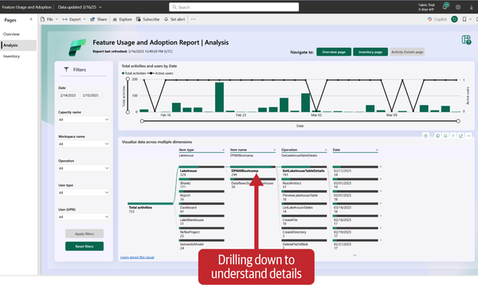

Figure 15-15. Analysis page of the Feature Usage and Adoption report

You can drill down even further by selecting a specific data point, and then looking into the lowest level of detail, which shows every individual operation for the particular date. To expand on our previous example, you may identify the high number for the ViewReport action on the Sales and Financials capacities. Then, on the Activity Details page, you may discover a new report created last week that was heavily accessed since then, which caused the high number of activities on the capacity.

Finally, the Inventory page displays all the items in the Fabric tenant and provides information about their use. Data can be analyzed per workspace or per item type, while the decomposition tree visual at the bottom enables visualizing the data across numerous dimensions, as shown in [Figure 15-16](https://learning.oreilly.com/library/view/fundamentals-of-microsoft/9781098172916/ch15.html#fabric_ch_15_figure_16_1748224987368238).

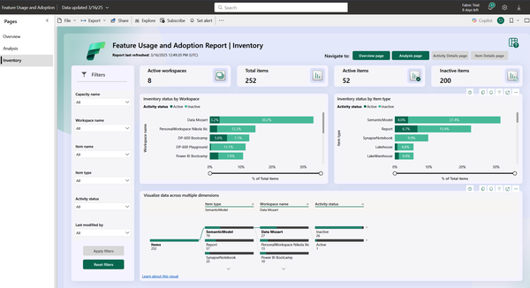

Figure 15-16. Inventory page of the Feature Usage and Adoption report

As on the Analysis page, the Inventory page enables you to drill down and obtain more detailed information by navigating to the Item Details page.

[Table 15-3](https://learning.oreilly.com/library/view/fundamentals-of-microsoft/9781098172916/ch15.html#fabric_ch_15_table_3_1748224987372193) provides information about the measures used in the Feature Usage and Adoption report and their definitions.

| **Measure** | **Definition** |
| --- | --- |
| Active capacities | The number of capacities with audit activity |
| Active users | The number of users who generated the audit activity |
| Active workspaces | The number of workspaces with audit activity |
| Activities | The number of audit activities generated |
| Items | The count of items displayed |
| Total activities | The number of audit activities generated (displayed only in card visuals) |
| Total items | The count of items displayed (displayed only in card visuals) |
| Table 15-3. Feature Usage and Adoption report measures and their definitions | |

You can also use Fabric REST APIs to obtain this information, if you prefer developing your own custom solution.

Summary

We covered a lot in this chapter! Administration and monitoring in Microsoft Fabric is such a vast topic that we won’t exaggerate if we say that we only scratched the surface here. Therefore, we did our best to equip you with the essential concepts and features to help you keep your Microsoft Fabric tenant in optimal shape.

Administration features in the Admin portal enable not only centralized management of workspaces, capacities, and other Fabric items, but also enforcing efficient data government policies. Numerous built-in monitoring capabilities provide out-of-the-box solutions for the early detection of performance issues and operation failures.

In the next chapter we’ll discuss various features and options for securing Microsoft Fabric workloads

[**1**](https://learning.oreilly.com/library/view/fundamentals-of-microsoft/9781098172916/ch15.html#id627-marker) *Capo di tutti cappi* (Italian) means “boss of all bosses.” It’s often used by law enforcement, the media, and the public in general to describe a Mafia boss who exerts significant influence on how the Mafia should be run.

Chapter 16. Securing Microsoft Fabric

**A Note for Early Release Readers**

With Early Release ebooks, you get books in their earliest form—the authors’ raw and unedited content as they write—so you can take advantage of these technologies long before the official release of these titles.

This will be the 16th chapter of the final book. Please note that the GitHub repo will be made active later on.

If you’d like to be actively involved in reviewing and commenting on this draft, please reach out to the editor at *sevans@oreilly.com*.

The need to keep data safe and secure is an ongoing concern and Microsoft Fabric, as a unified data platform, is no exception. In real-world implementations, Microsoft Fabric handles vast volumes of sensitive information across a variety of workloads—data engineering, data warehousing, data science, and real-time intelligence. Without proper security measures—such as data access control, sensitivity labels, and similar—this sensitive data may be exposed to unauthorized access or breach.

In this chapter, we’ll examine various options and features that enable the implementation of robust security policies to protect sensitive information.

Security represents a key aspect of any data analytics solution. Microsoft Fabric provides a wide range of security features to ensure that data is secured at rest and in transit, as well as to enable access and permission control of users and applications.

There are several aspects of security in Microsoft Fabric, so let’s briefly introduce them:

*Authentication*

In the same way as other Microsoft SaaS solutions, such as Microsoft Office or OneDrive, Fabric relies on Microsoft Entra ID as its cloud-based identity provider. Entra ID enables easy connection from any device and any network

*Network security*

In various scenarios, you’ll need to leverage data that resides outside of Microsoft Fabric. There are two directions to consider when configuring network security, inbound and outbound.

*Inbound security* handles securing the traffic coming into Fabric. Here, you can choose between Entra ID Conditional Access and private links:

* By implementing Entra ID Conditional Access, you can define a list of IP addresses for inbound connectivity to Fabric, use multifactor authentication (MFA), or restrict the traffic based on specific parameters, such as country or device type.
* Private links allow restricting access to the Fabric tenant from a VNet (Azure virtual network) only, while blocking all public access.

*Outbound security* enables connecting to external data sources and bringing the data into Fabric in a secure way. Let’s explore different ways to connect to external data:

* Trusted workspace access is a Fabric workspace that uses workspace identity and can securely access Azure Data Lake Gen2 storage accounts with public network access enabled, from selected virtual networks and IP addresses.
* Managed private endpoints allow a secure connection to data sources, such as Azure SQL database, without exposing them to a public network.
* Managed virtual networks are virtual networks created and managed by Fabric for each Fabric workspace. They provide network isolation for Spark workloads, ensuring that Spark compute clusters are provisioned in a dedicated network.
* Data gateway enables secure connection to either on-premises data sources, using an Oo-premises data gateway, or to a data source that might be protected by a firewall or virtual network. In the latter scenario, you may use a VNet data gateway.
* Connecting to OneLake from an existing service may be useful when you need to connect to Fabric using an existing PaaS service, such as Azure Synapse Analytics or Azure Data Factory. In these scenarios, you can use Azure Integration Runtime (IR) or Azure Data Factory managed virtual network.

*Securing data*

When you store data in OneLake, all the data is encrypted at rest and stored in the tenant home region or in one of the capacities in a different region of your choice. This is a common requirement for organizations that conduct business across multiple regions.

Let’s imagine a global retailer with headquarters in the US, selling its goods all over the planet. To comply with local regulations, the company must ensure that data remains stored at rest in different regions. This is called *data residency* in Microsoft Fabric. It’s important to keep in mind that in these cases, the query execution layer, query caches, and item data assigned to a multi-geo workspace remain in the Azure region where they were created. However, some metadata is stored at rest in the tenant’s home region.

*Accessing data*

Fabric items are stored in workspaces. Therefore, access control is implemented using workspace roles. However, there is the possibility to control the access on a more granular level, which we will examine in depth in the following section

*Protecting data*

In synergy with Microsoft Purview Information Protection, you can apply sensitivity labels to your data to label it as general, confidential, or highly confidential. Once you apply sensitivity labels, they will follow the data automatically as it flows through various Fabric workloads—all the way from the data source to the end user, and keep sensitive data protected from unauthorized access. Sensitivity labels are part of the wider Data Loss Prevention (DLP) solution, which enables organizations to identify, monitor, and protect sensitive data across various locations.

*Data recovery*

Data recovery encompasses both disaster recover and business continuity. Disaster recovery can be configured in the “Capacity settings” page of the Admin portal. When enabled, it will create a cross-region replication of the OneLake data. This feature may not be available in all regions. Additionally, you should be aware that disaster recovery, because it is geo-replication enabled, consumes more storage and transactions, which are billed as BCDR Storage and BCDR Operations, respectively (BCDR stands for Business Continuity Disaster Recovery), and can be found in the Microsoft Fabric Capacity Metrics app.

Secure Data Access in Microsoft Fabric

In this section, we will introduce various concepts and features to control data access in Microsoft Fabric. Let’s first revisit the Fabric storage architecture. The cornerstone of the entire Microsoft Fabric platform is OneLake, a central storage repository for the entire organization, regardless of whether the organization chooses to use a lakehouse, warehouse, KQL database, or any other Fabric item for storing the data. In the end, all roads lead to OneLake, as we described in [Chapter 3](https://learning.oreilly.com/library/view/fundamentals-of-microsoft/9781098172916/ch03.html#fabric_ch_3_all_roads_lead_to_onelake_1748224992659005).

In simple words, OneLake is nothing more than a logical structure of files and folders, as depicted in [Figure 16-1](https://learning.oreilly.com/library/view/fundamentals-of-microsoft/9781098172916/ch16.html#fabric_ch_16_figure_1_1748224988780080).

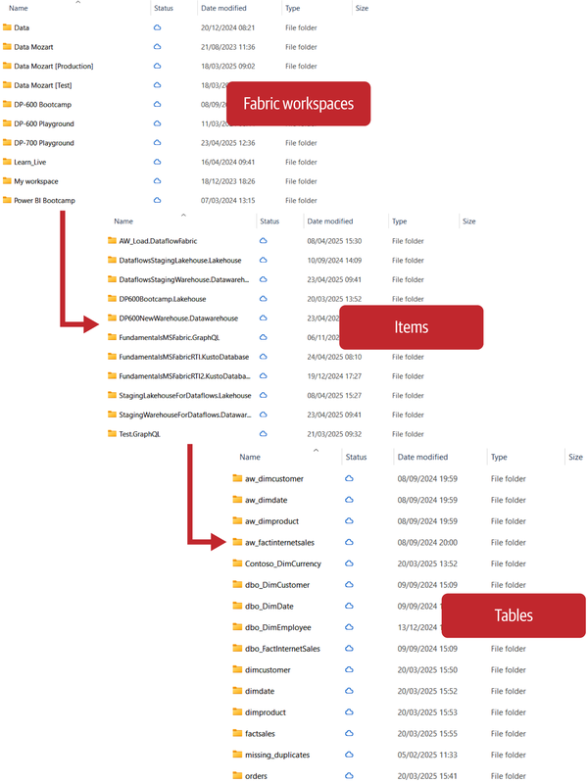

Figure 16-1. Physical representation of the OneLake structure

As you’ll see, OneLake itself is at the top level of this hierarchy. Then, we have one or multiple workspaces that serve as containers for various Fabric items, such as lakehouses, warehouses, KQL databases, semantic models, and so on. When you go one level further and open, say, a lakehouse, there are a lot of folders inside, each representing an individual table. Finally, each table folder consists of one or more files.

Let’s now examine the conceptual structure of OneLake, as shown in [Figure 16-2](https://learning.oreilly.com/library/view/fundamentals-of-microsoft/9781098172916/ch16.html#fabric_ch_16_figure_2_1748224988780118).

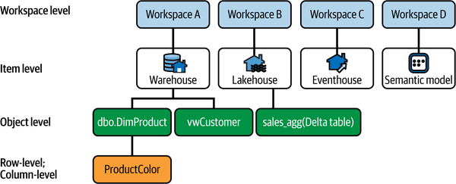

Figure 16-2. Conceptual representation of the OneLake structure

Understanding the conceptual structure of OneLake will help us break down how this structure impacts the data access control options in Fabric. Let’s start from the top.

**Workspace-Level Access Control**

When you grant access to a workspace, a user (or a group of users) gets access to all the items in the particular workspace. Imagine the scenario where you have a workspace that contains 5 lakehouses, 2 warehouses, and 10 semantic models. The workspace role will enable the user to access all of these items. Of course, depending on the role itself, the user can perform a certain set of actions on top of the items, but the key thing to keep in mind here is that with workspace roles, *every single item in the workspace is accessible***.**There are four workspace roles:

* Admin
* Member
* Contributor
* Viewer

[Table 16-1](https://learning.oreilly.com/library/view/fundamentals-of-microsoft/9781098172916/ch16.html#table-16-1), which is also available in [Microsoft’s official documentation](https://learn.microsoft.com/en-us/fabric/fundamentals/roles-workspaces#-workspace-roles), shows the capabilities of each workspace role.

| **Capability** | **Admin** | **Member** | **Contributor** | **Viewer** |
| --- | --- | --- | --- | --- |
| Update and delete workspace | ✅ |  |  |  |
| Add or remove people, including other admins | ✅ |  |  |  |
| Add members or others with lower permissions | ✅ | ✅ |  |  |
| Allow others to reshare items[**a**](https://learning.oreilly.com/library/view/fundamentals-of-microsoft/9781098172916/ch16.html#id629) | ✅ | ✅ |  |  |
| Create or modify database mirroring items | ✅ | ✅ |  |  |
| Create or modify warehouse items | ✅ | ✅ |  |  |
| Create or modify SQL database items | ✅ | ✅ |  |  |
| View and read content of data pipelines, notebooks, Spark job definitions, ML models and experiments, and eventstreams | ✅ | ✅ | ✅ | ✅ |
| View and read content of KQL databases, KQL querysets, and real-time dashboards | ✅ | ✅ | ✅ | ✅ |
| Connect to SQL analytics endpoint of lakehouse or warehouse | ✅ | ✅ | ✅ | ✅ |
| Read lakehouse and data warehouse data and shortcuts[**b**](https://learning.oreilly.com/library/view/fundamentals-of-microsoft/9781098172916/ch16.html#id630) with T-SQL through TDS endpoint[**c**](https://learning.oreilly.com/library/view/fundamentals-of-microsoft/9781098172916/ch16.html#id631) | ✅ | ✅ | ✅ | ✅ |
| Read lakehouse and data warehouse data and shortcuts**2** through OneLake APIs and Spark | ✅ | ✅ | ✅ |  |
| Read lakehouse data through lakehouse explorer | ✅ | ✅ | ✅ |  |
| Write or delete data pipelines, notebooks, Spark job definitions, ML models and experiments, and eventstreams | ✅ | ✅ | ✅ |  |
| Write or delete eventhouses[**d**](https://learning.oreilly.com/library/view/fundamentals-of-microsoft/9781098172916/ch16.html#id632), KQL querysets, Real-Time Dashboards, and schema and data of KQL databases, lakehouses, data warehouses, and shortcuts | ✅ | ✅ | ✅ |  |
| Execute or cancel execution of notebooks, Spark job definitions, and ML models and experiments | ✅ | ✅ | ✅ |  |
| Execute or cancel execution of data pipelines | ✅ | ✅ | ✅ |  |
| View execution output of data pipelines, notebooks, and ML models and experiments | ✅ | ✅ | ✅ | ✅ |
| Schedule data refreshes via the on-premises gateway[**e**](https://learning.oreilly.com/library/view/fundamentals-of-microsoft/9781098172916/ch16.html#id633) | ✅ | ✅ | ✅ |  |
| Modify gateway connection settings**4** | ✅ | ✅ | ✅ |  |
| [**a**](https://learning.oreilly.com/library/view/fundamentals-of-microsoft/9781098172916/ch16.html#id629-marker) Contributor and Viewer roles can also share items if they have an explicit Reshare permission  [**b**](https://learning.oreilly.com/library/view/fundamentals-of-microsoft/9781098172916/ch16.html#id630-marker) Additional permissions are required to read the data from the shortcut destination  [**c**](https://learning.oreilly.com/library/view/fundamentals-of-microsoft/9781098172916/ch16.html#id631-marker) TDS endpoint is a Tabular Data Stream protocol that emulates a SQL data connection. It allows querying data sources using the T-SQL language.  [**d**](https://learning.oreilly.com/library/view/fundamentals-of-microsoft/9781098172916/ch16.html#id632-marker) Additional permissions are required to perform certain operations in eventhouses  [**e**](https://learning.oreilly.com/library/view/fundamentals-of-microsoft/9781098172916/ch16.html#id633-marker) Permissions on the gateway are also required | | | | |
| Table 16-1. Fabric workspace roles and their capabilities | | | | |

**Item-Level Access Control**

If you need to enable a specific user or group of users to access a particular item or a subset of items in the workspace, but not necessarily all the items in that workspace, you should grant them access by sharing the item. With this approach, the user has restricted access to a workspace—they don’t even need any of the workspace roles—and can access only the shared item.

Depending on the item type (lakehouse, warehouse, KQL database), the set of permissions might differ. Whenever you share the item with the user, it will automatically grant them read permission for that item.

[Figure 16-3](https://learning.oreilly.com/library/view/fundamentals-of-microsoft/9781098172916/ch16.html#fabric_ch_16_figure_3_1748224988780143) shows Item-level access control options for a lakehouse item.

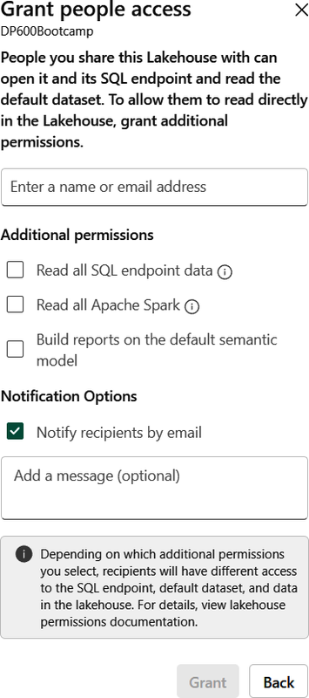

Figure 16-3. Item-level access for a Fabric Lakehouse

When you want to share a KQL database item, the workflow is slightly different because sharing is available only by creating and sending a link, as shown in [Figure 16-4](https://learning.oreilly.com/library/view/fundamentals-of-microsoft/9781098172916/ch16.html#fabric_ch_16_figure_4_1748224988780164).

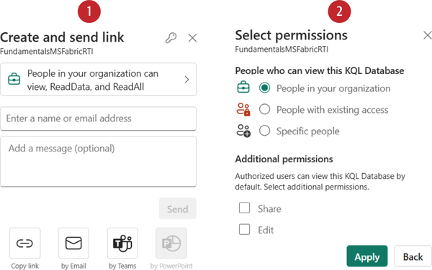

Figure 16-4. Item-level access for a KQL database

[Table 16-2](https://learning.oreilly.com/library/view/fundamentals-of-microsoft/9781098172916/ch16.html#fabric_ch_16_table_2_1748224988787647) displays the effect in place for each of the granted permissions.

| **Permission granted** | **Effect** |
| --- | --- |
| Read | Discover the item in the data hub, open it, and connect to the warehouse or SQL analytics endpoint of the lakehouse. |
| Edit | Edit the item or its content. |
| Share | Share the item and grant permissions up to the permissions they have. |
| Read All with SQL analytics endpoint | Read data from the SQL analytics endpoint of the lakehouse through TDS endpoints. |
| Read All with Apache Spark | Read lakehouse data via OneLake APIs and Spark. Read lakehouse data via Lakehouse explorer. |
| Build | Build new Power BI content based on the semantic model. |
| Execute | Execute or cancel the item execution. |
| Table 16-2. Permission options when sharing a lakehouse | |

When you want to share a warehouse item, the options are slightly different, as you’ll notice in [Figure 16-5](https://learning.oreilly.com/library/view/fundamentals-of-microsoft/9781098172916/ch16.html#fabric_ch_16_figure_5_1748224988780184).

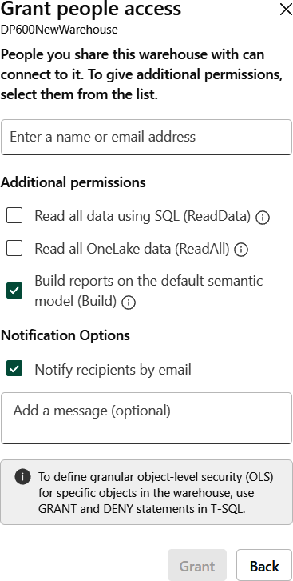

Figure 16-5. Item-level access for a Fabric warehouse

Let’s examine the permission model of the warehouse. If nothing is selected, the user will have read permission, which allows connecting to the SQL analytics endpoint, but doesn’t allow querying data unless they are granted explicit permission using the T-SQL GRANT statement:

*Read all data using SQL (ReadData)*

The user can read all the objects in the warehouse. If you need to apply more granular control, you can do this using the T-SQL GRANT/REVOKE/DENY statements. This permission is equivalent to the “Read all with SQL analytics endpoint” permission on a lakehouse.

*Read all OneLake data (ReadAll)*

The user has read access to the underlying parquet files in OneLake. ReadAll should be provided only in scenarios where the user needs full access to the warehouse files.

*Build reports on the default semantic model (Build)*

The user can create Power BI reports on top of the default semantic model.

You can also manage the access directly. Once you click on the three dots next to the item name and choose “Manage permissions,” you’ll go to a dedicated page as shown in [Figure 16-6](https://learning.oreilly.com/library/view/fundamentals-of-microsoft/9781098172916/ch16.html#fabric_ch_16_figure_6_1748224988780204). This page provides not only an overview of all the users and their permissions on the selected item, but also the possibility to add new users if needed, as well as grant or revoke permissions for the existing user.

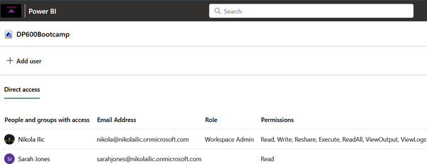

Figure 16-6. Manage permissions page

**Row-Level Security**

As its name suggests, row-level security allows you to control access to particular rows in a Delta table. Let’s imagine your company is running a business in multiple regions (US, Europe, Asia), and you have analytics teams in each of these regions. The requirement is to restrict access so that US analysts can see only US sales data, analysts from Europe see only European sales data, and so on.

**Note**

Just to make this clear from the beginning: here, *we are not talking about the row-level security (RLS) for Power BI semantic models*, but rather examining the RLS feature for Fabric Warehouse and the SQL analytics endpoint of the Lakehouse. Don’t confuse these two, as they are configured and managed completely independently.

To be able to implement row-level security, you need to either be an Admin, Member, or Contributor in the workspace where the item resides *or* have elevated permissions on the warehouse or SQL analytics endpoint of the lakehouse.

In the following code snippet, we show how to implement RLS using T-SQL language. The first step is to define roles and predicates: *roles* determine *who* can access the data, whereas *predicates* define *which* data can be accessed:

-- Creating schema for Security

CREATE SCHEMA Rls;

GO

-- Creating a function for the analyst evaluation

CREATE FUNCTION Rls.tvf_location(@analyst AS varchar(50))

RETURNS TABLE

WITH SCHEMABINDING

AS

RETURN SELECT 1 AS tvf_location_result

WHERE @analyst = USER_NAME();

GO

-- Using the function to create a Security Policy

CREATE SECURITY POLICY LocationRls

ADD FILTER PREDICATE Rls.tvf_location(analyst)

ON MySchema.MyTable

WITH (STATE = ON);

GO

To wrap up, it’s important to keep in mind that the analyst must be part of the MySchema.MyTable.

**Object-Level and Column-Level Security**

With *object-level security*, we can control access to specific database objects—[tables](https://data-mozart.com/working-with-tables-in-microsoft-fabric-lakehouse-everything-you-need-to-know/), [views](https://data-mozart.com/3-reasons-to-use-views-instead-of-tables-in-power-bi/), or stored procedures. This way, we ensure that a user, or group of users, can access only those objects to which they’ve been granted permission. For those of you coming from the SQL Server world, this might sound familiar (because it is): By using GRANT, DENY, and REVOKE commands, we can implement object-level security in the Fabric warehouse as well.

**Note**

Similar to the previous section, don’t confuse object-level security (OLS) for Power BI semantic models with the object-level security feature for the Fabric warehouse and SQL analytics endpoint of the lakehouse.

In the following code snippet, we are granting the users that belong to the SalesAnalysts group permission to query the data from the Sales table:

GRANT SELECT ON dbo.Sales TO [SalesAnalysts];

*Column-level security* (CLS) works in a similar manner, but it allows for more granular access control, since you can grant access to specific columns. In the following code snippet we grant permissions to users in the SalesAnalysts group to query the data from the columns CustomerKey, FirstName, LastName, and Email:

GRANT SELECT ON dbo.Customer (CustomerKey, FirstName, LastName, Email) TO [SalesAnalysts];

If the user who belongs to the SalesAnalysts group tries to execute a query that retrieves data from columns other than those specified, it will return an error.

**Warning**

Please be aware that it is possible to circumvent granular Fabric warehouse security rules. If a user has been granted ReadAll permission when sharing the warehouse, they will be able to see all data in a specific table. Therefore, make sure to double-check if various data access rules are in collision and always implement them by sticking with the principle of least privilege.

Additionally, bear in mind that when you implement RLS/OLS/CLS in a warehouse or SQL analytics endpoint of a lakehouse, and you use Direct Lake semantic models for Power BI, all queries will, by default, *fall back to DirectQuery mode*. If you want to learn more about Direct Lake mode for Power BI semantic models, please refer to [Chapter 9](https://learning.oreilly.com/library/view/fundamentals-of-microsoft/9781098172916/ch09.html#fabric_ch_9_power_bi_1748224996890066), where we cover Direct Lake in depth.

**Folder-Level Access Control**

Let’s wrap up this section by understanding how to control access on the lowest level of the OneLake hierarchy—individual folders. This is implemented through the OneLake Data Access Roles feature, which can be accessed directly from the lakehouse explorer, as displayed in [Figure 16-7](https://learning.oreilly.com/library/view/fundamentals-of-microsoft/9781098172916/ch16.html#fabric_ch_16_figure_7_1748224988780224).

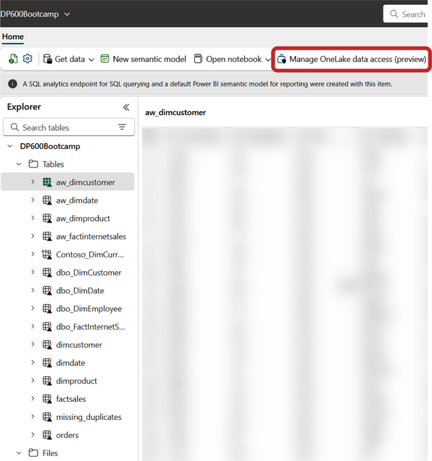

Figure 16-7. Accessing the OneLake data access feature

The process of configuring the access is fairly straightforward, as shown in [Figure 16-8](https://learning.oreilly.com/library/view/fundamentals-of-microsoft/9781098172916/ch16.html#fabric_ch_16_figure_8_1748224988780243). First, we need to create the role. Then, we choose which folders or individual files should be accessible to this role. Finally, we assign the role to a user or group of users.

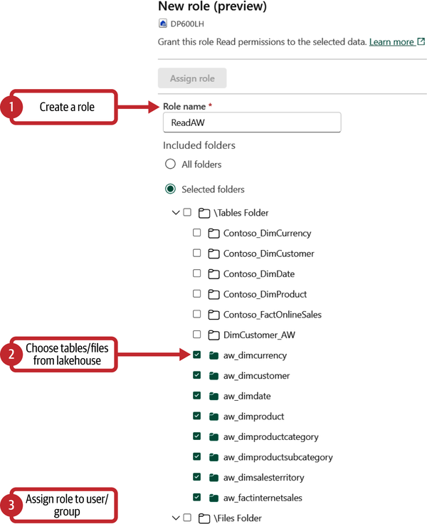

Figure 16-8. Configuring folder-level access control

However, there are a few important considerations when implementing OneLake data access roles:

* These roles apply only to users accessing OneLake directly.
* When you start configuring the OneLake data access role, before you create any new role, be aware that there is already a DefaultReader role defined for the selected lakehouse, which was generated when the lakehouse was created. By default, this role grants access to all folders in the lakehouse to users with ReadAll permission. Hence, make sure that you don’t have the same user or group of users assigned to the DefaultReader and any custom role, because these users will then be able to see all the lakehouse folders.
* You can leverage the current set of lakehouse permissions when assigning users to a group. It’s enough to choose the option “Add users based on Lakehouse permissions,” and we can immediately add users who already have particular permissions on the lakehouse, as shown in [Figure 16-9](https://learning.oreilly.com/library/view/fundamentals-of-microsoft/9781098172916/ch16.html#fabric_ch_16_figure_9_1748224988780265).

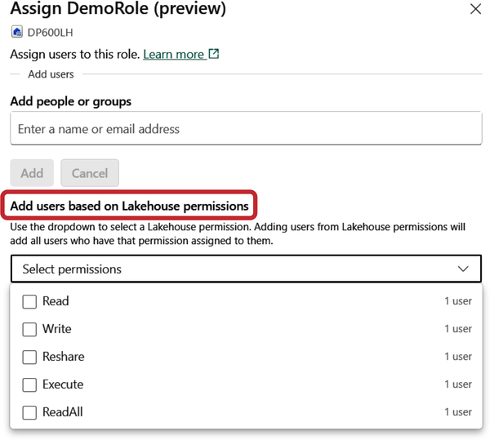

Figure 16-9. Assigning users to a role based on their lakehouse permissions

To summarize, [Figure 16-10](https://learning.oreilly.com/library/view/fundamentals-of-microsoft/9781098172916/ch16.html#fig-16-10) depicts how OneLake role-based access control (RBAC) is evaluated in the imaginary scenario of the user requesting to read the data from Folder A in Lakehouse B in the Fabric workspace.

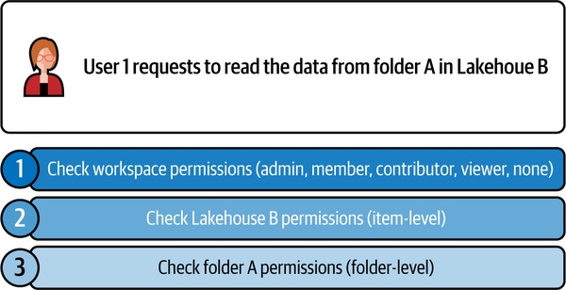

Figure 16-10. OneLake RBAC permissions evaluation process

**Shortcuts Security Model**

Before we dig into explaining the shortcuts security model in Microsoft Fabric, let’s first make a connection between two key terms to understand different shortcut paths:

* *Target path* refers to the location that a shortcut points to.
* *Shortcut path* refers to the location where the shortcut appears.

[Figure 16-11](https://learning.oreilly.com/library/view/fundamentals-of-microsoft/9781098172916/ch16.html#fig-16-11) illustrates the difference between these two paths.

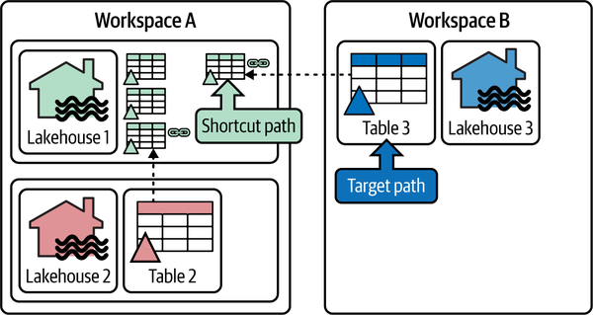

Figure 16-11. Shortcut versus target path

Let’s first examine the OneLake RBAC for internal shortcuts. Just as a reminder, internal shortcuts are objects that point to other locations inside OneLake. For any folder in the lakehouse, RBAC permissions always inherit permissions to all internal shortcuts where this folder is defined as a target path. Simply said, the user must have read permission in the target location. Defining RBAC permissions is not allowed in the shortcut path; they have to be specified on the folder in the target path, as shown in [Figure 16-12](https://learning.oreilly.com/library/view/fundamentals-of-microsoft/9781098172916/ch16.html#fabric_ch_16_figure_11_1748224988780311).

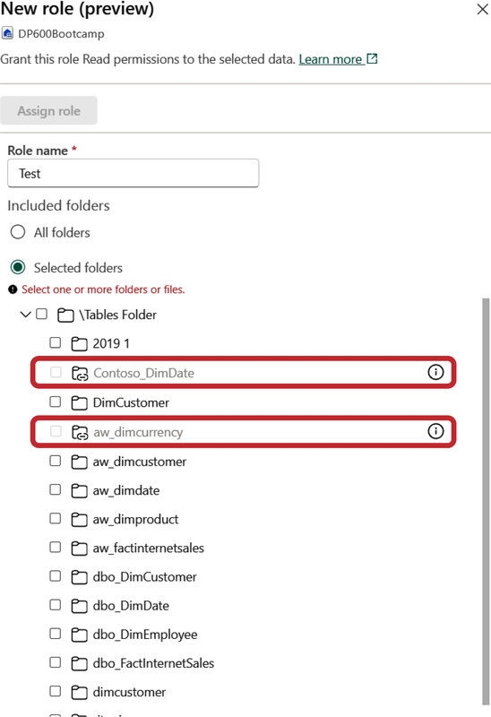

Figure 16-12. RBAC permissions can’t be defined in the shortcut path

RBAC permissions can be defined for external shortcuts as well. Again, as a quick reminder, external shortcuts are OneLake objects that point to storage locations *outside* OneLake, such as ADLS Gen2, Dataverse, Amazon S3, Google Cloud Platform, and so on. When defined, these permissions will be applied *on top* of the delegated authorization model enabled for the external shortcut.

Let’s imagine the following scenario: User1, who has access to the target path, created a shortcut pointing to the Amazon S3 storage. After that, another user, User2, tries to access the data in the OneLake shortcut. [Table 16-3](https://learning.oreilly.com/library/view/fundamentals-of-microsoft/9781098172916/ch16.html#fabric_ch_16_table_3_1748224988787663) examines all the possible outcomes.

| **S3 authorization for User1** | **OneLake RBAC authorization for User2** | **Can User2 access data in the OneLake shortcut?** |
| --- | --- | --- |
| Yes | Yes | Yes |
| No | No | No |
| No | Yes | No |
| Yes | No | No |
| Table 16-3. RBAC permissions with external shortcuts | | |

**Common Security Scenarios**

In this section, we introduce common security scenarios that you may need to implement when working with Microsoft Fabric, and how to ensure that you follow the recommended security practices in each instance. [Table 16-4](https://learning.oreilly.com/library/view/fundamentals-of-microsoft/9781098172916/ch16.html#fabric_ch_16_table_4_1748224988787678) shows which tools might be used based on the traffic direction.

| **Traffic direction** | **Scenario** | **Tools** |
| --- | --- | --- |
| Inbound | Fabric endpoints protected from the public internet | Fabric is, by default, protected from the public internet. For additional protection, use Entra conditional access policies for Fabric and/or enable private links on the tenant level |
| Inbound | Fabric may be accessed only from the organizational network and/or from specific devices | Entra conditional access policies for Fabric |
| Inbound | Enforce MFA when accessing Fabric | Entra conditional access policies for Fabric |
| Outbound | No-code/Low-code data ingestion from on-premises data sources | On-premises data gateway with Dataflow Gen2 and/or pipelines |
| Outbound | No-code/low-code data ingestion from data sources in Azure behind private endpoints | VNet gateway with Dataflow Gen2 and/or pipelines |
| Outbound | Code-first data ingestion using notebooks from data sources in Azure behind private endpoints | Fabric notebooks with Azure private endpoints |
| Table 16-4. Common security scenarios and tools to ensure security | | |

Data Discovery and Trust

Getting your head around all the data assets in an organization can often be a daunting task. This is particularly the case in large enterprises, where discovering data assets is rightly considered a mastery on its own. To overcome this challenge, many organizations implemented a centralized inventory of all data assets called a *data catalog*.

The data catalog leverages metadata (data *about* data) to establish an informative and searchable inventory of all the organizational data assets. These assets may include, but are not limited to:

* Structured data
* Unstructured data
* Reports and query results
* Data visualizations and operational dashboards
* Machine learning models

A data catalog enhances capabilities to collect and enrich the metadata, thus making it easier to identify and use properly. There are numerous benefits that a data catalog provides:

*Better data understanding*

Improved context enables data analysts and other data professionals to find detailed data descriptions and understand the business relevance of the particular data.

*Enhanced operational efficiency*

Regular business users can access and analyze data faster, while IT professionals can focus on high-priority tasks.

*Reduced risk*

Data analysts can work with data with more confidence.

*Better data for better analysis*

Data professionals can confidently respond to challenges and provide business answers based on the appropriate and trustworthy data.

Now that you know what data catalog in general is, let’s examine how this concept is implemented in Microsoft Fabric.

**OneLake Catalog**

OneLake catalog represents a centralized location that enables you to search and explore various Fabric items, as well as govern the data you own. Once you open OneLake from the menu on the left, there are two key areas inside the OneLake catalog: Explore and Govern. [Figure 16-13](https://learning.oreilly.com/library/view/fundamentals-of-microsoft/9781098172916/ch16.html#fabric_ch_16_figure_12_1748224988780332) displays the Explore tab content.

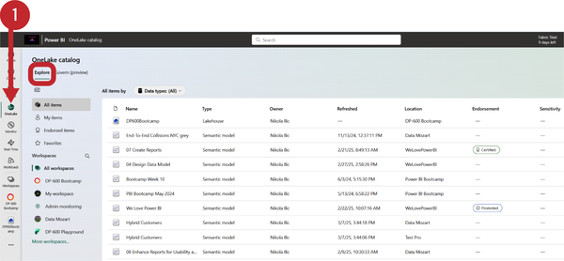

Figure 16-13. Explore tab of the OneLake catalog

The Explore tab provides a list of all the Fabric items you have access to. In addition, you can filter the displayed data based on different criteria, such as Data, Insights, Processes, Solutions, and Configurations, thus narrowing down displayed results based on your specific needs.

You may also explore particular items in more detail, as shown in [Figure 16-14](https://learning.oreilly.com/library/view/fundamentals-of-microsoft/9781098172916/ch16.html#fabric_ch_16_figure_13_1748224988780352), where we’re taking a thorough look into one of the Power BI semantic models.

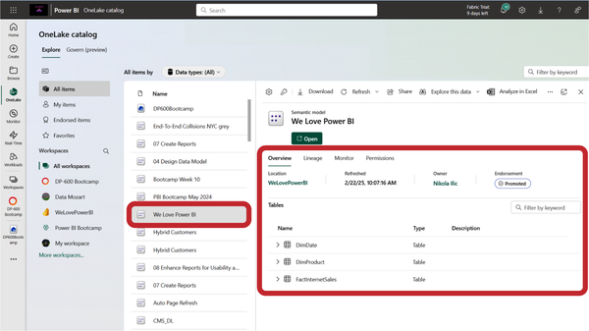

Figure 16-14. Detailed overview of a Fabric item in OneLake catalog explorer

Here, you can find not only a general overview of the item, such as tables that are part of the model or endorsement type, but also the item lineage—both upstream and downstream dependent items, monitoring, and permissions. Therefore, we can easily think of the Explore tab in the OneLake catalog as a one-stop shop for understanding a particular Fabric item.

The Govern tab provides insights about the governance status of all the Fabric items you own and recommended actions you might consider taking to improve the governance status of the data. [Figure 16-15](https://learning.oreilly.com/library/view/fundamentals-of-microsoft/9781098172916/ch16.html#fabric_ch_16_figure_14_1748224988780371) displays the main Govern tab content.

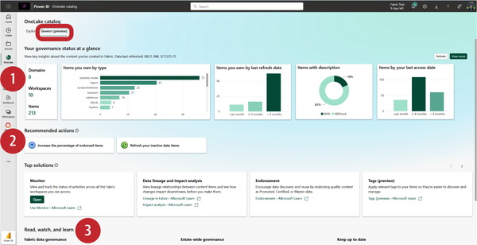

Figure 16-15. Main Govern tab in the OneLake catalog

There are three main areas to examine in the Govern tab:

*Insights*

Provides a visual overview of the governance status of your data

*Recommended actions*

Shows actions you can take to enhance the governance status of your data. Recommended actions also include guidance to help you accomplish them.

*Tools and learning resources*

Provides a list of resources you may explore to help you better understand and manage your data from the governance point.

Within the Insights area, once you click on the “View more” button, you’ll go to a detailed overview of your data estate, which includes more granular information in a dashboard-like representation, where you can examine the “Sensitivity label coverage” and “Discover, trust, and reuse” insights.

**Endorsement**

When you have high-quality, trustworthy data and content, you probably want to make it easier for users to identify that content. This is where the Endorsement feature comes in, enabling you to clearly label particular items with a badge.

There are three available endorsement badges in Microsoft Fabric, as displayed in [Table 16-5](https://learning.oreilly.com/library/view/fundamentals-of-microsoft/9781098172916/ch16.html#fabric_ch_16_table_5_1748224988787692).

| **Endorsement type** | **Description** | **Which items can be endorsed?** | **Who can endorse items?** |
| --- | --- | --- | --- |
| Promoted | Item creator thinks the item is ready for sharing and reuse | Any Fabric item except Power BI dashboards | Any user with write permission on the item |
| Certified | Authorized reviewer certifies that the item meets the organization’s quality standards and is ready for use across the organization | Any Fabric item except Power BI dashboards | Users defined by the Fabric administrator |
| Master data | Data in the item is a core source of organizational data (single source of truth) | Items that contain data (e.g., lakehouses, warehouses, semantic models) | Users defined by the Fabric administrator |
| Table 16-5. Endorsement options in Microsoft Fabric | | | |

Please keep in mind that Certified and Master data endorsement types are available only if the Fabric administrator enabled them in the Admin portal. In addition, the Certified option may be delegated to domain administrators, which allows having different reviewers for each domain.

Once endorsed, Fabric items appear in the list with the assigned badge, as shown in [Figure 16-16](https://learning.oreilly.com/library/view/fundamentals-of-microsoft/9781098172916/ch16.html#fabric_ch_16_figure_15_1748224988780390).

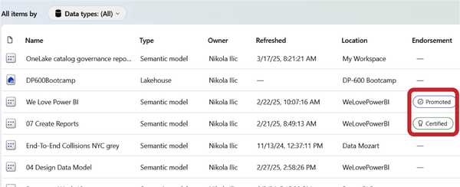

Figure 16-16. Endorsement badges for Fabric items

**Tags**

When the built-in endorsement badges are not sufficient, you can expand the item metadata by implementing tags. *Tags* are customizable text labels defined by Fabric administrators. Based on the specific organizational needs, the Fabric admin may create tags such as FY 2025, Marketing—Events, Sales—US 2024, and so on. These tags can then be applied to Fabric items so that users can search for and find the data based on the specific tag.

[Figure 16-17](https://learning.oreilly.com/library/view/fundamentals-of-microsoft/9781098172916/ch16.html#fabric_ch_16_figure_16_1748224988780410) illustrates the workflow when implementing Tags in the organization.

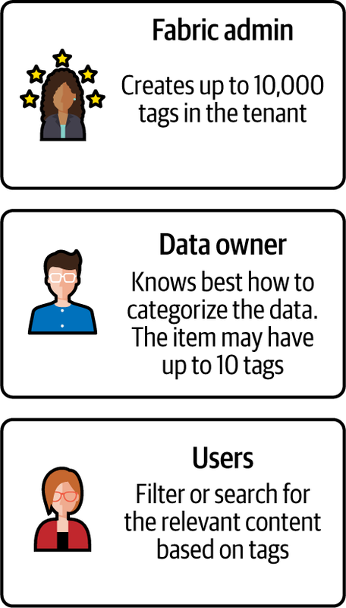

Figure 16-17. Workflow for implementing tags in Microsoft Fabric

**Sensitivity Labels**

Sensitivity labels represent a key component in enabling your organization to meet compliance and governance requirements. The main purpose of sensitivity labels in Microsoft Fabric is to protect sensitive data against unauthorized access.

Say Hello to Microsoft Purview. Sensitivity labels require using an additional, non-Fabric solution, called Microsoft Purview. In a nutshell, Microsoft Purview is a set of services and features for data governance, data security, and risk and compliance. Sensitivity labels are defined in Microsoft Purview Information Protection and then applied in Microsoft Fabric to specific Fabric items.

Please bear in mind that Microsoft Purview (unlike Microsoft Purview hub, which we discussed in [Chapter 15](https://learning.oreilly.com/library/view/fundamentals-of-microsoft/9781098172916/ch15.html#fabric_ch_15_administering_and_monitoring_microsoft_fabric_1748224987379944)) *is not* part of Microsoft Fabric; thus, it requires separate licensing and pricing.

[Figure 16-18](https://learning.oreilly.com/library/view/fundamentals-of-microsoft/9781098172916/ch16.html#fabric_ch_16_figure_17_1748224988780430) shows how to apply a Confidential sensitivity label to a Fabric lakehouse.

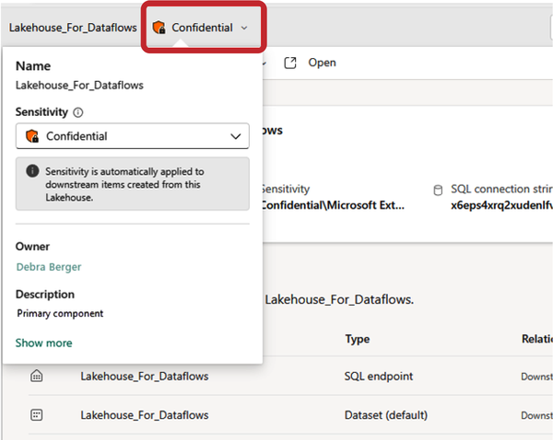

Figure 16-18. Applying a sensitivity label to a Fabric lakehouse

There are three areas where sensitivity labels may be leveraged to control access:

*Fabric tenant*

This scenario relies on sensitivity labels associated with Microsoft Purview protection policies. When the user logs in to the Fabric tenant and tries to access the protected item, their access is controlled by that protection policy.

*Power BI Desktop*

This scenario relies on sensitivity labels associated with Microsoft Purview publishing policies.

*Supported export paths*

This scenario relies on sensitivity labels associated with Microsoft Purview publishing policies. The following export paths are supported: export to Excel, PDF, and PowerPoint; Analyze in Excel; PivotTable in Excel with a live connection to Power BI semantic model; download to Power BI Desktop file (*.pbix*).

You can find more information about [using sensitivity labels for information protection in Microsoft Fabric in the official documentation](https://learn.microsoft.com/en-us/fabric/governance/information-protection).

Summary

By implementing various security features, you are ensuring that your sensitive data is protected from unauthorized access and compliant with regulatory requirements. The topics discussed in this chapter are no means an exhaustive list of features and best practices relevant to keeping your data secure, reliable, and maintainable. And this is especially true considering the number of updates and enhancements Microsoft implements in each product development iteration. Therefore, we strongly encourage you to consider this chapter as a starting point in your Fabric security journey and stay up-to-date with the latest features in this area.

In the next chapter, we will explore core concepts and capabilities for implementing CI/CD workflows in Microsoft Fabric.

Chapter 17. CI/CD in Microsoft Fabric

**A Note for Early Release Readers**

With Early Release ebooks, you get books in their earliest form—the authors’ raw and unedited content as they write—so you can take advantage of these technologies long before the official release of these titles.

This will be the 17th chapter of the final book. Please note that the GitHub repo will be made active later on.

If you’d like to be actively involved in reviewing and commenting on this draft, please reach out to the editor at *sevans@oreilly.com*.

Continuous integration (CI) and continuous deployment (CD) are crucial concepts in the modern software development workflow. When implemented properly, CI/CD processes enhance the software or data delivery workflow and enable faster, more reliable, and more frequent releases, ensuring high code quality and developer efficiency.

If we take a look into CI/CD concepts with our Fabric lens off, we might conclude that CI represents the practice of regularly integrating (merging) code with the rest of the organization and that CD is a set of practices to always keep your application in a deployable state, usually implemented through a pipeline, which ensures that all changes go through a series of test environments before culminating in a production deployment.

CI/CD Workflow Options

Before we examine particular features and concepts for implementing effective CI/CD workflows in Microsoft Fabric, let’s first take a step back and explain how these concepts fit into the big picture of the more generic lifecycle management concept. In a nutshell, lifecycle management enables an effective workflow for releasing products quickly by continuously delivering up-to-date content into production, while maintaining the ongoing development of new features and bug fixes and ensuring they are deployed using the most efficient delivery method.

We can identify three main components of lifecycle management in Microsoft Fabric:

* *Git integration* is a CI part of the workflow.
* *Deployment pipelines* are a CD part of the workflow.
* *Fabric APIs* enable automation and programmatic management of CI/CD processes.

In the following sections, we’ll examine these components in more depth.

**Git Integration**

Git integration enables developers to back up and version their work, revert to previous stages if needed, collaborate with others, or work individually using Git branches, and apply familiar source control tools to manage Fabric items.

**Tip**

Explaining general Git and version control concepts is beyond the scope of this book. Therefore, we will *assume* that you are already familiar with Git basics and focus on examining how Git integration can be implemented in Microsoft Fabric.

If you are not familiar with Git in general, here is a list of resources you may find helpful:

[What is Git?](https://learn.microsoft.com/en-us/devops/develop/git/what-is-git)

[What is version control?](https://learn.microsoft.com/en-us/devops/develop/git/what-is-version-control)

[Git integration process](https://learn.microsoft.com/en-us/fabric/cicd/git-integration/git-integration-process)

[Git branches](https://learn.microsoft.com/en-us/fabric/cicd/git-integration/manage-branches)

Microsoft Fabric supports the following Git providers: Git in Azure Repos, GitHub, and GitHub Enterprise. Most Fabric items support Git integration. Even in those scenarios where the workspace or Git repository contains unsupported items, it can still be connected, but the unsupported items will be ignored during the integration process.

Let’s now examine the entire process of Git integration. As a prerequisite, you first need to set up either an Azure DevOps or GitHub account. Then, we need to connect the Fabric workspace with a Git repository. This is done from the workspace settings, as shown in [Figure 17-1](https://learning.oreilly.com/library/view/fundamentals-of-microsoft/9781098172916/ch17.html#fabric_ch_17_figure_1_1748224989586233).

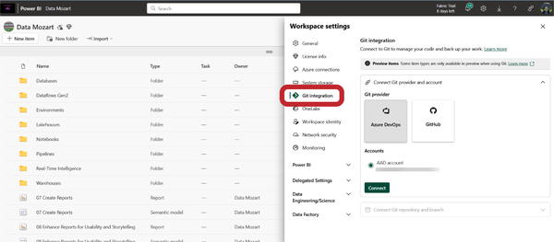

Figure 17-1. Setting up Git integration for the Fabric workspace

Once you provide all the necessary information, such as project name, Git repository, and branch, the synchronization process starts automatically. After you connect to the repository, you can see the Git status of each item in the Fabric workspace, as shown in [Figure 17-2](https://learning.oreilly.com/library/view/fundamentals-of-microsoft/9781098172916/ch17.html#fabric_ch_17_figure_2_1748224989586268).

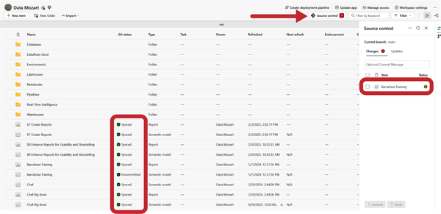

Figure 17-2. Git status for each item in the workspace

Each item may have one of the following statuses:

* Synced
* Conflict (the item was changed in both the workspace *and* the Git repository)
* Unsupported item
* Uncommitted changes in the workspace
* Update required from Git
* Item identical in both places but needs to be updated to the last commit

In [Figure 17-2](https://learning.oreilly.com/library/view/fundamentals-of-microsoft/9781098172916/ch17.html#fabric_ch_17_figure_2_1748224989586268), you may notice that there is one uncommitted item in the workspace—a Power BI semantic model. This happened because we made some changes to the item, so the Git integration process automatically labels the item as Uncommitted and also flags the warning in the “Source control” button in the top ribbon. From here, we can commit changes directly to the repository in Azure DevOps.

The same will happen if someone uploads a new version of the file to the Git repository, or makes changes to the file directly inside the Git repository. The Git integration process will again display the warning and provide you with the option to update the content in the workspace, as shown in [Figure 17-3](https://learning.oreilly.com/library/view/fundamentals-of-microsoft/9781098172916/ch17.html#fabric_ch_17_figure_3_1748224989586299).

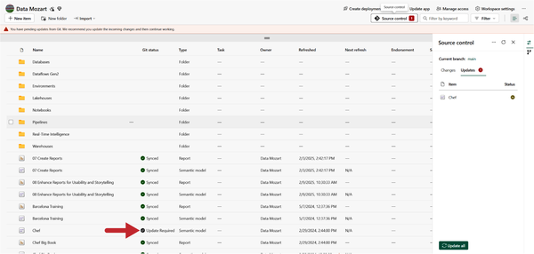

Figure 17-3. Update required status for the item that was changed directly in the Git repository

As you may conclude, when you make changes in the Fabric workspace, you can synchronize them with the Git repository using the Changes option in the Source control window. On the flip side, when new commits are made in the Git repository branch, you may synchronize them with the workspace content using the Updates option in the Source control window.

There are several recommended practices when developing Microsoft Fabric content in the shared environment. The key thing to be aware of is that when you are developing in the shared environment, it will affect all users in that workspace. Therefore, you should either use an isolated environment (i.e., a separate workspace) or use client tools such as Power BI Desktop or VS Code for development purposes. In addition, development should be done in a separate branch instead of the main branch to ensure that multiple developers can work in parallel on the feature without impacting the main branch.

If you still prefer developing directly in the Fabric web interface, you can isolate your work by selecting the “Source control” button, and then choosing the “Branch out to new workspace” option, as shown in [Figure 17-4](https://learning.oreilly.com/library/view/fundamentals-of-microsoft/9781098172916/ch17.html#fabric_ch_17_figure_4_1748224989586331).

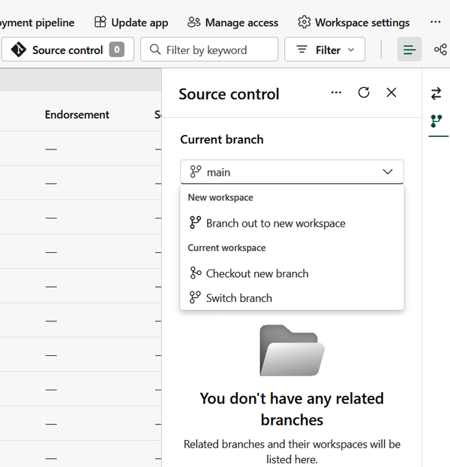

Figure 17-4. Creating an isolated branch in another workspace

Let’s wrap up by examining required Fabric permissions for common actions in a Git repository. [Table 17-1](https://learning.oreilly.com/library/view/fundamentals-of-microsoft/9781098172916/ch17.html#fabric_ch_17_table_1_1748224989590637) lists popular actions and necessary Fabric workspace roles.

| **Action** | **Fabric workspace role** |
| --- | --- |
| Connect/disconnect workspace to/from Git repository | Admin |
| Sync workspace with Git repository | Admin |
| Switch branch in the workspace | Admin |
| View Git connection details | Admin, Member, Contributor |
| See workspace Git status information | Admin, Member, Contributor |
| Update from Git | * Contributor in the workspace (write permission on all items) * Item owner (in cases where the tenant switch blocks updates for non-owners) * Build permission on external dependencies (if any) |
| Commit workspace changes from Git | * Contributor in the workspace (write permission on all items) * Item owner (in cases where the tenant switch blocks updates for non-owners) * Build permission on external dependencies (if any) |
| Create new Git branch from Fabric | Admin |
| Branch out to another workspace | Admin, Member, Contributor |
| Table 17-1. Common actions and their required workspace roles | |

**Tip**

When the items *in the workspace* have been changed, you should *commit* changes to the Git repository. If more than one item has changed, you can pick individual items to commit.

When the items *in the connected Git branch* have been changed, you should *update* the items in the workspace. The Update command always updates the entire branch—you can’t pick individual items to update.

**Deployment Pipelines**

Deployment pipelines are the out-of-the-box Microsoft Fabric solution for CD. The main reason to use deployment pipelines is to enable efficient and flexible, automated movement of Fabric items through the various development lifecycle stages.

Although you may define between two and ten stages in a pipeline, the general idea is to have stages for development, test, and production. Once you create a pipeline, it will contain these three core environments. From there, you may add, delete, or rename stages per your needs.

Let’s briefly introduce the key principles for each of the core environments:

*Development*

You should use this environment for designing, reviewing, and playing around with the Fabric content. You can start small, using minimal amounts of data for development, and once you confirm that the content is ready for review, you can push it to the next stage.

*Test*

This is a pre-production environment, where you should test and verify that the content meets certain criteria. In this stage, you should run tests on larger, more realistic data volumes, but also test items you plan to share with users, such as the Power BI App, to confirm it’s fully ready. Once you confirm that the content is at the level necessary to meet end users’ expectations, you’ll push it to the final stage.

*Production*

This is the final version of the content, and it needs to provide the highest possible level of quality and accuracy.

Before we examine some of the key concepts and inner workings of deployment pipelines, let’s first explain how to create a deployment pipeline in Microsoft Fabric. A pipeline can be created from the Workspaces window, as shown in [Figure 17-5](https://learning.oreilly.com/library/view/fundamentals-of-microsoft/9781098172916/ch17.html#fabric_ch_17_figure_5_1748224989586355).

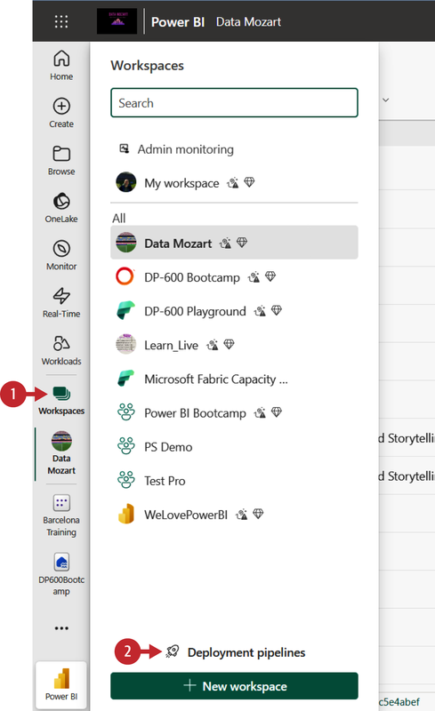

Figure 17-5. Creating a deployment pipeline

After you’ve created a pipeline, you have to add the content you plan to manage in the pipeline. This is done by assigning a workspace to the specific pipeline stage, unless you are creating a pipeline directly from the particular workspace, in which case the workspace will be automatically assigned to the pipeline. Please bear in mind that a workspace can only be assigned to one deployment pipeline at a time.

Once we assign the workspace to the development stage, we’ll get a warning if there are any unsupported items. [Figure 17-6](https://learning.oreilly.com/library/view/fundamentals-of-microsoft/9781098172916/ch17.html#fabric_ch_17_figure_6_1748224989586384) shows the dialog for deploying items from the development to the test stage.

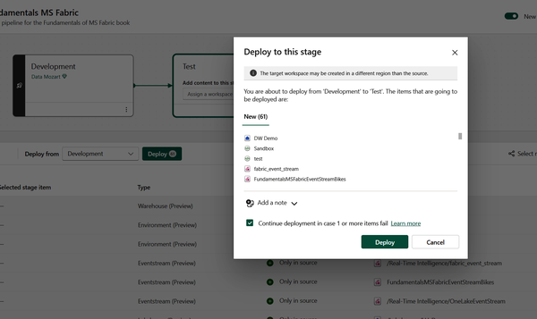

Figure 17-6. Deploying items from the development to the test stage

**A Word of Warning About Lakehouse Deployment**

At the time of writing, deployment pipelines for the majority of Fabric items are still in preview. This means that the way the deployment process works, as well as supported functionalities, might change when the feature becomes generally available.

This also means that the behavior of the deployment process might differ from item to item. A good example is the lakehouse item. If nothing is specified during the deployment pipeline configuration, a new *empty* lakehouse will be created in the target stage, while the notebooks are remapped to reference the new empty lakehouse. If you configure a pipeline to reference an existing lakehouse in the target stage, a new empty lakehouse with the same name will still be created, but notebooks references are preserved and will point to the existing lakehouse if configured.

It’s possible that the aforementioned behavior will not be relevant by the time you are reading this book. Therefore, when you set up deployment pipelines, make sure to check [the list of currently supported Fabric items](https://learn.microsoft.com/en-us/fabric/cicd/deployment-pipelines/intro-to-deployment-pipelines?tabs=new-ui#supported-items) and their specific features in the Microsoft documentation.

If you haven’t assigned an existing workspace to the test stage, Fabric will automatically create a new workspace with the same name as the one in the previous stage and append the suffix [Test]. As a prerequisite, you need to select the items that should be deployed, otherwise, the new workspace will not be created. Similarly, if you haven’t assigned an existing workspace to the production stage, a new, automatically created workspace will be assigned the suffix [Production]. The user who deploys the content automatically becomes the owner of the cloned semantic models and the only admin of the newly created workspace.

When moving content between the stages, you may choose among these three options:

*Full deployment*

Deploys all the content from the source to the target stage (e.g., from the development to the test stage)

*Selective deployment*

You can pick individual items that should be deployed to the target stage

*Backward deployment*

Deploys content from the target stage to the source stage (e.g., from the test to the development stage)

Let’s now introduce several important concepts in deployment pipelines.

**Autobinding**

During the deployment process, deployment pipelines will check for any dependencies between the items being deployed. For example, a Power BI report always depends on the semantic model item. If the linked item exists in the target stage, deployment pipelines will automatically connect the deployed item to the dependent item in the target stage. For example, if you are deploying a Power BI report from the development to the test stage, and the report is connected to the semantic model Sales that was previously deployed to the test stage, the report will automatically connect to the Sales semantic model. However, if the Sales semantic model doesn’t exist in the test stage, the deployment will fail. The potential failure can be resolved by choosing the “Select related” option for the deployment.

In some scenarios, you might want to avoid autobinding. For example, if you develop a pipeline for organizational semantic models and another pipeline for reports, you might prefer to have all the reports linked to semantic models in the production stage. Autobinding can be avoided by defining a parameter rule (see “Deployment rules,” below).

**Item pairing**

*Item pairing* is associating an item in one stage with the same item in another stage. Pairing might occur in two ways:

*Deployment*

When an unpaired item is copied from, let’s say, the development to the test stage, a copy of the item is automatically created in the test stage and paired with the item from development.

*Assigning a workspace to the deployment stage*

When a workspace is assigned, the pipeline will try to pair the items by the item name and type. If there are two or more items with the same name and type in the stage, then the folder location will also be taken into account. [Table 17-2](https://learning.oreilly.com/library/view/fundamentals-of-microsoft/9781098172916/ch17.html#fabric_ch_17_table_2_1748224989590666) considers various scenarios for item pairing.

| **Development** | **Test** | **Item pairing** |
| --- | --- | --- |
| Item name: Report1  Item type: Power BI report | Item name: Report1  Item type: Power BI report | ✅ Items are paired |
| Item name: Report1  Item type: Power BI report | Item name: Report1  Item type: Power BI report  Item name: Report1  Item type: Power BI report | ⛔ No pairing (duplicates identified); deployment fails |
| Item name: Report1  Item type: Power BI report  Folder location: Folder1 | Item name: Report1  Item type: Power BI report  Folder location: Folder2 | ⛔ No pairing, but deployment succeeds |
| Item name: Report1  Item type: Power BI report  Folder location: Folder1 | ✅ Items are paired |
| Item name: Report1  Item type: Power BI report | ⛔ No pairing, but deployment succeeds |
| Table 17-2. Item pairing in different scenarios | | |

**Deployment rules**

When you are implementing deployment pipelines, different stages may have different configuration settings. For example, each stage may have a different database or different query parameters. Also, the development stage might be used only to query sample data from the database, while the test and production stages query the entire database.

Configuring *deployment rules* enables you to allow changes to content when you deploy content between the stages. For example, if you want a semantic model in a production stage to point to a production database, you can define a rule for that semantic model. The rule is defined in the production stage, under the specific semantic model.

Once you define the rule, content deployed from test to production will inherit the value from the deployment rule, and will always apply it as long as the rule is unchanged and valid.

[Figure 17-7](https://learning.oreilly.com/library/view/fundamentals-of-microsoft/9781098172916/ch17.html#fabric_ch_17_figure_7_1748224989586406) displays the workflow for defining deployment rules for the production stage.

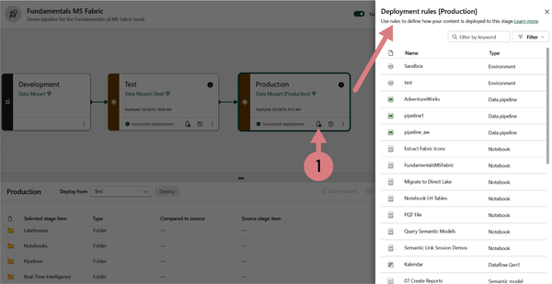

Figure 17-7. Defining deployment rules for the specific stage

Once you select the particular Fabric item, you’ll be able to set deployment rules for both data source and parameters (if you have any parameters defined). [Figure 17-8](https://learning.oreilly.com/library/view/fundamentals-of-microsoft/9781098172916/ch17.html#fabric_ch_17_figure_8_1748224989586426) illustrates the data source rule definition for the Power BI semantic model so that it connects to another database when deployed to the production stage.

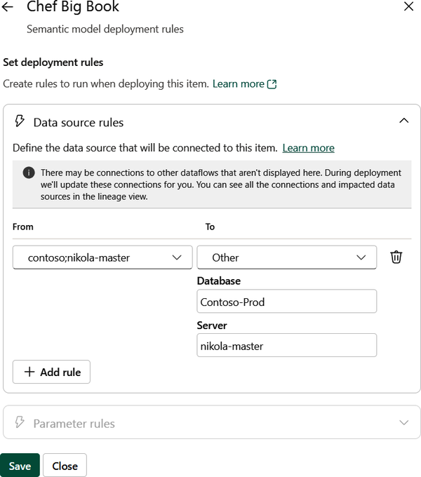

Figure 17-8. Defining data source deployment rule for a Power BI semantic model

For notebooks, you may also specify the default lakehouse rule. You should always check the [list of supported items and deployment rules](https://learn.microsoft.com/en-us/fabric/cicd/deployment-pipelines/create-rules?tabs=new-ui) in the official Microsoft documentation.

**Copy item properties between the stages**

When you deploy content between stages, not all item properties will be copied to the target stage. [Table 17-3](https://learning.oreilly.com/library/view/fundamentals-of-microsoft/9781098172916/ch17.html#fabric_ch_17_table_3_1748224989590682) shows which item properties are copied or not copied during the deployment process.

| **Copied** | **Not copied** |
| --- | --- |
| Data sources | Data |
| Parameters | Permissions for a workspace or specific item |
| Report visuals | Workspace settings |
| Report pages | Personal bookmarks |
| Dashboard tiles | App content and settings (needs to be done manually) |
| Model metadata | Role assignment[**a**](https://learning.oreilly.com/library/view/fundamentals-of-microsoft/9781098172916/ch17.html#id635) |
| Item relationships | Refresh schedule1 |
| Sensitivity labels[**b**](https://learning.oreilly.com/library/view/fundamentals-of-microsoft/9781098172916/ch17.html#id636) | Data source credentials and endorsement settings** |
| [**a**](https://learning.oreilly.com/library/view/fundamentals-of-microsoft/9781098172916/ch17.html#id635-marker) Semantic model property  [**b**](https://learning.oreilly.com/library/view/fundamentals-of-microsoft/9781098172916/ch17.html#id636-marker) Labels are copied when a new item is deployed, when an existing item is deployed to an empty stage, or when the source item contains a sensitivity label and the target item doesn’t. | |
| Table 17-3. Item properties copied between the stages | |

**Deployment pipeline permission model**

Deployment pipelines rely on their own permission model, although it’s still interconnected and highly dependent on the workspace permission model. There are two possible ways to allow users to work with deployment pipelines—through the Pipeline admin role, which is the only role specifically used for deployment pipelines, or via workspace roles *in combination* with the Pipeline admin role. As you may conclude, the Pipeline admin role is required for all the operations related to the deployment pipeline.

[Table 17-4](https://learning.oreilly.com/library/view/fundamentals-of-microsoft/9781098172916/ch17.html#fabric_ch_17_table_4_1748224989590695) displays the deployment pipeline permission model.

| **Role** | **Permission** |
| --- | --- |
| Pipeline admin | * View a pipeline * Share a pipeline with others * Edit and delete a pipeline * Unassign a workspace from a stage * No permissions on the workspace content |
| Workspace Viewer (and Pipeline admin) | * Consume content * Unassign a workspace from a stage |
| Workspace Contributor (and Pipeline admin) | The same as Viewer plus:   * Compare stages * View semantic models * Deploy items (must be at least Contributor in both source and target workspaces) |
| Workspace Member (and Pipeline admin) | The same as Contributor plus:   * View workspace content * Update semantic models * Configure semantic model deployment rules |
| Workspace Admin (and Pipeline admin) | The same as Member plus:   * Assign a workspace to a stage |
| Table 17-4. Deployment pipeline permission model | |

Recommended Practices for Lifecycle Management

Let’s wrap up this section by introducing the recommended practices when implementing lifecycle management in Fabric. We’ll follow the common workflow, starting from content preparation, and then moving through the three main stages: development, test, and production.

[Table 17-5](https://learning.oreilly.com/library/view/fundamentals-of-microsoft/9781098172916/ch17.html#fabric_ch_17_table_5_1748224989590708) displays the list of recommended practices for each part of the workflow.

| **Stage** | **Recommended practices** |
| --- | --- |
| Content preparation | * Separate development between teams * Plan a permission model * Connect different stages to different databases * Use parameters to change configuration settings between stages |
| Development | * Back up work into a Git repository * Roll back changes * Use an isolated environment (workspace) to work |
| Test | * Simulate the production environment * Configure deployment rules with a real-life data source * Check related items to avoid breaking changes * Update data items * Test the Power BI app if needed |
| Production | * Define who can deploy to production * Set deployment rules * Update the production Power BI app if needed * Deploy using Git integration |
| Table 17-5. Recommended workflow practices | |

Automating CI/CD Workflows with Fabric REST APIs

Fabric REST APIs enable the automation of numerous Fabric procedures and processes, improving efficiency and productivity. When it comes to CI/CD REST APIs specifically, you can leverage them for different actions and operations, such as committing the changes from the workspace to the connected Git repository, updating the workspace with commits made to the Git repository, checking which items have incoming changes, deploying the deployment pipeline content between stages, and many more.

Since Microsoft constantly updates the list of available REST APIs, we suggest you always check the list of currently supported REST APIs for the specific task. In the official Microsoft documentation, you can find a [list of all deployment pipelines APIs](https://learn.microsoft.com/en-us/rest/api/fabric/core/deployment-pipelines) as well as a list of all [Git-related APIs](https://learn.microsoft.com/en-us/rest/api/fabric/core/git).

Summary

We are not exaggerating when we say that CI/CD workflows are critical for successful Microsoft Fabric implementation because they enable automated, consistent processes for developing, testing, and deploying analytics solutions.

By establishing CI/CD processes, organizations ensure consistent quality and reduce the space for manual errors, while at the same time increasing the overall data platform quality and agility. Microsoft Fabric environments often assume tight collaboration between data engineers, data analysts, and developers, working simultaneously on notebooks, data pipelines, semantic models, and other Fabric items. With Git integration and deployment pipelines, Microsoft Fabric provides out-of-the-box solutions for implementing effective CI/CD workflows. Moreover, implementing CI/CD processes promotes DevOps and DataOps principles by automating repetitive tasks, enforcing quality gates, and establishing continuous feedback loops. This is of paramount importance in enterprise-grade environments, where any inconsistency or delay may significantly affect the decision-making process.

In the next, final chapter of the book, we put all the pieces of the Microsoft Fabric puzzle in the right place, and provide you with clear guidance about “when to choose what” in Fabric.

Chapter 18. Fabric Decision Guide: When to Choose What

**A Note for Early Release Readers**

With Early Release ebooks, you get books in their earliest form—the authors’ raw and unedited content as they write—so you can take advantage of these technologies long before the official release of these titles.

This will be the 18th chapter of the final book. Please note that the GitHub repo will be made active later on.

If you’d like to be actively involved in reviewing and commenting on this draft, please reach out to the editor at *sevans@oreilly.com*.

You’ve come a long way by reading this book so far, and you should be well-equipped with a thorough understanding of the individual Microsoft Fabric components.

We like to think about this chapter as a puzzle. You know the feeling when you start building a jigsaw—you are very well aware of each individual piece and what’s displayed on it. Not only that, there are probably pieces that have the shape to fit well in the various parts of the jigsaw. But, are these pieces really in the right spot? Or, should you use another one? Consider this chapter as the final jigsaw—you know each and every individual piece—and we will now help you put all of these pieces into the right place.

How to Pick the Right Option

Microsoft Fabric is all about the options. As you’ve seen up to this point in the book, the same task can often be completed in multiple ways. And, it doesn’t necessarily mean that one way is better than the other. Sometimes, it boils down to the skill set of the individuals in your organization performing the data task, or maybe it’s just a personal preference. Sometimes, however, these decisions might have a larger impact on the entire data platform workload. Therefore, it is of paramount importance to understand the implications of choosing Option Aversus Option Bto complete Task XYZ in Microsoft Fabric.

In the following sections, we’ll do our best to provide you with guidance on the most common Fabric dilemmas. Please bear in mind that the list of dilemmas is not definitive—we simply handpicked some of the challenges that Fabric practitioners face most frequently, and where we believe that such guidance would make the lives of these practitioners much easier in their day-to-day work with Microsoft Fabric.

**Generally Recommended Practices and Edge-Case Scenarios**

Before we proceed, an important disclaimer: the guidance we are providing here is based on both our experience with implementing Microsoft Fabric in real-world scenarios, and the recommended practices provided by Microsoft.

Please keep in mind that the guidance relies on *generally recommended* practices (we intentionally avoid using the phrase “best practices,” because the best is very hard to determine and agree on). The word “generally” means that the practice we recommend should be used in*most* of the relevant scenarios, but there will always be edge cases where the recommended practice is simply not the best solution. Therefore, you should always evaluate if the generally recommended practice makes sense in your specific use case.

Choosing an Analytical Engine

All Microsoft Fabric roads lead to OneLake! You learned that mantra in [Chapter 3](https://learning.oreilly.com/library/view/fundamentals-of-microsoft/9781098172916/ch03.html#fabric_ch_3_all_roads_lead_to_onelake_1748224992659005). However, which road is the right one for *you*, dear reader? Should you pick a lakehouse, a warehouse, or maybe an eventhouse for storing your data in OneLake? There are numerous factors to take into account, so let’s explore three that we consider most relevant: data volume, supported data types, and supported programming languages.

In this section, we’ll break down the key considerations for choosing the optimal path.

**Data Volume**

Although there is no single number that differentiates *small* from *big* data, and you’ll probably find dozens of opinions in the various resources on the web or other books, we often refer to big data as an extremely large and diverse collection of data that continuously grows over time. However, for the sake of setting boundaries when making decisions, we’ll consider big data anything above 5 TB of stored data with 100+ GB of ingested data per day.

When choosing the optimal analytical engine in Microsoft Fabric, there is no such thing as the minimum amount of data suitable for warehouse versus lakehouse, or vice versa. In theory, you could store only a handful of data records in any of the analytical stores in Fabric, but you’ll start reaping the benefits of massively parallel processing (MPP) architectures, which are implemented in both Fabric lakehouse and Fabric warehouse, only with large amounts of data. Explaining the details about MPP is beyond the scope of this book, but you can find more details in the [TIBCO glossary](https://www.tibco.com/glossary/what-is-massively-parallel-processing).

To wrap up, data volume shouldn’t be a determining factor when deciding which analytical engine to use, as each lakehouse, warehouse, and eventhouse scales to support petabytes of data if necessary.

**Supported Data Types**

When choosing a storage option in OneLake, you’ll need to first consider the data type. [Table 18-1](https://learning.oreilly.com/library/view/fundamentals-of-microsoft/9781098172916/ch18.html#fabric_ch_18_table_1_1748224990828143) depicts supported data formats for three Fabric analytical storage types.

| **Supported data format** | **Lakehouse** | **Warehouse** | **Eventhouse** |
| --- | --- | --- | --- |
| Structured | Yes | Yes | Yes |
| Semi-structured | Yes | Limited (JSON) | Yes |
| Unstructured | Yes | No | Yes |
| Table 18-1. Supported data formats per analytical storage | | | |

As you can see in [Table 18-1](https://learning.oreilly.com/library/view/fundamentals-of-microsoft/9781098172916/ch18.html#fabric_ch_18_table_1_1748224990828143), both lakehouses and eventhouses support all data formats. So, the fair question would be, When should I use a lakehouse over an eventhouse? The short answer is that whenever you need to handle any type of streaming or event-based data, choose an eventhouse. A few examples of event-based data are telemetry and log data, time series data, and data collected from IoT devices.

The long answer is more nuanced and depends on numerous factors, such as:

*Using data downstream*

It’s important to consider how you plan to use the data downstream. For example, if you are using Direct Lake mode for Power BI semantic models, data must be available in Delta format, which is not supported in eventhouses. We cover Direct Lake mode in depth in [Chapter 9](https://learning.oreilly.com/library/view/fundamentals-of-microsoft/9781098172916/ch09.html#fabric_ch_9_power_bi_1748224996890066). Luckily, there is a feature in Fabric Eventhouse “OneLake availability,” that allows replicating eventhouse data in Delta Parquet format in OneLake, although keep in mind that the synchronization between the eventhouse data and Delta-replicated data sometimes may take a while.

*Optimizing storage cost*

Generally speaking, storage is more expensive for eventhouses than for lakehouses, since eventhouses use [OneLake Cache Storage](https://learn.microsoft.com/en-us/fabric/real-time-intelligence/real-time-intelligence-consumption#storage-billing) to provide the fastest query response times at an additional cost.

*Processing streaming data*

Eventhouses are optimized for processing streaming data (indexing and partitioning happen automatically), whereas processing streaming data using a lakehouse will force the creation of multiple small Parquet files that must be vacuumed and optimized later, which can lead to increased capacity unit consumption. Explaining the vacuum and optimize operations is out of the scope of this book, but you can read more about it in the [Microsoft documentation](https://learn.microsoft.com/en-us/fabric/data-engineering/lakehouse-table-maintenance).

**Supported Programming Languages**

This is undoubtedly one of the key factors when making a decision, not only about the analytical engine, but also when designing the entire Fabric architecture. The reason is obvious—let’s imagine that the entire data team in your organization consists of hard-core T-SQL developers. Would you force them to learn another programming language (Python, for example)? Or would you rather choose a Fabric component that plays to their strengths?

[Table 18-2](https://learning.oreilly.com/library/view/fundamentals-of-microsoft/9781098172916/ch18.html#fabric_ch_18_table_2_1748224990828183) shows supported programming languages for both read and write operations.

| **Operation type** | **Lakehouse** | **Warehouse** | **Eventhouse** |
| --- | --- | --- | --- |
| Read | * Spark   + PySpark   + Spark SQL   + Scala   + R * T-SQL * Python | * T-SQL | * KQL * T-SQL |
| Write | * Spark   + PySpark   + Spark SQL   + Scala   + R * Python | * T-SQL * Python (using pyodbc library) | * KQL |
| Table 18-2. Supported programming languages per analytical storage | | | |

Let’s stop for a moment and examine the importance of the selection you make based on the information in [Table 18-2](https://learning.oreilly.com/library/view/fundamentals-of-microsoft/9781098172916/ch18.html#fabric_ch_18_table_2_1748224990828183). Imagine that you’re implementing a medallion architecture in Microsoft Fabric. (We cover the medallion architecture in detail in [Chapter 5](https://learning.oreilly.com/library/view/fundamentals-of-microsoft/9781098172916/ch05.html#fabric_ch_5_data_engineering_1748224993699749).) In accordance with the recommended practice of building a star schema dimensional model in the final layer (gold/curated), you’d need to apply various data transformations to implement business rules and logic. If your data engineers or analytics engineers are feeling comfortable writing T-SQL, you should probably choose a warehouse for this layer, since T-SQL can’t be used for inserting, updating, or deleting the data in a lakehouse or eventhouse.

On the flip side, if the majority of the data team is proficient with Python or any language that can be used to manipulate the data using the Spark engine, you’d probably go all the way with a lakehouse. Although, in full honesty, the road between T-SQL and Spark SQL is not that long, in case you plan to leverage SQL skills while using a lakehouse.

**Supported Data Ingestion and Data Access Methods**

Data can be ingested into Microsoft Fabric using numerous tools or accessed by leveraging particular features such as shortcuts. (We covered shortcuts in [Chapter 3](https://learning.oreilly.com/library/view/fundamentals-of-microsoft/9781098172916/ch03.html#fabric_ch_3_all_roads_lead_to_onelake_1748224992659005).) Therefore, a decision on which analytical engine to use might also depend on the ingestion option you choose or feel most comfortable with.

We provide a decision guide on various data ingestion options in a later. Here, we just want to help you understand which ingestion methods are supported in regard to the selected analytical engine, as shown in [Table 18-3](https://learning.oreilly.com/library/view/fundamentals-of-microsoft/9781098172916/ch18.html#fabric_ch_18_table_3_1748224990828201).

| **Data ingestion/access method** | **Lakehouse** | **Warehouse** | **Eventhouse** |
| --- | --- | --- | --- |
| Pipeline | Yes | Yes | Yes |
| Dataflow Gen2 | Yes | Yes | Yes |
| Eventstream | Yes | No | Yes |
| Spark connectors | Yes | Yes, but limited | Yes, but limited |
| T-SQL commands | No, except when executed using Python pyodbc library | Yes | No |
| KQL commands | No | No | Yes |
| Shortcuts | Yes | Yes, but only as a source | Yes |
| Table 18-3. Supported data ingestion/data access methods per analytical storage | | | |

**Access Control**

In [Chapter 16](https://learning.oreilly.com/library/view/fundamentals-of-microsoft/9781098172916/ch16.html#fabric_ch_16_securing_microsoft_fabric_1748224988802503), we examined various options for securing the data in Microsoft Fabric. The availability of particular access control features may also impact the decision about the analytical engine you want to use. [Table 18-4](https://learning.oreilly.com/library/view/fundamentals-of-microsoft/9781098172916/ch18.html#fabric_ch_18_table_4_1748224990828214) shows how the access control can be implemented in a lakehouse, warehouse, and eventhouse.

| **Access control feature** | **Lakehouse** | **Warehouse** | **Eventhouse** |
| --- | --- | --- | --- |
| Object-level security | Yes | Yes | Yes, via Restricted View Access Policies |
| Row-level security | Yes, via SQL analytics endpoint | Yes | Yes |
| Column-level security | Yes, via SQL analytics endpoint | Yes | No |
| Table 18-4. Available access control options per analytical storage | | | |

OneLake Interoperability

“What if I choose a lakehouse for my silver layer, and a warehouse for the gold layer? Can I combine the data from them?”

“I’ve already configured my eventhouse to store the streaming data generated by our IoT devices. How can I mix and match this data with the existing data from a lakehouse or warehouse?”

These are some of the questions we’re often asked by customers considering or already using Microsoft Fabric. In this section, we’ll provide an overview of the interoperability between various analytical engines in Fabric, as shown in [Table 18-5](https://learning.oreilly.com/library/view/fundamentals-of-microsoft/9781098172916/ch18.html#fabric_ch_18_table_5_1748224990828226).

| **Interoperability feature** | **Lakehouse** | **Warehouse** | **Eventhouse** |
| --- | --- | --- | --- |
| Data stored in OneLake | Yes | Yes | Yes, when the Eventhouse “OneLake availability” is enabled |
| Data stored in Delta format | Yes | Yes | Yes, when the OneLake Integration property is enabled |
| Source for shortcuts | Yes | Yes | Yes, when the OneLake Integration property is enabled |
| Target for shortcuts | Yes | Yes, via cross-database queries | Yes |
| Cross- lakehouse/warehouse/ eventhouse queries | Yes | Yes | Yes, when the OneLake Integration property is enabled |
| Table 18-5. Interoperability features per analytical storage | | | |

Scenario-Based Decision Guide

Based on all of the aforementioned criteria and typical analytical requirements, we identified a few common scenarios you might face when deciding which Fabric component to pick for a particular use case. [Table 18-6](https://learning.oreilly.com/library/view/fundamentals-of-microsoft/9781098172916/ch18.html#fabric_ch_18_table_6_1748224990828238) illustrates the *level of suitability* of each analytical engine for the scenario in the scope. A 5-star rating means that the particular engine is a good fit for the specific use case. A 3-star rating means that the required scenario may be accomplished by using the particular analytical engine, but with some limitations or considerations. Finally, a 1-star rating means that we don’t recommend using the particular engine for that specific use case.

For the sake of clarity, we would like to provide a brief overview of each of the scenarios identified in [Table 18-6](https://learning.oreilly.com/library/view/fundamentals-of-microsoft/9781098172916/ch18.html#fabric_ch_18_table_6_1748224990828238):

*Operational reports with low data latency*

The emphasis is on providing low latency and high concurrency for small-to-medium volumes of structured data.

*Enterprise data warehousing*

The emphasis is on providing scalability for storing and analyzing medium-to-high volumes of structured, semi-structured, or unstructured data.

*Implementing a medallion architecture*

This refers to a design pattern where data goes through multiple layers (such as bronze, silver, and gold, or raw, validated, curated) on its way from ingestion to consumption-ready. In real life, there are dozens of scenarios where a medallion architecture is implemented by combining multiple analytical engines. One of the most common is using a lakehouse for the bronze and silver layers and a warehouse for the gold layer. Of course, this is not set in stone, and depending on the specific use case, you may use a lakehouse-only or warehouse-only approach when implementing a medallion architecture. On the flip side, the eventhouse would be a good fit when implementing a medallion architecture for streaming data.

*Implementing data marts*

The emphasis is on providing efficient analytical capabilities for structured data as a subset of an enterprise data warehouse focused on a particular line of business, department, or subject area.

*Real-time analytics*

The emphasis is on providing efficient processing and analytical capabilities for the data as soon as it becomes available. In streaming data scenarios, an eventhouse is the most obvious choice, although you might also pick a lakehouse in some cases where query concurrency is not a concern.

*Handling arbitrary unstructured data*

A lakehouse is a no-brainer here, because of its support for all data types.

| **Scenario** | **Lakehouse** | **Warehouse** | **Eventhouse** |
| --- | --- | --- | --- |
| Operational reports with low data latency | ⭐⭐⭐ | ⭐⭐⭐ | ⭐⭐⭐⭐⭐ |
| Enterprise data warehousing | ⭐⭐⭐⭐⭐ | ⭐⭐⭐⭐⭐ | ⭐⭐⭐ |
| Implementing a medallion architecture[**a**](https://learning.oreilly.com/library/view/fundamentals-of-microsoft/9781098172916/ch18.html#id638) | ⭐⭐⭐⭐⭐ | ⭐⭐⭐ | ⭐⭐⭐⭐⭐ |
| Implementing data marts | ⭐⭐⭐⭐⭐ | ⭐⭐⭐⭐⭐ | ⭐ |
| Real-time analytics | ⭐⭐⭐ | ⭐ | ⭐⭐⭐⭐⭐ |
| Handling arbitrary unstructured data | ⭐⭐⭐⭐⭐ | ⭐ | ⭐⭐⭐ |
| [**a**](https://learning.oreilly.com/library/view/fundamentals-of-microsoft/9781098172916/ch18.html#id638-marker) When a single analytical engine is used across all medallion layers | | | |
| Table 18-6. Scenario-based level of suitability | | | |

We’ll wrap up this section with [Figure 18-1](https://learning.oreilly.com/library/view/fundamentals-of-microsoft/9781098172916/ch18.html#fabric_ch_18_figure_1_1748224990820789) which shows a high-level decision tree for the analytical storage engine. Please keep in mind that it shows a simplified overview based on the common scenarios we’ve examined, and it’s by no means a definitive guidance when choosing the optimal analytical engine. In addition, we would also like to emphasize that combining multiple engines should be an option when you need to incorporate diverse analytical workloads across the data platform.

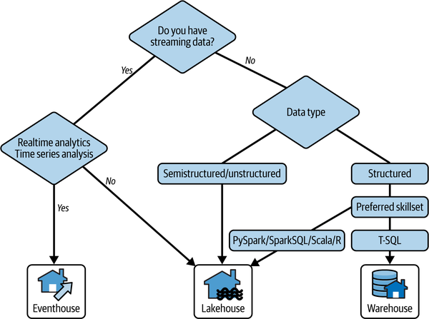

Figure 18-1. Decision tree for choosing the optimal analytical engine

Mirrored Azure SQL Database Versus SQL Database

You learned about mirroring and SQL databases in Fabric in detail in Chapters [11](https://learning.oreilly.com/library/view/fundamentals-of-microsoft/9781098172916/ch11.html#fabric_ch_11_mirroring_1748224984034275) and [10](https://learning.oreilly.com/library/view/fundamentals-of-microsoft/9781098172916/ch10.html#fabric_ch_10_sql_databases_1748224983704930), respectively. And, if you wondered after reading these two chapters, what the difference is between the mirrored Azure SQL Database and SQL database in Fabric, we don’t blame you. These two are “children” of the same “mother”—Azure SQL Database.

From a purely conceptual and technical point of view, there is very little difference between the mirrored Azure SQL Database and the SQL database in Fabric. In both cases, your operational data is replicated in near real-time and stored in Delta format in OneLake, using the same technology under the hood.

The key difference, and the key factor that you should consider when choosing between these two, is *who* is taking care of the operational database itself. If you choose mirroring for Azure SQL Database, since we are talking about a PaaS offering, *you* are in charge of the database—security, number of vCores or DTUs (database transaction units as a blended measure of CPU, memory, reads, and writes), managing costs, scalability, and so on. On the flip side, as a SaaS offering, the SQL database in Fabric is managed as part of the entire Fabric ecosystem. This means it automatically scales and integrates with the development and analytics framework in Fabric and costs are included in your Fabric bill.

**Note**

Mirrored Azure SQL Database or SQL database in Fabric. Which one is better? We’re afraid there is no correct answer to this question, as it would be the same as trying to answer the question. Is it better to sit in the backseat of a self-driving car or drive the car yourself?

[Figure 18-2](https://learning.oreilly.com/library/view/fundamentals-of-microsoft/9781098172916/ch18.html#fabric_ch_18_figure_2_1748224990820830) depicts the key difference between the mirrored Azure SQL Database and the SQL database in Fabric.

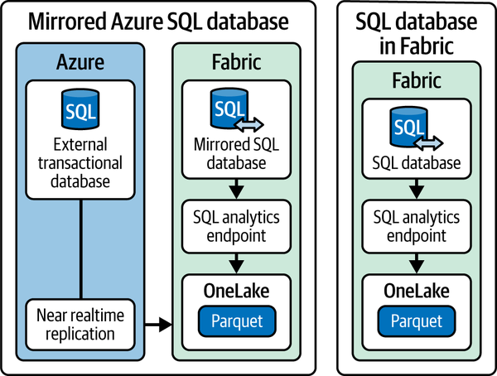

Figure 18-2. The key difference between the mirrored Azure SQL DB and SQL DB in Fabric

Let’s wrap up this section by introducing two real-life scenarios that might help you choose between the mirrored Azure SQL Database and the SQL database in Fabric.

**Scenario 1: Web Application with Operational Data**

*Task*

You are a developer tasked with creating a web application to store operational data. You need an easy and straightforward database setup and management process. One of the requirements is enabling integration of the operational data with other analytical workloads, where the master data is managed within the Fabric warehouse. What should you choose?

*Solution*

You should choose SQL database in Fabric, since creating a database is one click away and Microsoft Fabric automatically handles database management. Additionally, by creating a near real-time replica of the transactional data, the data is readily available for cross-querying with other Fabric analytical storage engines, such as a lakehouse or warehouse.

**Scenario 2: Big Data Containing Sensitive Information**

*Task*

You are a developer tasked with creating a .NET application that should support a large amount of data (10+ TB). Additionally, since the application will handle sensitive information about credit card numbers, you need to ensure that the data is always encrypted.

*Solution*

You should choose Azure SQL Database and configure mirroring of the database to Fabric. Since the SQL database in Fabric supports only up to 4 TB of storage, it won’t meet the requirement regarding the amount of data. In addition, Azure SQL DB has an “Always Encrypted” feature, which is not available in the SQL database in Fabric. Hence, to fulfill this requirement, you must choose the Azure SQL DB.

SQL Database in Fabric Versus Fabric Warehouse

If you are a hard-core T-SQL person, you’ll probably feel at home while reading this section. If you haven’t skipped previous chapters, especially [Chapter 5](https://learning.oreilly.com/library/view/fundamentals-of-microsoft/9781098172916/ch05.html#fabric_ch_5_data_engineering_1748224993699749), you are probably aware that T-SQL can be used for read-only operations over the data stored in a lakehouse via a SQL analytics endpoint. However, we owe you clarification about *data-writing* possibilities using the T-SQL language.

There are two Fabric items that support the CRUD (create, read, update, delete) set of operations using T-SQL: Fabric warehouse and SQL database in Fabric. Therefore, the fair question would be, When and why should I choose one over the other?

Before we dive into exploring scenarios, [Figure 18-3](https://learning.oreilly.com/library/view/fundamentals-of-microsoft/9781098172916/ch18.html#fabric_ch_18_figure_3_1748224990820855) provides a decision tree based on the common requirements when working with structured data.

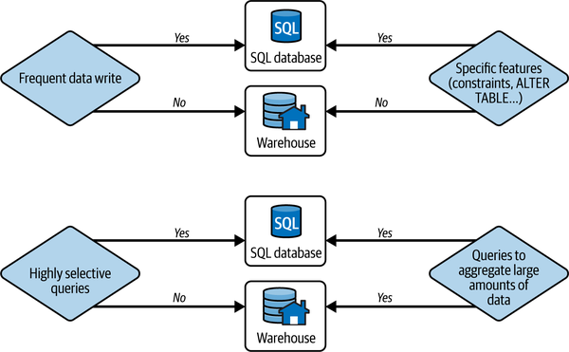

Figure 18-3. SQL database versus warehouse decision tree based on the common requirements

Let’s now examine a few use cases based on the requirements you might face when choosing between the SQL database in Fabric and a warehouse.

**Scenario 1: Aggregating Big Data for Analytical Reports**

*Task*

You are an analytics engineer tasked with designing a solution to support complex business reporting requirements. The end users must be able to perform analysis over large amounts of data, where most of the queries should be able to efficiently support aggregating the data per different attributes. The acceptable data latency in reports is up to 12 hours.

*Solution*

You should choose the Fabric warehouse. The warehouse relies on the MPP paradigm, which provides an efficient solution for queries performing aggregations over huge amounts of data. Additionally, since there is no requirement for frequent data writes, choosing a warehouse would make more sense.

**Scenario 2: Near Real-Time Operational Reporting with Enforced Database Constraints**

*Task*

You are a database developer tasked with designing a solution for storing the data in a high concurrency database that guarantees strongly enforced foreign keys for relational integrity. The end users should be able to create reports that combine the data from this database and other Fabric analytical engines, namely a lakehouse, but occasionally, also a few near real-time operational reports retrieving specific database records.

*Solution*

You should choose the SQL database in Fabric, because, unlike the Fabric warehouse, it provides enforced constraints (primary keys, unique keys, etc.). The requirement to combine the data with other Fabric items could be fulfilled by the automatic data replication from the SQL database to OneLake. Finally, SQL database in Fabric is not constrained by latency and is optimized for highly selective query patterns, which are commonly present in operational reporting scenarios.

Direct Lake Versus Import Mode for Semantic Models

For Power BI professionals reading this book, this is probably one of the most exciting sections. Since the introduction of Microsoft Fabric and the Direct Lake feature, there have been many ongoing debates on the topic of this section. If you are not sure what the difference is between Direct Lake and Import mode, please refer to [Chapter 9](https://learning.oreilly.com/library/view/fundamentals-of-microsoft/9781098172916/ch09.html#fabric_ch_9_power_bi_1748224996890066), where we cover all semantic model storage modes in more depth.

While our intention here is to provide thorough guidance about choosing between Direct Lake and Import mode, this is by no means a definitive guide, nor do we want to proclaim the winner in this battle. In the end, maybe it’s not even a fair battle, as the Import mode has been here since Power BI was introduced a decade ago, whereas the Direct Lake is still very much a work in progress. However, our goal is to provide clear guidance and examine potential use cases for both Import and Direct Lake based on common sense and experiences from real-life Direct Lake implementations at the time of writing this book. Apparently, as the Fabric adoption grows over time, there will be more Direct Lake reference points to compare.

**Tip**

While there is no doubt that Direct Lake *is* an amazing feature, it is by no means a solution that fits every scenario, nor is it a direct replacement for Import and DirectQuery storage modes. Both Import and DirectQuery are here to stay—Direct Lake is just another option that supplements the old-guard Power BI storage mode.

We ask you to take a look at [Figure 18-4](https://learning.oreilly.com/library/view/fundamentals-of-microsoft/9781098172916/ch18.html#fabric_ch_18_figure_4_1748224990820878), which shows a decision guide for using Import versus Direct Lake mode. After that, we will elaborate on particular decision points and provide further explanation when necessary.

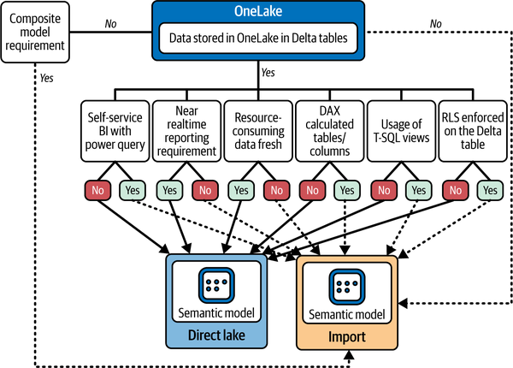

Figure 18-4. Direct Lake versus Import mode decision tree based on the common requirements

Let’s break down [Figure 18-4](https://learning.oreilly.com/library/view/fundamentals-of-microsoft/9781098172916/ch18.html#fabric_ch_18_figure_4_1748224990820878) and provide additional context to particular decisions. If there is a requirement for using composite models, which are not supported in Direct Lake mode at all, the choice is obvious—you must go the Import mode route. This doesn’t necessarily mean that you’ll use pure Import mode—this is not going to be a composite model then—but when using Import mode, you may combine these tables with DirectQuery and/or Dual mode tables within a single semantic model.

The next key decision-maker is the storage location, or if you want to be more precise, the storage format of the data. One of the prerequisites for using Direct Lake is that the data must be stored in Delta format. We want to emphasize the following point here: data doesn’t necessarily need to be *physically* stored in OneLake. If you are, for example, leveraging shortcuts to a Delta table stored in ADLS Gen2, Dataverse, or any other supported external storage location, as long as the data is stored in the Delta format, it can be part of the Direct Lake semantic model. However, keep in mind that the best possible performance of Direct Lake storage mode semantic models is achieved by applying V-Order to Delta tables, which is not applied to Delta tables stored outside Microsoft Fabric.

Finally, if your data sources reside in workspaces that are in a different region than the workspace where you store semantic models, you can’t use Direct Lake because creating a Direct Lake semantic model in a workspace that is in a different region of the data source workspace is currently not supported.

Let’s now examine the main consideration points from [Figure 18-4](https://learning.oreilly.com/library/view/fundamentals-of-microsoft/9781098172916/ch18.html#fabric_ch_18_figure_4_1748224990820878) using an already familiar scenario-based approach.

**Scenario 1: Self-Service BI with Power Query**

*Task*

You are a seasoned Power BI developer with strong experience in transforming and preparing data using Power Query. You are aware of Dataflow Gen2 capabilities to leverage the Power Query skill set in Fabric, but the centralized IT department manages the lakehouse, and you don’t have permission to modify Delta tables.

*Solution*

You should choose Import mode because it supports data preparation using Power Query, whereas Direct Lake models don’t allow using Power Query at all.

**Scenario 2: Near Real-Time Reporting Requirement**

*Task*

You are developing a sales report in Power BI that requires the data to be available in the report as soon as it lands in OneLake. The maximum tolerance for data latency is five minutes.

*Solution*

You should choose Direct Lake storage mode. When using Direct Lake mode, the data is retrieved from OneLake and loaded into memory at query time. This ensures that the latest data will always be available in the semantic model. Import mode, however, is not suitable for near real-time reporting requirements because you’d need to refresh the data on a high cadence, which, depending on the semantic model size, may not be frequent enough to fulfill the business requirement.

**Scenario 3: Resource-Consuming Data Refresh Rrocess**

*Task*

You are an analytics engineer in a large global corporation. who is building a complex semantic model that’s initially around 20 GB in size and is expected to grow over time. Since the older data is also subject to change, incremental refresh is not an option. The data in the report should be refreshed every four hours.

*Solution*

You should choose Direct Lake storage mode. When refreshing the Import mode semantic model, the system needs available memory that is approximately double the size of the model—in our scenario, approximately 40 GB. This is because the system keeps the read-only copy of the model available for querying while the data refresh process runs. The entire process is described on the [Microsoft website](https://learn.microsoft.com/en-us/power-bi/connect-data/refresh-data#semantic-models-in-import-mode).

A full refresh of a large semantic model is very resource-consuming, both in terms of capacity units and time. When using Direct Lake mode, the refresh process (also known as framing) refreshes metadata only. This means that even for large semantic models, a refresh operation should not take more than a few seconds.

**Scenario 4: Using DAX Calculated Tables/Columns**

*Task*

You are a Power BI developer who is proficient with the DAX language. In the company you work for, data preparation and transformation are performed by a dedicated team of data engineers. The Fabric warehouse is managed by the IT department, and you don’t have permission to modify Delta tables. To extend a relatively small semantic model for the HR department, you need to implement business logic, which assumes creating additional calculated tables and columns based on the existing model tables.

*Solution*

You should choose Import mode. DAX calculated tables and columns are calculated and persisted when the model is refreshed. Since there is no data refresh in Direct Lake mode (only metadata is refreshed), these types of model objects are not supported in Direct Lake. Although this will produce the desired outcome in this specific scenario, for the sake of sticking with generally recommended practices, we suggest avoiding the use of DAX calculated tables and columns and instead implement the transformation logic as upstream as possible—in this case, by applying the calculation logic in the Delta table in Fabric warehouse.

**Scenario 5: Using T-SQL Views**

*Task*

You are a Power BI developer tasked with creating a Power BI semantic model for the financial department in your organization. Your analytics engineer colleague, a seasoned T-SQL professional, implemented the entire logic for the serving (gold) layer using T-SQL views. You need to leverage these views in the semantic model.

*Solution*

You should choose Import mode. Although T-SQL views can be used in Direct Lake semantic models, all queries that retrieve the data from views will automatically fall back to DirectQuery storage mode, which may impact the report queries’ performance. You can learn more about the DirectQuery storage mode and the Direct Lake fallback behavior in [Chapter 9](https://learning.oreilly.com/library/view/fundamentals-of-microsoft/9781098172916/ch09.html#fabric_ch_9_power_bi_1748224996890066).

**Scenario 6: RLS/OLS Enforced in the Warehouse/SQL Analytics Endpoint of the Lakehouse**

*Task*

You are a Power BI developer tasked with creating a Power BI semantic model for the sales department in your organization. The data source for the model is Delta tables in the Fabric warehouse. Your company applies strict data access policies, which assume that access is granted using T-SQL commands to enforce RLS and OLS on the Delta table stored in a warehouse.

*Solution*

You should choose Import mode. Although implementing both RLS and OLS on the Delta table in the warehouse will not prevent using these tables in Direct Lake mode, all queries will automatically fall back to DirectQuery storage mode, which may impact the report queries’ performance. Please don’t confuse this type of RLS and OLS with features of the same name that are implemented on the semantic model level. When applied on a semantic model level, both RLS and OLS are supported in Direct Lake mode.

All Roads Lead to OneLake—but Which One Is the Right Road?

In [Chapter 3](https://learning.oreilly.com/library/view/fundamentals-of-microsoft/9781098172916/ch03.html#fabric_ch_3_all_roads_lead_to_onelake_1748224992659005), we first introduced the phrase “all roads lead to OneLake.” You may recall that one way or another, all organizational data ends up in OneLake. When we say “one way or another,” we refer to the fact that data can be both ingested and stored in OneLake and/or accessible via different OneLake data access mechanisms, such as shortcuts, for example.

However, even if we can unequivocally agree that all roads lead to OneLake, this doesn’t necessarily mean that any of these roads should be taken without some upfront thinking and consideration.

We’ll explain this by using a simple analogy. Imagine that we are based in Salzburg, Austria. And we promised our kids we’d take them on a trip to Disneyland in Paris, France. We can reach Paris in a multitude of ways:

* We can take a plane and reach Paris very quickly. It would probably take no more than five hours in total and, moneywise, this is probably the most expensive option. Let’s say it would cost about $2,000.
* We can drive a car from Salzburg to Paris. This option would probably take approximately 12 hours, but it would cost us about $1000.
* We can ride a bicycle from Salzburg to Paris. This option would take more than 50 hours, but it would cost us only $200.

Now, which option is the best? Well, it depends! If you don’t have the money, then a plane is not an option. If you don’t have a skilled driver, then a car is not an option. What if you have a fear of flying or are not allowed to fly for whatever reason? Then, no amount of money would make you choose that option. Also, you probably don’t want to expose your kids to a 50-hour bicycle ride—but, hey, what if they are professional cyclists? There are, of course, many more considerations and “ifs” to take into account, but we hope you get the point: the final decision will depend on numerous factors.

The same applies to roads that lead to Microsoft Fabric OneLake. The goal of this section is to provide high-level guidance to help you choose the path that makes the most sense for your organization and the data workloads you need to perform.

**What Is Covered in This Guidance?**

As in other sections in this chapter, we are *not* focusing on providing a definitive guide that covers every single scenario. The reason is simple—there are so many different use cases and so many determining factors that it would be utterly arrogant if we proclaimed that in the next couple of pages, you’ll find the answer to every scenario.

Therefore, we are covering conceptual differences between various data ingestion/data access options. Performance-wise, we will just provide a few basic hints, without explicitly telling you to use, say, a notebook instead of Dataflow Gen2 due to *the notebook’s better performance*. Don’t forget our analogy about the trip to Disneyland: what good will it do you if the notebook performs better if you don’t know how to code in a notebook?

Dataflow Versus Notebook Versus Pipeline Versus Mirroring Versus Shortcut

Now that we’ve laid the groundwork about the expectations in regard to performance and possible limitations, let’s examine what’s in the scope of our guidance. We’ve intentionally omitted the eventstream item, as its main purpose is to ingest streaming data into OneLake, it should always be your preferred choice when you have requirements for handling streaming data. In batch data scenarios, the selection is more nuanced, as you may notice in [Figure 18-5](https://learning.oreilly.com/library/view/fundamentals-of-microsoft/9781098172916/ch18.html#fabric_ch_18_figure_5_1748224990820905). As usual, we will provide an extended version below, including your favorite (at least we*hope* it’s your favorite) scenario-based approach.

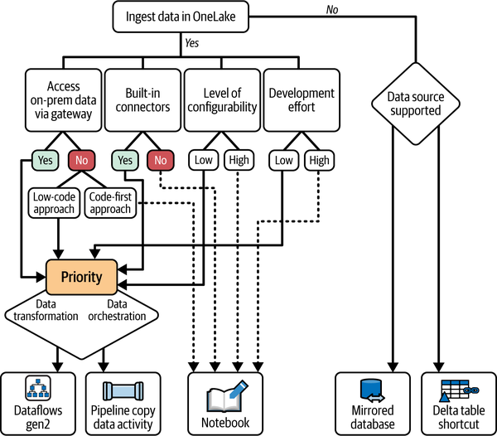

Figure 18-5. All roads lead to OneLake—but which one to choose?

Let’s break down key findings from [Figure 18-5](https://learning.oreilly.com/library/view/fundamentals-of-microsoft/9781098172916/ch18.html#fabric_ch_18_figure_5_1748224990820905). First and foremost, you need to decide whether you want to *ingest* the data and physically store it in OneLake or *access* data that is stored outside OneLake (and will stay outside OneLake), but still make it available for Fabric workloads using mechanisms such as mirroring and shortcuts. If you decide on the latter, then the decision between mirroring and shortcuts is based on the sources supported for each of these features. Microsoft maintains a lists of currently supported data sources for [mirroring](https://learn.microsoft.com/en-us/fabric/database/mirrored-database/overview) and for [shortcuts](https://learn.microsoft.com/en-us/fabric/onelake/onelake-shortcuts).

We’ll give you a simple example: if you need the data stored in the Azure SQL Database available in OneLake (but without you implementing an ingestion process), you must use mirroring, since shortcuts don’t support this data source. However, if your data resides in, say, Google Cloud Storage, and you want that data available in OneLake without physically moving it, you have to use shortcuts, because there is no mirroring for Google Cloud Storage.

A decision on when to use each of the ingestion methods is significantly more complex and requires a lot of upfront planning. The key consideration is, Do you or your team prefer a low-code/no-code approach versus a code-first approach?

Answering this question may immediately push you away from using notebooks, for example. Even if you don’t know how to code and hire proficient data engineers to build a solution using notebooks, bear in mind that this type of solution will probably require more development effort for continuous monitoring and optimization. Although notebooks provide a higher level of configurability than Dataflow Gen2 or data pipelines, with great power comes great responsibility. In many cases, a possible performance gain may result in higher maintenance costs over time. While low-code solutions are very much “set it and forget it”, Spark-related workloads require continuous monitoring and optimization. However, truth to be told, low-code solutions often don’t provide the same level of transparency as, for example, notebooks when trying to troubleshoot potential issues.

**Note**

It is by no means our intention to scare you off from using notebooks. On the contrary! We firmly believe that notebooks provide the most power and flexibility of all ingestion methods in Fabric and, when configured and managed properly, may provide the best possible performance. It’s just that using Spark and notebooks requires a specific skill set and data engineers with strong technical expertise.

**Scenario 1: Ingesting Data As Is from On-Premises Data Source**

*Task*

You are a seasoned Python data engineer tasked with ingesting data to OneLake from a large table stored in the on-premises SQL Server database. To adhere to the company’s data security policies, on-premises data sources can be accessed only via on-premises data gateway. The data should be ingested in the Fabric lakehouse staging area as is, without applying any further transformations during the ingestion process.

*Solution*

You should choose “Copy data activity” in the data pipeline. Although your primary skill set (Python) would enable you to comfortably use notebooks in Fabric, connecting to a SQL Server database via an on-premises data gateway is not supported with notebooks. Since the primary use case of Dataflow Gen2 is to apply various data transformations, and there is no such requirement in the task, you should proceed with the Copy data activity in the pipeline, which provides the highest throughput for copying the data between the source and destination.

**Scenario 2: Customizing the Data Writing Process**

*Task*

You are a data engineer tasked with ingesting data to Fabric lakehouse from a bunch of CSV files stored in ADLS Gen2. Since the files var significantly in size and number of rows, you need to customize and configure various data writing options, such as V-Order, the number of rows per file, and the number of rows within row groups in the Parquet file.

*Solution*

You should choose notebooks. Neither Dataflow Gen2 nor Copy data activity in the data pipeline offer a possibility to customize the data writing process—it is automatically handled in the background. On the other hand, you can use Python to configure the V-Order behavior as well as the minimum and maximum number of rows per row group, and the maximum number of rows per file. Generally speaking, notebooks provide full flexibility in customizing the data writing process.

**Scenario 3: Transforming Data for the Serving Layer**

*Task*

You are an analytics engineer tasked with building a semantic model for the serving layer. The model will be used by numerous data analysts for creating Power BI reports. Before you transitioned into the analytics engineer role, you worked as a data analyst yourself, and you feel most comfortable using Power Query to shape and transform the data. You need to ensure that after the Dataflow Gen2 successfully runs, a semantic model is immediately refreshed.

*Solution*

You should choose Dataflow Gen2 activity and add it to the data pipeline orchestration workflow. Dataflow Gen2 provides a low-code, Power Query-based user interface, which allows you to perform all kinds of data transformations. Dataflow Gen2 can be run either as a standalone item, or as a part of the data orchestration workflow. To efficiently fulfill the business requirement, you should add the Dataflow Gen2 activity, with all the transformation logic applied, to a pipeline canvas, and then add the semantic model refresh activity to the pipeline, which will be executed after the Dataflow Gen2 activity is successfully completed.

To wrap up this section, you won’t be wrong if you conclude that choosing the appropriate data ingestion method, in the end, represents a trade-off between the simplicity and straightforwardness of GUI-based options (Dataflow Gen2, data pipeline) and potential performance gains you may get by leveraging the full power of notebooks. Do you want to click rather than code? Sure, you can, but there’s a cost to having the code abstracted for you by a GUI. However, in many scenarios, this cost is well worth it if you are not proficient with Spark-related workloads.

To V-Order or Not to V-Order?

In previous sections, we discussed when to use a particular Microsoft Fabric feature or item to complete a specific task. In this section, we are taking a slightly different approach. Instead of examining whether you should choose feature A or feature B to complete task C, we want to wrap up this chapter by exploring a single Fabric feature—which is by default turned on—and in which scenarios, if any, you might want to consider disabling that feature. The feature in the spotlight is called V-Order.

V-Order is a proprietary Microsoft algorithm that applies some special techniqueswhen writing data to Delta Parquet files in OneLake. The main reasoning behind V-Order is that subsequent data reading operations should be more performant. By default, all Fabric workloads write data applying V-Order. Consequently, any Fabric analytical engine that reads data from the OneLakecan potentially benefit from V-Ordered Delta Parquet files.

It’s important to keep in mind that V-Ordered Delta tables are still just Delta tables. Hence, any engine that is capable of reading regular Delta tables can also read the data from a V-Ordered Delta table

Before we examine specific scenarios when you might consider modifying the default behavior, let’s first explain various techniques incorporated in the V-Order operation.

*Sorting*

During the writing process, data is reshuffled and sorted so that similar values are grouped together to increase the data compression rate. Sorting may include one or multiple columns of the table.

*Row group distribution*

A single Parquet file consists of multiple row groups. A row group represents a subset of the data determined by the row group size. V-Order optimizes the data distribution within these row groups to enhance data compression and enable efficient data pruning. Data pruning means that during the query execution, the engine can skip scanning unnecessary row groups.

*Encoding*

By applying two special encoding algorithms, dictionary encoding and run-length encoding (RLE), data is additionally compressed and replaced with shorter, numeric values (dictionary encoding), or the count of repeating values (RLE). Figures [18-6](https://learning.oreilly.com/library/view/fundamentals-of-microsoft/9781098172916/ch18.html#fabric_ch_18_figure_6_1748224990820926) and [18-7](https://learning.oreilly.com/library/view/fundamentals-of-microsoft/9781098172916/ch18.html#fabric_ch_18_figure_7_1748224990820946) illustrate the logic behind both the dictionary encoding and RLE.

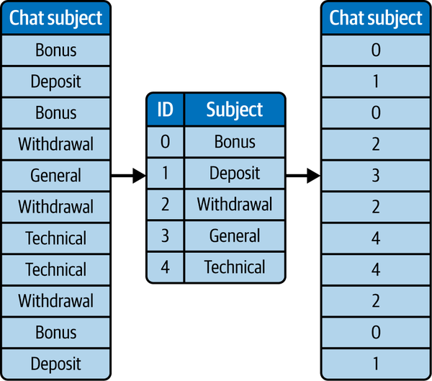

Figure 18-6. Dictionary encoding without reshuffling

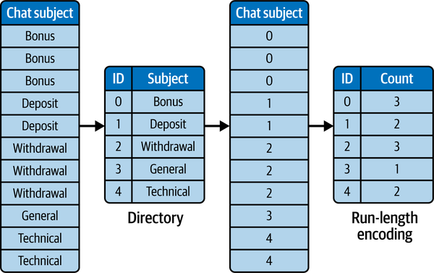

Figure 18-7. Run-length encoding with reshuffled data

As you may rightly assume, the RLE algorithm provides the best possible compression rate. However, it requires the data to be sorted in a specific order; the more buckets of repeating values, the higher the compression. That’s why V-Order applies special sorting during the data writing process.

But, there is no free lunch, and this special sorting comes with a price. Obviously, the engine that writes the data needs a certain amount of time and compute resources to reshuffle and sort the data compared to simply dumping it in OneLake in a random order.

Now that you know what V-Order is and how it works under the hood, let’s examine how various workloads in Fabric may benefit from it. The biggest beneficiary is Power BI and its new Direct Lake feature. (We cover Direct Lake in depth in [Chapter 9](https://learning.oreilly.com/library/view/fundamentals-of-microsoft/9781098172916/ch09.html#fabric_ch_9_power_bi_1748224996890066).) The reason is simple—when V-ordered, data in Delta Parquet files is stored in almost the same way as in the native Power BI database called VertiPaq, an in-memory database used to store data when using Import mode for semantic models. When using Import mode, VertiPaq applies the same encoding types we previously examined, dictionary and run-length encoding. Hence, having the data already sorted in advance using the same encoding logic immensely helps in Direct Lake scenarios. In numerous real-life implementations, we’ve noticed that cold-cache Direct Lake queries (the initial query that is run *before* the data is loaded into VertiPaq memory) perform 20% to 50% better on V-Ordered tables compared to regular, non-V-Ordered Delta tables.

The second beneficiary is the Fabric warehouse and SQL analytics endpoint of the lakehouse. These two are powered by the same engine, so technically there should be no difference in performance between the warehouse and SQL analytics endpoint of the lakehouse. In the end, the SQL engine in Fabric is also based on Microsoft’s Verti-Scan technology, which applies similar encoding and compression algorithms as VertiPaq. Based on multiple tests and benchmarks we performed, the query performance increased by approximately 10% to 15% when the V-Ordered table was used.

What about lakehouses? Can the Spark engine also benefit from V-Order? Well, if you are to believe Microsoft’s official documentation, yes. However, in our tests and in real-life use cases, the Spark engine either performed worse with V-Ordered tables, or, at best, performed slightly better, but that was before we incurred the increased cost of the V-Order data writing process. Again, the reason why Spark doesn’t benefit from V-Order is simple—unlike VertiPaq and the SQL engine, which are built to get the best out of data sorted in a specific order, Spark is not based on the same architecture. Of course, you may find particular cases when the V-Ordered table performs better than the non-V-Ordered table, but generally speaking, the Spark engine doesn’t rely too much on the key advantages that V-Order provides for VertiPaq and the SQL engine.

[Figure 18-8](https://learning.oreilly.com/library/view/fundamentals-of-microsoft/9781098172916/ch18.html#fabric_ch_18_figure_8_1748224990820965) displays a decision tree to be used when making the case for disabling the default V-Order behavior.

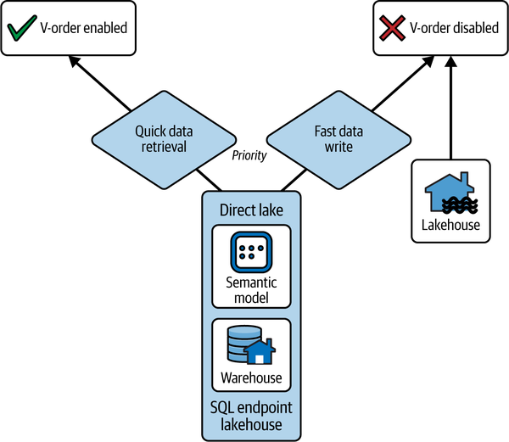

Figure 18-8. Decision tree for V-Order setting

Obviously, this is a simplistic decision tree. In reality, a decision is way more nuanced and depends on multiple factors. Here is a simple example: let’s agree that V-Ordered tables in the Fabric warehouse will provide a 10% improved query performance. You might be (rightly) wondering, Is it worth sacrificing 10% to 20% more time and capacity units for the data writing process to apply V-Order to these tables? Sounds like a bad deal, right? But, what if you have hundreds or even thousands of ad hoc SQL queries running every day to retrieve the data from those tables? In this scenario, it’s probably worth it to apply V-Order. If you decide to disable V-Order for Fabric warehouse workloads, please be aware that it’s done on the warehouse level, not the individual database or table level. Hence, if you’re building your Fabric architecture with warehouses only, you might consider disabling the V-Order feature in the staging warehouse, while keeping it enabled in the curated/gold warehouse.

**Warning**

A word of warning, though: disabling V-Order on the warehouse level is an irreversible operation. So please make sure that you are doing the right thing by changing the default V-Order behavior. It is strongly recommended that you create a copy of the warehouse and test the impact with the V-Order feature disabled.

Below, we provide a set of code snippets you might find helpful when dealing with the V-Order feature. In our examples, we are using Spark SQL, but you can also use other Spark languages, such as PySpark, Scala, and SparkR.

Check the V-Order configuration in the Spark session:

%%sql

SET spark.sql.parquet.vorder.enabled

Disable V-Order writing in the Spark session:

%%sql

SET spark.sql.parquet.vorder.enabled = FALSE

Enable V-Order writing in the Spark session:

%%sql

SET spark.sql.parquet.vorder.enabled = TRUE

Check the V-Order configuration on a warehouse:

SELECT [name], [is_vorder_enabled]

FROM sys.databases;

Disable V-Order on a warehouse:

ALTER DATABASE CURRENT SET VORDER = OFF;

You can read more about the process of controlling the V-Order writes in the [Microsoft documentation](https://learn.microsoft.com/en-us/fabric/data-engineering/delta-optimization-and-v-order?tabs=sparksql#controlling-v-order-writes).

Summary

Congratulations! You’ve made it to the end of this book. Thank you for joining us on this journey through Microsoft Fabric. We traversed a high-level overview of the platform and OneLake as its central storage repository and the core Fabric components and workloads. We’ve also explored strategies for choosing the best tool for the job at a time when Microsoft Fabric continues to evolve at an extraordinary pace.

Microsoft Fabric is a vast topic. While it was hard to go deep into each and every individual component, we hope that we’ve succeeded in creating a user guide that will enable data engineers, analytics engineers, data analysts, data scientists, and, let’s be a little bit immodest, any data professional, to find their way in a product that is growing at an unprecedented rate. We strongly encourage you to continue learning and exploring on your own. As you discover interesting topics and concepts in this book, be curious and don’t hesitate to try them. Additionally, identify domain experts who can help you on your Microsoft Fabric journey. Of course, do your best to stay up-to-date with all the latest changes and announcements about Microsoft Fabric. However, don’t lose your critical nose for every single shiny new product feature, and take all the promises with a healthy grain of salt.

What’s coming next for Fabric? The good news is that Microsoft is investing heavily in this new platform, and so you may expect a lot of new features to be introduced, as well as fine-tuning of the existing ones as the product matures. Last but not least, many of*you* may play a pivotal role in determining what is coming next. Technology is defined not only by those who create it, but also by those who use it and adopt it.

Finally, we wish you an exciting journey with Microsoft Fabric! We decided to work with Microsoft Fabric and write this book, not just because *Microsoft Fabric is a cool new product out there*, but because we wanted to share our excitement about using Fabric in real life. If we’ve managed to convey this excitement to you, we consider our mission successful.